

**Escuela Colombiana de Ingeniería Julio Garavito**

**Redes de Computadores 2025-2**

**Laboratorio II**

**Cristian Santiago Pedraza Rodríguez**

**Andersson David Sánchez Méndez**

**Presentado a: Fabian Eduardo Sierra Sánchez**

**28 de agosto de 2025**

Lab No. 2 – OS Setup, Shell and Network Support Software

# Objective

* Continue the installation of base operating systems.
* Understand how network tools operate.
* Learn about operating system administration using Shell programs.

# Tools to be used

* Computers from the Computer Lab
* Internet access
* Virtualization software
* Operating system images
* Packet tracer
* Wireshark

# Introduction

As we have already discussed, a company typically has various IT infrastructure services. These include wired and wireless user workstations and servers (both physical and virtualized), all connected through switches (Layer 2 and Layer 3), wireless devices, and routers that connect the network to the Internet. It is also common to have cloud infrastructures from which resources are provisioned according to the organization's needs.

Among the servers, you may find services such as web hosting, DNS, email, databases, storage, and applications, among others.

Below is a possible configuration:

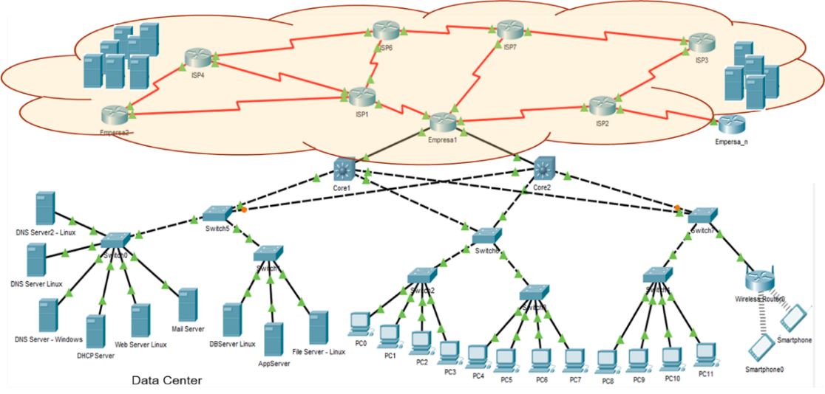

# Experiments

To build a technological infrastructure like the one shown in the previous diagram, you need to have computers and servers, each with an operating system installed. It's also crucial to understand how these systems operate from the perspective of the system administrator, as well as to support automation processes. Below, we present different activities aimed at understanding this structure.

## Getting to Know Packet Tracer

* Answer the following questions

1. What version of Packet Tracer is available on the Cisco platform?

It’s currently at version 8.2.2:

<https://www.netacad.com/es/articles/news/download-cisco-packet-tracer>

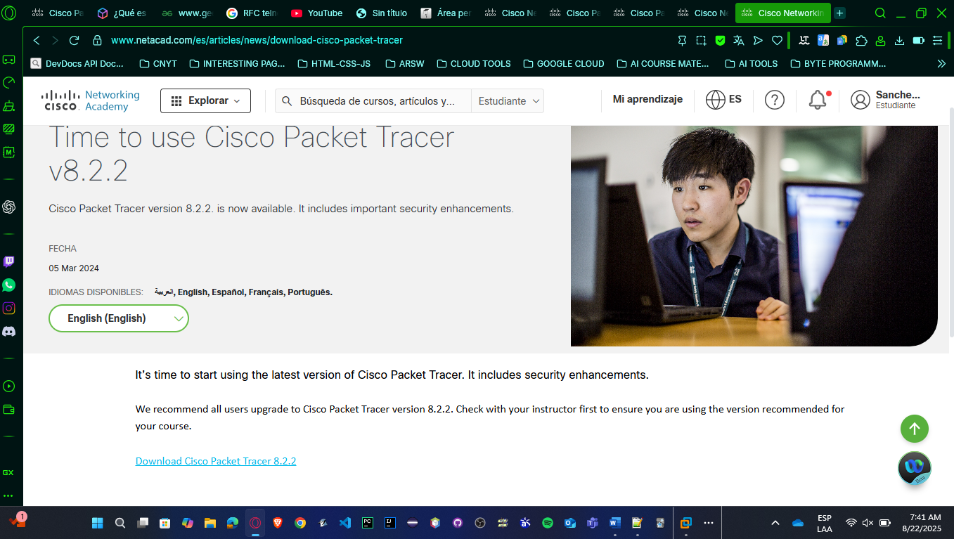

1. Through the Cisco platform, enroll in the "Introduction to Packet Tracer" course (<https://www.netacad.com/courses/packet-tracer/introduction-packet-tracer>). Create a video summarizing the first 4 chapters of the course. Maximum length: 5 minutes.

[**VIDEO**](https://www.canva.com/design/DAGw5nZ_yUY/QiRF71zMWU2geqTyfg1yTA/edit?utm_content=DAGw5nZ_yUY&utm_campaign=designshare&utm_medium=link2&utm_source=sharebutton) **LINK:** [**https://youtu.be/imZyjLkGtLw**](https://youtu.be/imZyjLkGtLw)

This short course allowed us to understand what Cisco Packet Tracer is, so we’re going to describe the best aspects we took:

* With Packet Tracer, you can simulate real-world networks using just your computer, whether it’s a small home network, an office setup, or even larger enterprise networks.
* It also includes support for IoT devices and cybersecurity concepts, making it a very versatile tool.
* The software itself is organized into different tabs that make device configuration easier. For example:
* **Physical tab** lets you power devices on or off and install hardware modules.
* The **Config tab** provides a graphical interface to configure routers and switches.
* **CLI tab** directly, which is the command line interface used in real Cisco devices.
* End devices, like PCs, have a **Desktop tab** that gives you access to things like IP configuration, the command prompt, or even a web browser
* **Services tab**, where you can configure DHCP, DNS, HTTP, and other server functions.
* Another important concept in Packet Tracer is the different file types. For example:
* **.pkt files** are regular network files that you create and save.
* **.pka files** are activity files that usually include instructions and scoring, so you can practice and get feedback.
* **.pksz files**, which are special tutorial-based activities that include hints, and finally,
* **.pkz files**, which were used in older versions and are mostly deprecated now.
* Packet Tracer is also used for assessments. Sometimes you’ll find **Packet Tracer Media Objects**, which are small exercises embedded in quizzes or exams, and also **Packet Tracer Skills Assessments**, where you demonstrate your ability to configure a network as part of a graded test.
* In short, Cisco Packet Tracer is not just software – it’s a learning environment.

1. Complete the "Introduction to Packet Tracer - PT Basics Quiz" from the course and take a screenshot of your evaluation result. Note: Each student must complete the evaluation individually.
   * You need to get into the course by clicking up in “Get-Started With Self-Paced” button. You can find different modules.

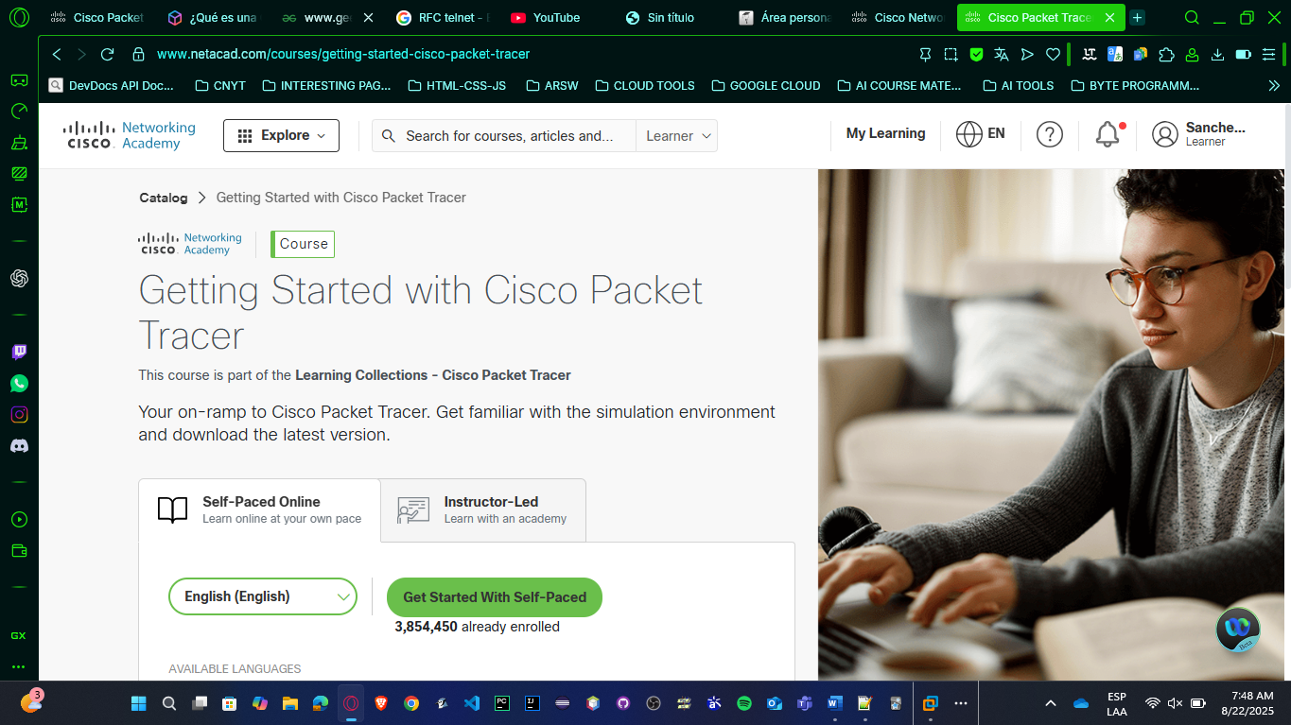

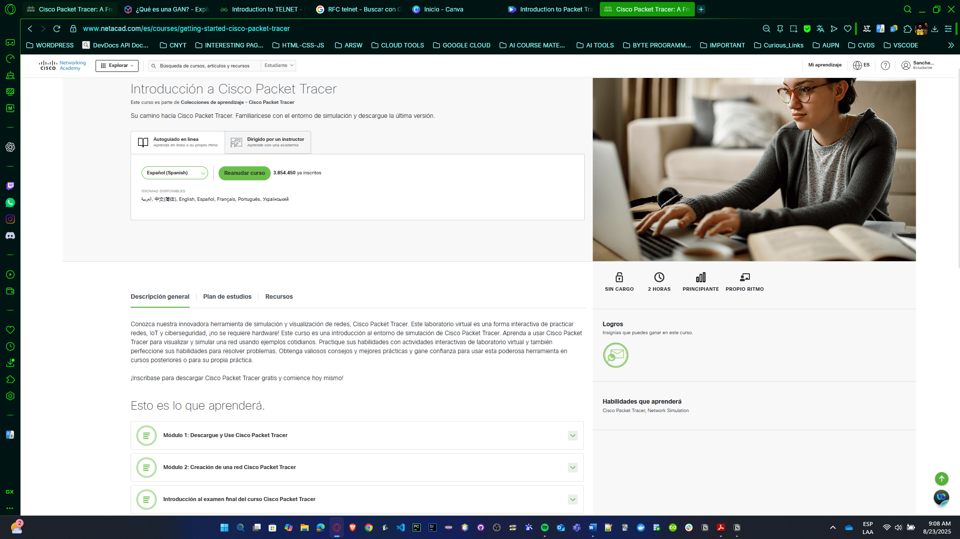

* + **First Module - Download and Use Cisco Packet Tracer**

In this module, students learn how to install Packet Tracer and get familiar with both its graphical and command-line interfaces. It explains how to deploy devices, how to use the logical and physical environments, and provides guided activities for practice. Essentially, it serves as an introduction to the software and its basic tools.

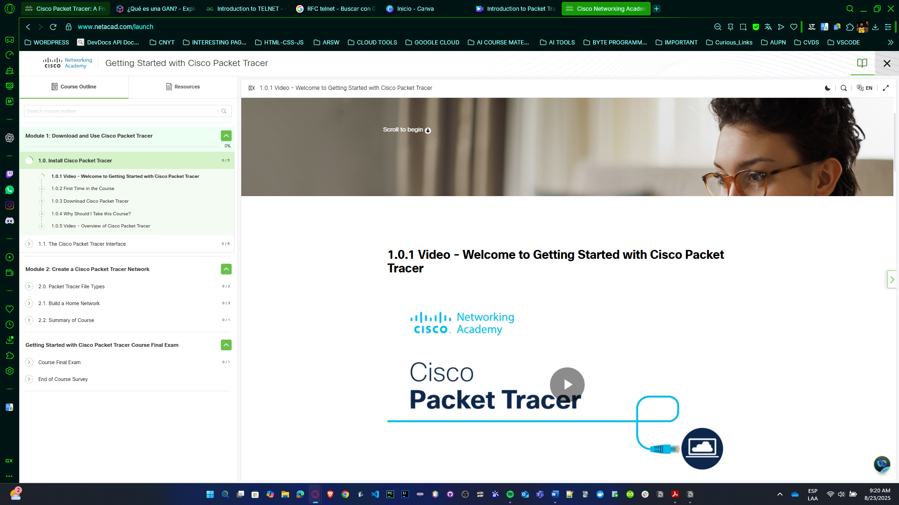

* + **Second Module – Create a Cisco Packet Tracer Network**

This module focuses on building simple networks within Packet Tracer. It covers the program’s file types, how to create a basic home network, and how to configure devices to communicate with each other. It is more hands-on, emphasizing how real networks are represented and configured inside the simulator.

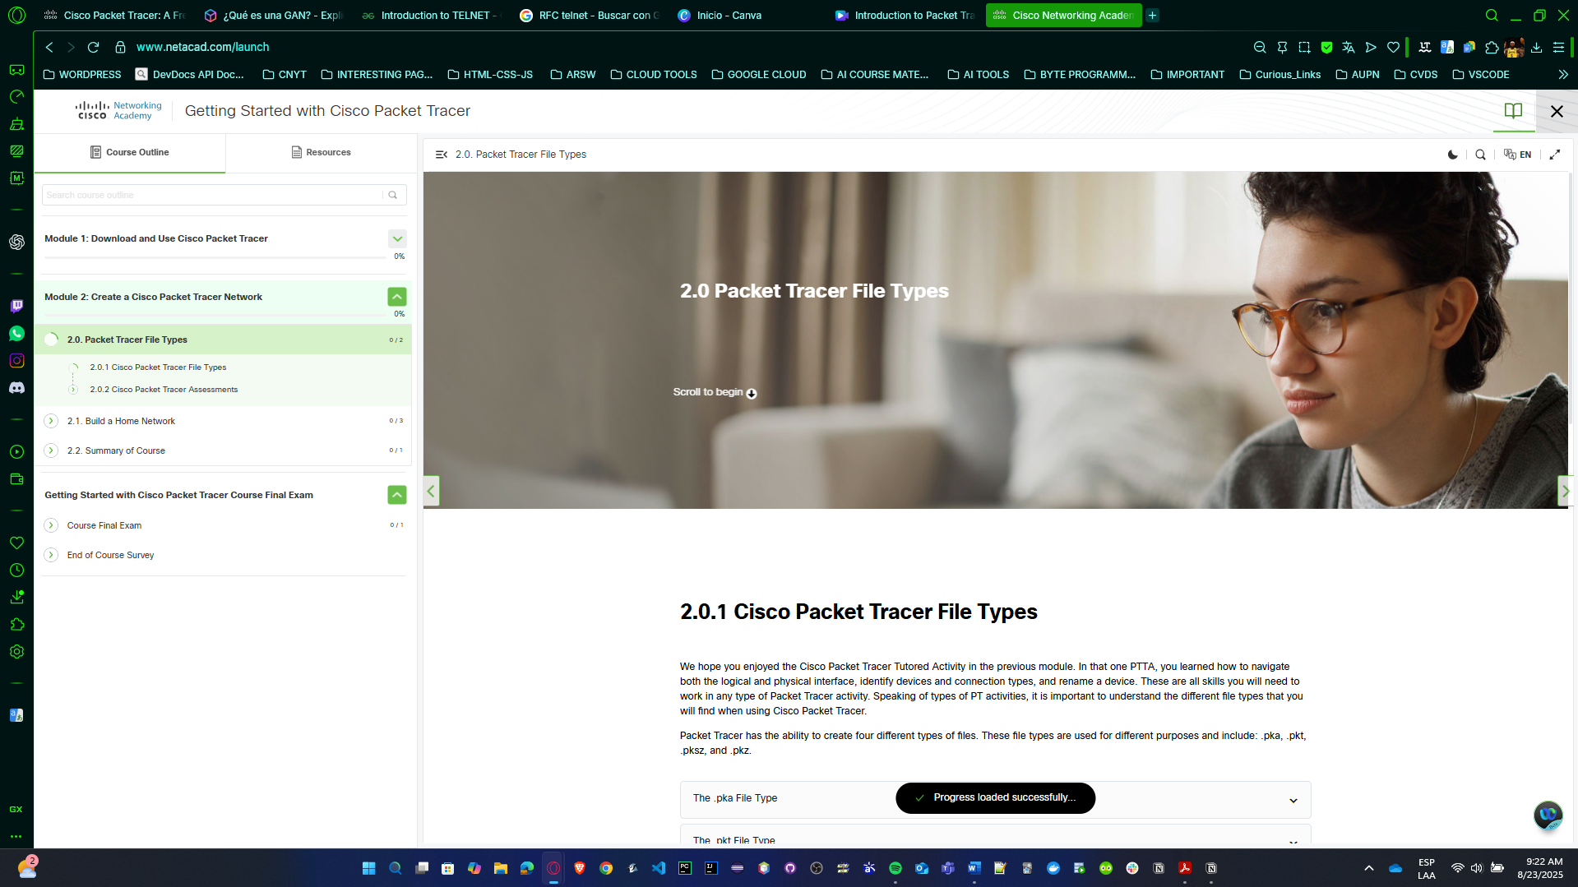

* + **Third Module – Getting Started with Cisco Packet Tracer Course Final Exam**

This module contains the final evaluation. It includes an exam to test the knowledge gained in the previous modules and a closing survey. Its purpose is to validate what has been learned and to consolidate the student’s overall experience.

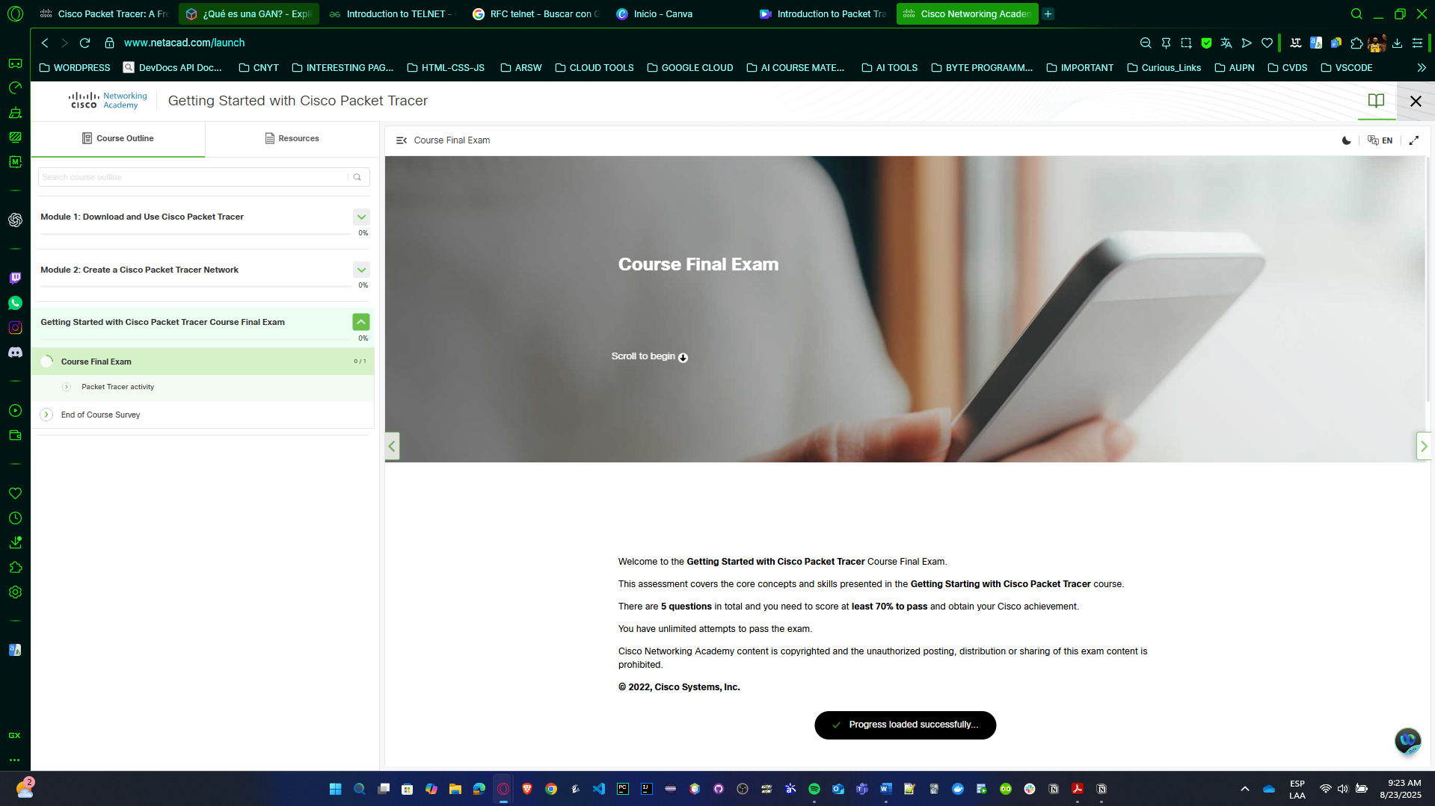

* + After we completed the course, this is our screenshot evidence passing the exam and obtaining the badge.

Andersson’s SS:

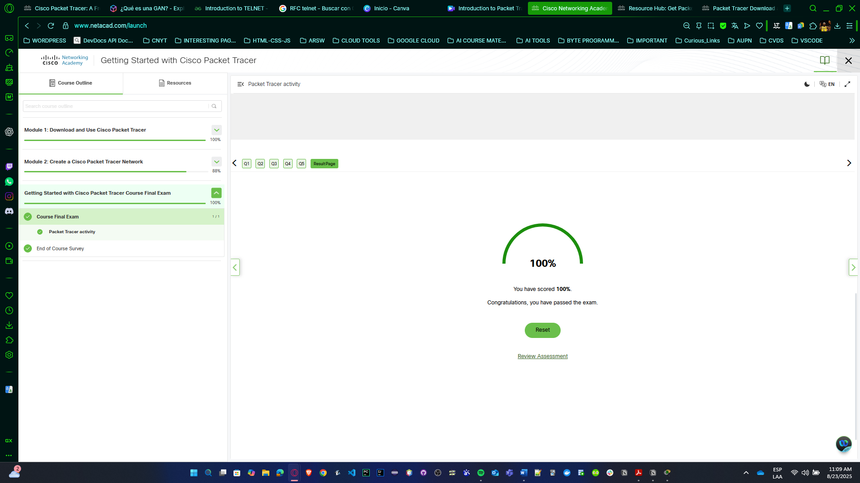

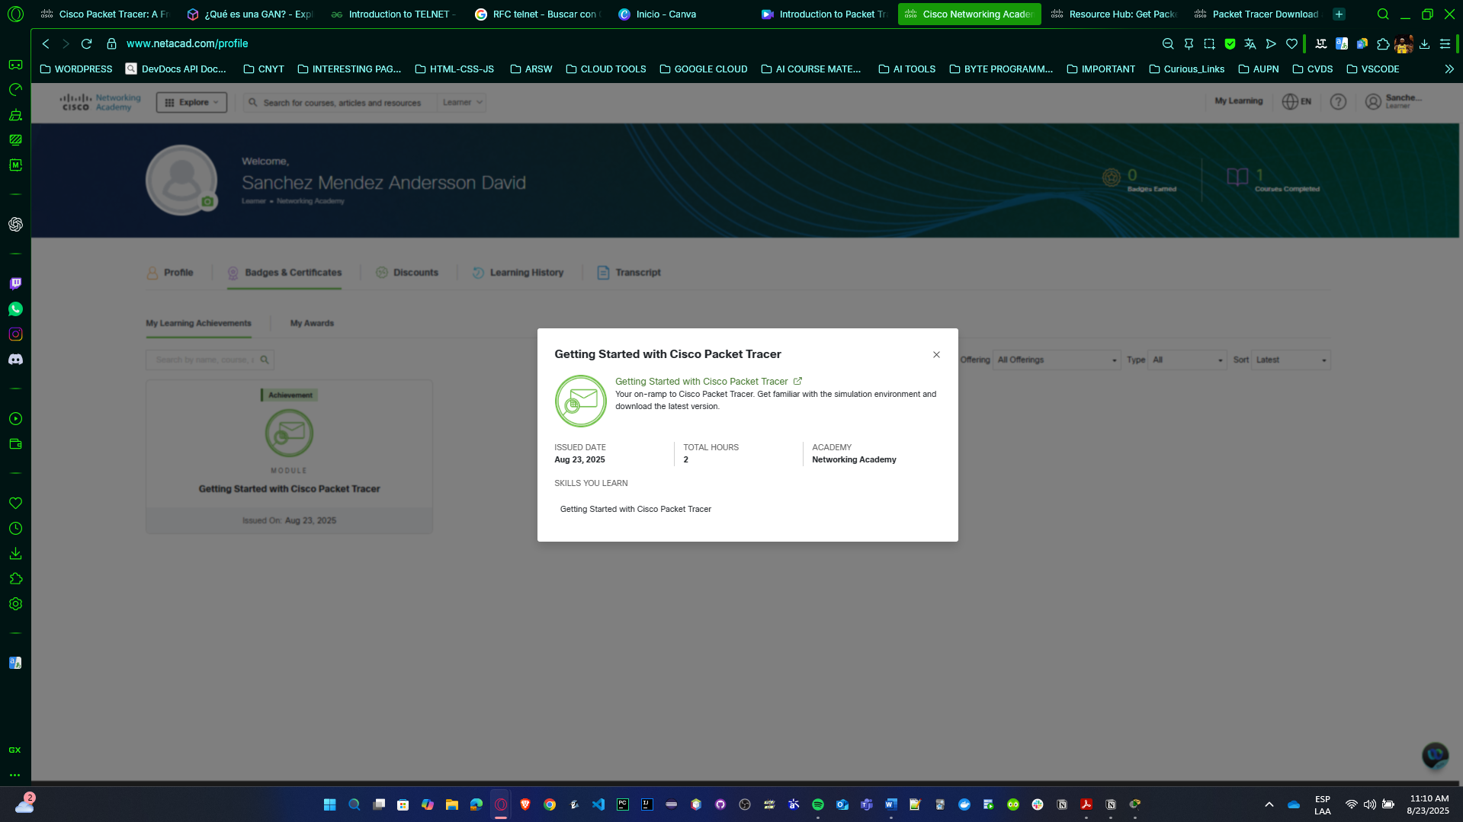

Cristian’s SS:

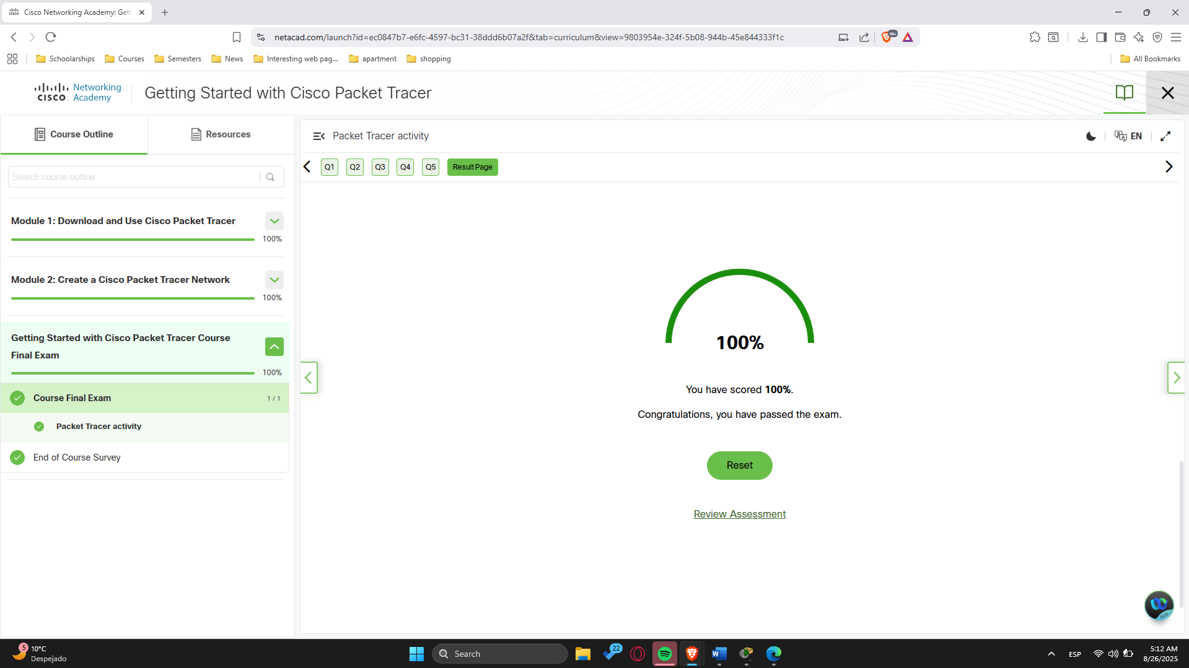

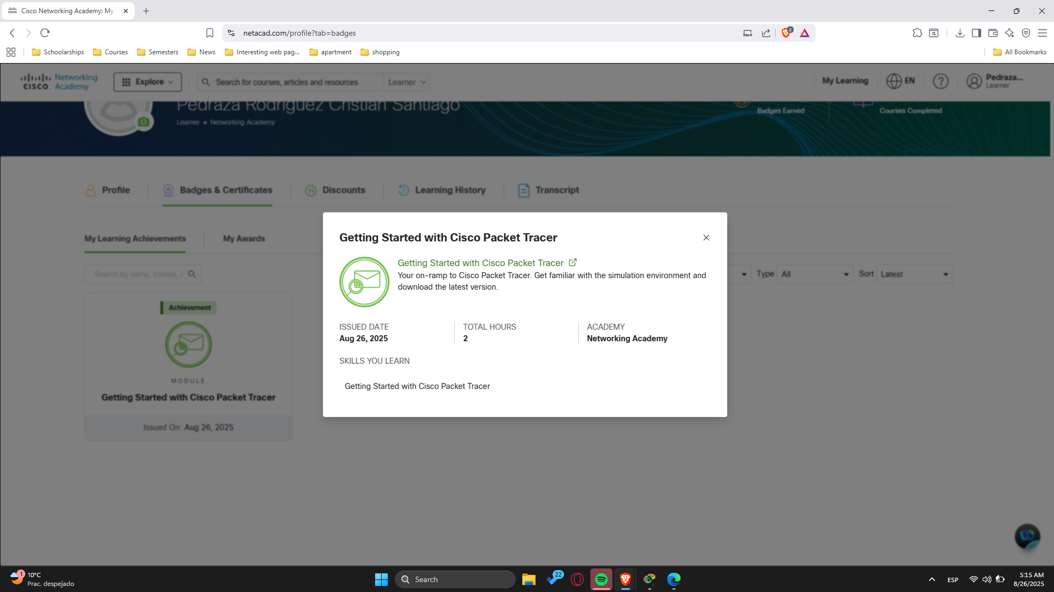

* Using Packet Tracer, each student must create the network diagram presented on the next page.

Note:

* Do not take into account the colors of the points/rectangles that appear in the links (the links are the connection lines between devices. The colors of these links will become important later, but we will review them at that time).
* The connections or links presented in the diagram are as follows:

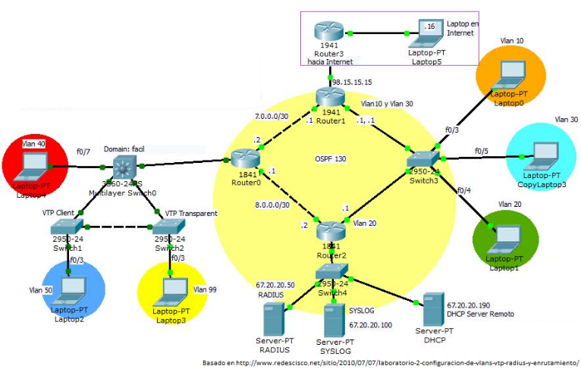t

* + Black connections correspond to Ethernet cables (Ethernet, FastEthernet, or GigabitEthernet).
    - What do the continuous black connections signify?

→ Represent **active Ethernet links** (the cable is connected correctly and the interface is enabled and operational).

* + - What do the discontinuous black connections signify?

→ Represent **inactive or administratively down Ethernet links** (the cable is connected, but the interface is shut down or not yet configured).

Andersson’s network diagram

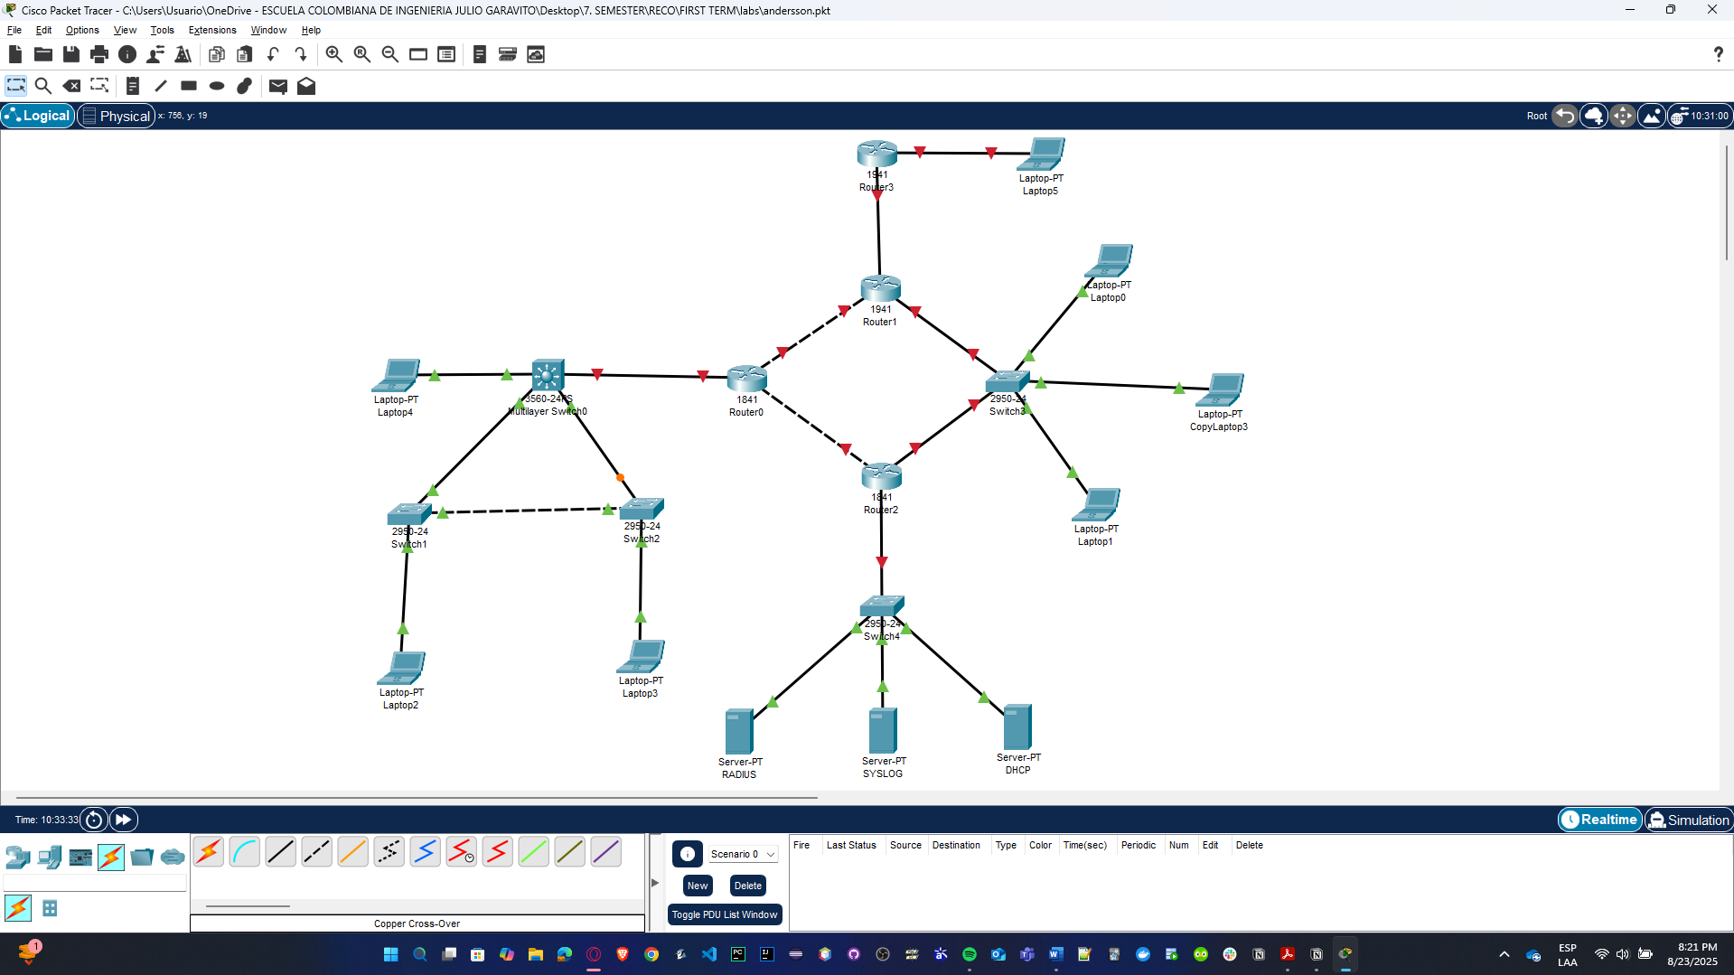

Cristian’s network diagram

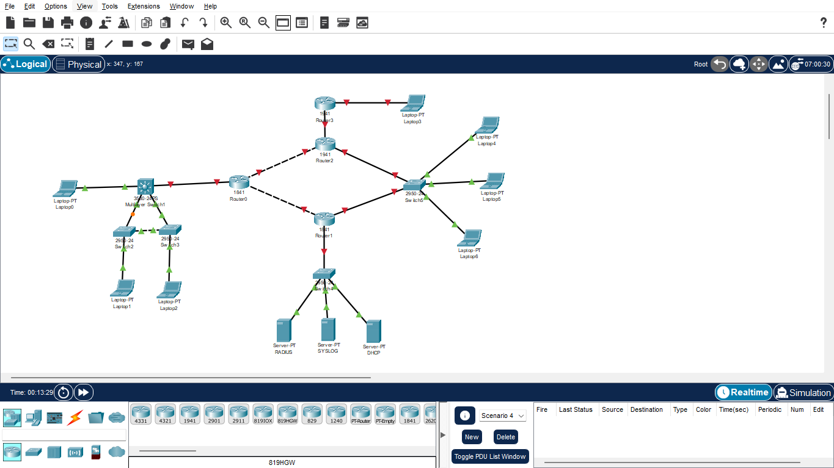

* + Change the connection between Router0 and Router2 so that they use a serial cable for the connection (red cables correspond to serial cables—typically used for WAN connections).
* When you press router 0 and router 2, you need to drag WIC-2T into slot 0 to be able to add the serial cable if the power is off.

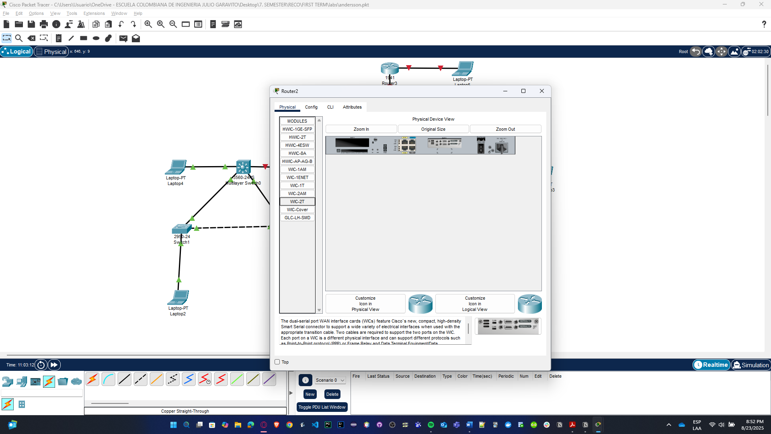

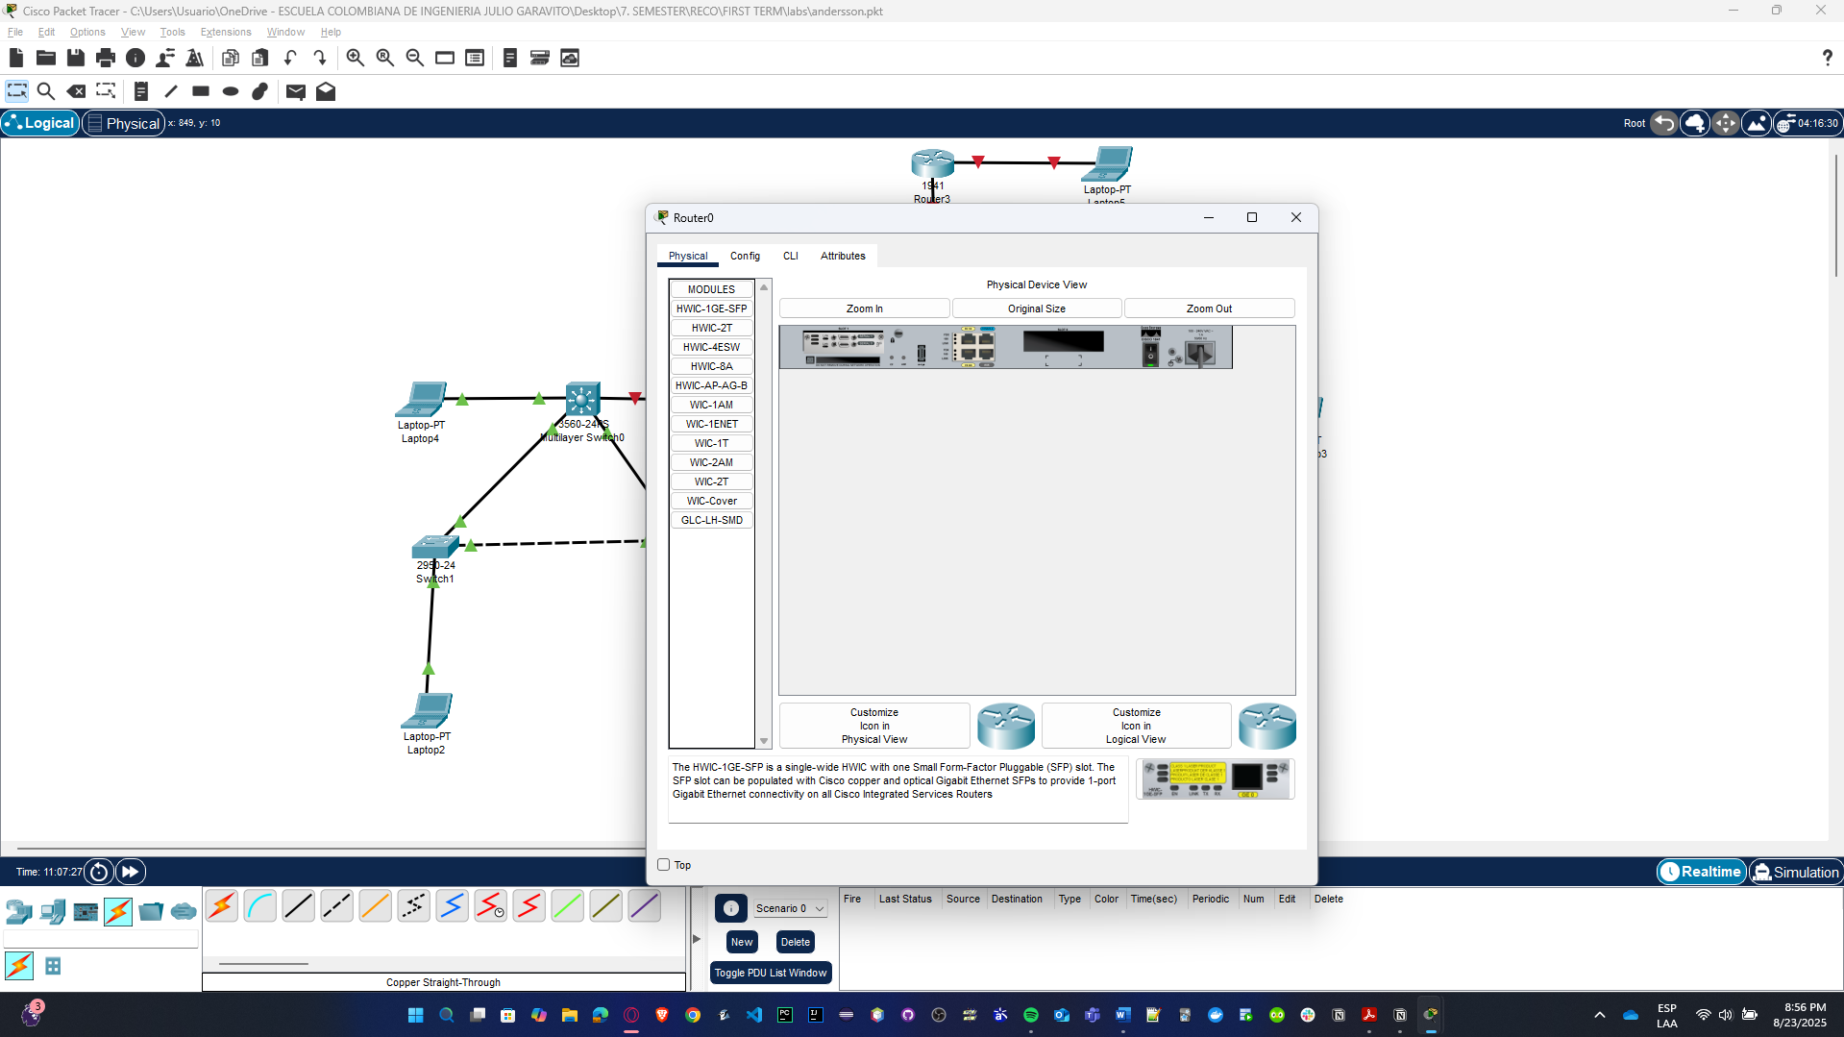

Andersson’s network diagram with Serial Cable

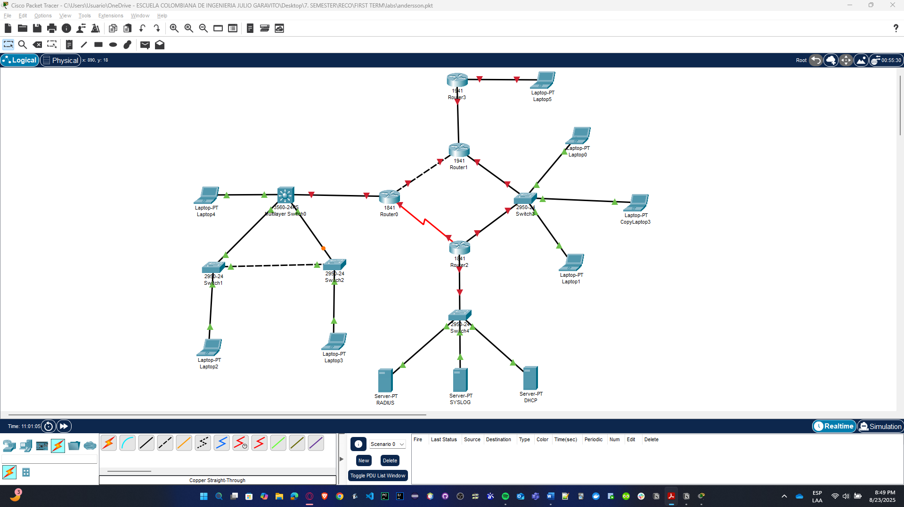

Cristian’s network diagram with Serial Cable

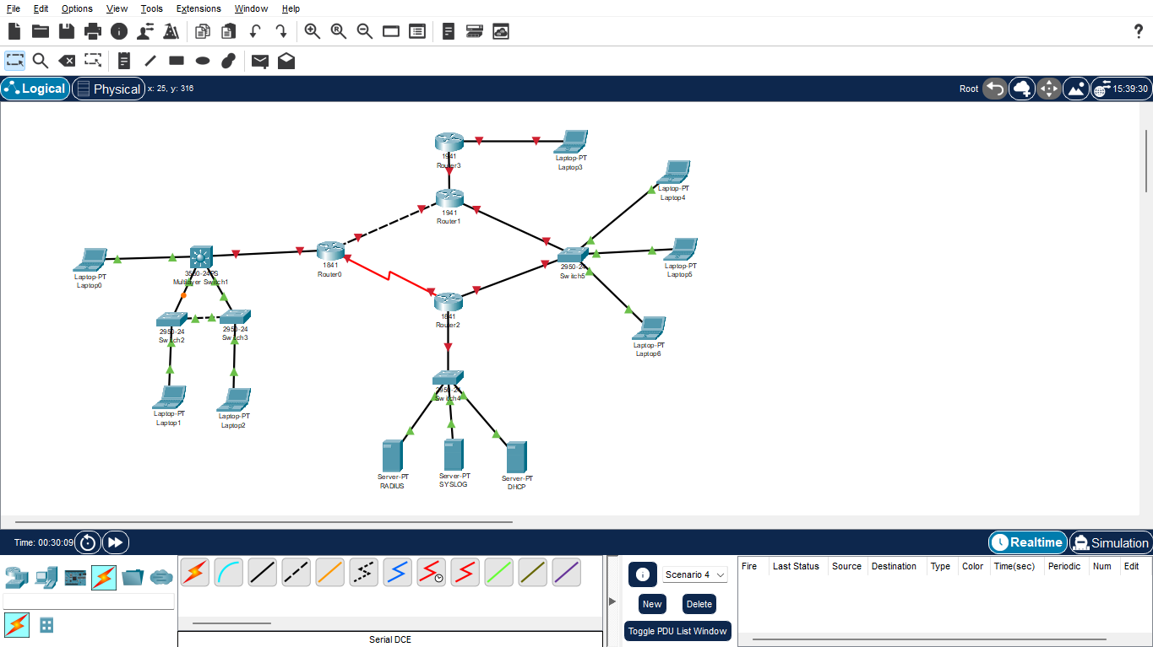

* + Finally, we configure the IP address assigned in servers, and VLAN, MAN, VTP Client, VTP Transparent for the other different devices.

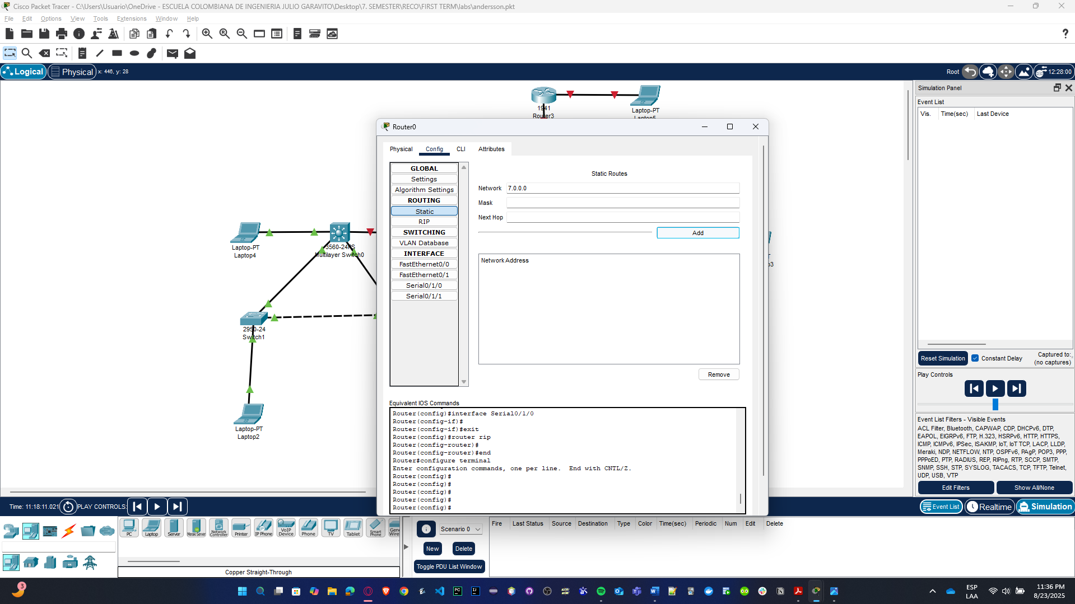d

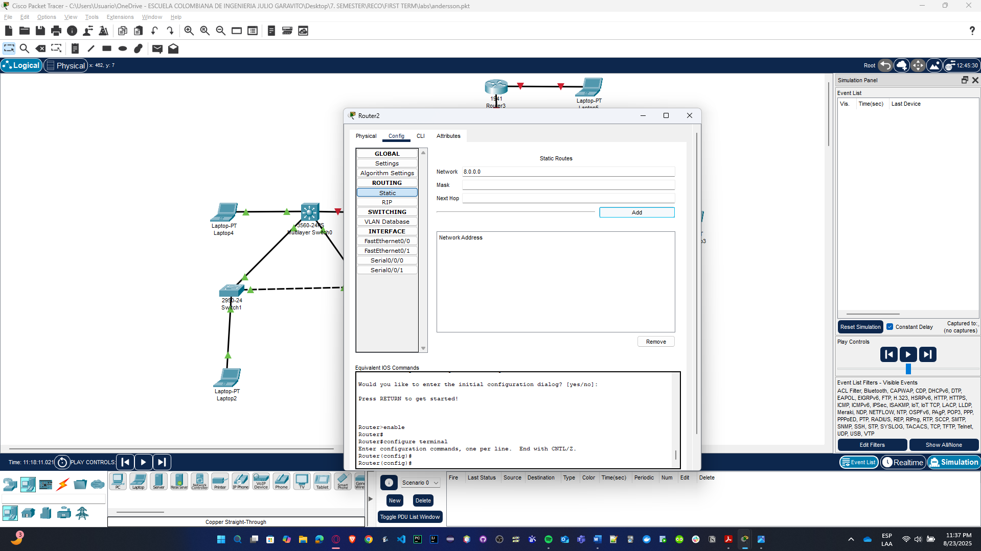

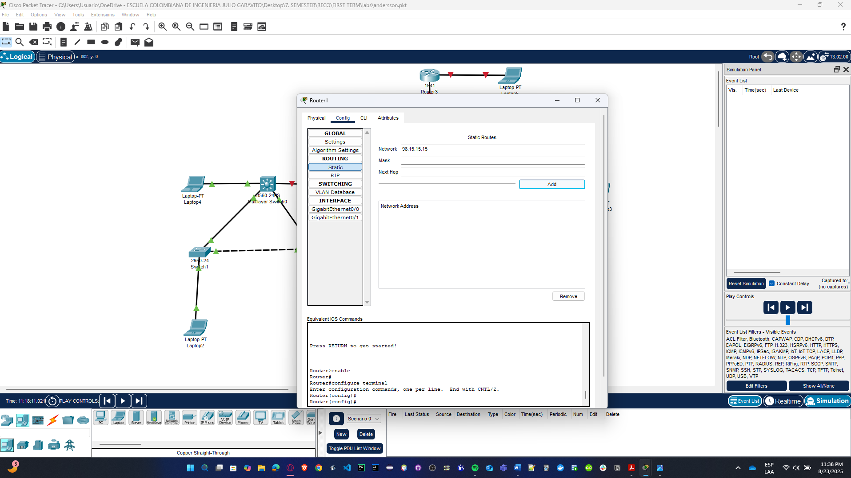

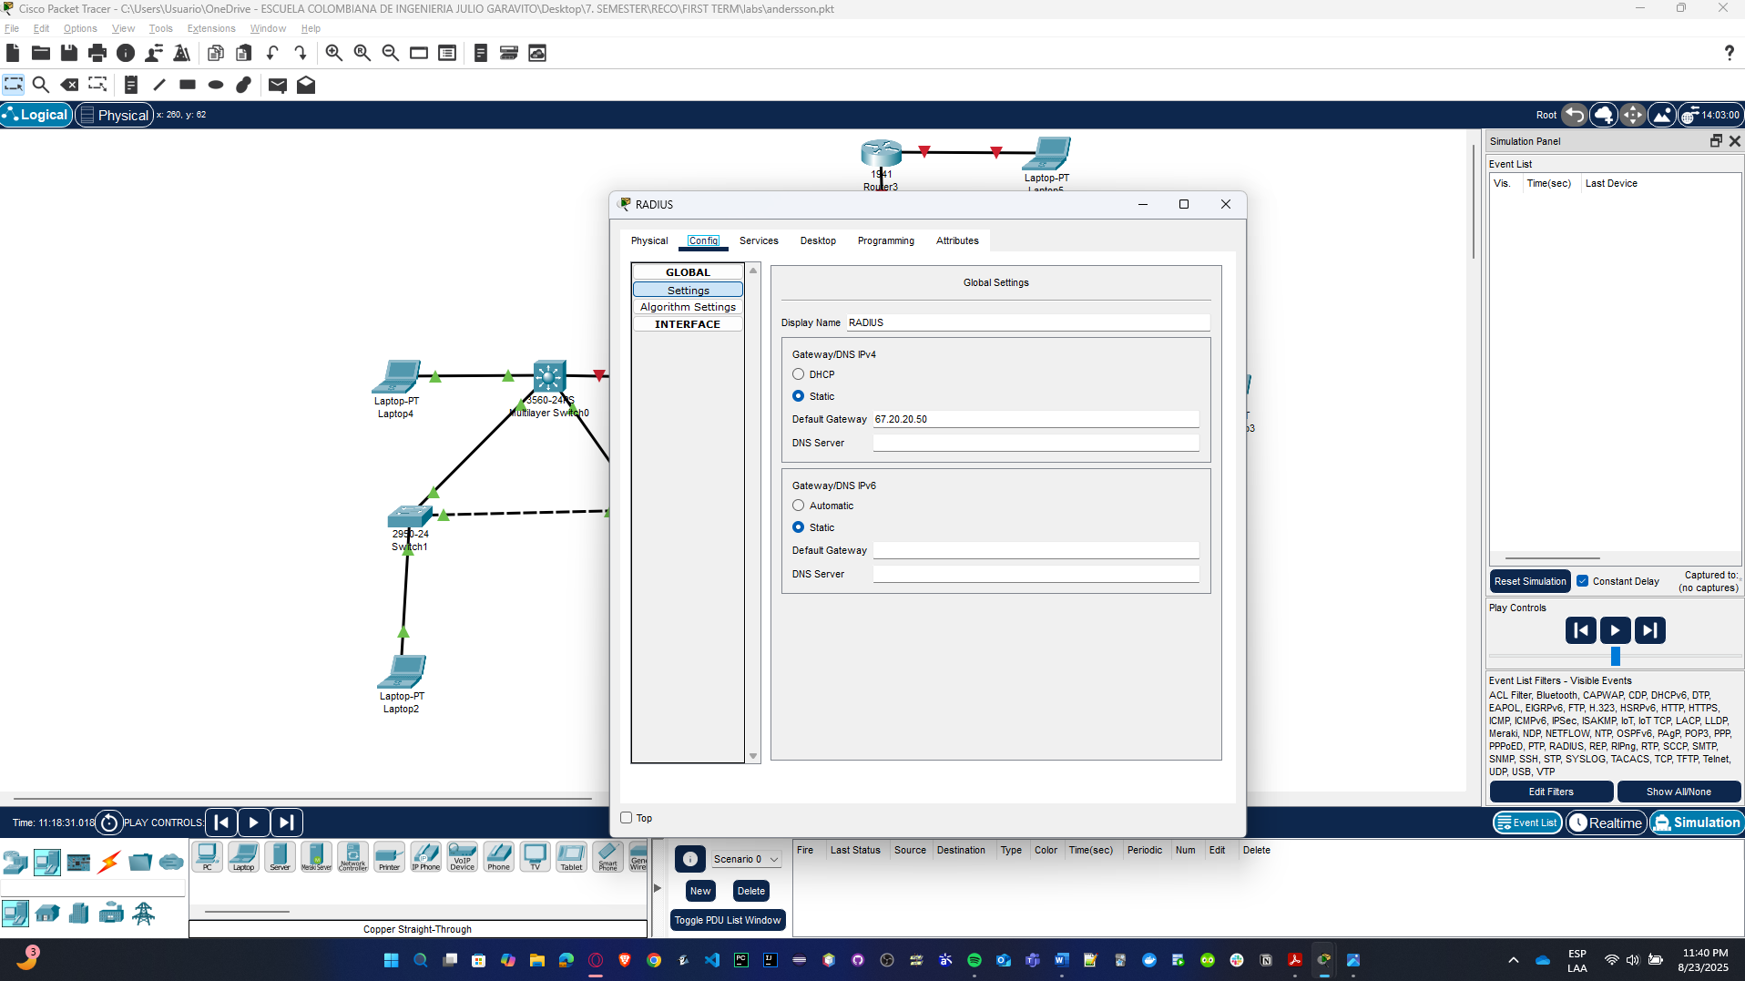

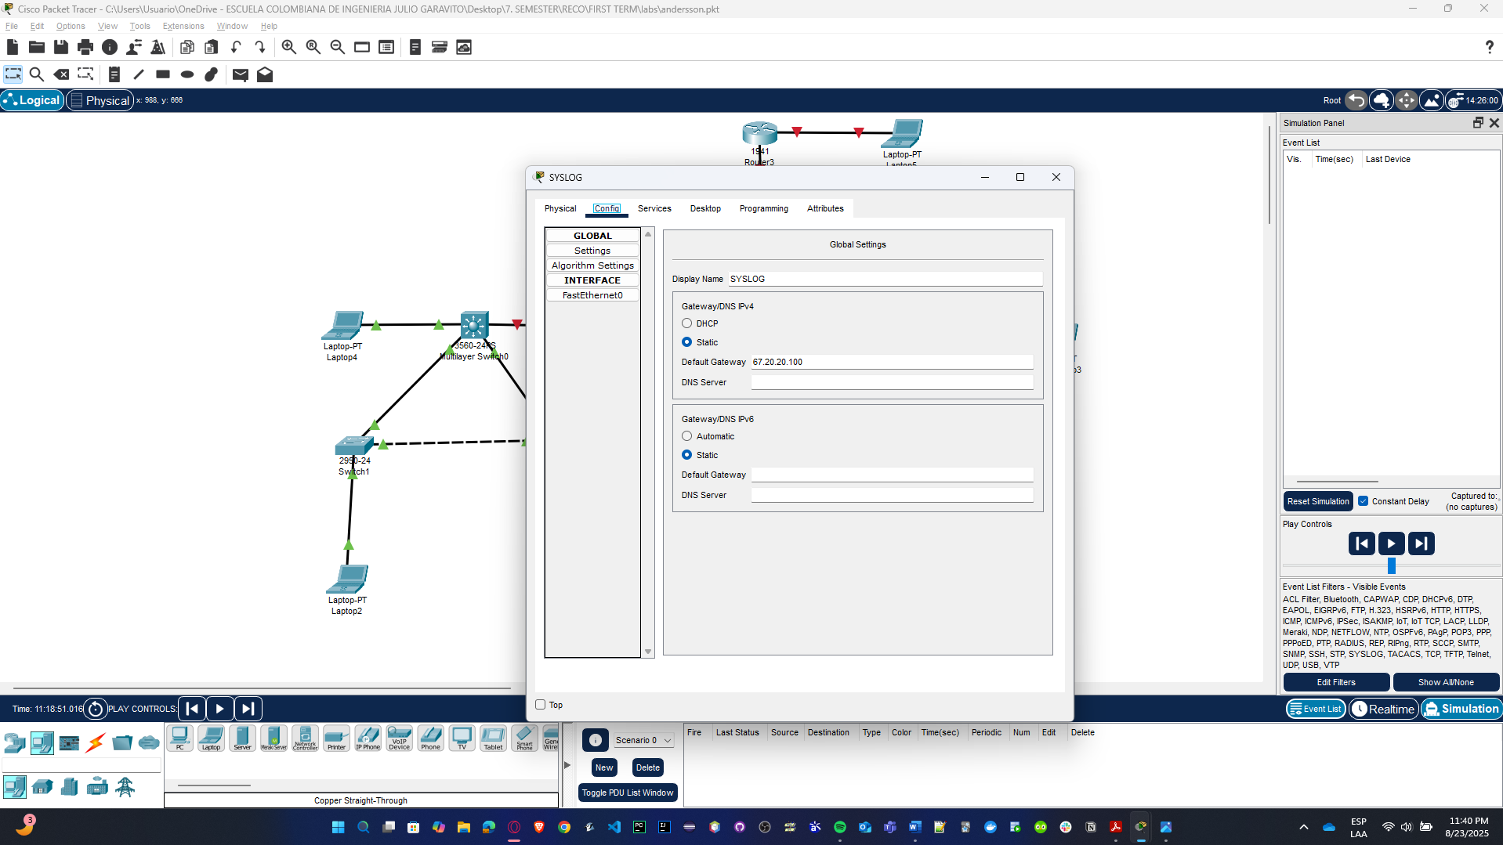

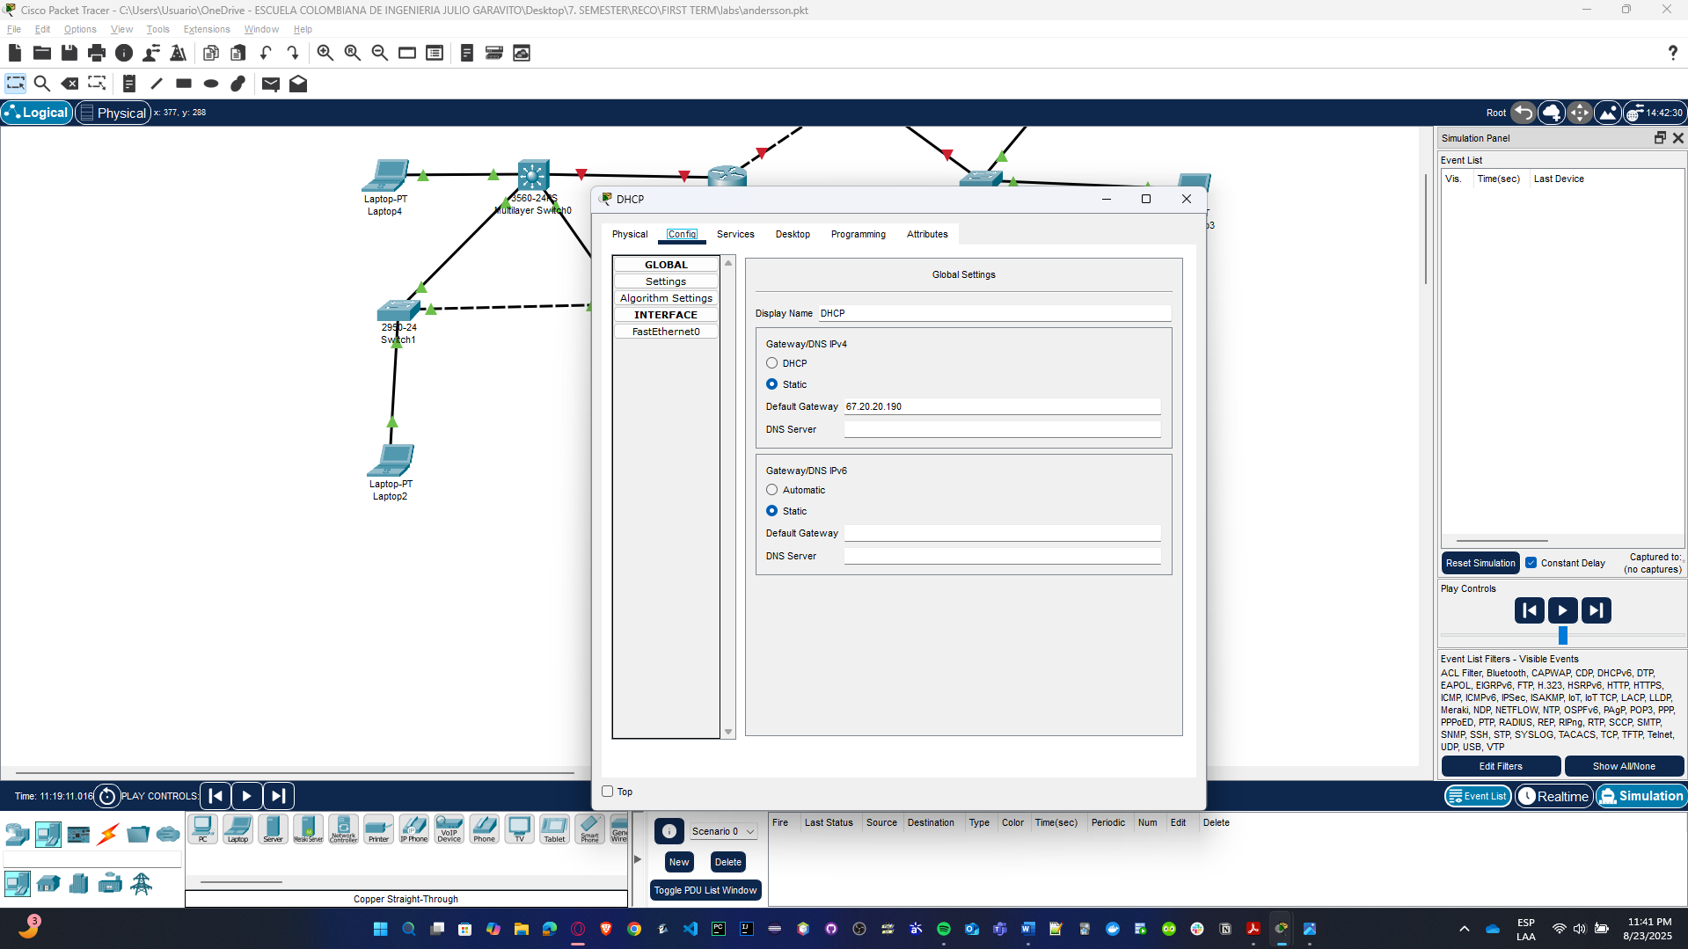

**Note**: Each student must build and submit the Packet Tracer file with the network.

## Following messages with Packet Tracer

**To run the simulation and capture the traffic[1], do the following steps.**

* In the far lower right of the PT interface is the toggle between Realtime and Simulation mode. Click on Simulation mode.

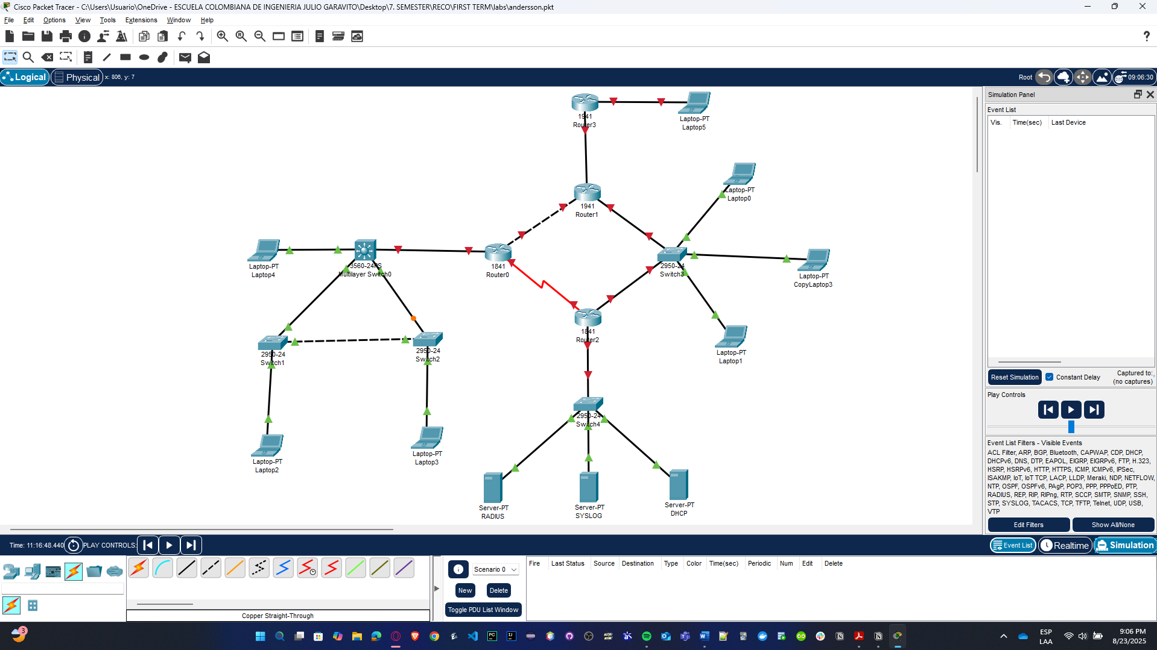

* Click in the Edit filters button and select only ICMP.

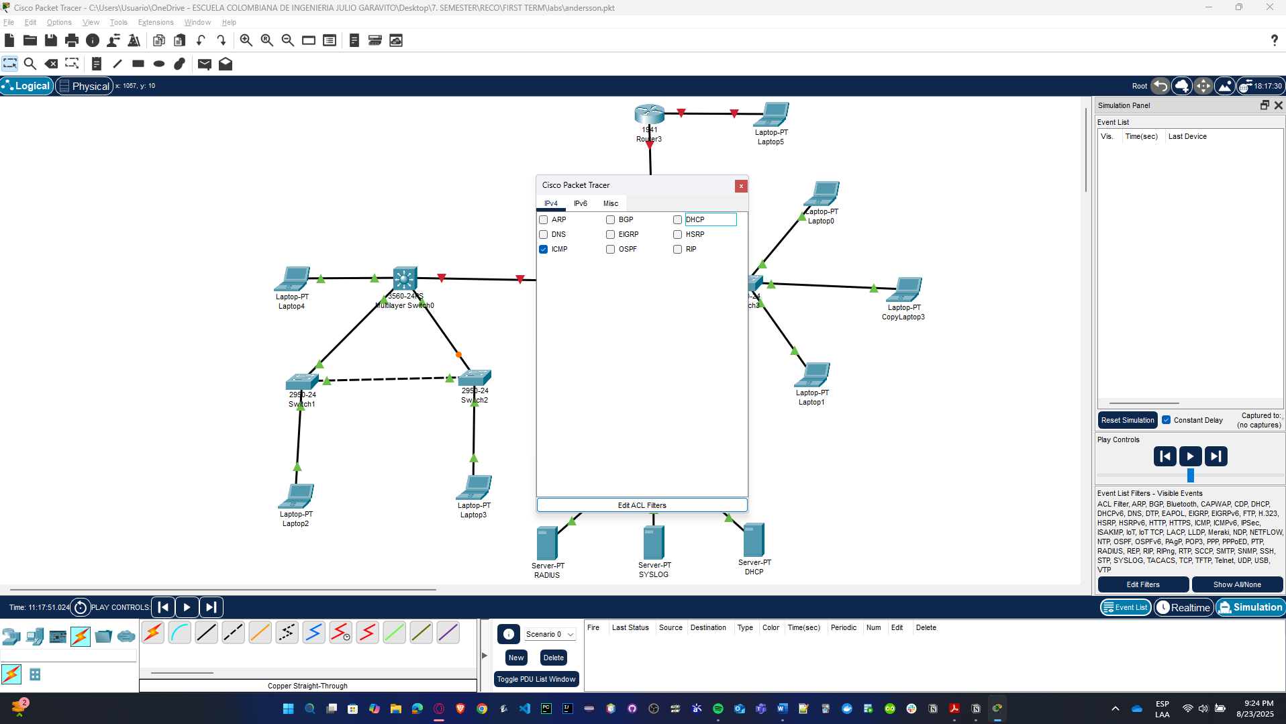

* Click in Server-PT_RADIUS. Choose the Desktop tab. Open the Command Prompt. Enter the command ping IP_SERVER-PT_DHCP). Pressing the Enter key will initiate four ICMP echo requests. Minimize the PC configuration window. Two packets appear in the Event List, the first ICMP echo request and an ARP request needed to resolve the IP address of the server to its hardware MAC address.

For this case, we test ping 67.20.20.190 because its the DHCP IP address; after we press ENTER key, four ICMP echo requests were successfully

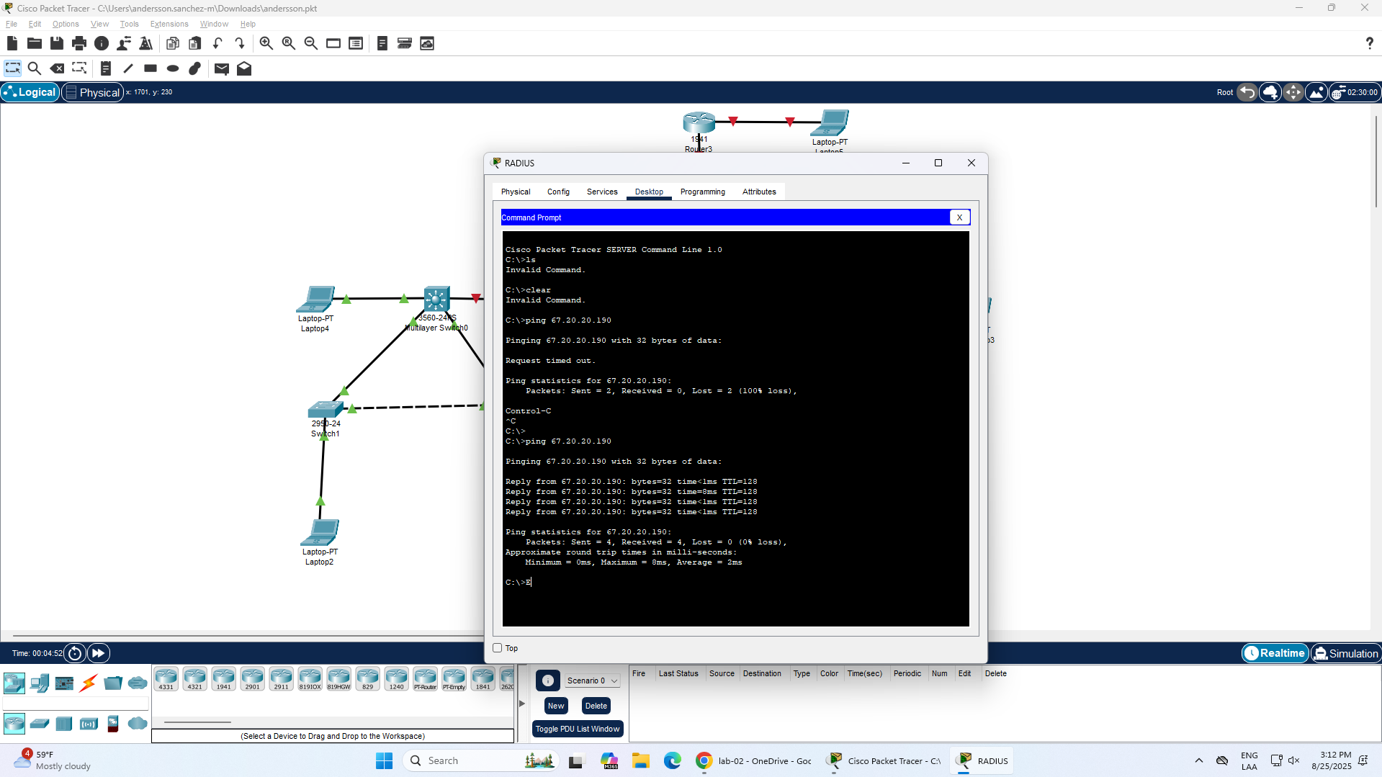

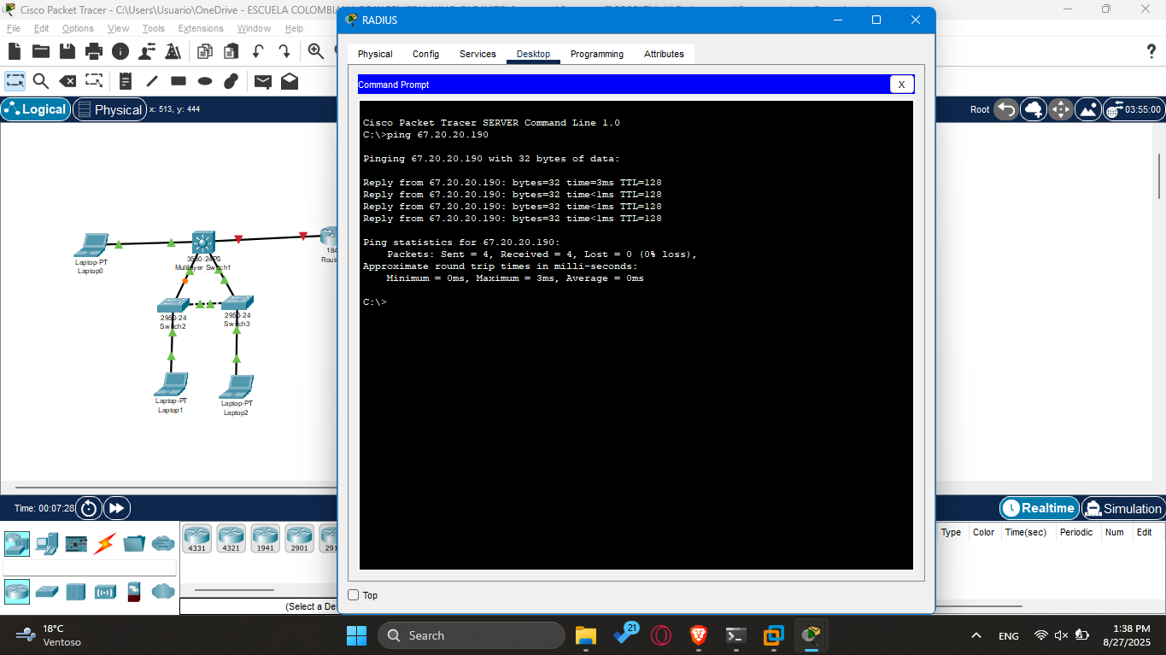

* Click the Auto Capture / Play button to run the simulation and capture events. Click OK when the "No More Events" message is reached.

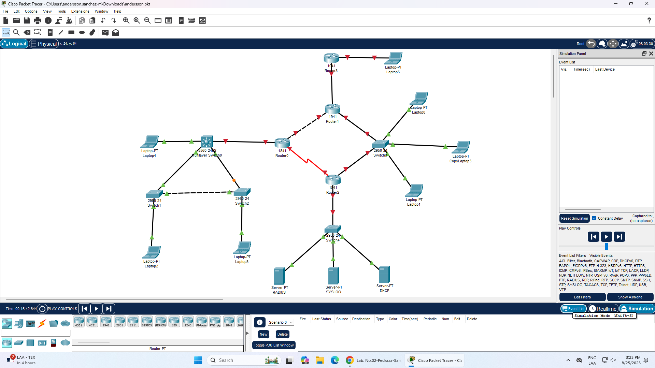

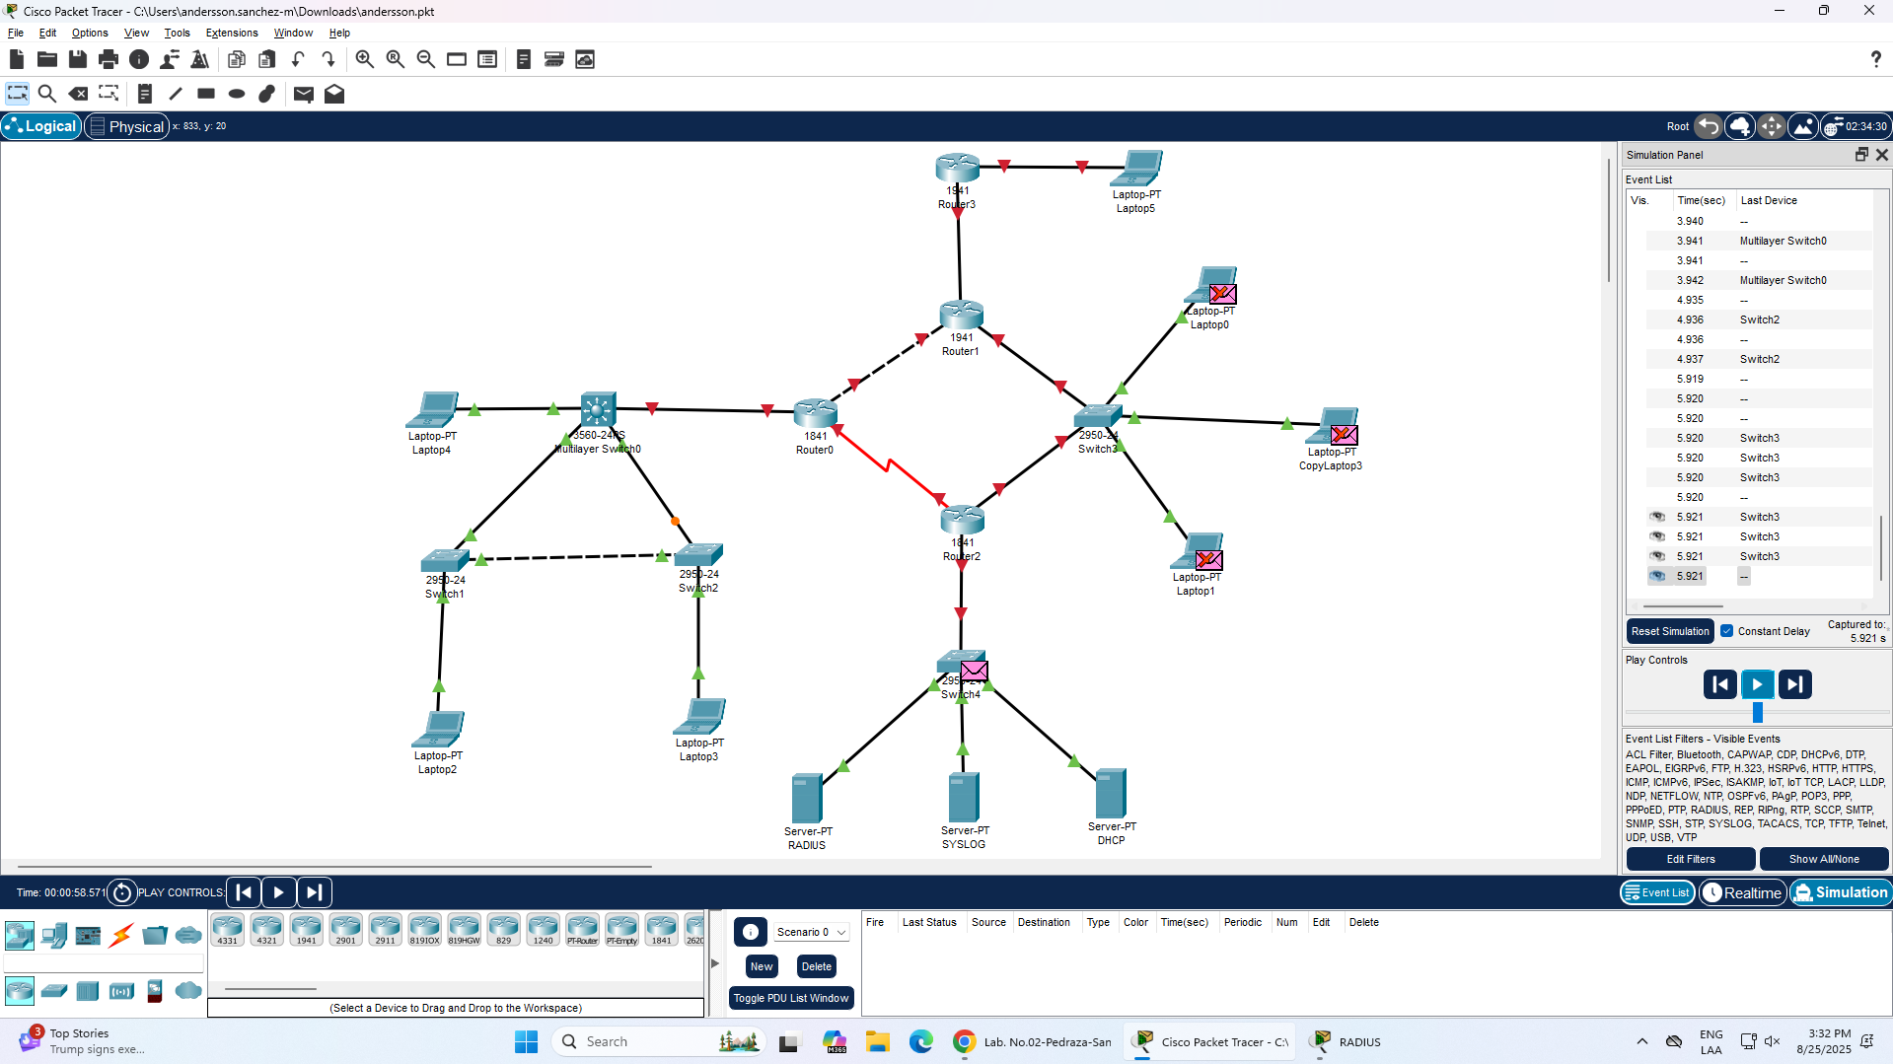

* Now, review the PDUs (Protocol Data Units) by layer (we haven't yet discussed the meaning of each, but note that they exist, and each layer adds information to the user data).
* Selecting a packet and choosing the **“Outbound PDU Details”** or **“Inbound PDU Details”** displays how the packet is processed and constructed at each OSI layer.
* Every layer adds specific headers or metadata that support the transmission and delivery of the packet.

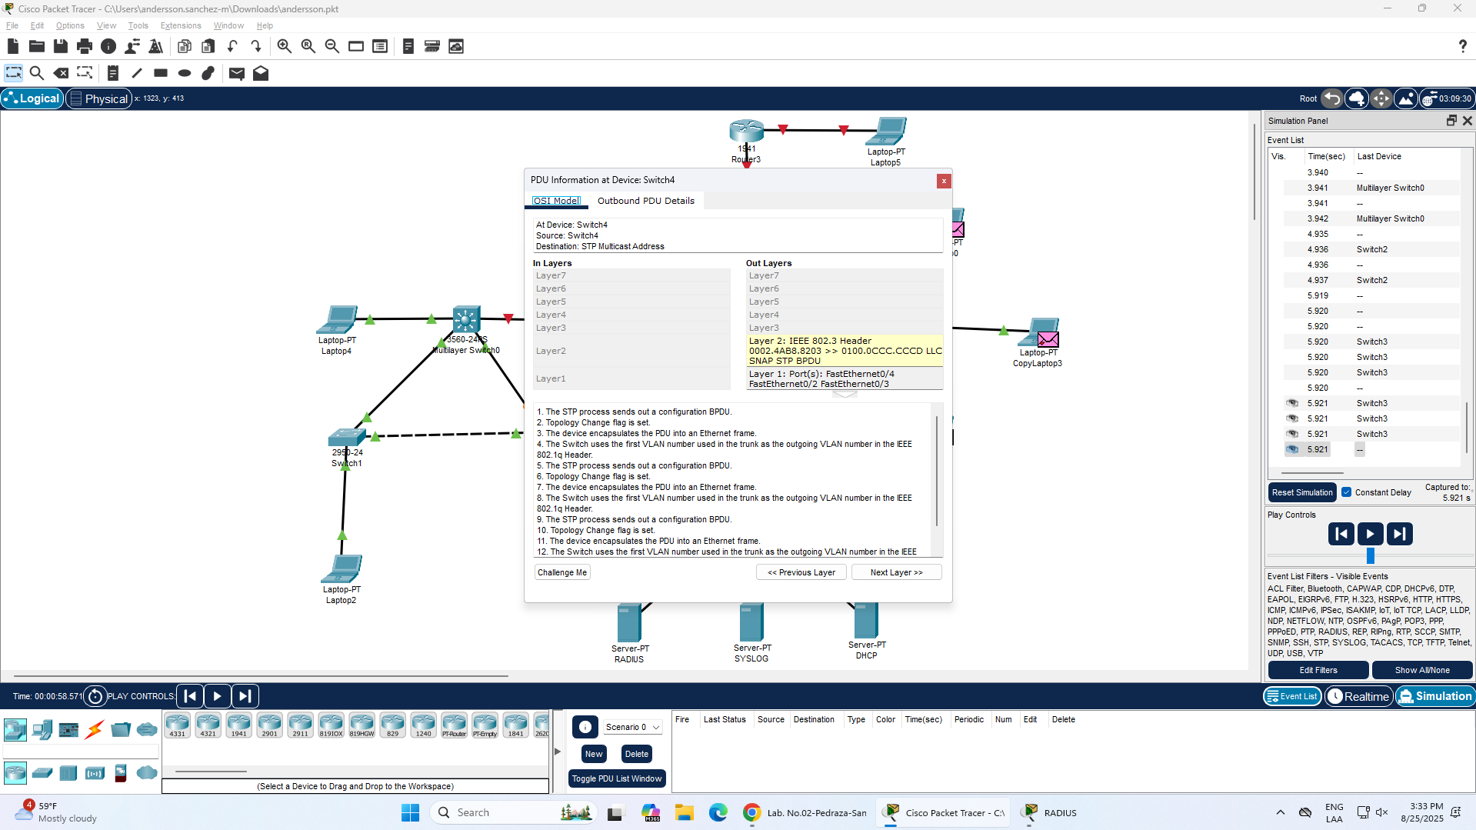

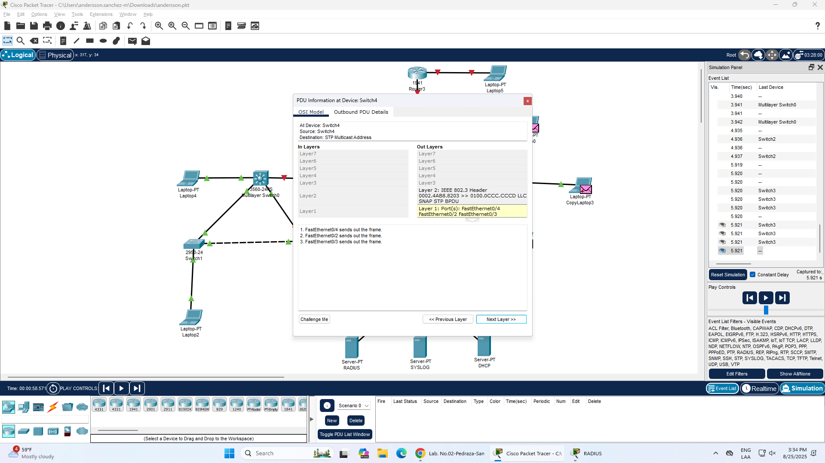

* Review the content of the captured packets. Observe how the PDUs of each layer are constructed.

You can see that each layer contributes specific data:

* **Layer 1 (Physical):** Represents the physical transmission over the network.
* **Layer 2 (Data Link):** Adds MAC addresses and frame control information (e.g., source/destination MAC, frame check sequence).
* **Layer 3 (Network):** Adds IP headers with source and destination IP addresses.
* **Layer 4 (Transport):** Would include port numbers if using TCP/UDP (not always shown for ICMP).
* **Layer 7 (Application):** Contains the actual ICMP message (e.g., echo request/reply).

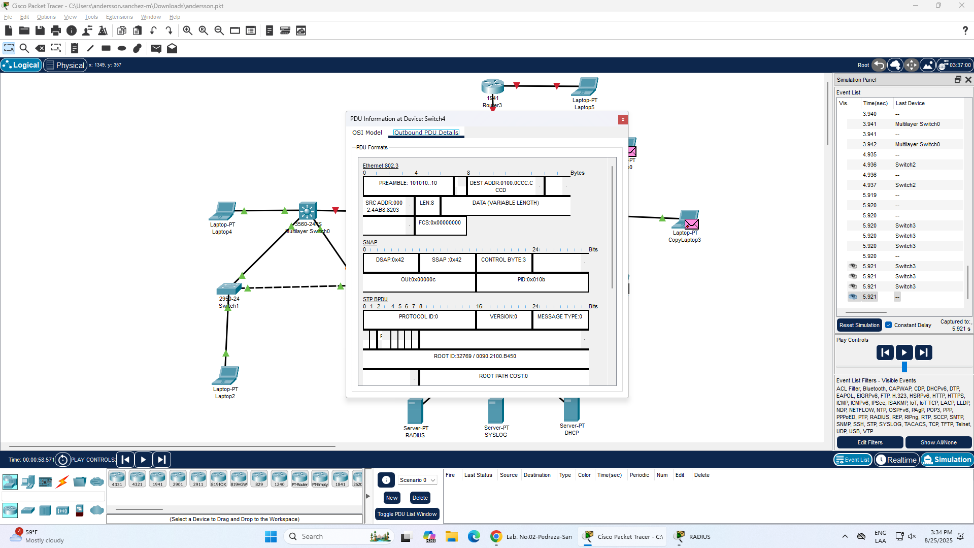

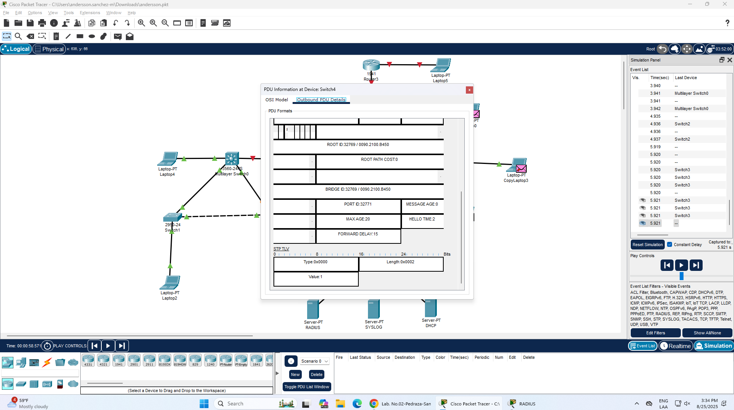

# In the real network

Make the following tests using Wireshark tool.

## Using Wireshark

Wireshark is a cross-platform tool used to analyze network packets. We will use it in the course to observe, in real-time, the data passing through the network[2] and the operation of the various protocols we will study. For that reason:

* **Install (if at home) and run Wireshark on the computer you're working on.**

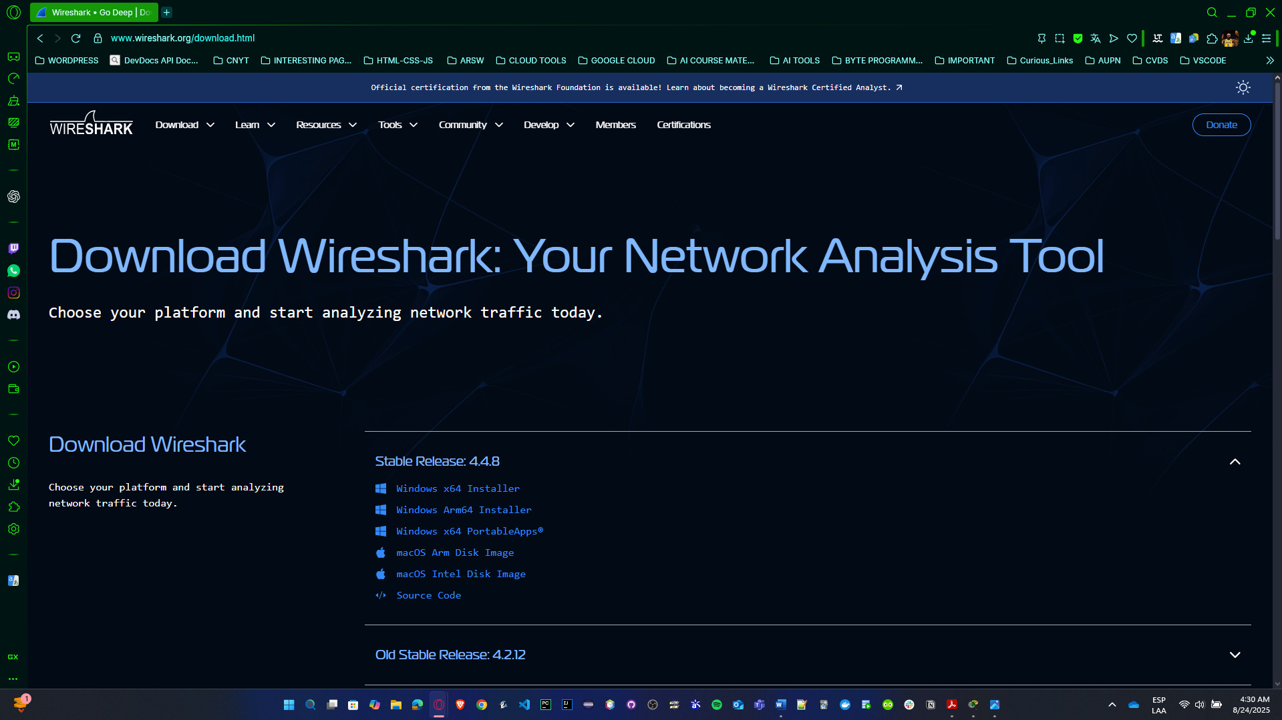

<https://www.wireshark.org/download.html>

* **Review videos and documentation on how Wireshark operates. What is Wireshark?**
* **One-liner:** Wireshark is a cross-platform packet sniffing and protocol analysis tool. It captures frames off a NIC and decodes them all the way up the stack so you can inspect headers, payloads, and timing.
* **Why admins use it:** troubleshooting (latency, drops, retransmits), security (suspicious hosts, failed logins), and protocol learning.

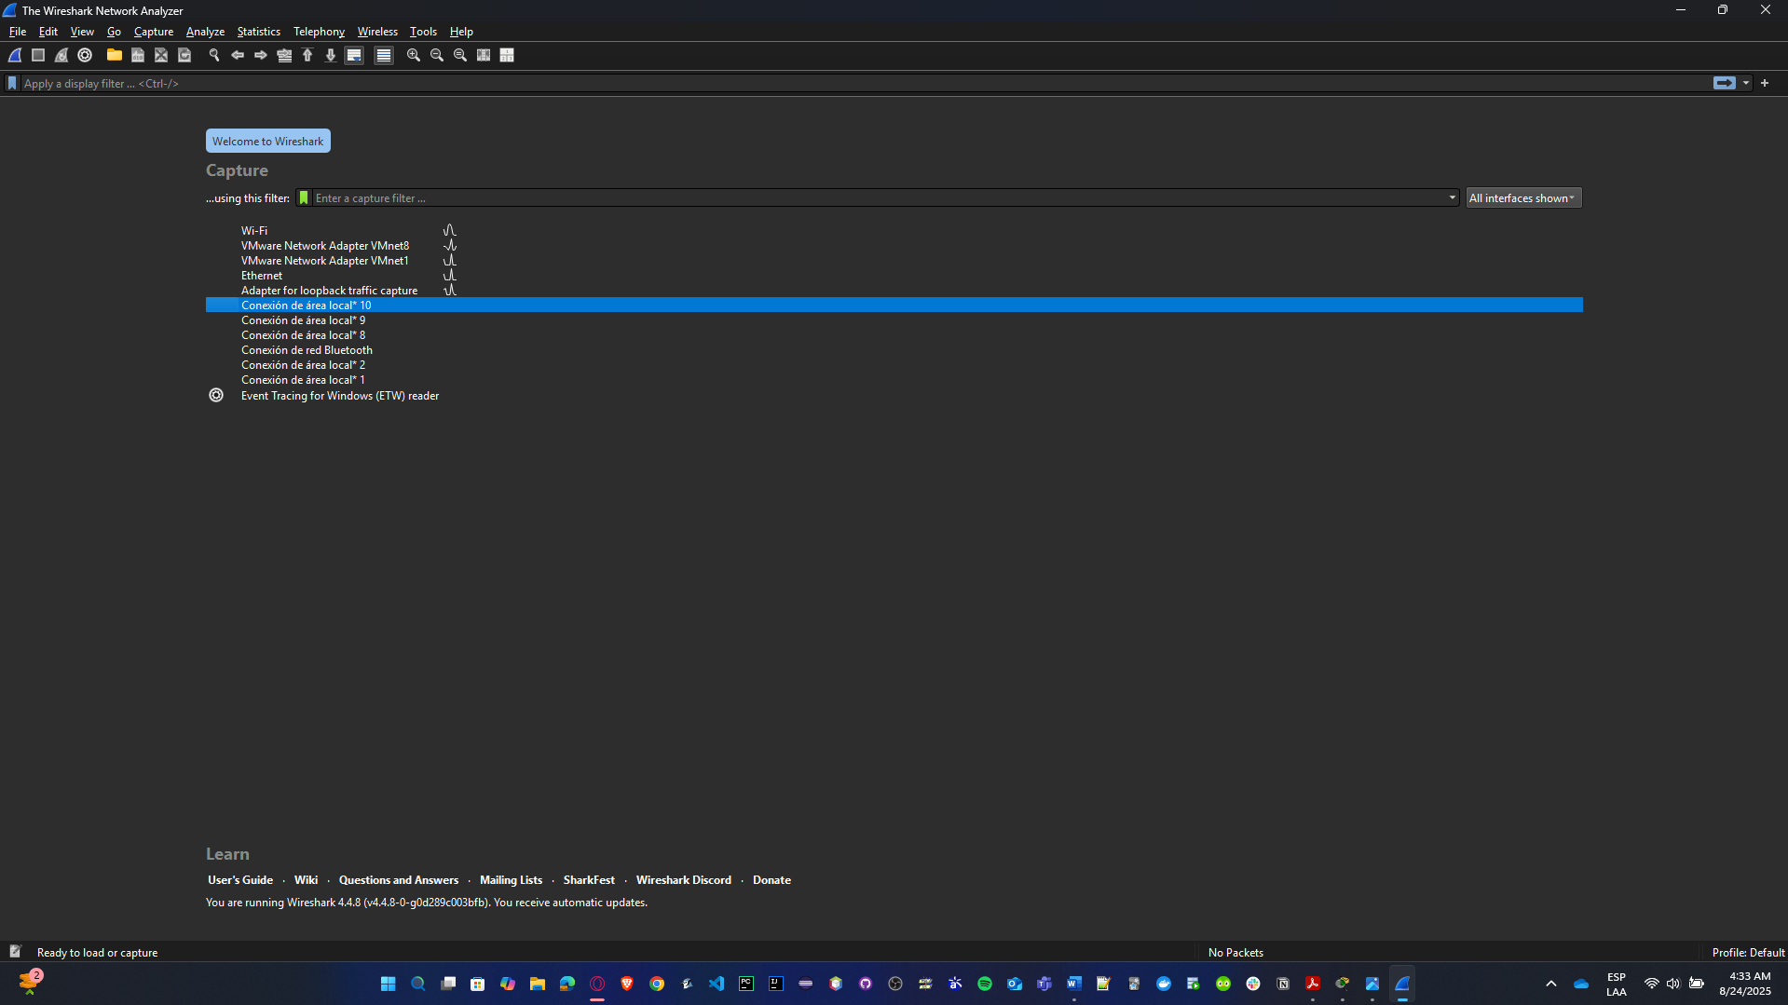

* **What does it mean for the network card to be in promiscuous mode?**
* **Promiscuous mode:** the NIC hands **every** frame it sees to the OS (not just frames to its own MAC). Required when you want to observe traffic beyond your host on hubs/SPAN/mirrored ports.
* **Monitor mode (Wi-Fi only):** capture raw 802.11 management/control/data frames on-air (not the usual 802.3/EAPOL you see after association). Mentioned just to flex knowledge.

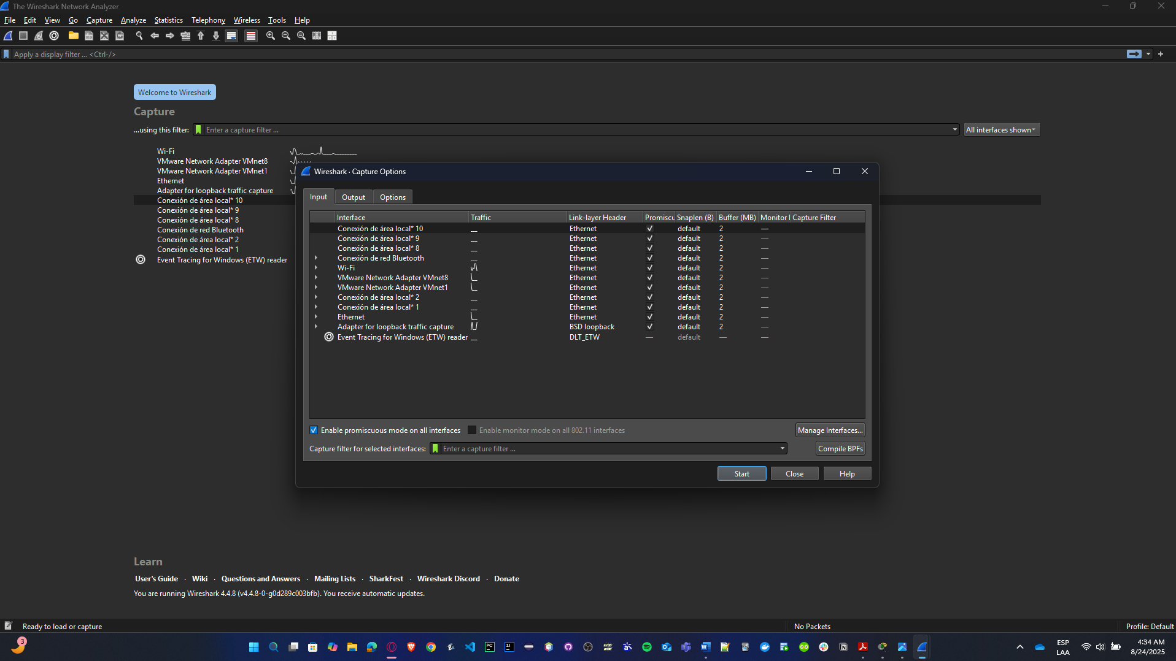

* **Create a video where you explain the parts of the interface. How to create filters? What are filters used for? Provide examples. The video should be about 5 minutes long.**

[**VIDEO**](https://www.canva.com/design/DAGw-25PCmA/hkU7LK-YCC_GhFaI_OfO7A/edit?utm_content=DAGw-25PCmA&utm_campaign=designshare&utm_medium=link2&utm_source=sharebutton) **LINK:** [**https://youtu.be/59Ij4c9dbDM**](https://youtu.be/59Ij4c9dbDM)

These are the main parts of the interface:

* **Top toolbar:** Start/Stop capture, Reload, Capture Options (pick NIC, enable promiscuous).
* **Display Filter bar:** evaluates **after** capture; super fast BPF-like engine.
* **Packet List (top pane):** each row = a packet (time, src/dst, protocol, length, info).
* **Packet Details (middle):** tree of layers (Ethernet ▸ IP ▸ TCP/UDP ▸ App).
* **Packet Bytes (bottom):** hex + ASCII.
* **Statistics menu:** Conversations, Endpoints, Protocol Hierarchy, I/O Graphs.
* **Follow Streams:** right-click TCP/UDP ▸ “Follow … Stream” to reconstruct flows.

The filters are used for:

* Captures are noisy. In seconds, you’ll have thousands of packets (DNS, ARP, broadcast, HTTP, TLS, etc.). Filters let you isolate just the traffic you care about.
* There are two types of filters:
* **Capture filters** – applied **before** capture, so Wireshark only stores packets that match. Defined using libpcap syntax (like tcpdump). Example: port 80.
* **Display filters** – applied **after** capture. They don’t affect what’s captured, just what’s shown. Way more powerful and flexible. Example: http.request.method == "GET".

And you can create filters in this way depending on the type:

* **Display filters**
  + - 1. Type in the **filter bar** right under the toolbar.
      2. Wireshark autocompletes fields and shows green = valid, red = invalid.
      3. You can **save** a filter (click the bookmark icon).
      4. Example demo steps in video:
         1. Type dns → press enter → only DNS packets remain.
         2. Then try ip.addr == 192.168.1.9 → only packets where either source or destination IP is your PC appear.
* **Capture filters**
  + - 1. Go to **Capture Options** (the gear next to the shark fin).
      2. In the field labeled *Capture Filter*, type your filter before you start.
      3. Example: tcp port 443 → only capture HTTPS traffic.
      4. Pro: Keeps file small. Con: If you misfilter, you might lose important packets forever.

And we can simulate or provide some examples like that:

* http → show all HTTP packets.
* http.request → show only HTTP requests (GET/POST).
* http.request.method == "GET" → only GETs.
* dns → isolate DNS queries/responses.
* icmp → ping packets only.
* ip.addr == 192.168.1.9 → show only traffic involving your host.
* tcp.flags.syn == 1 → only TCP SYN packets (start of handshake).
* tcp.port == 80 → all TCP traffic over port 80.
* Combine with logical ops:
  + dns || http → show both DNS and HTTP.
  + ip.src == 192.168.1.9 && tcp.port == 443 → only HTTPS traffic **from** your machine.
* **Make a web request to the link** [**http://www.scielo.org.co**](http://www.scielo.org.co) **and capture the generated traffic. (Open your browser, start the capture with Wireshark, visit the website, and then stop the capture).**
* So, we select Wifi as the network interface type.
* We open the link in a browser.

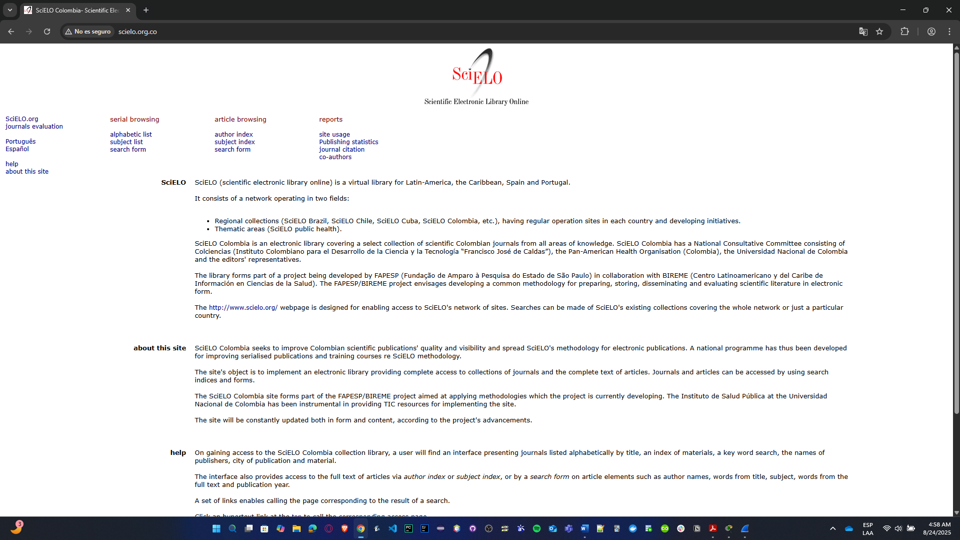

* This is what we see, then we stop the capture.

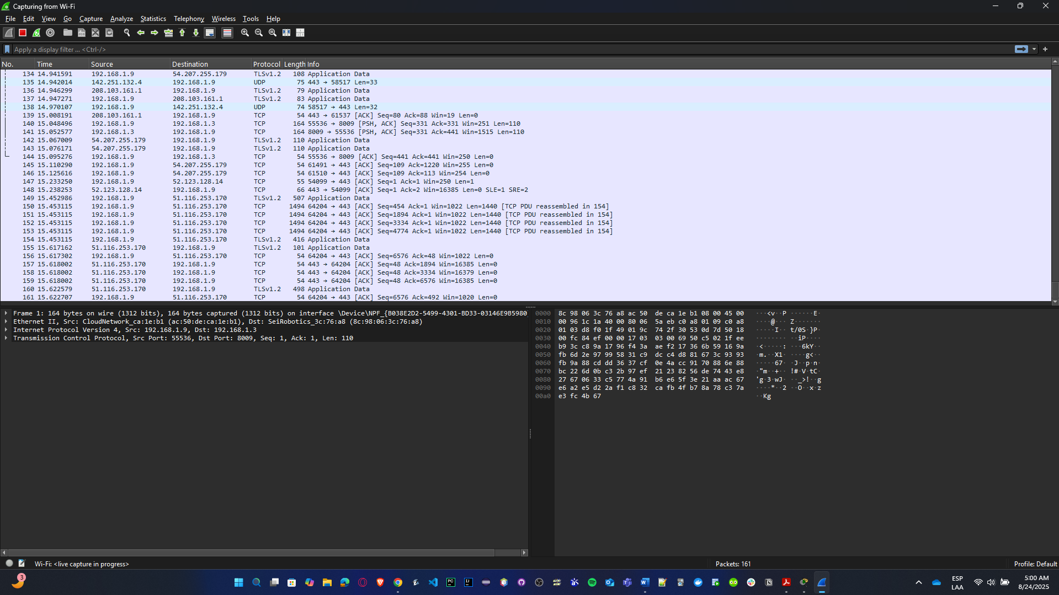

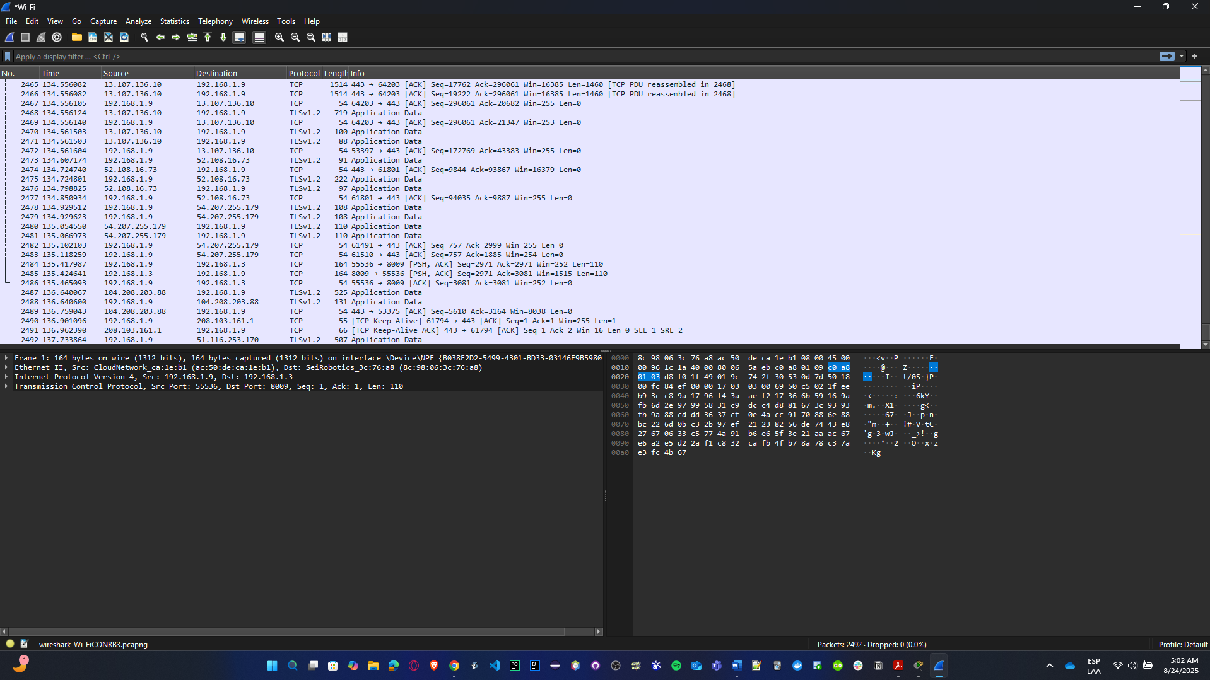

* **Analyze the data found in one of the captured packets. Look at the encapsulation each layer performs, review the information visible in different areas of the Wireshark screen, and present screenshots of it. (To make analysis easier, filter and find a captured packet that contains the word "GET").**
* To obtain GET word, we need to use **http.request.method == “GET”** filter**.**

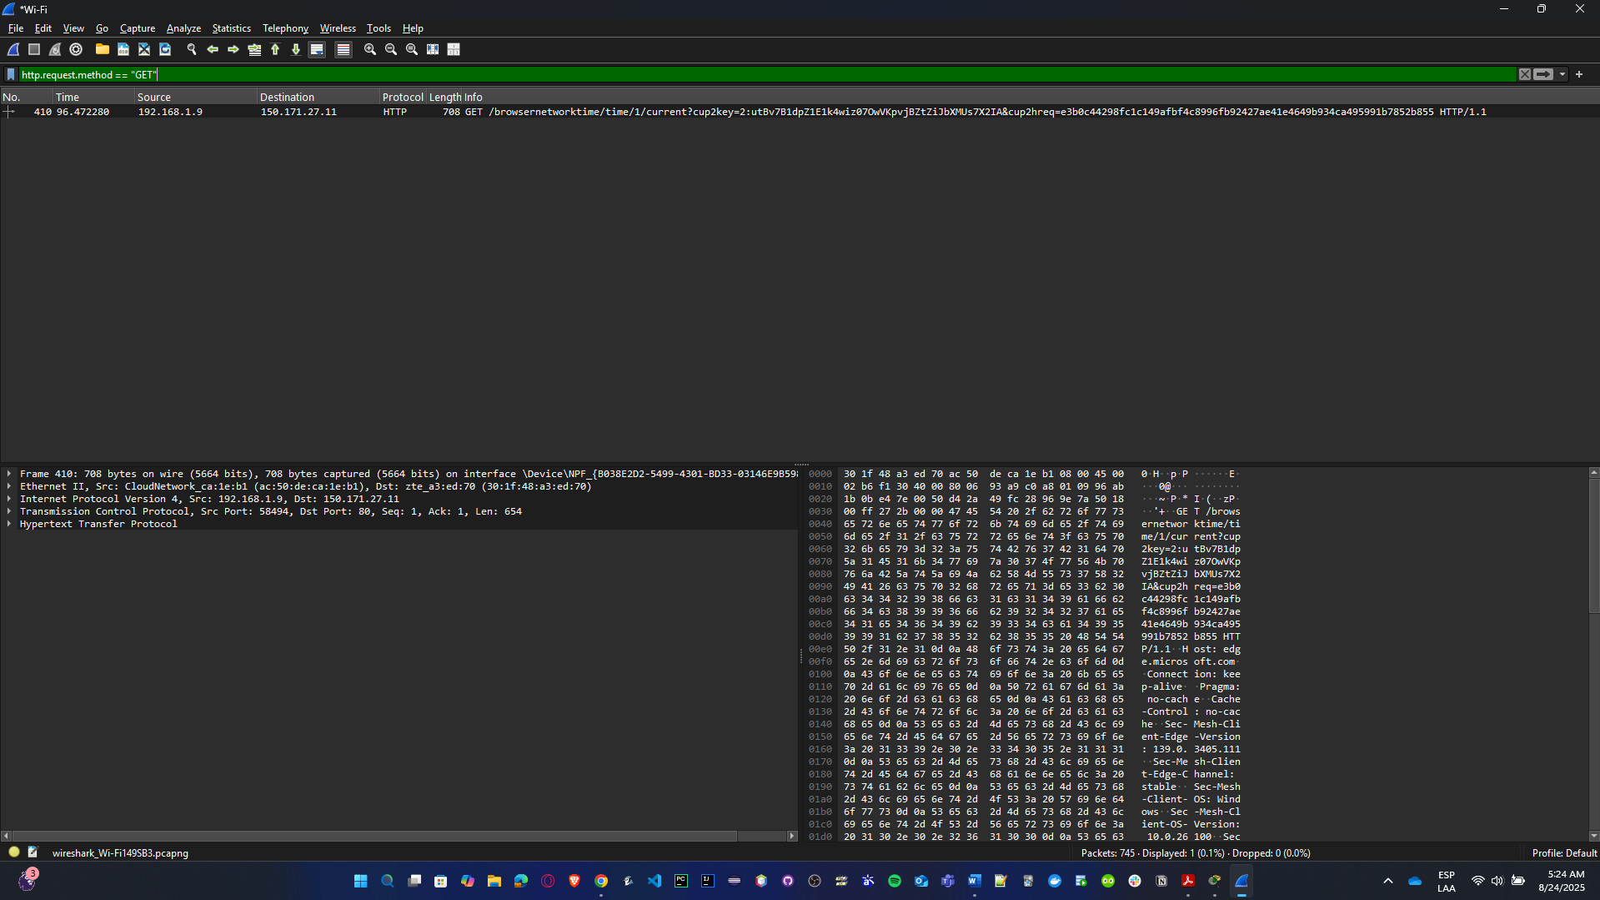

* To see the packages of the link, we click in the obtained package.

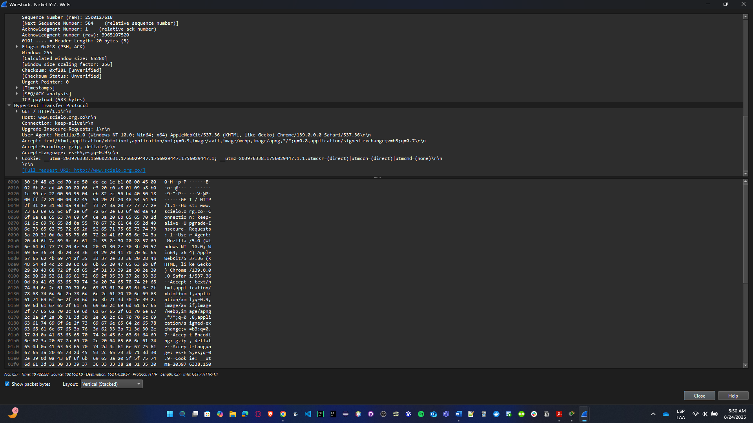

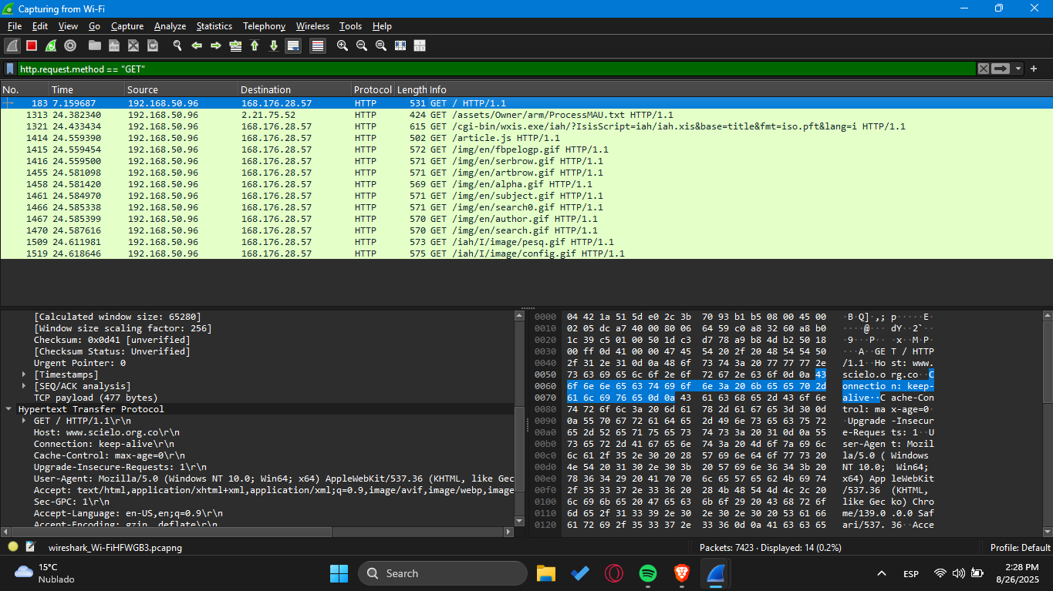

* So, we can evidence that:

**1. Frame (Physical Layer)**

* **Wireshark info:** e.g., “Frame: X bytes on wire, X bytes captured.”
* This shows the total size of the packet and confirms it was captured through your Wi-Fi interface.
* At this lowest level, Wireshark displays how many bytes were transmitted, but not the actual bits on the medium.

**2. Ethernet (Data Link Layer)**

* **Ethernet II Header:**
  + **Source MAC:** the hardware address of your PC’s Wi-Fi card.
  + **Destination MAC:** the next-hop device (your router/gateway).
* The Data Link Layer ensures delivery within the local network segment using **MAC addresses**.

**3. Internet Protocol (Network Layer)**

* **IPv4 Header:**
  + **Source IP:** your host’s private IP (likely 192.168.x.x).
  + **Destination IP:** the server hosting SciELO (public IP).
  + **Protocol:** TCP (6).
* This layer makes sure the packet travels end-to-end from your PC to the SciELO web server across the internet.

**4. Transmission Control Protocol (Transport Layer)**

* **TCP Header:**
  + **Source Port:** an ephemeral port chosen by your machine.
  + **Destination Port:** 80 → standard HTTP (unencrypted web traffic).
  + **Flags:** e.g., PSH, ACK → indicating the request is being pushed while acknowledging prior data.
* TCP guarantees reliability by segmenting the data, tracking sequence numbers, and confirming receipt with ACKs.

**5. Hypertext Transfer Protocol (Application Layer)**

* **Request Line:**
  + GET /path/to/resource HTTP/1.1
* **HTTP Headers (important):**
  + Host: scielo.org → this specifies the website the request is targeting.
  + User-Agent: Mozilla/5.0 ... Chrome/... → identifies the browser and version.
  + Accept-Encoding, Cache-Control, etc. → additional client preferences.
* This layer is the actual content generated by your browser — here we clearly see that the request was made to **SciELO**.

**6. Wireshark Interface Walkthrough**

* **Top Pane (Packet List):** shows the “GET” request row, with source/destination, protocol = HTTP, and a short description.
* **Middle Pane (Packet Details):** shows the encapsulation tree — Ethernet → IP → TCP → HTTP. Expanding the HTTP section reveals the Host: scielo.org header.
* **Bottom Pane (Packet Bytes):** shows the raw data in **hexadecimal** and ASCII. If you scroll through, you can literally read “GET … scielo.org” in ASCII.
* **Present your findings in a video of no more than 7 minutes.**

[**VIDEO**](https://www.canva.com/design/DAGw-6T5_J8/WpBZmK6Puy-cMDvfNzUpDQ/edit?utm_content=DAGw-6T5_J8&utm_campaign=designshare&utm_medium=link2&utm_source=sharebutton) **LINK:** [**https://youtu.be/R9ds-sEa5BQ**](https://youtu.be/R9ds-sEa5BQ)

## Networks cards

Know the network cards of various devices. To do this, gather information about the network cards of the school computers and at least 3 different devices (computers, laptops, smartphones, tablets, game consoles, etc.) from each member of your work team.

Include information such as vendor, model, speed, MAC Address, IPv4 Address, IPv6 Address, number of bytes transmitted and received. For wireless network cards: Connection speed, SSID.

Now, check the same information for two of your virtual machines and compare the results with the information from the host machines.

**SCHOOL COMPUTERS**

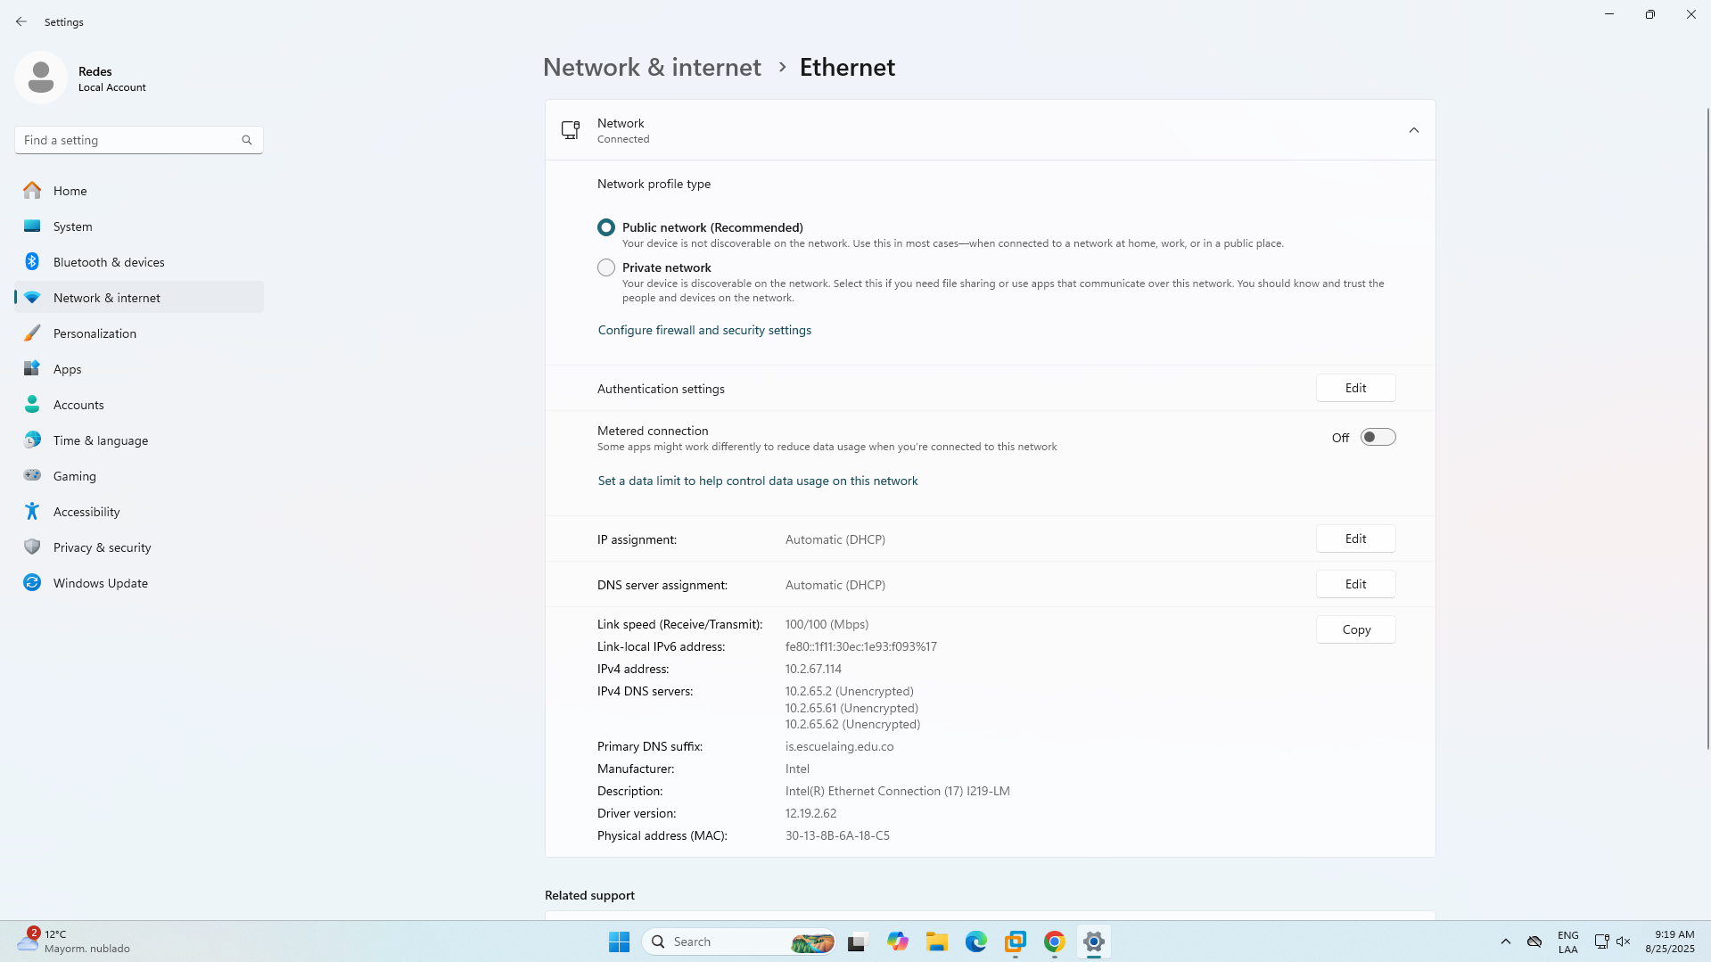

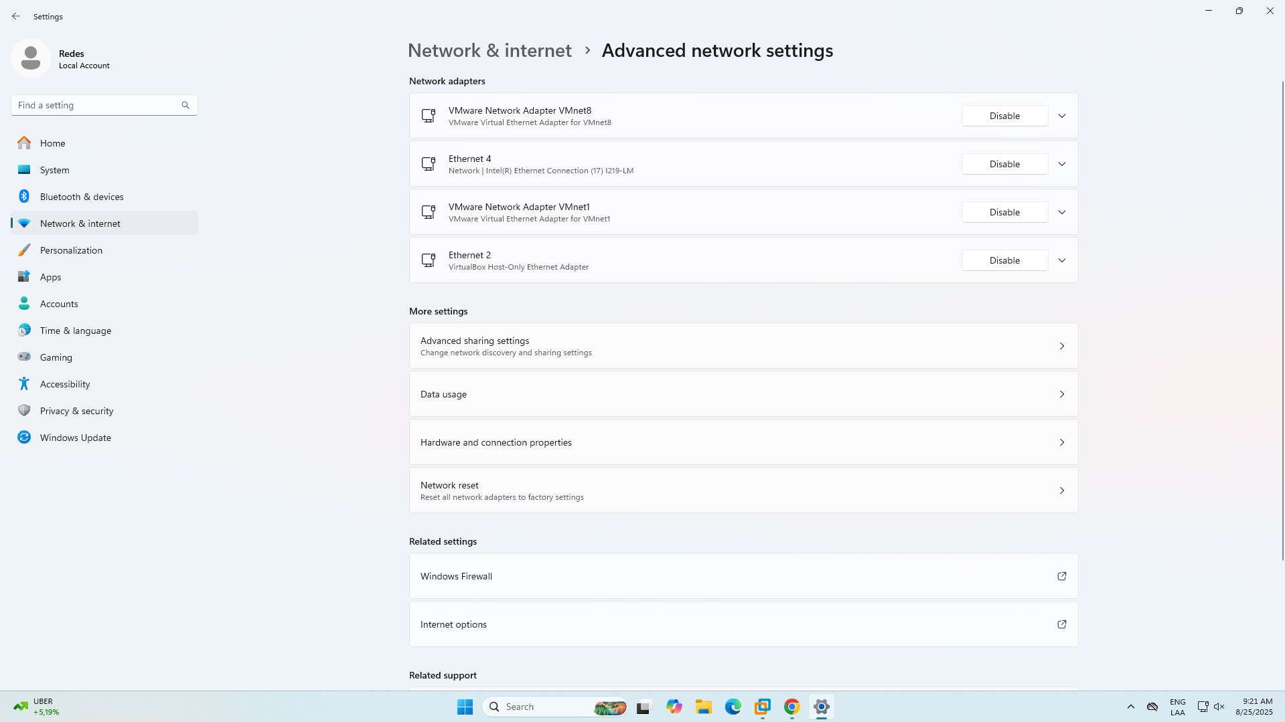

**ANDERSSON’S DEVICES**

* **Personal Computer (ipconfig /all, netstat -e):**

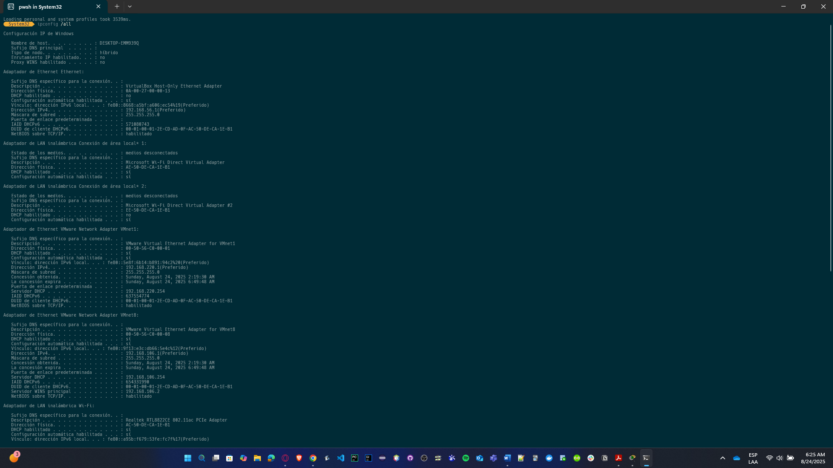

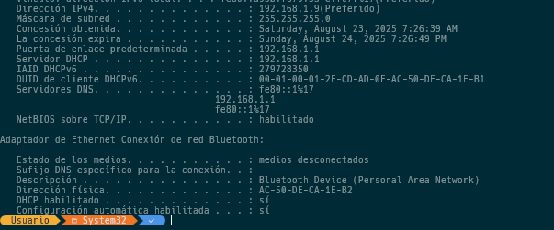

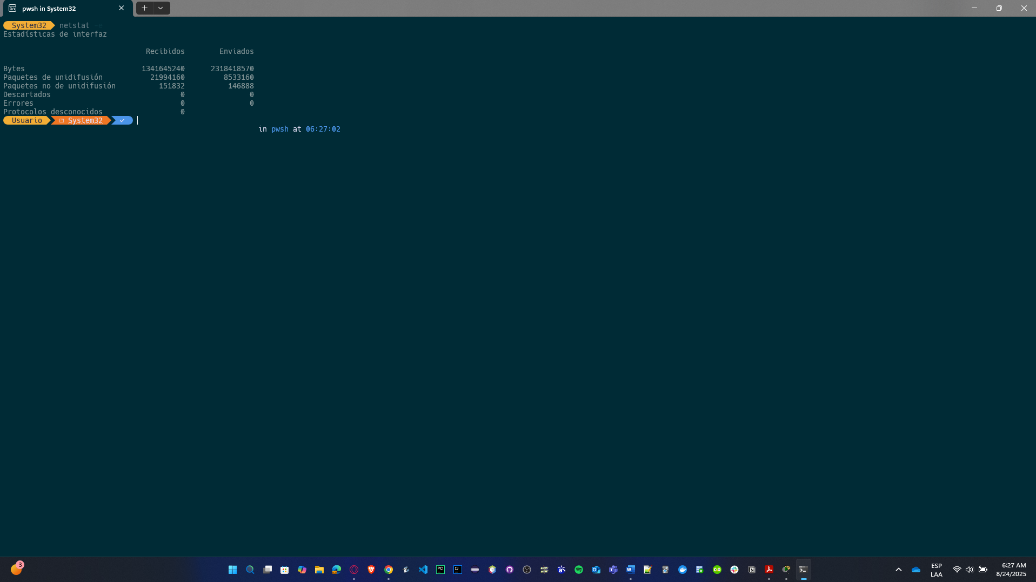

* **PS5 Game Console:**

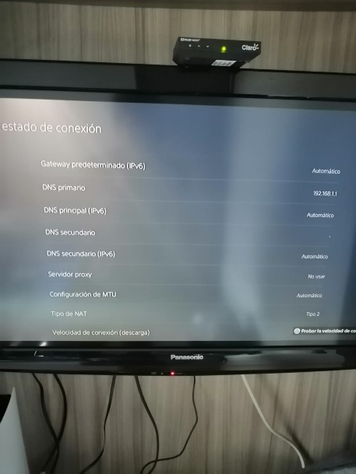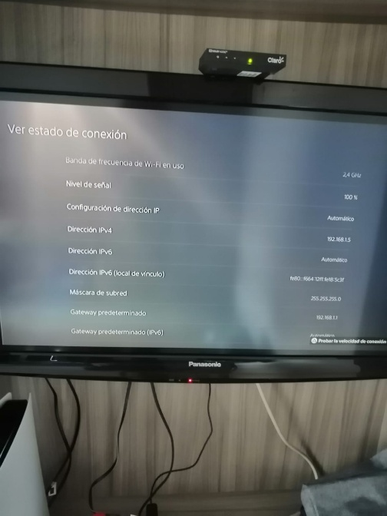

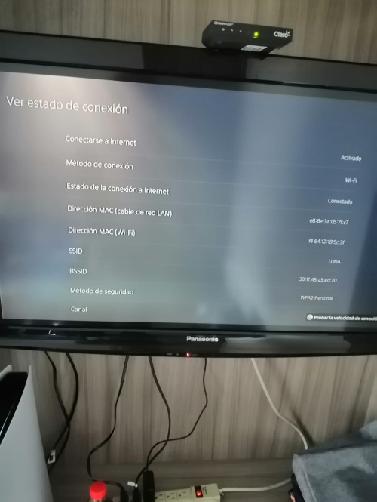

* **Smartphone:**

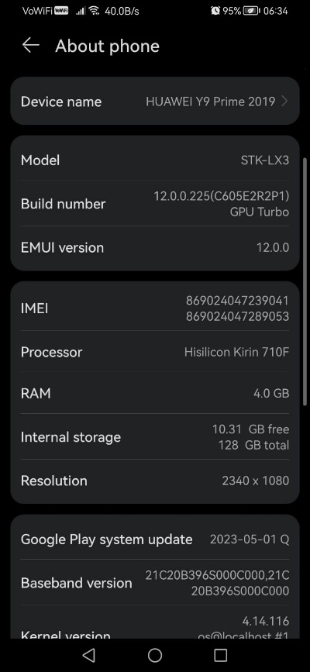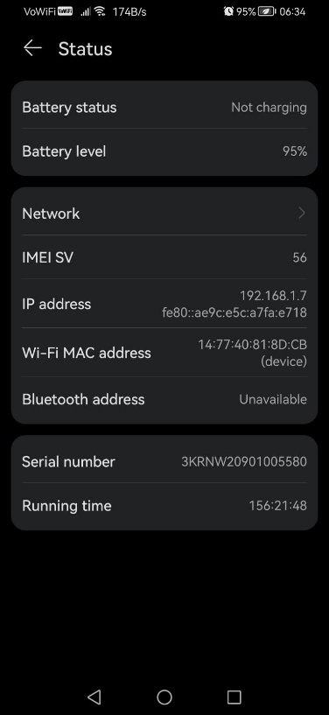

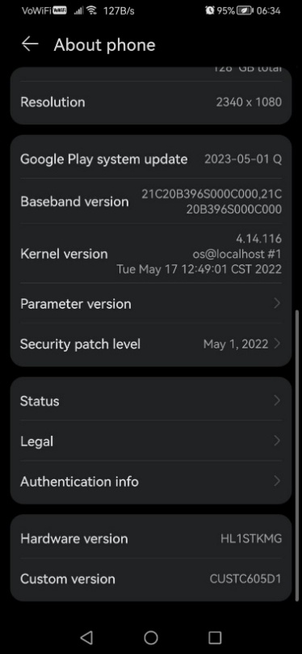

**CRISTIAN’S DEVICES**

* **Personal Computer (ipconfig /all):**

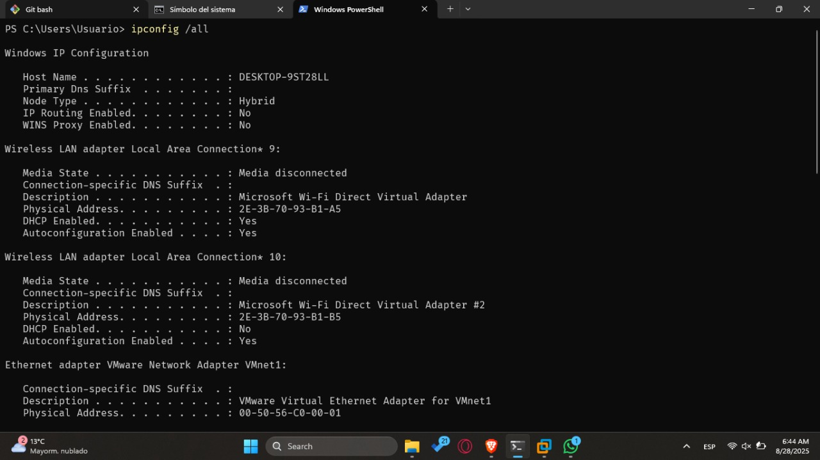

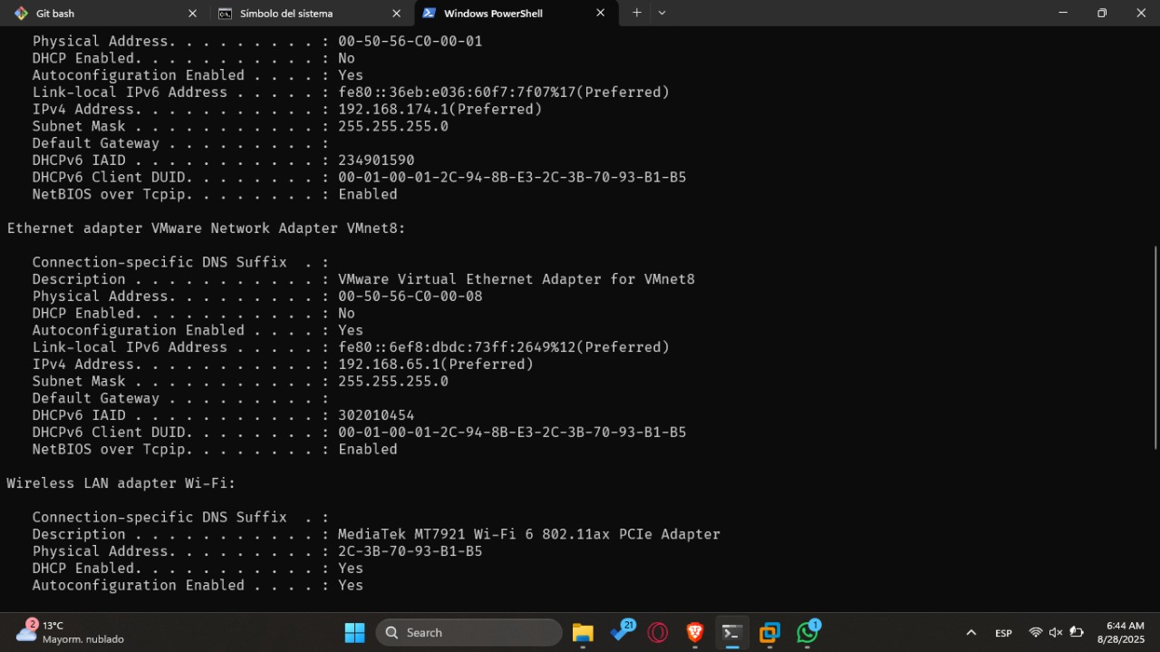

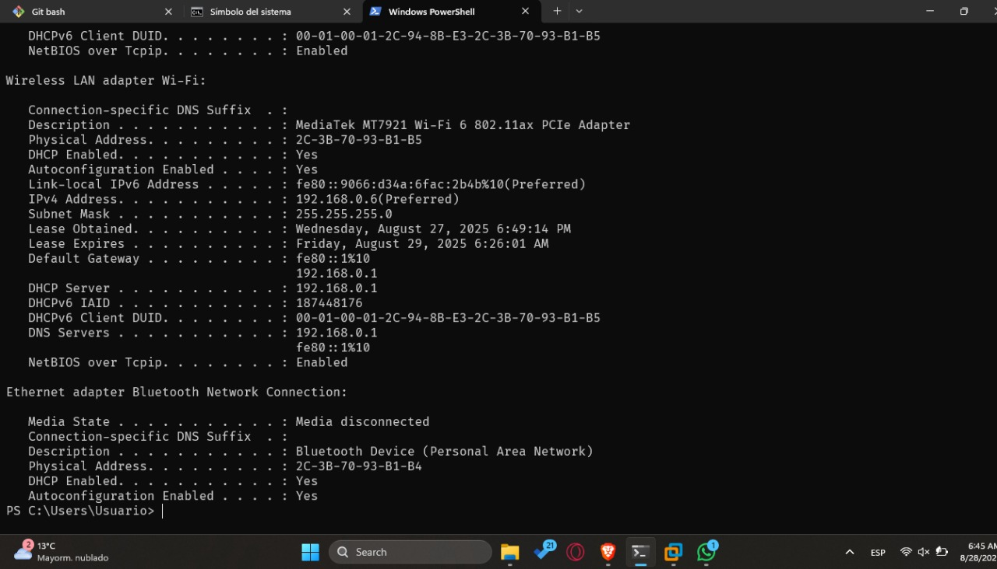

* **PS3 Game Console:**

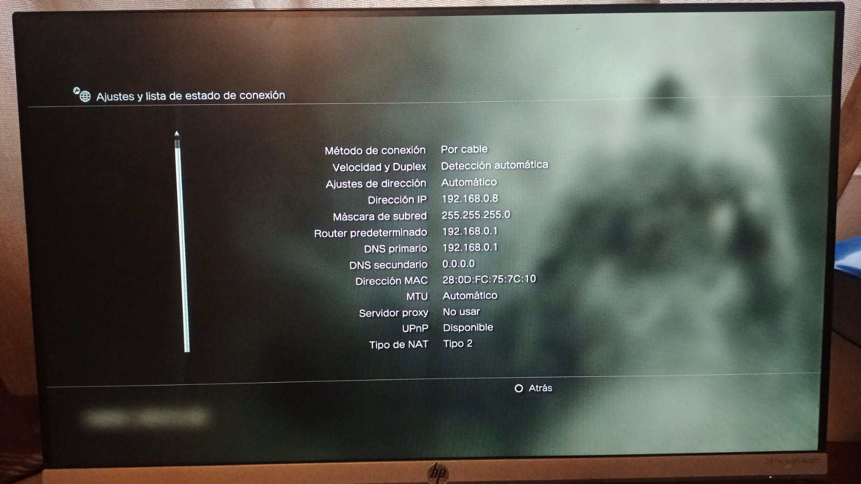

* **Smartphone:**

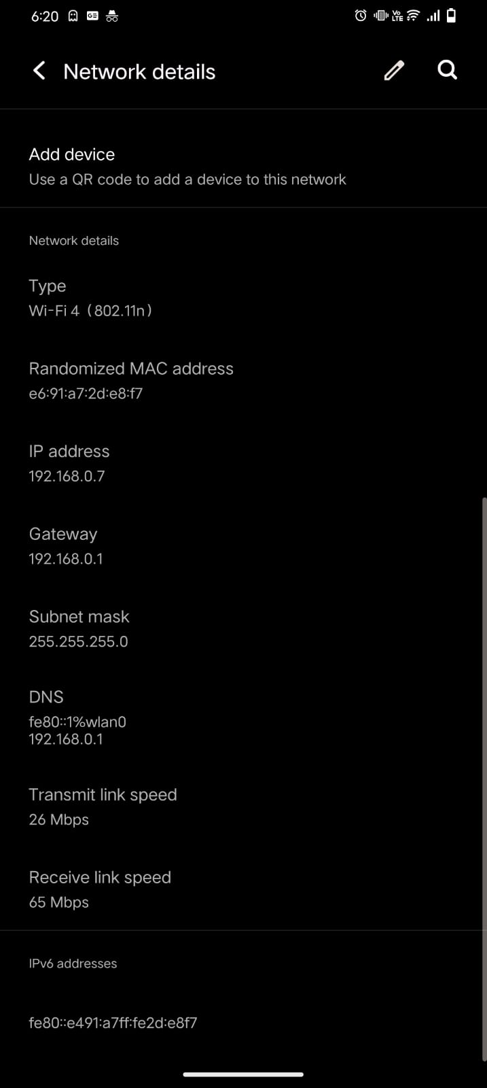

**VIRTUAL MACHINES**

* **Slackware (ifconfig -a):**

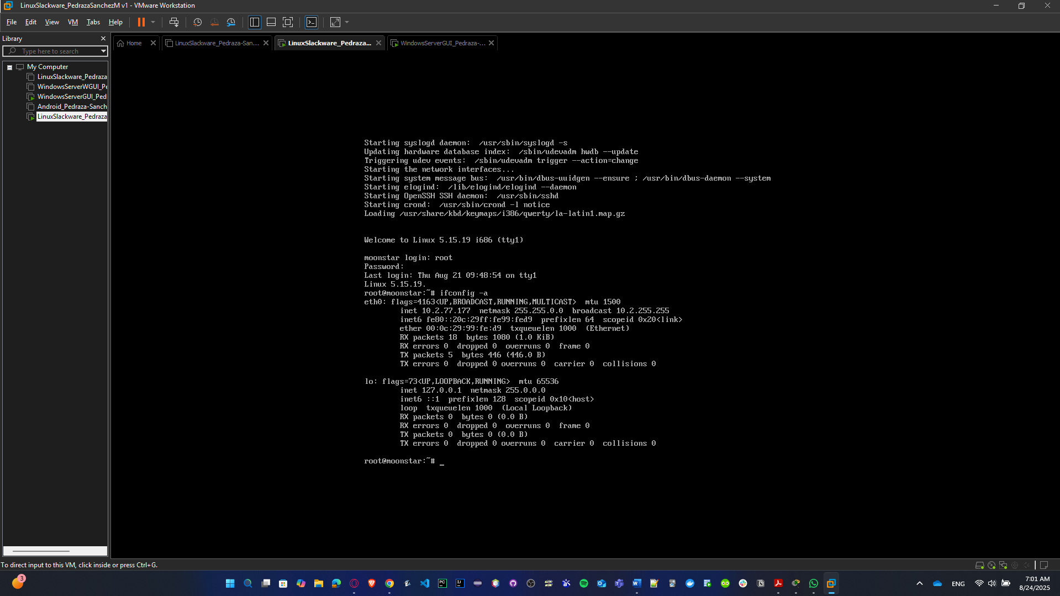

* **Windows Server with GUI (ipconfig /all):**

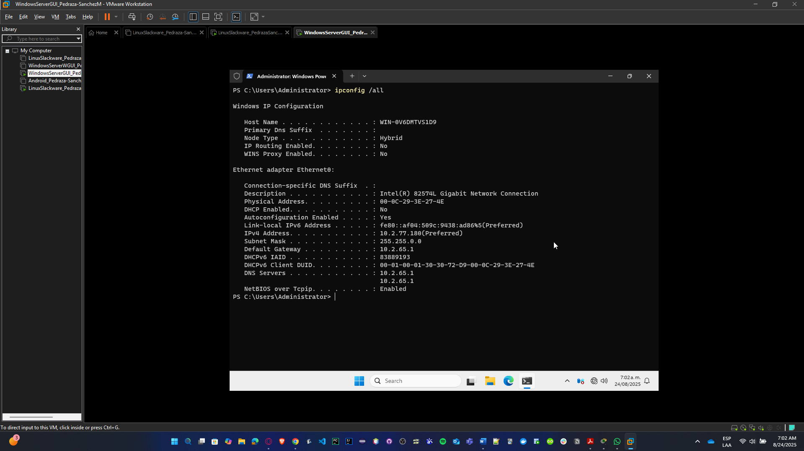

**COMPARATION**

As we took account of our host machines, then, we can compare them with VMs. These are some differences:

* **Vendor / Model:**
  + Host: real hardware (Intel, Realtek, Qualcomm, Broadcom, etc.).
  + VM: usually a **virtual adapter** emulated by the hypervisor (e.g., “Intel PRO/1000 MT”, “VMware Virtual Ethernet Adapter”, “Hyper-V Virtual Switch”).
* **MAC Address:**
  + Host: real, burned-in MAC from the manufacturer.
  + VM: hypervisor generates a **virtual MAC** (different from host, even if bridged).
* **IP Addresses:**
  + Host: normal LAN IP from the router.
  + VM: could be the same LAN range (if using **Bridged mode**) or a private NAT/subnet (if using **NAT mode**).
* **Speed:**
  + Host: real adapter speed (100 Mbps, 1 Gbps, Wi-Fi link speed like 433 Mbps, 866 Mbps, etc.).
  + VM: usually shows **1 Gbps** or some fixed virtual speed, regardless of the real physical link.
* **Bytes transmitted/received:**
  + Host: real traffic count.
  + VM: only counts **traffic of that VM**, even though it ultimately goes through the host NIC.
* **Wireless info (SSID, signal):**
  + Host: visible (actual SSID of your Wi-Fi).
  + VM: does **not** see SSID — because the VM only sees the virtual adapter, not the Wi-Fi directly.

# Base Software

The infrastructure also requires programs that support the administration of various operating system activities. We will carry out activities to help you understand the operating system and its management.

Before we create the shells in the respective VMs, we install Open SSH service in the machines, because of the need of not to copy manually the shells, just to copy and paste directly from our computer to the VM.

**SLACKWARE**

**# Verify if it already exists sshd**

which sshd || echo "no sshd found"

**# If it’s not installed and you have internet and slackpkg configured:**

sudo slackpkg update

sudo slackpkg install openssh

**# Enable / boot the syslog (Slackware use scripts in /etc/rc.d)**

sudo chmod +x /etc/rc.d/rc.sshd

sudo /etc/rc.d/rc.sshd start

**# Test:**

sudo /etc/rc.d/rc.sshd status # o pgrep sshd

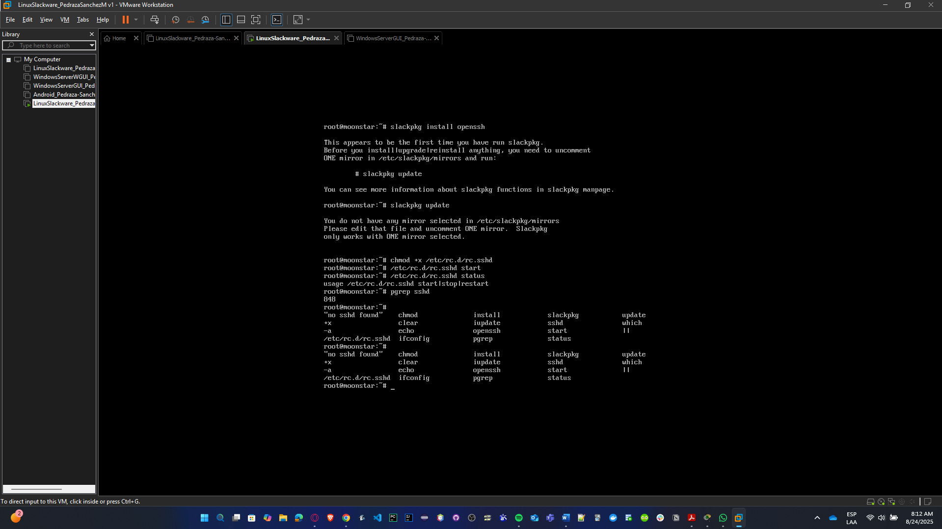

**SOLARIS**

**# See the status**

svcs ssh

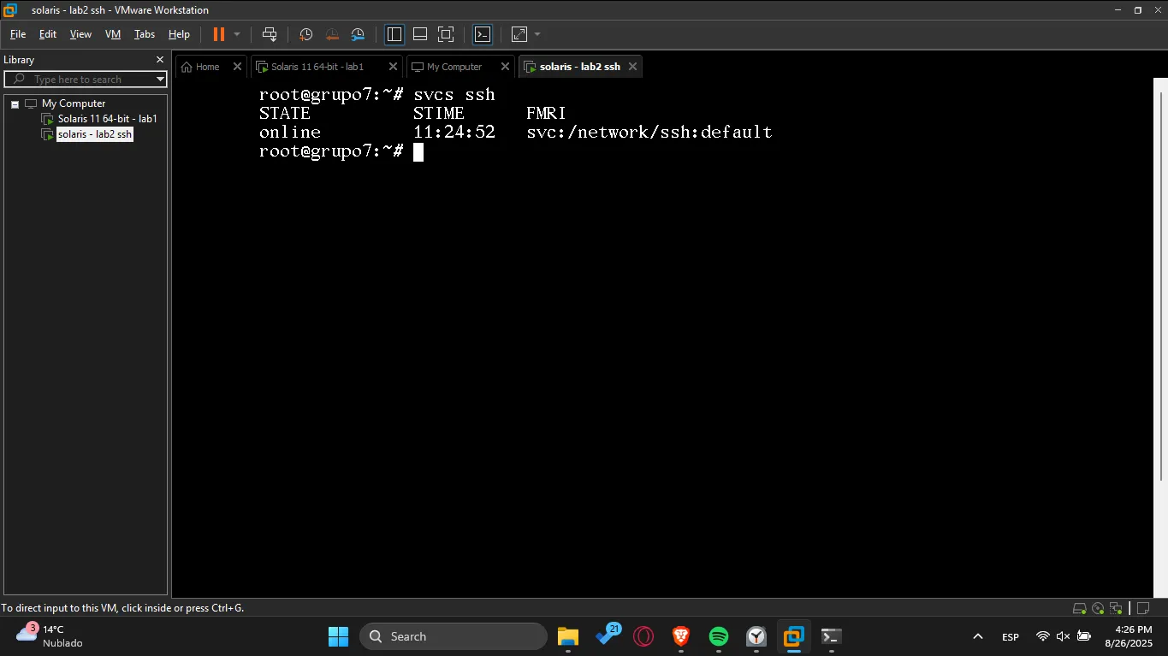

d

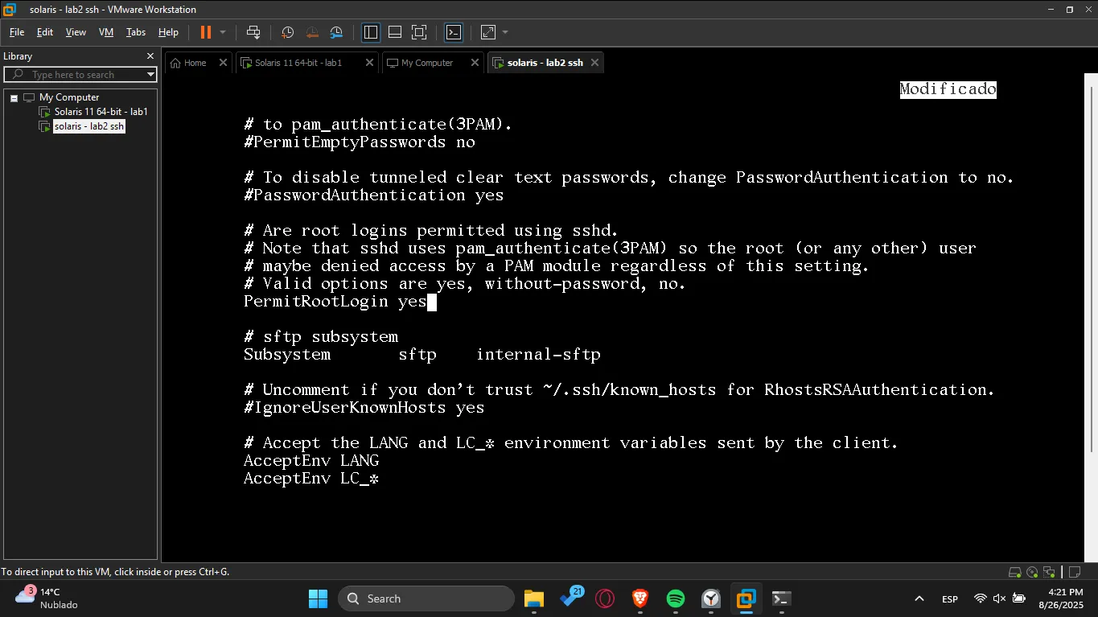

You can access to ssh in any terminal (git bash, cmd, powershell,etc.)

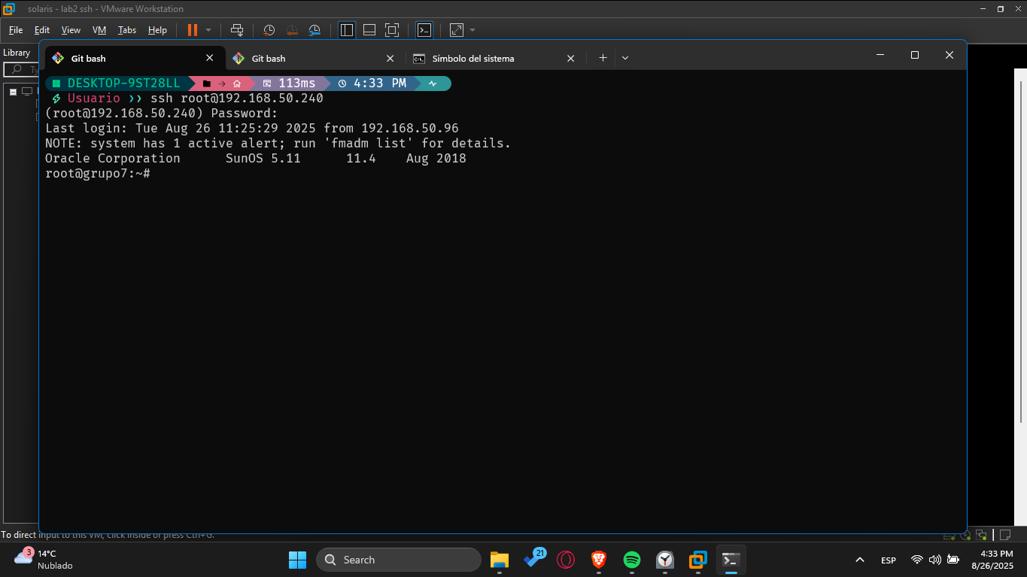

## Shell programming- Unix

Using a virtual machine with Linux Slackware, Solaris, and CentOS, depending on the number of people in the group, develop the following applications (remember to document your code).

We’re going to use this structure to handle file scripts into the VMs.

**SLACKWARE (it’s also valid for Solaris):**

* Create the directory: **mkdir -p /usr/local/bin** in root mode
* Connect via WSL terminal to send file scripts to the VM. For example:

**scp -r "/mnt/c/Users/Usuario/Downloads/lab-02" root@10.2.77.177:/usr/local/bin/**

* Allow permission to file script: **chmod +x /usr/local/bin/filename.sh**
* Test menu.

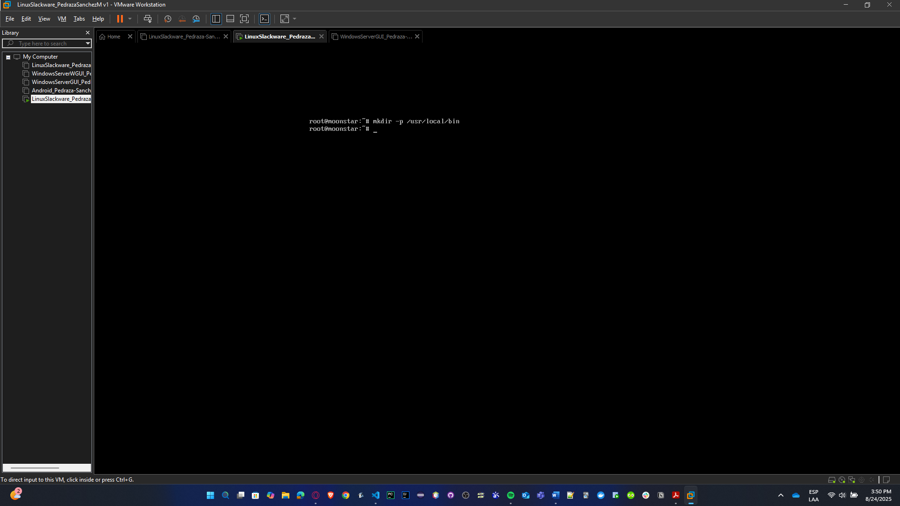

**SOLARIS (it’s also valid for Slackware):**

* Create the directory: **mkdir -p /usr/local/bin** in root mode
* We should connect by ssh, ssh [root@192.168.50.240](mailto:root@192.168.50.240), now you can copy-paste commands easily.

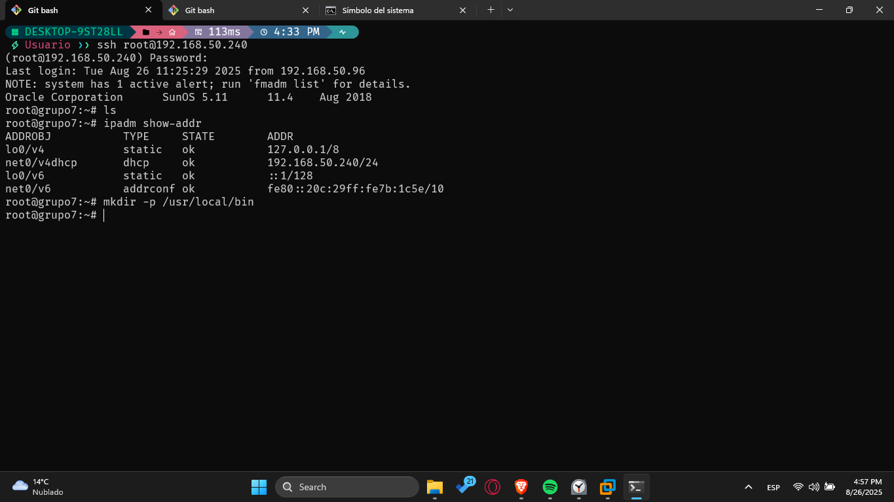

### ls Command

* Create a Shell script to list the files in a directory, including hidden ones, with the following options:
  + Sort by various parameters and group by quantity:
    - Most recent (must state how many files share the same date).
    - Oldest (must state how many files share the same date).
    - Largest to smallest size (must state how many files share the same size).
    - Smallest to largest size (must state how many files share the same size).
    - File type (File/Directory) (must state how many files share the same type).
  + Additional conditions: Only within the given directory or its subdirectories.
    - Start with a given string.
    - End with a given string.
    - Contain a given string.

After asking for the directory, create a menu with the options mentioned. The script should stay in the menu until the user decides to exit. The script should clear the screen before showing the results, and if the results are too extensive, it should paginate them.

**SLACKWARE:**

* **Save:** nano /usr/local/bin/ls_menu.sh

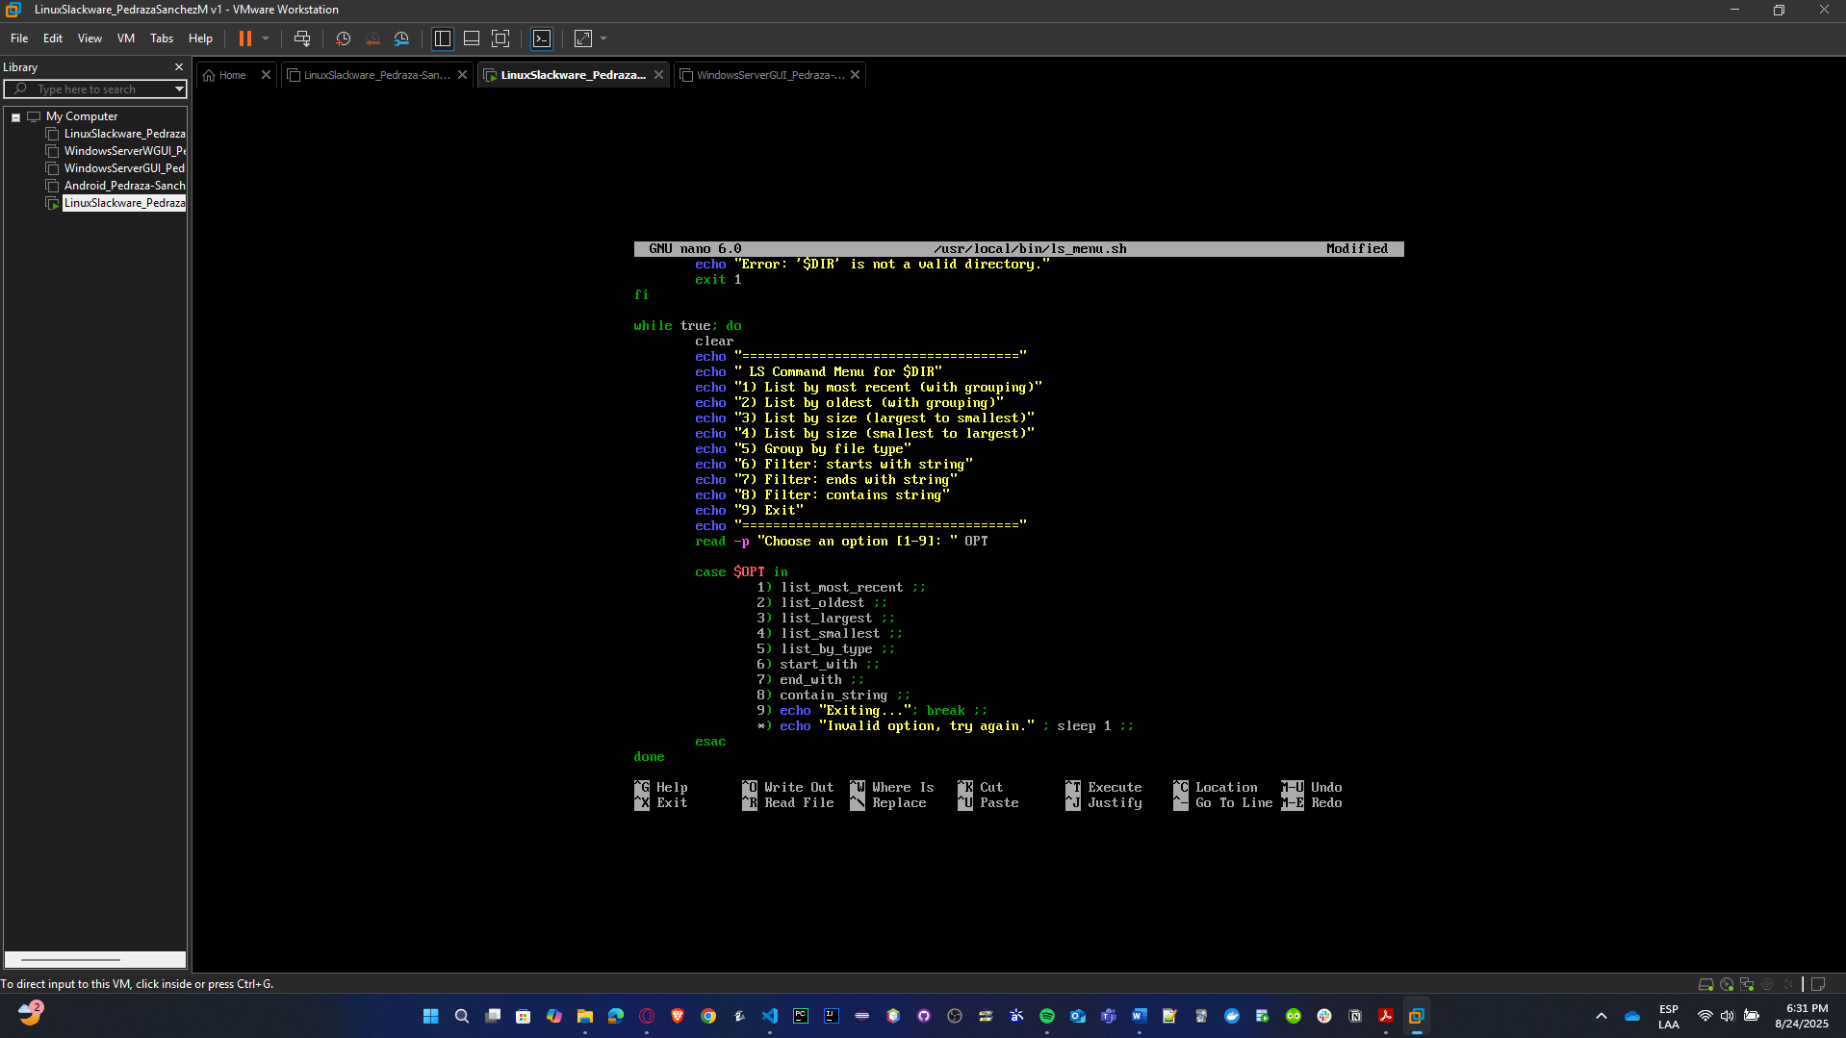

* **Exec:** chmod +x /usr/local/bin/ls_menu.sh

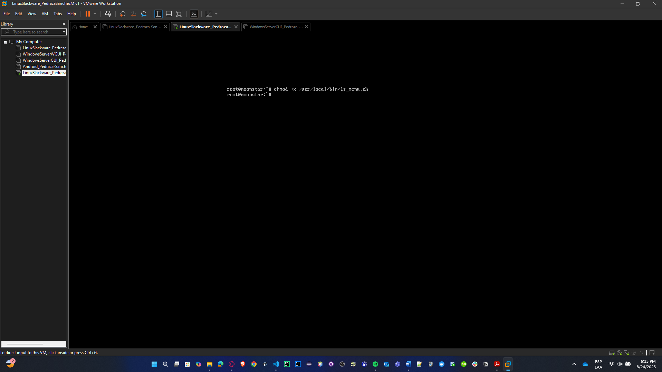

* **Run:** /usr/local/bin/ls_menu.sh

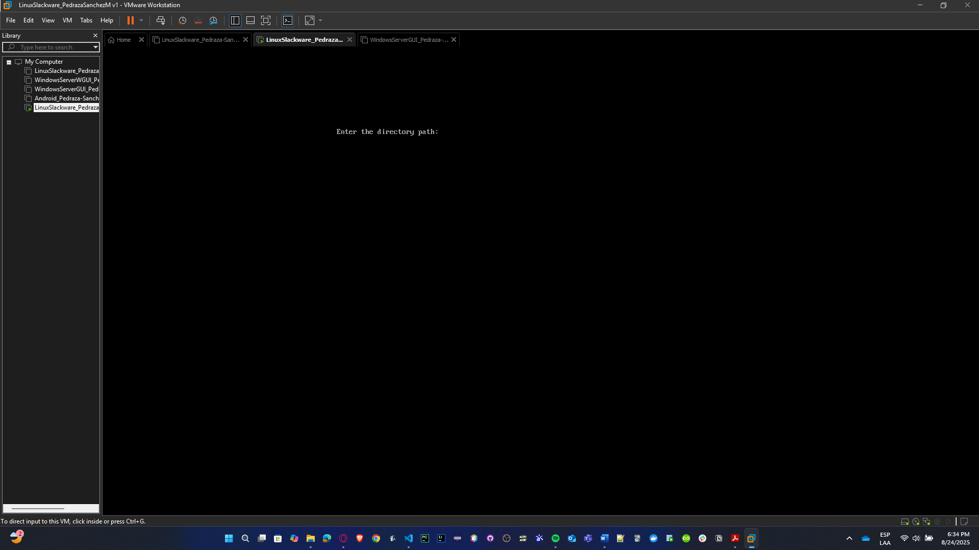

* **Tests:**
  + 1. **Most recent files test:**

mkdir -p /tmp/testls

cd /tmp/testls

touch a.txt b.txt c.txt

sleep 2

touch d.txt

/usr/local/bin/ls_menu.sh

Select option **1 (Most recent)**.

**Expected:** d.txt should appear first, and the grouping by date should show how many files share the same modification date.

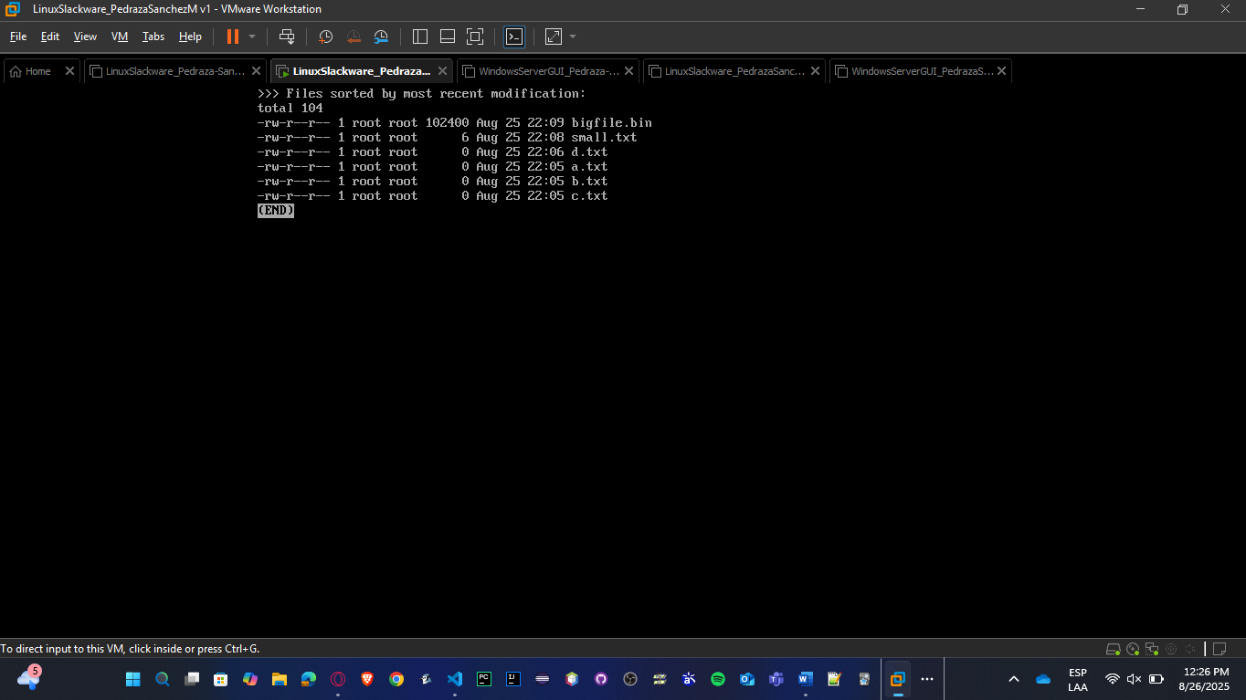

* + 1. **Size-based test:**

echo "hello" > small.txt

dd if=/dev/zero of=bigfile.bin bs=1K count=100 # 100KB file

/usr/local/bin/ls_menu.sh

Select option

**3 (Largest to smallest)**.

**Expected:** bigfile.bin appears at the top, then small.txt.

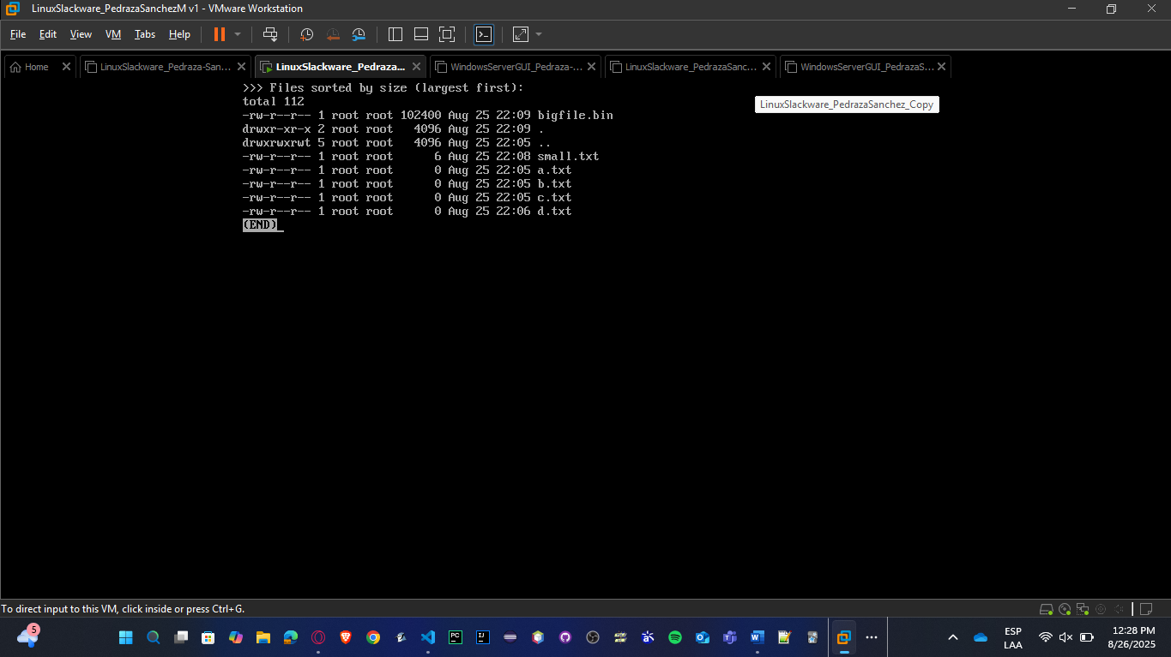

* + 1. **Filter test (starts with):**

touch start_abc.txt start_xyz.log notstart.txt

/usr/local/bin/ls_menu.sh

Select option **6 (Starts with string)** and enter start_.

**Expected:** only start_abc.txt and start_xyz.log appear.

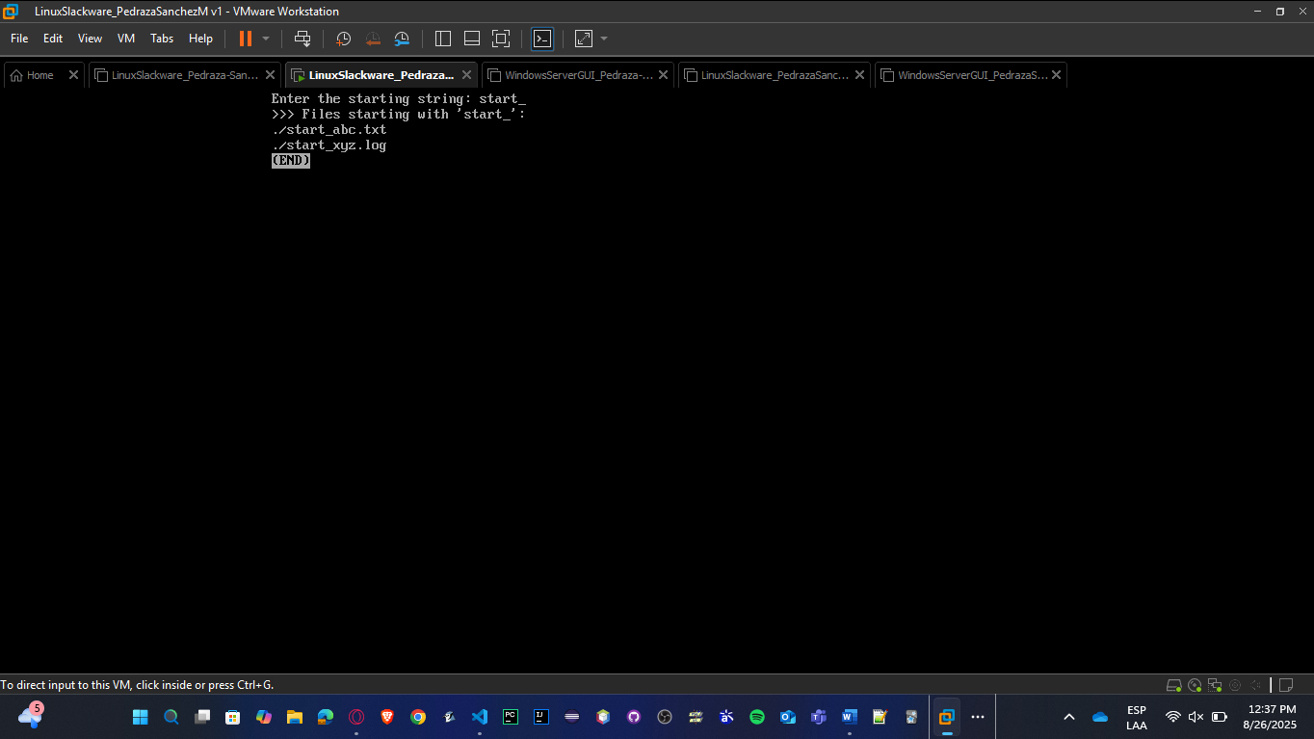

**SOLARIS:**

* **Save:** nano /usr/local/bin/ls_menu.sh

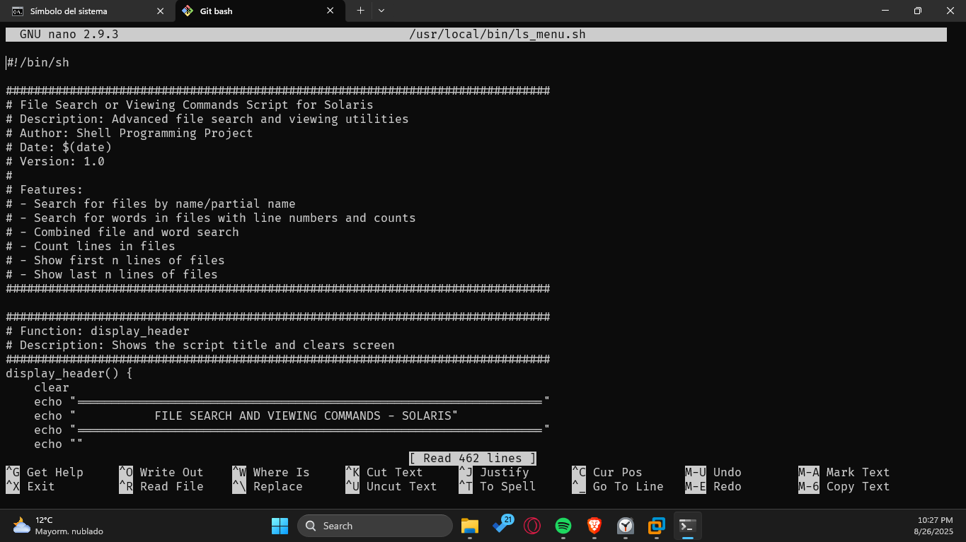

* **Exec:** chmod +x /usr/local/bin/ls_menu.sh

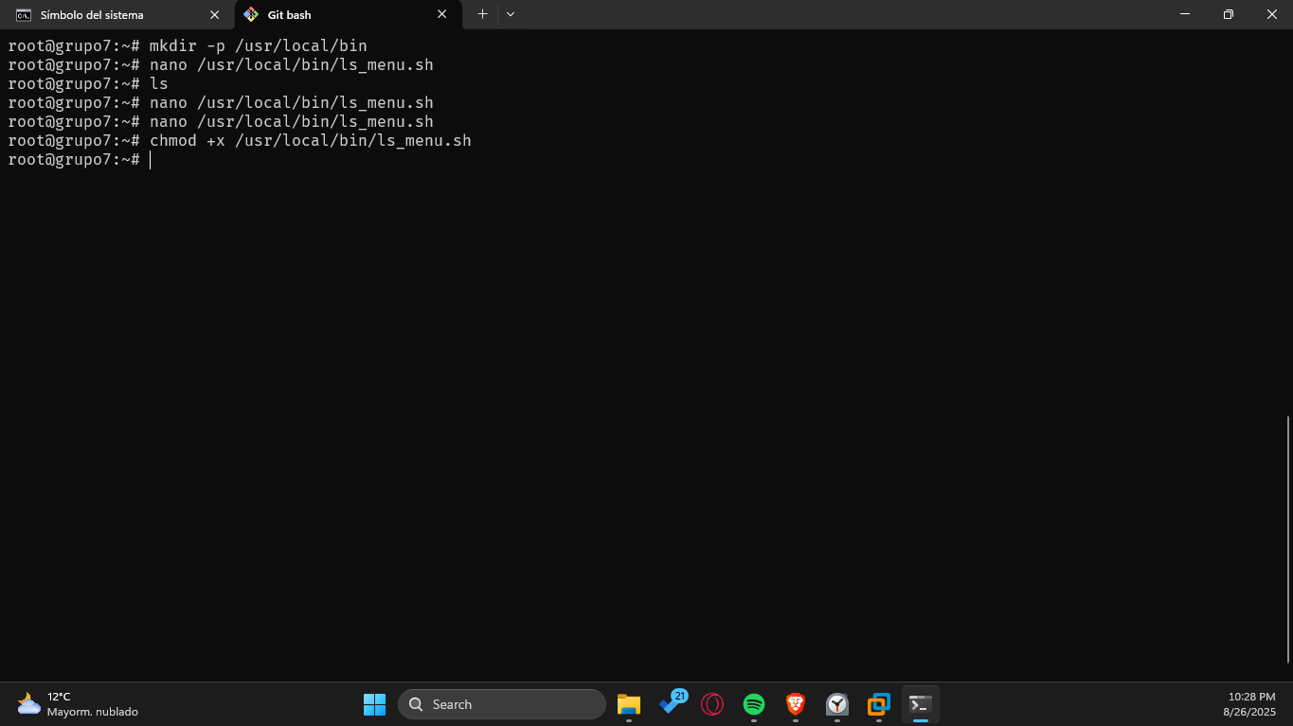

* **Run:** /usr/local/bin/ls_menu.sh

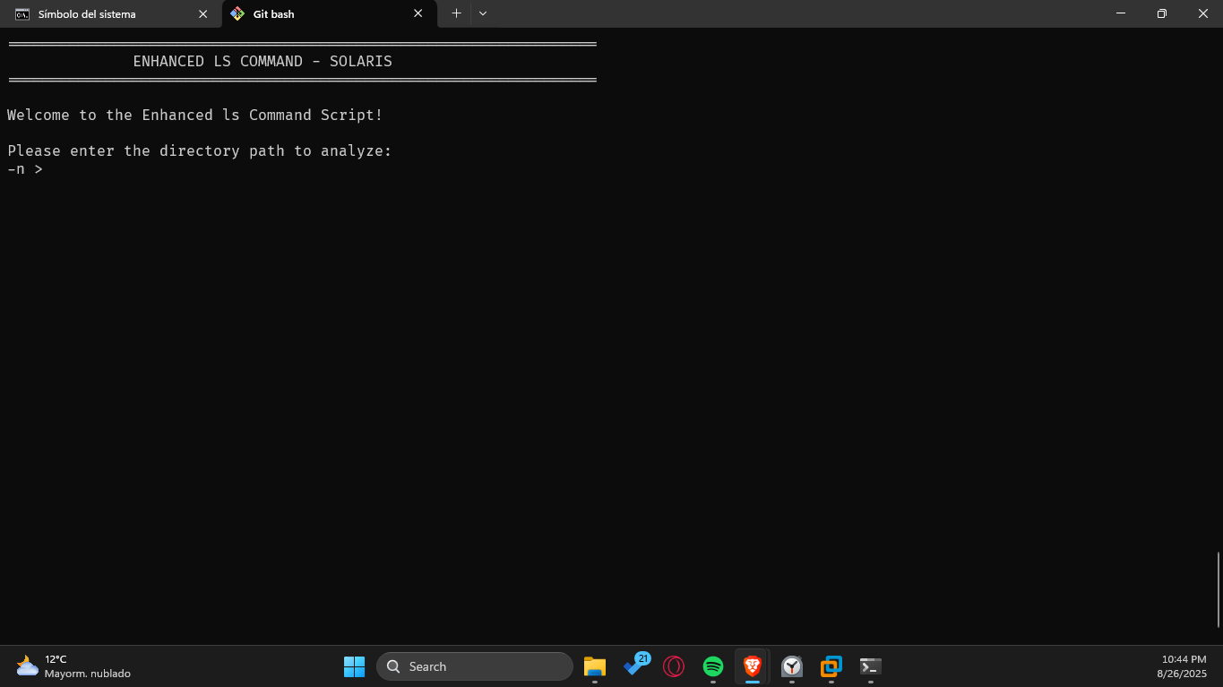

* **Tests:**

1. **Most recent files test:**

mkdir -p /tmp/testls

cd /tmp/testls

touch a.txt b.txt c.txt

sleep 2

touch d.txt

/usr/local/bin/ls_menu.sh

Select option **1 (Most recent)**.

**Expected:** d.txt should appear first, and the grouping by date should show how many files share the same modification date.

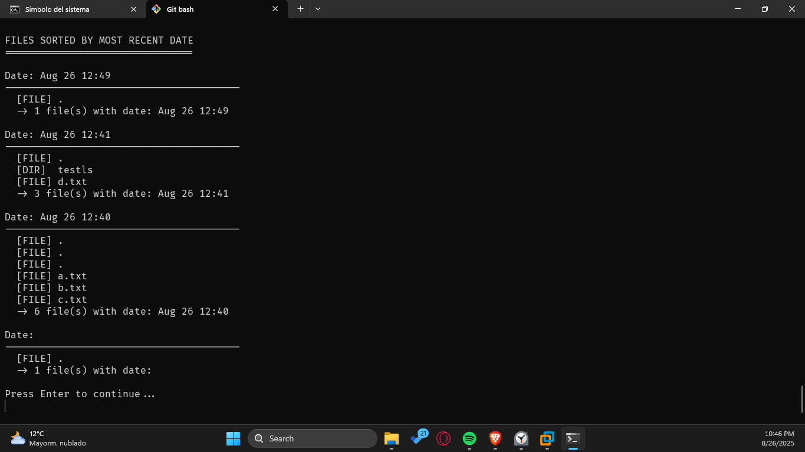

1. **Size-based test:**

echo "hello" > small.txt

/tmp/testls# dd if=/dev/zero of=bigfile.bin bs=1024 count=100 # 100KB file

/usr/local/bin/ls_menu.sh

Select option 3



1. **Largest to smallest)**:

**Expected:** bigfile.bin appears at the top, then small.txt.

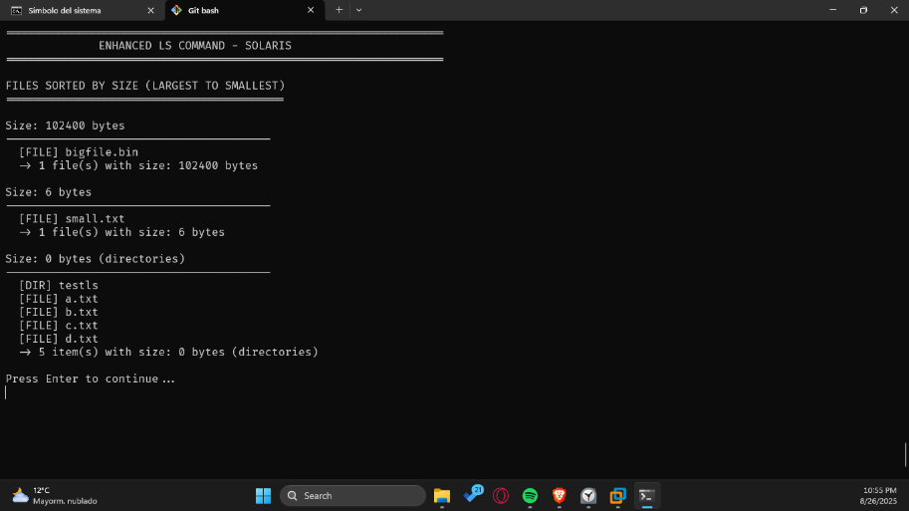

1. **Filter test (starts with):**

touch start_abc.txt start_xyz.log notstart.txt

/usr/local/bin/ls_menu.sh

Select option **6 (Starts with string)** and enter start_.

**Expected:** only start_abc.txt and start_xyz.log appear.

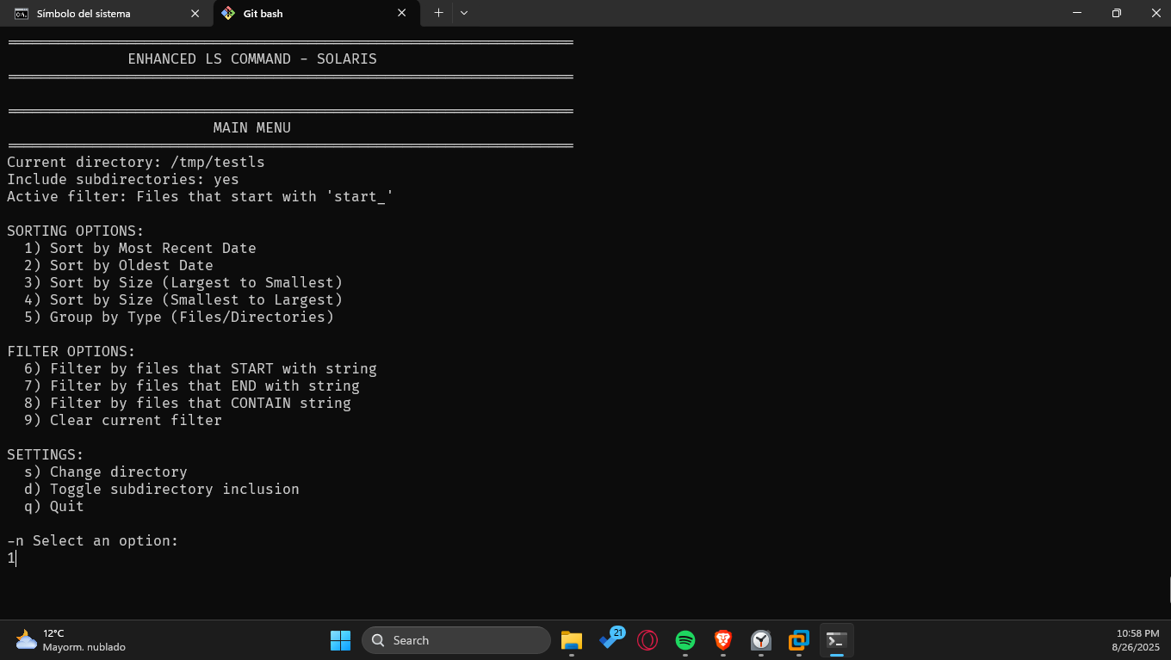

And now, once the filter is activated, we use 1

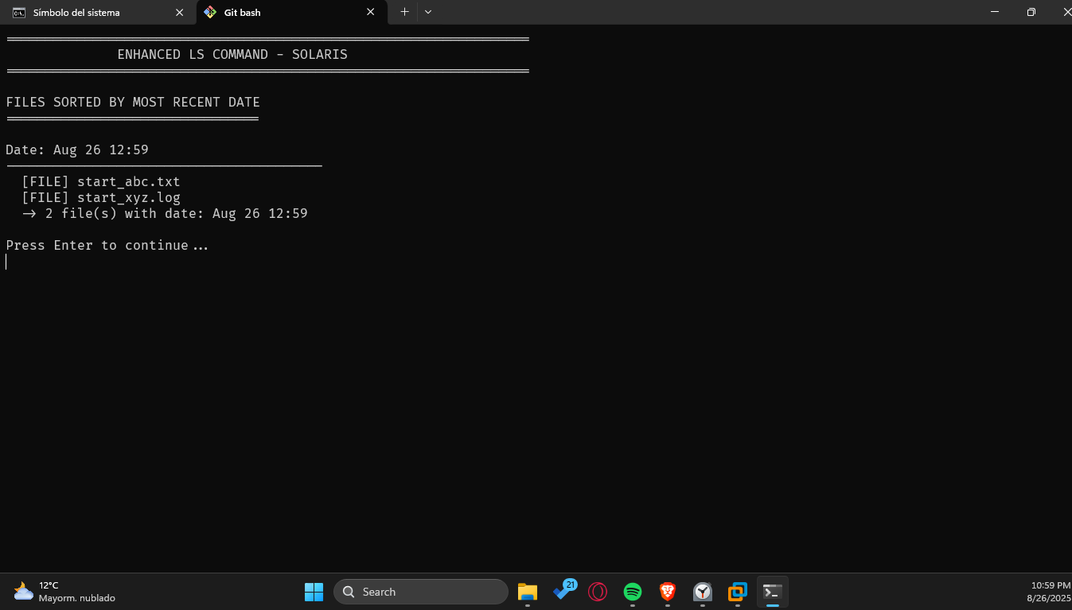

### File Search or Viewing Commands

* Create a Shell script that, through a menu (the menu will only exit when the user indicates so), allows the user to:
* Search for a file/part of a file by specifying a path and file name/part of the name. Output the locations and names of the files, followed by the number of times the file was found.
* Search for a word/part of a word in a given file. Output the found words and the lines where they were found, followed by the number of repetitions.
* Search for a file/part of a file in a given path, and when found, search for a word/part of a word. For each found file, show the line where the word was found, followed by the total number of repetitions.
* Count the number of lines in a file.
* Show the first n lines of a given file.
* Show the last n lines of a given file.

**SLACKWARE:**

* **Save:** nano /usr/local/bin/file_search_menu.sh

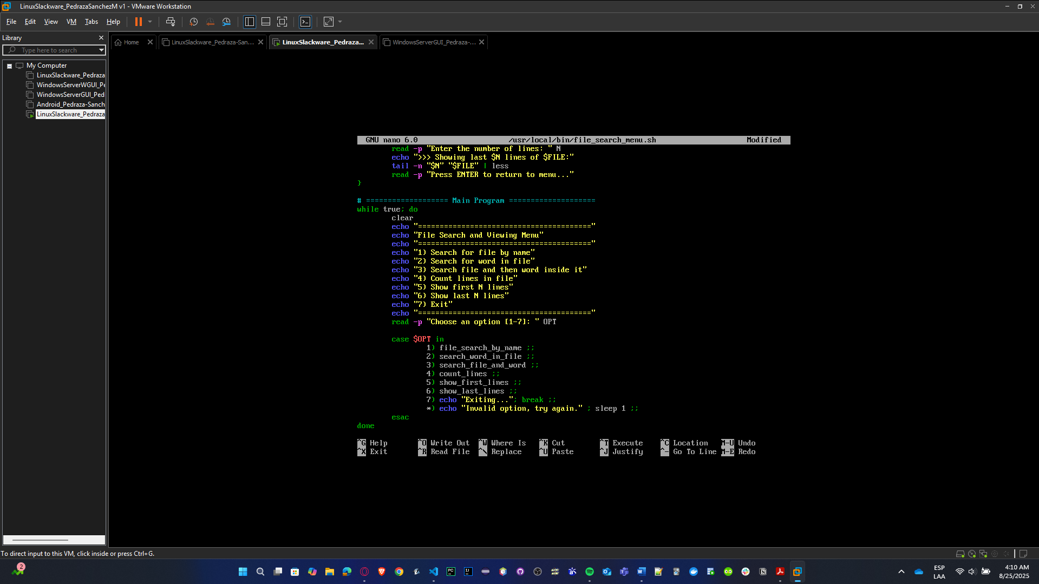

* **Exec:** chmod +x /usr/local/bin/file_search_menu.sh

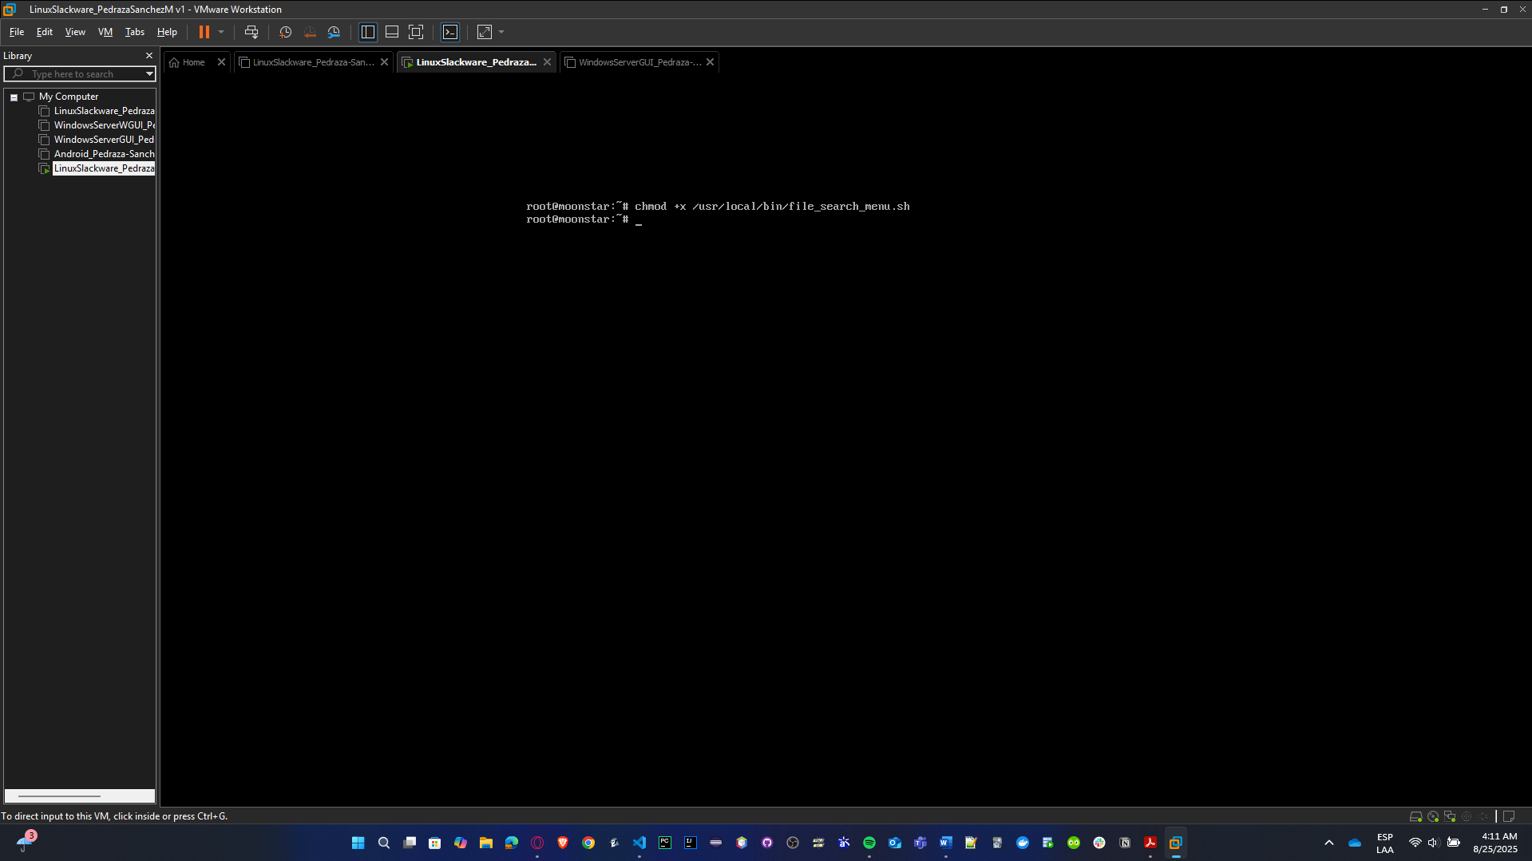

* **Run:** /usr/local/bin/file_search_menu.sh

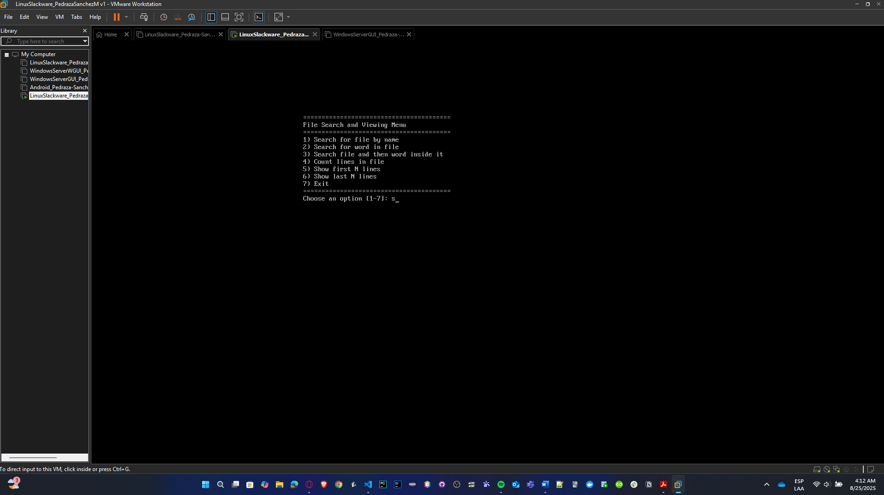

* **Tests:**
  + 1. **Search for an existent file:**

./file_search_menu.sh

# In the menu, select "1. Search for a file by name"

# Enter: /etc/hosts

**Expected:** complete route for existent file

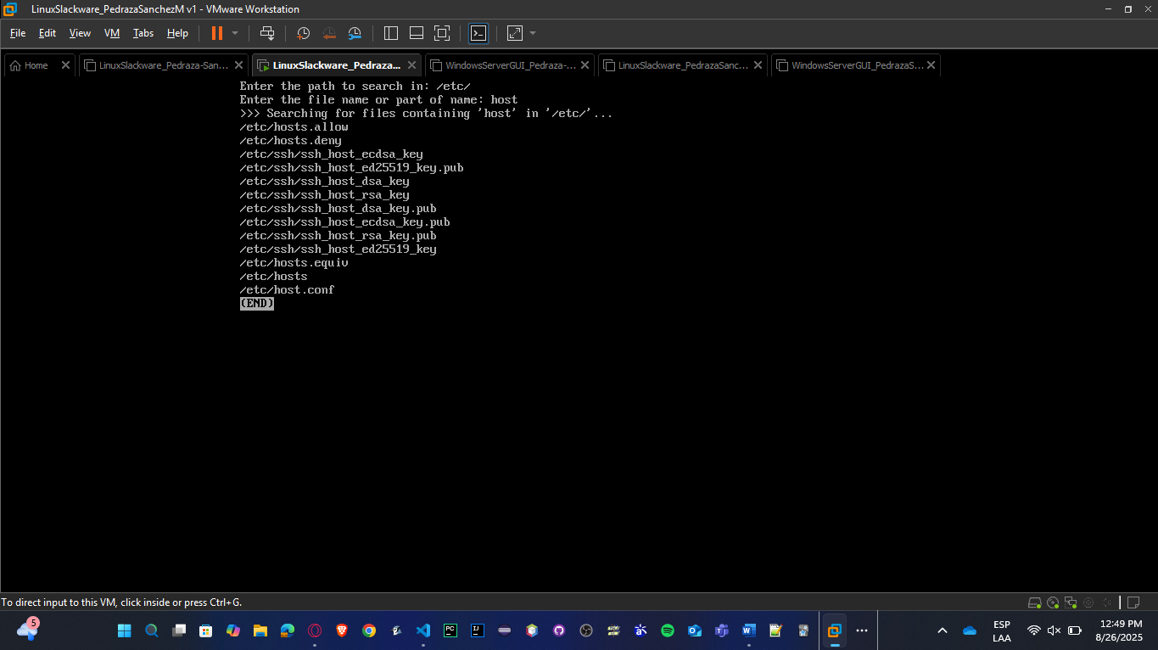

* + 1. **Search inside a directory:**

./file_search_menu.sh

# Select "2. Search for a string inside files"

# Enter word: root

# Enter directory: /etc/passwd

**Expected**: various lines with configurations that include "root".

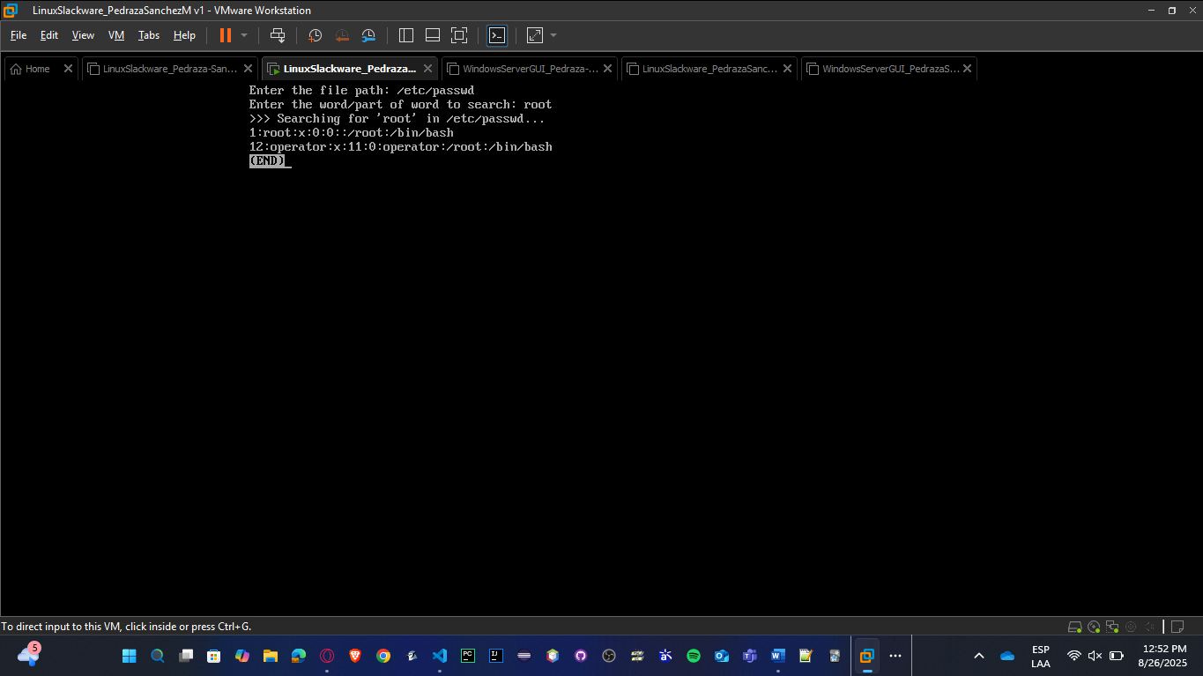

* + 1. **List modified files recently:**

./file_search_menu.sh

# Select "3. Show recently modified files"

# Enter directory: /var/log

**Expected:** files list in /var/log ordered by modified date

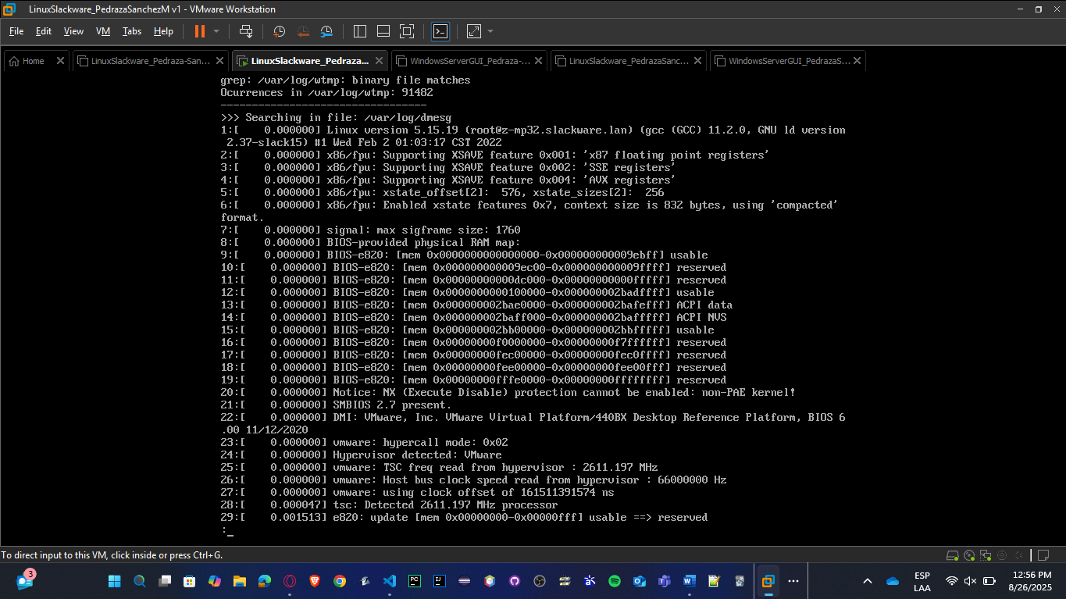

**SOLARIS:**

* **Save:** nano /usr/local/bin/file_search_menu.sh

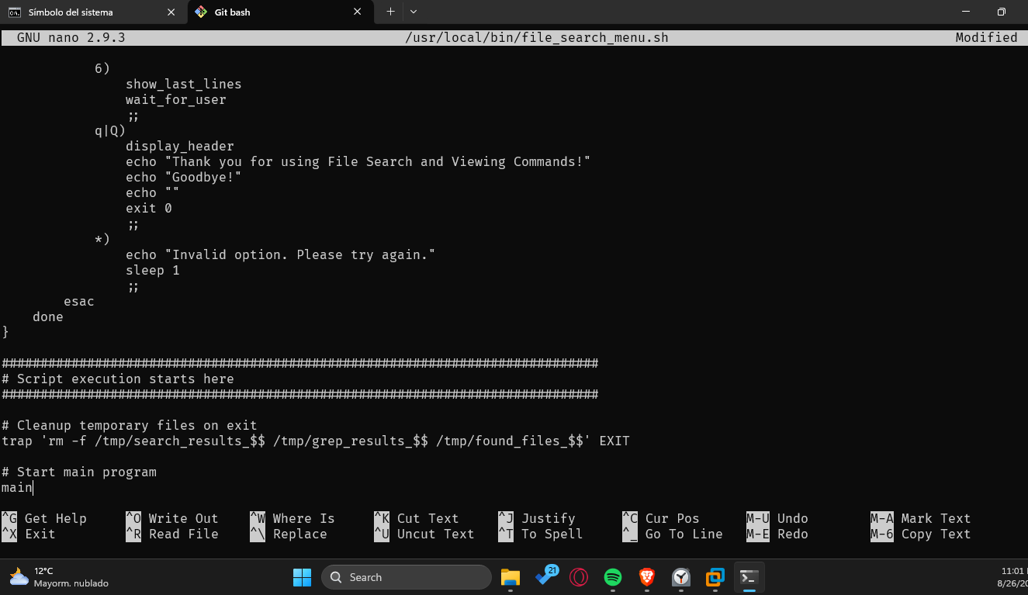

* **Exec:** chmod +x /usr/local/bin/file_search_menu.sh

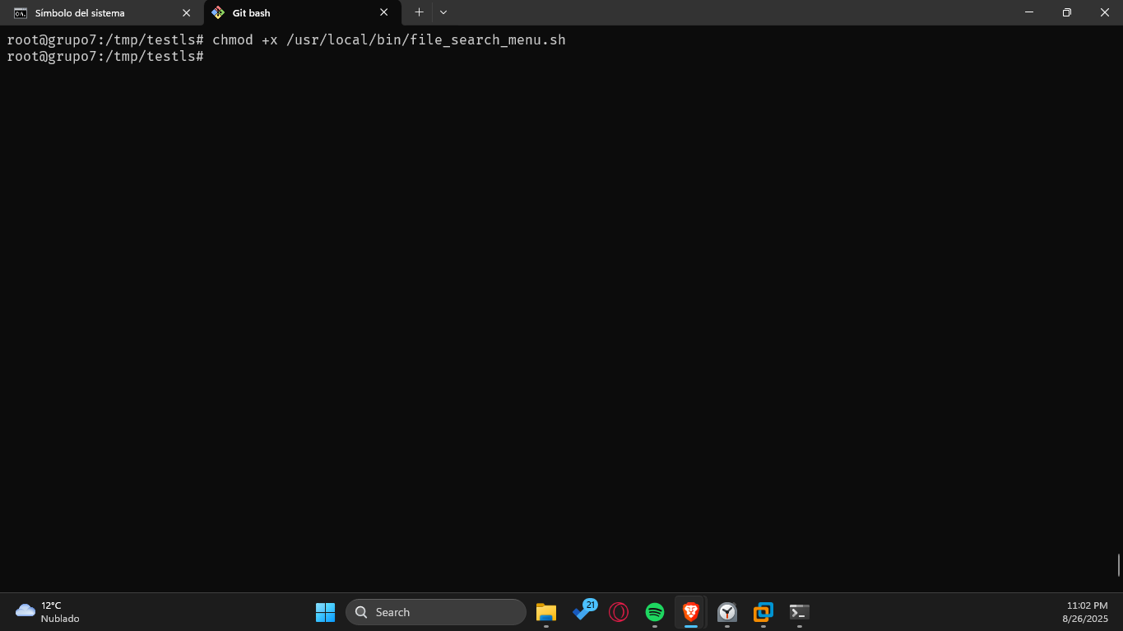

* **Run:** /usr/local/bin/file_search_menu.sh

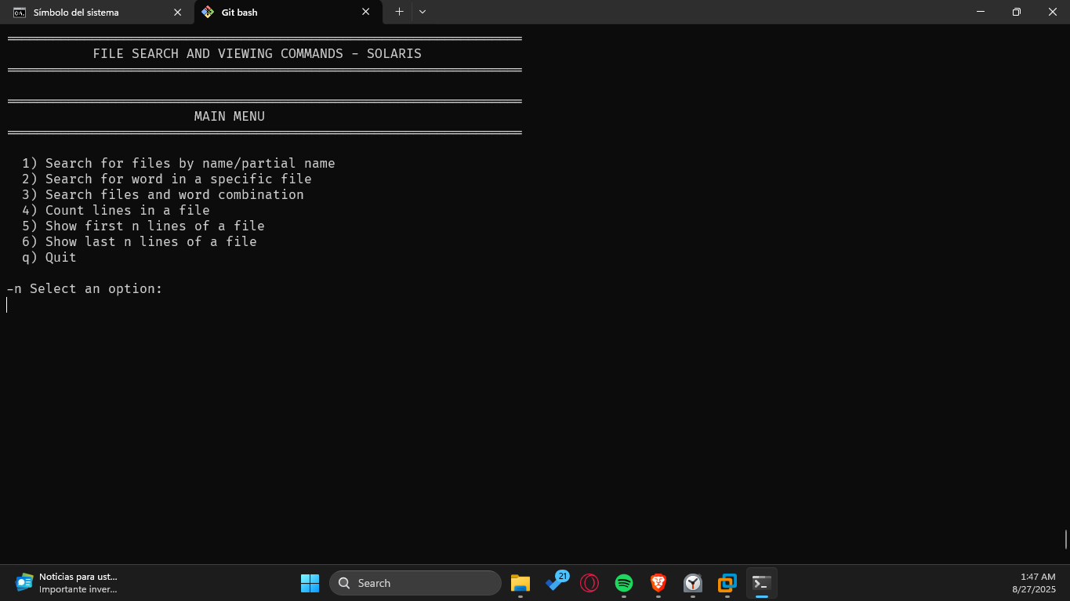

* **Tests:**

1. **Search for an existent file:**

./file_search_menu.sh

# In the menu, select "1. Search for a file by name"

# Enter: /etc/hosts

**Expected:** complete route for existent file

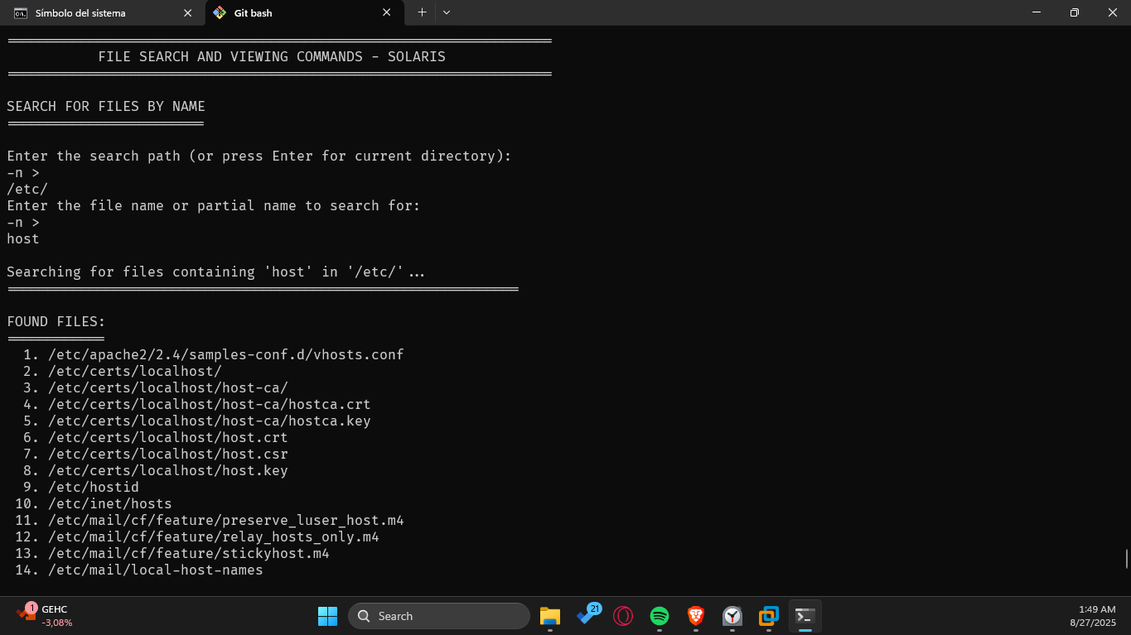

1. **Search inside a directory:**

./file_search_menu.sh

# Select "2. Search for a string inside files"

# Enter word: root

# Enter directory: /etc/passwd

**Expected**: various lines with configurations that include "root".

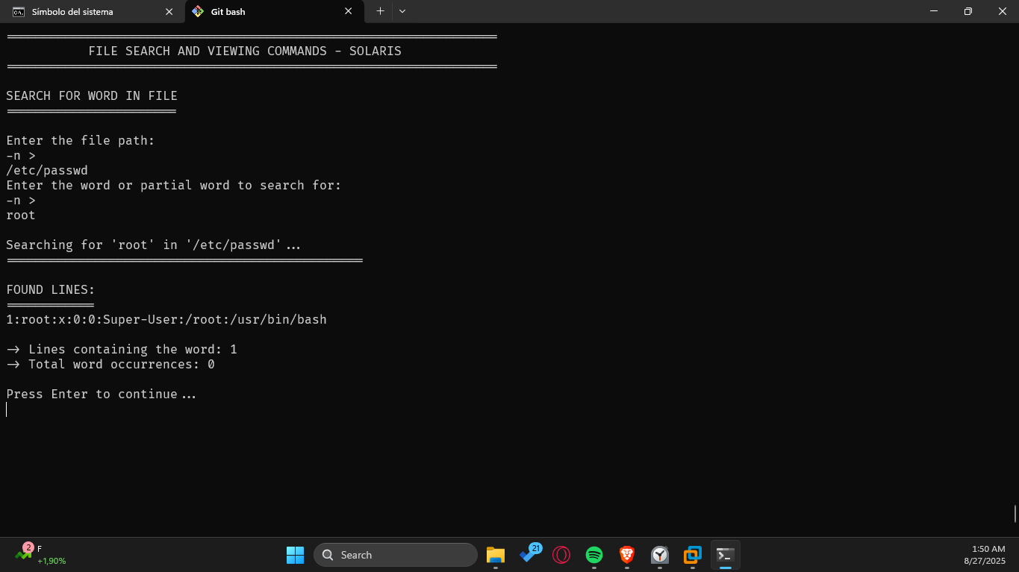

1. **List modified files recently:**

./file_search_menu.sh

# Select "3. Show recently modified files"

# Enter directory: /var/log

**Expected:** files list in /var/log ordered by modified date

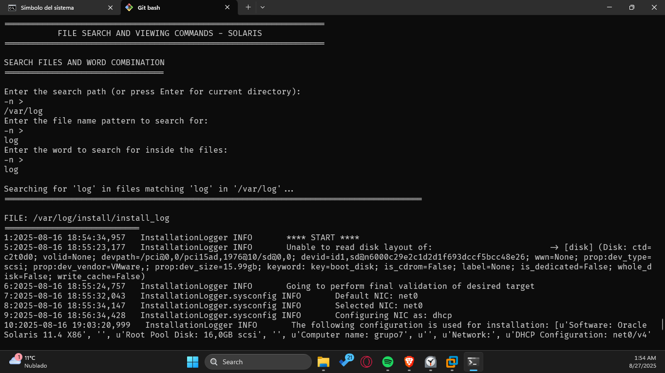

### Log Review

Write a Shell program to:

* What are logs?
* What types of logs are found in the operating systems you installed?
* What is syslog? What is this standard? Do the logs found in your operating systems follow this standard?
* Clean the screen
* Allow, via a menu, to perform the following activities:
* Show the last 15 lines from three log files that contain general system activity data.
* From those 15 lines, show the ones that contain a specific word.

**SLACKWARE:**

* **Save:** nano /usr/local/bin/log_review_menu.sh

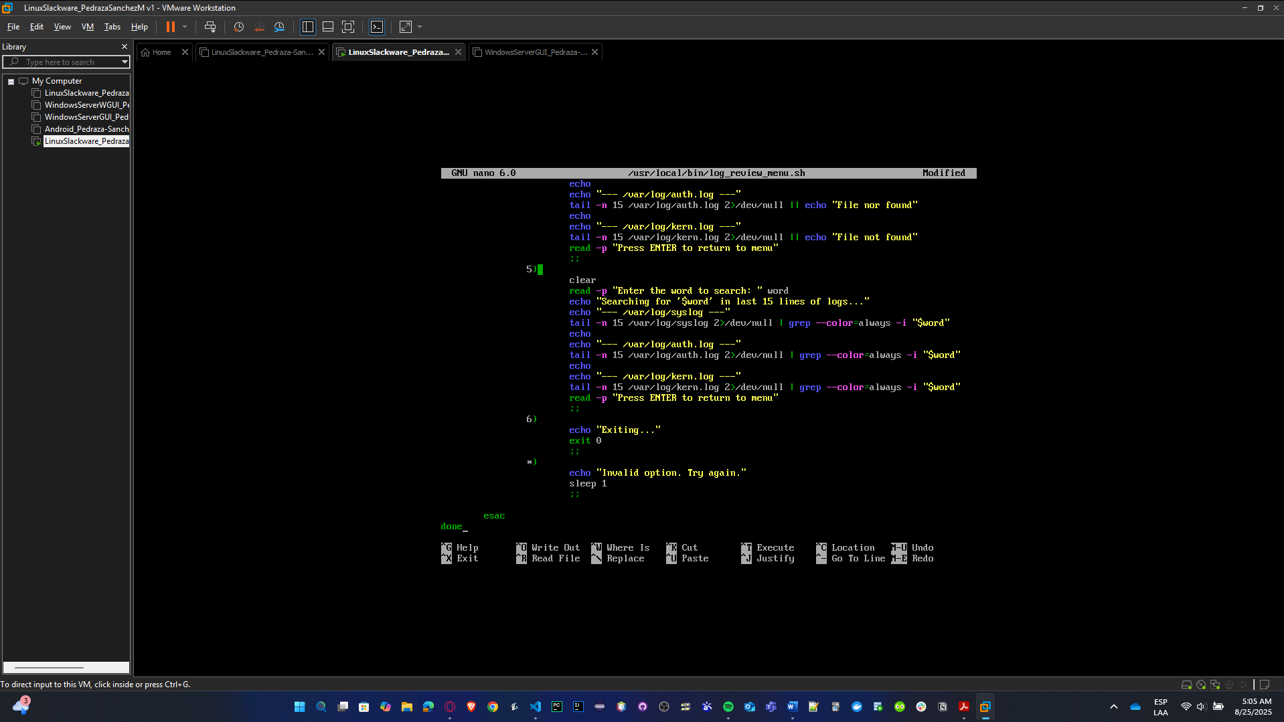

* **Exec:** chmod +x /usr/local/bin/ log_review_menu.sh

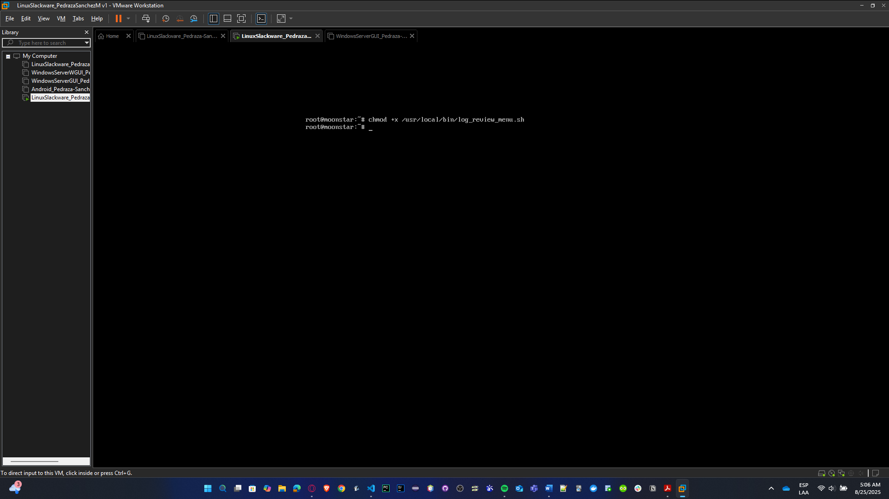

* **Run:** /usr/local/bin/ log_review_menu.sh

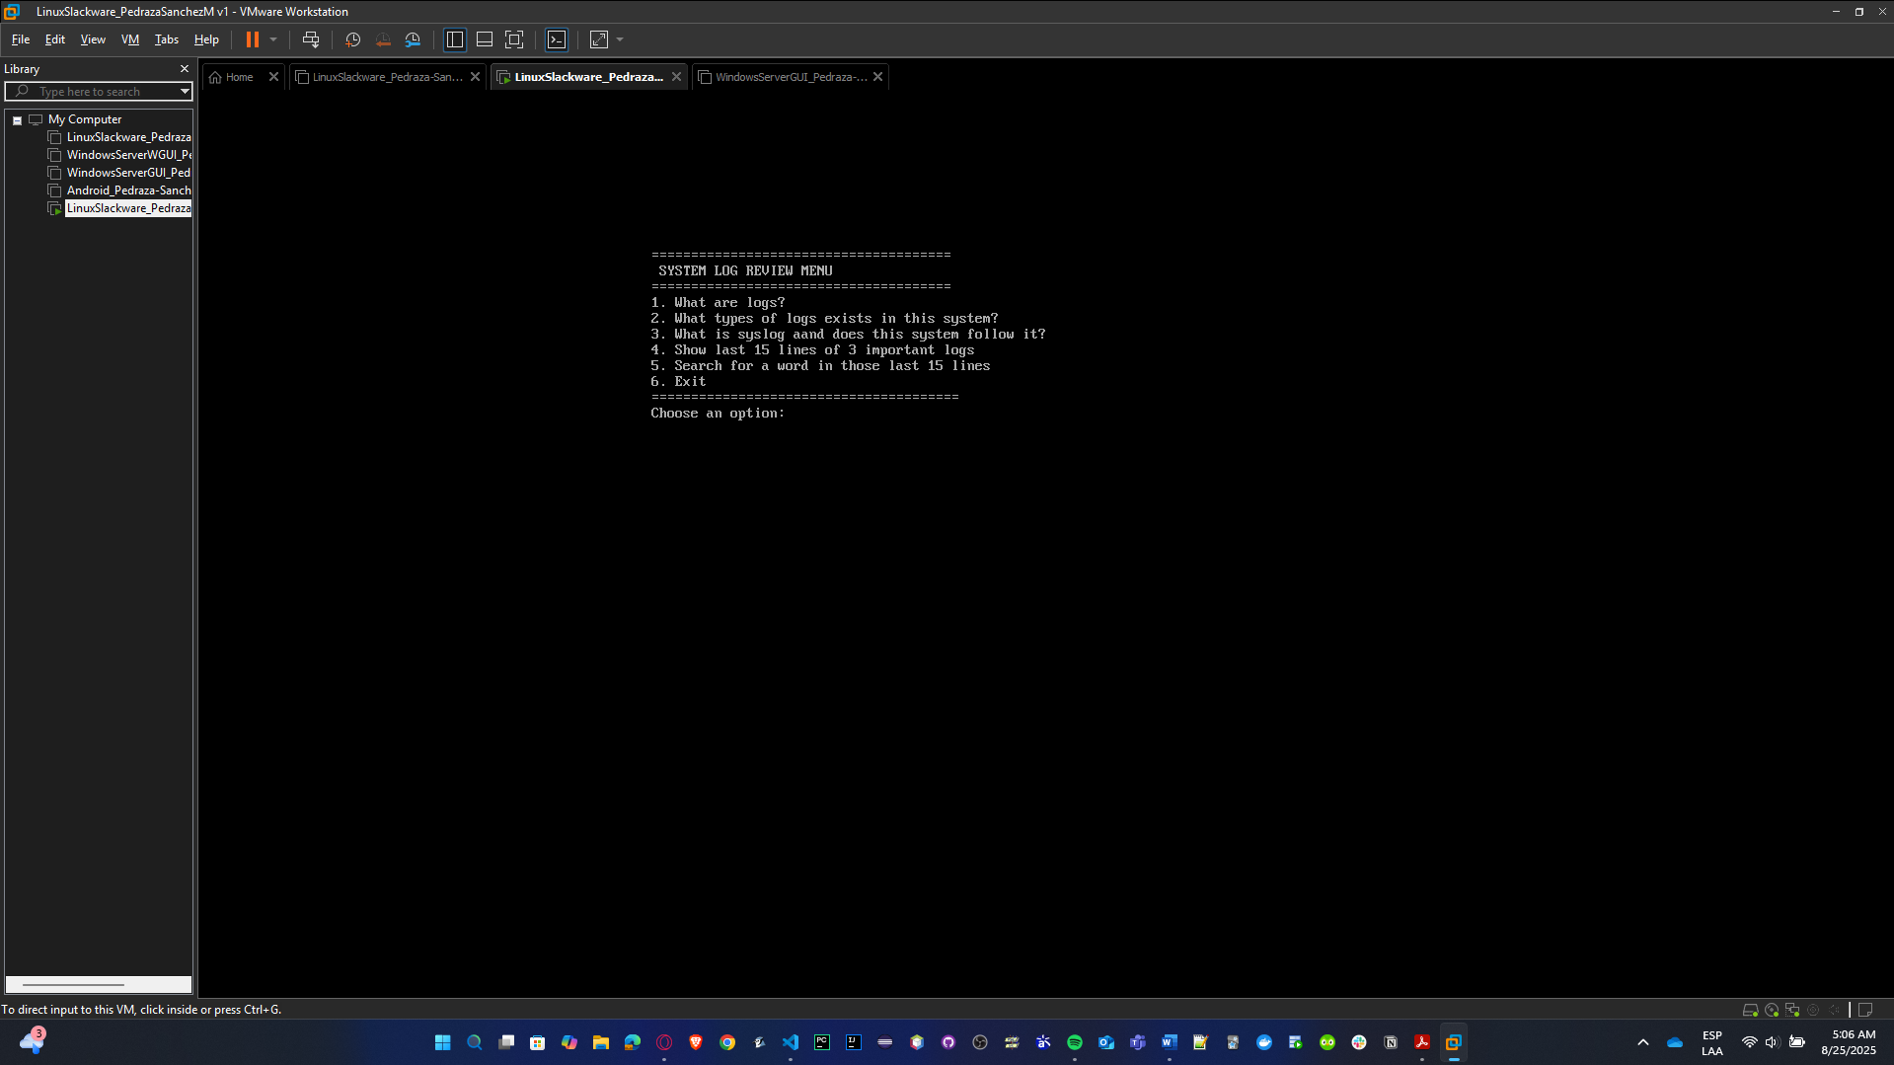

* **Tests:**
  + - * 1. **Run the script and check the menu appears:**

/usr/local/bin/log_review_menu.sh

You should see the options (1, 2, 3, etc.) printed on screen.

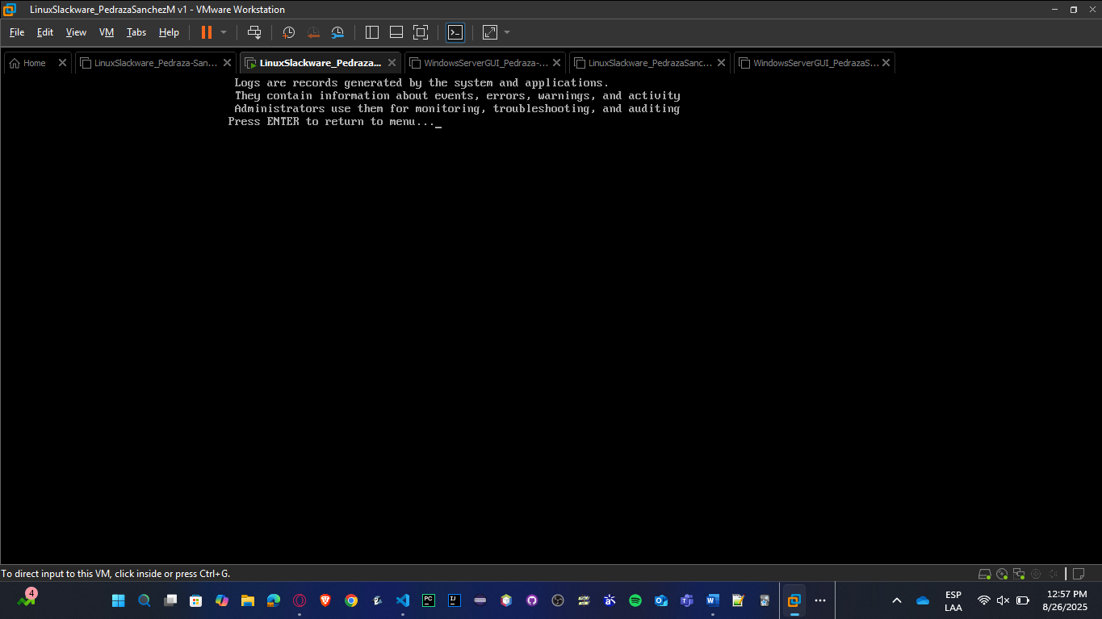

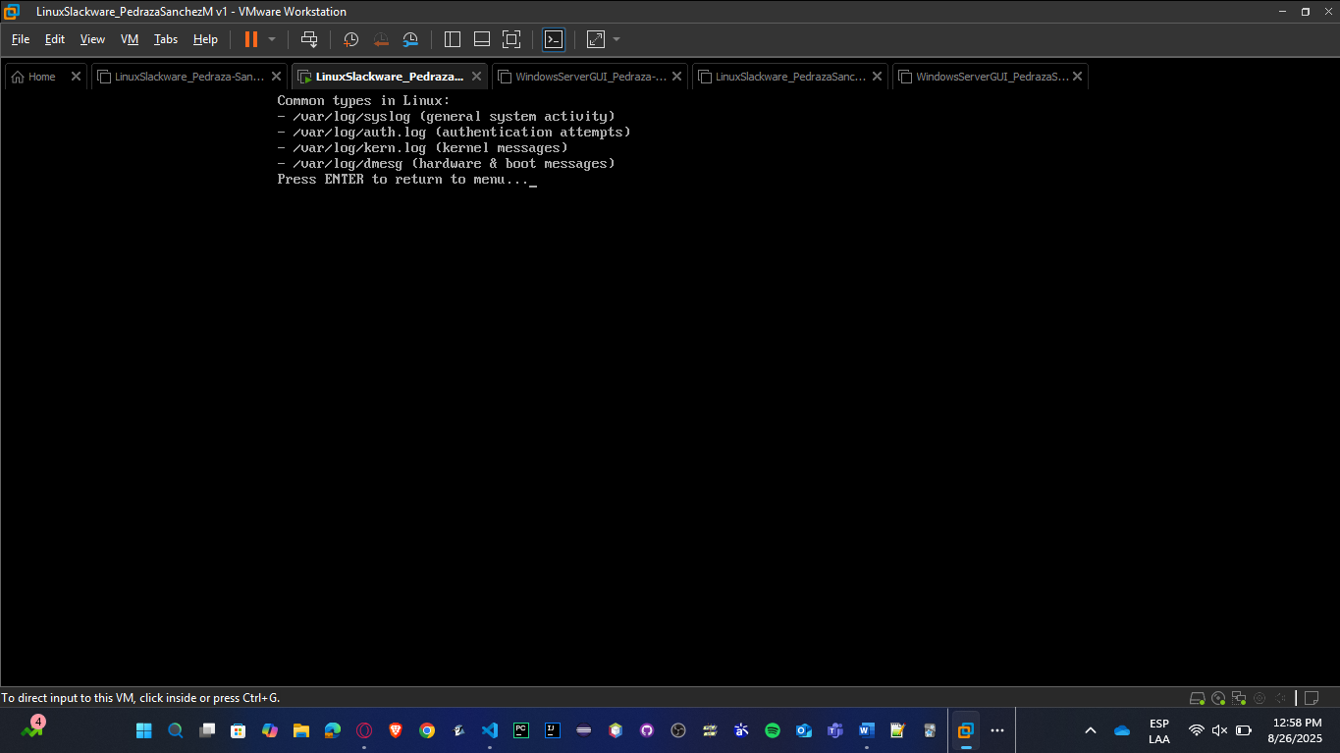

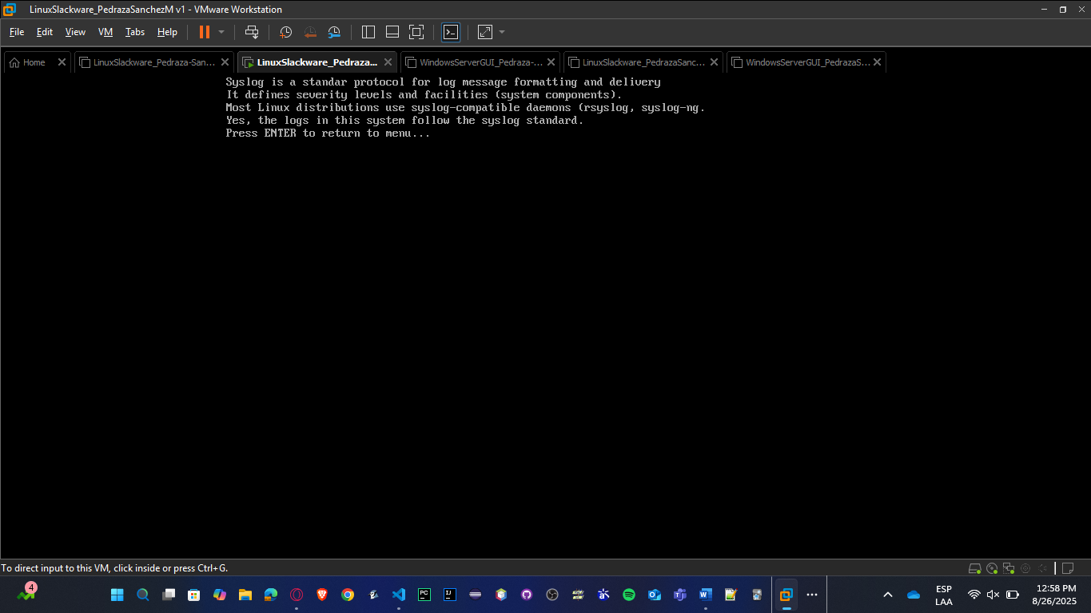

* + - * 1. **Select option 4 to show last 15 lines of 3 important logs:**

It should display content from /var/log/auth.log (or say “file not found” if the log doesn’t exist on the distro).

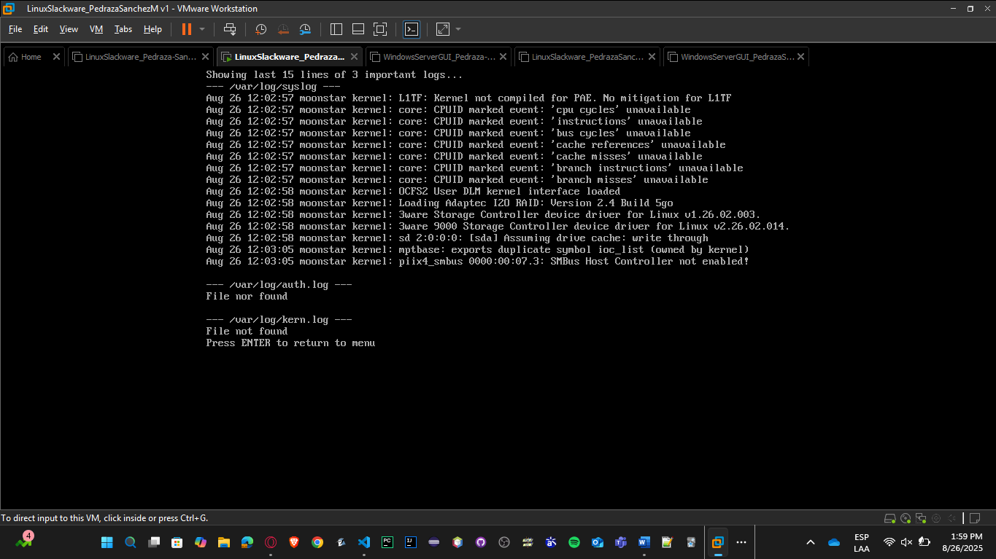

* + - * 1. **Select option 5 to search for a word in those 15 lines:**

Search for the word ‘event’ in those 15 lines.

It should return only the lines with that word.

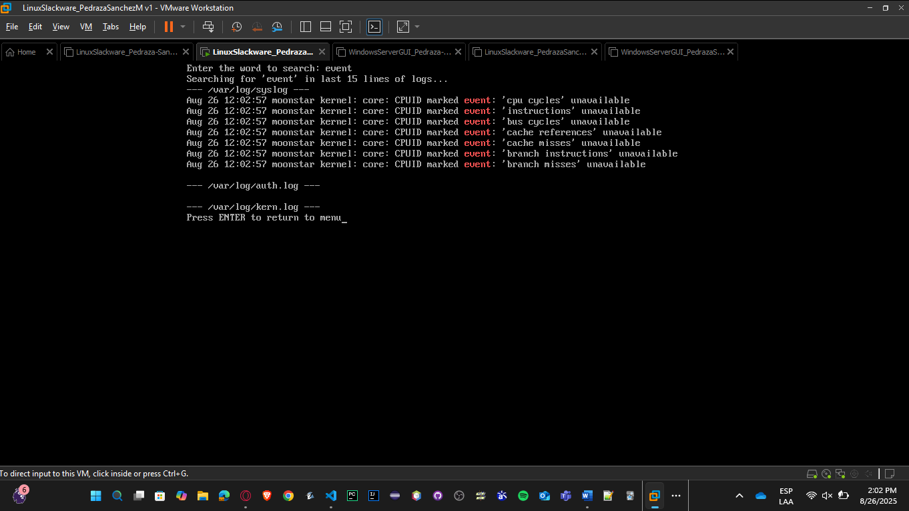

**SOLARIS:**

* **Save:** nano /usr/local/bin/log_review_menu.sh

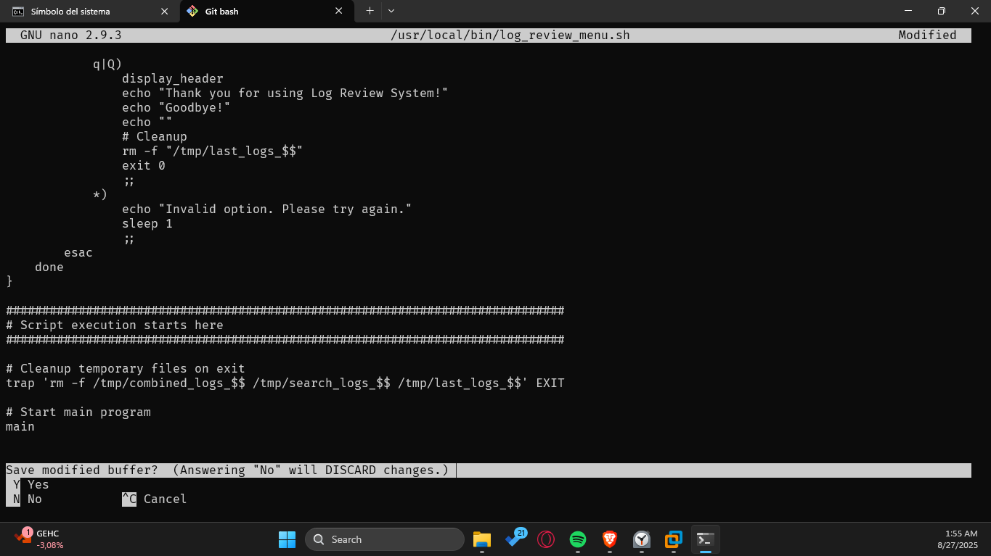

* **Exec:** chmod +x /usr/local/bin/ log_review_menu.sh

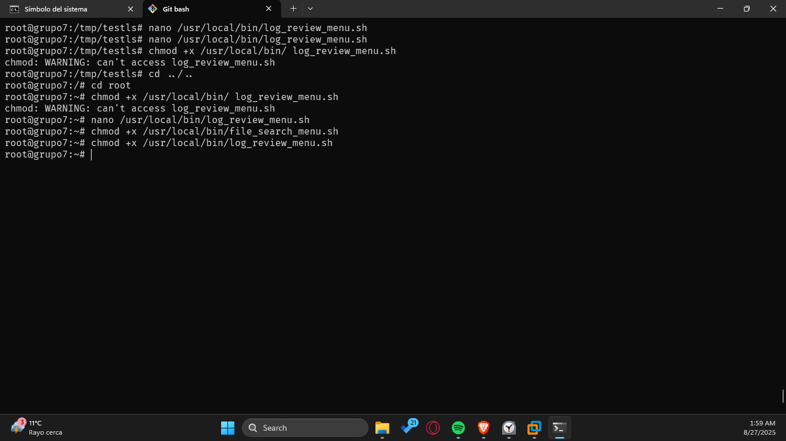

* **Run:** /usr/local/bin/log_review_menu.sh

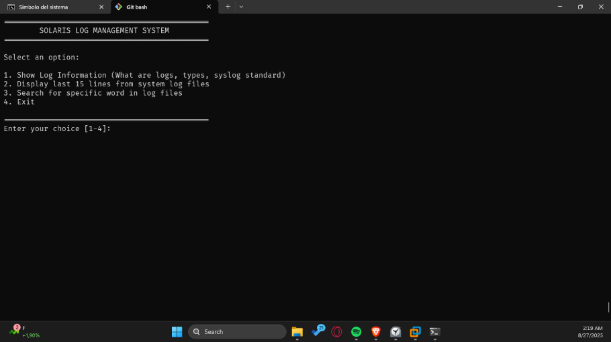

* **Tests:**
  + 1. **Run the script and check the menu appears:**

/usr/local/bin/log_review_menu.sh

You should see the options (1, 2, 3, etc.) printed on screen.

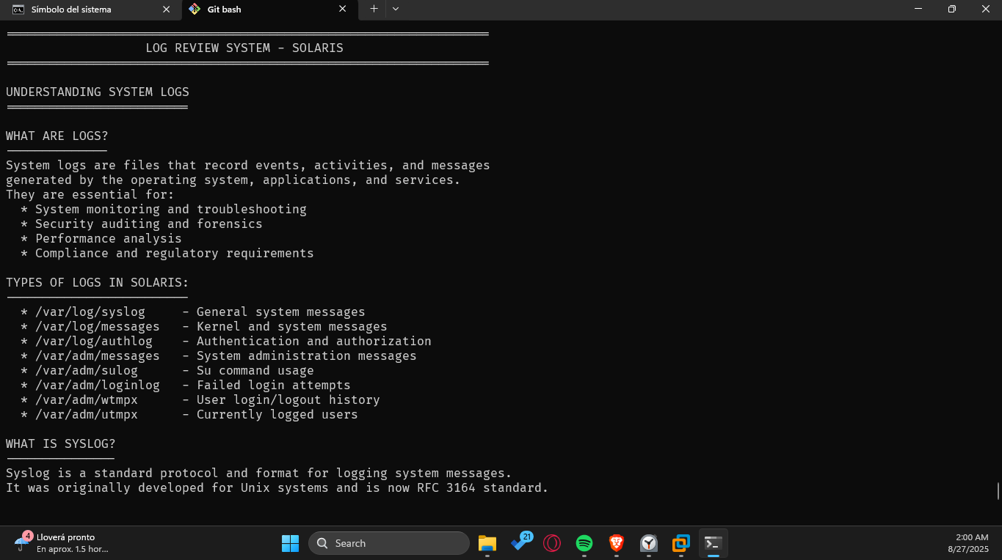

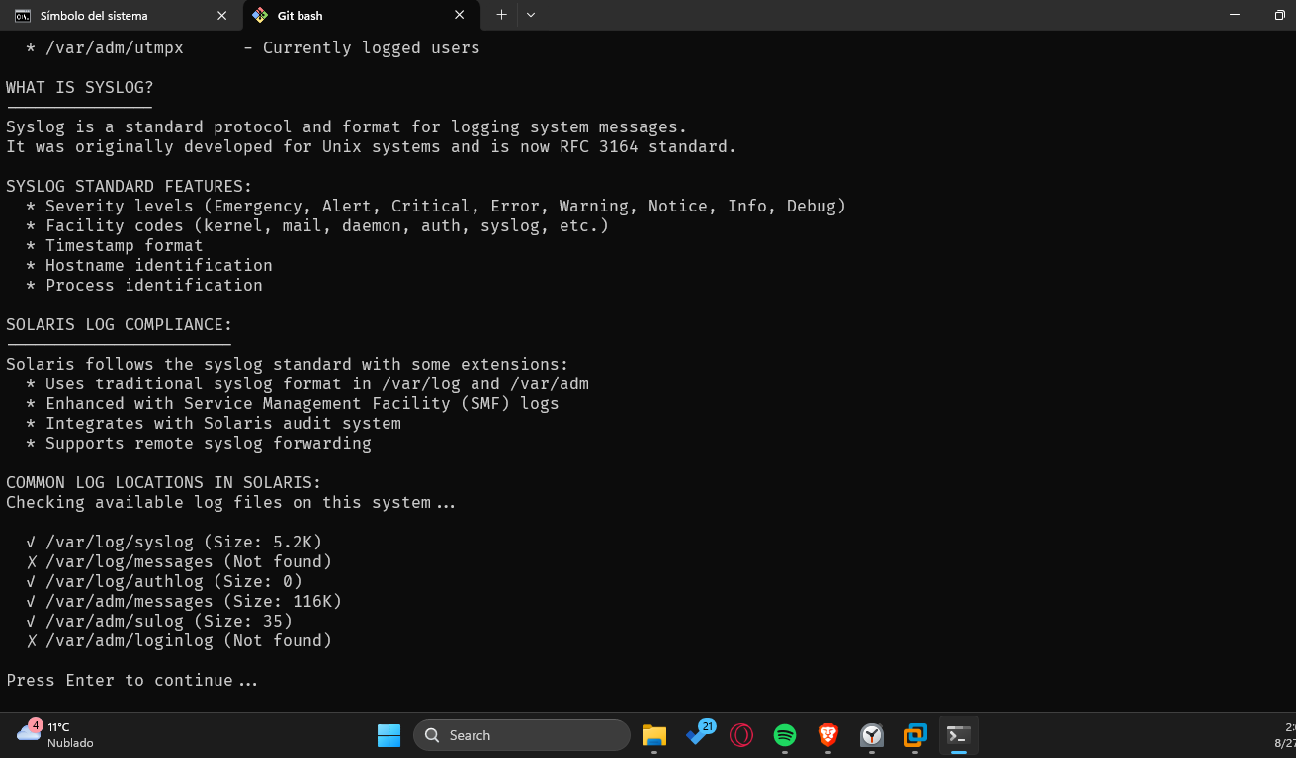

* + 1. **Select option 4 to show last 15 lines of 3 important logs:**

It should display content from /var/log/auth.log (or say “file not found” if the log doesn’t exist on the distro).

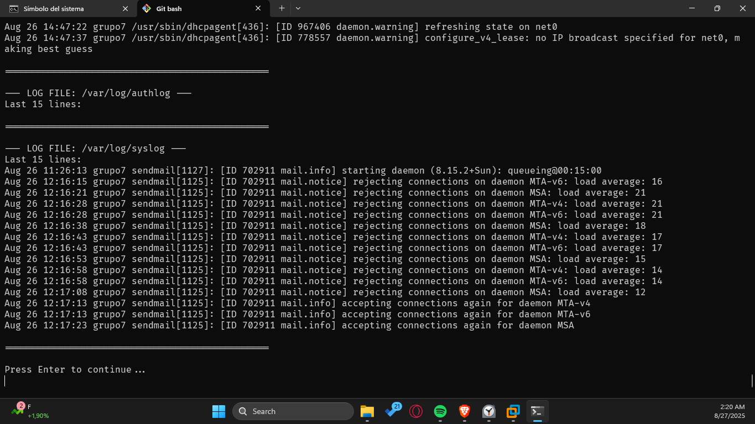

* + 1. **Select option 3 to search for a word in those 15 lines:**

Search for the word connection’ in those 15 lines.

It should return only the lines with that word.

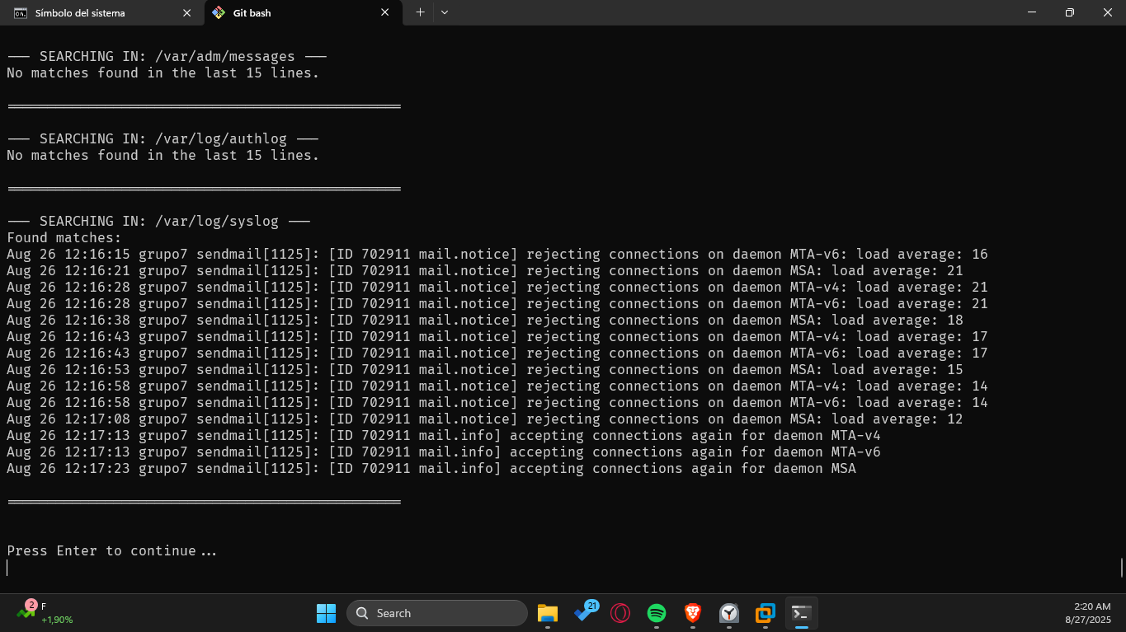

### User Creation

Write a Shell program to implement the creation of users, groups, and permissions from the previous lab. Request all necessary information in the command line. The style should be like:

newuser name group description directory shell user_permission group_permission other_permission

newgroup group_name group_ID

**SLACKWARE:**

* **Save:** nano /usr/local/bin/ user_group_creation.sh

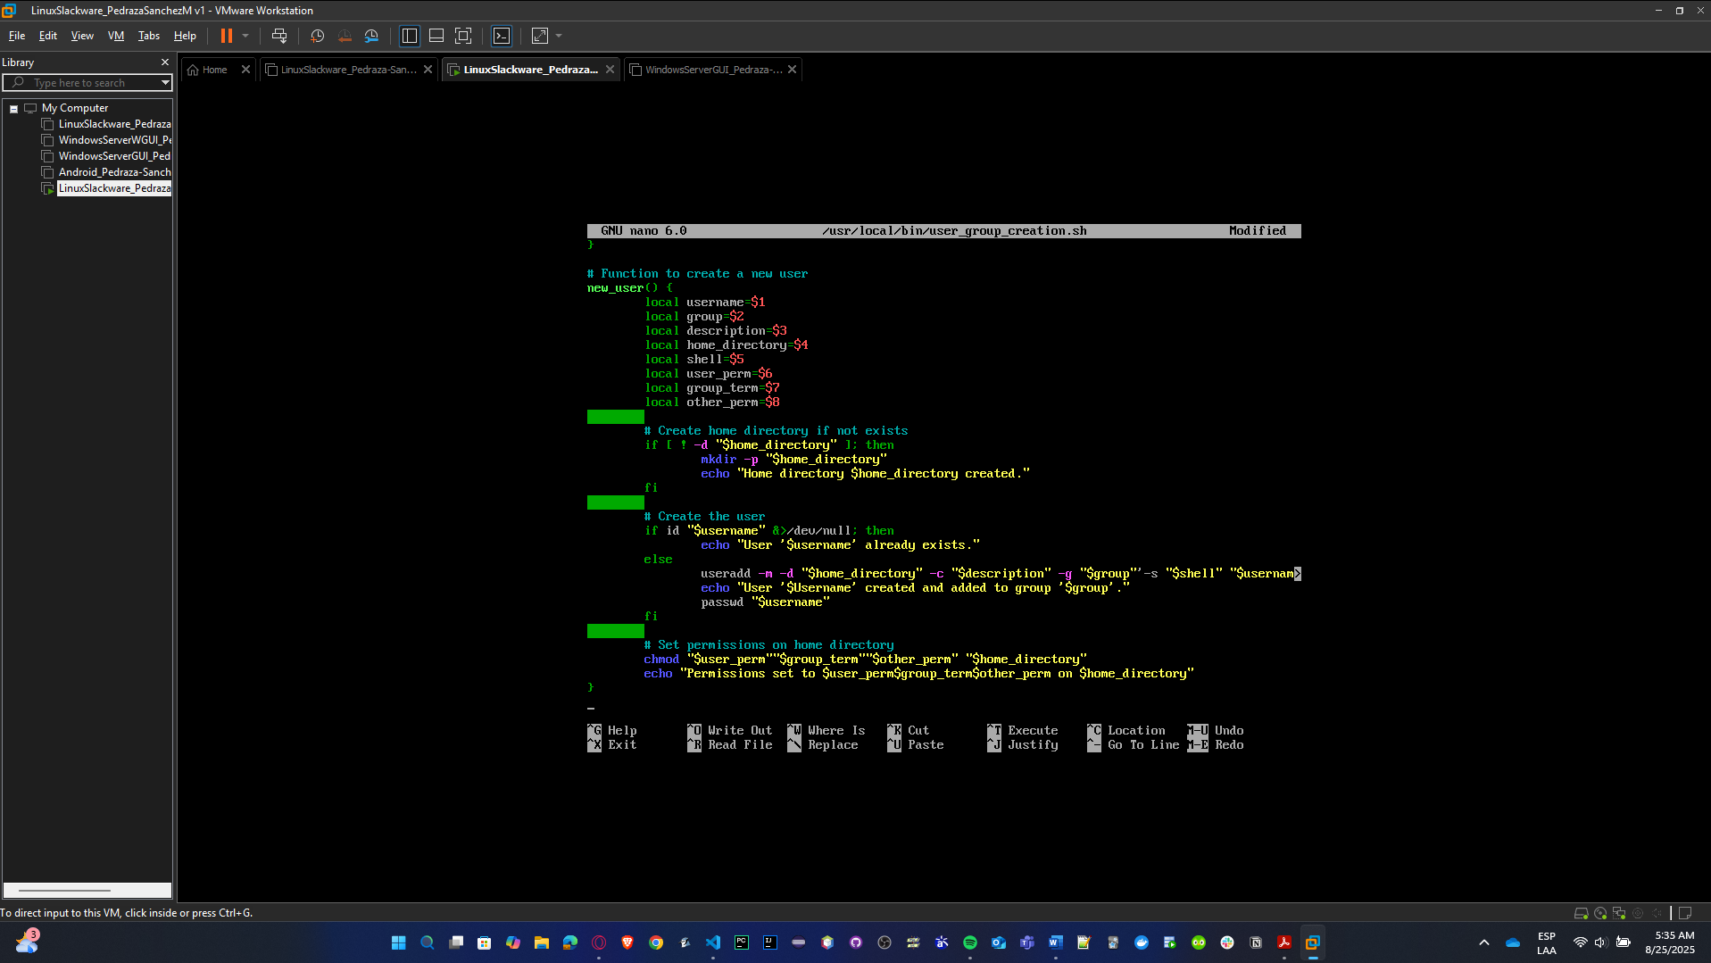

* **Exec:** chmod +x /usr/local/bin/ user_group_creation.sh

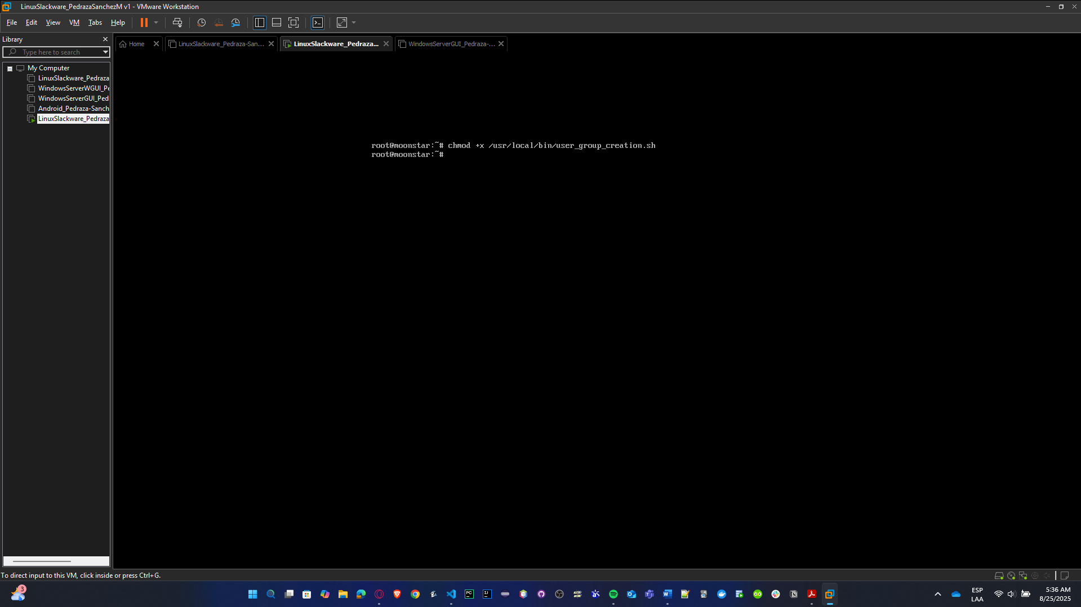

* **Run:** /usr/local/bin/ user_group_creation.sh

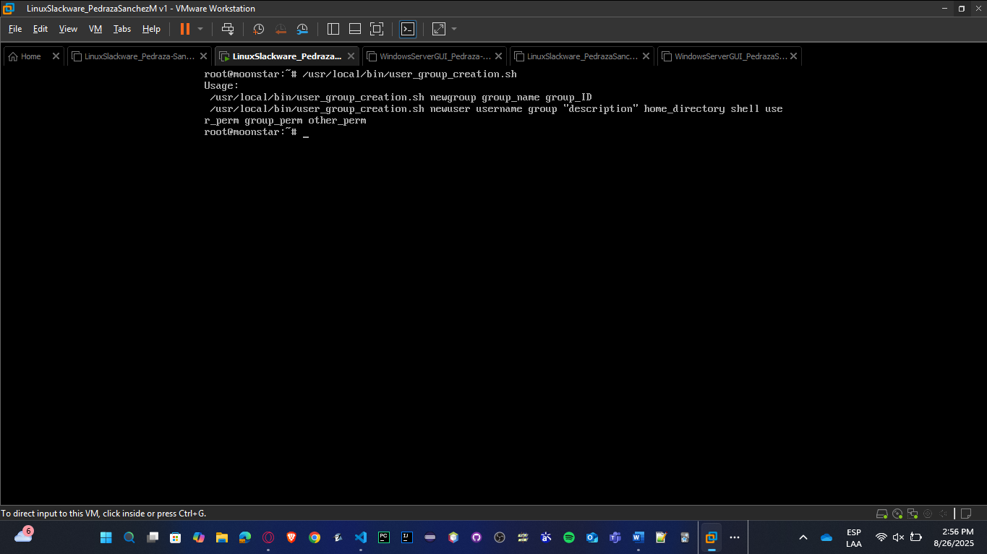

* **Tests:**

Make sure:

**chmod +x /usr/local/bin/user_group_creation.sh**

**mkdir -p /usuarios**

1. **Create groups**

/usr/local/bin/user_group_creation.sh newgroup finance 1001

/usr/local/bin/user_group_creation.sh newgroup business 1002

**Expected:** Confirm the group creation with commands: **grep finance /etc/group** and **grep /etc/group business.**

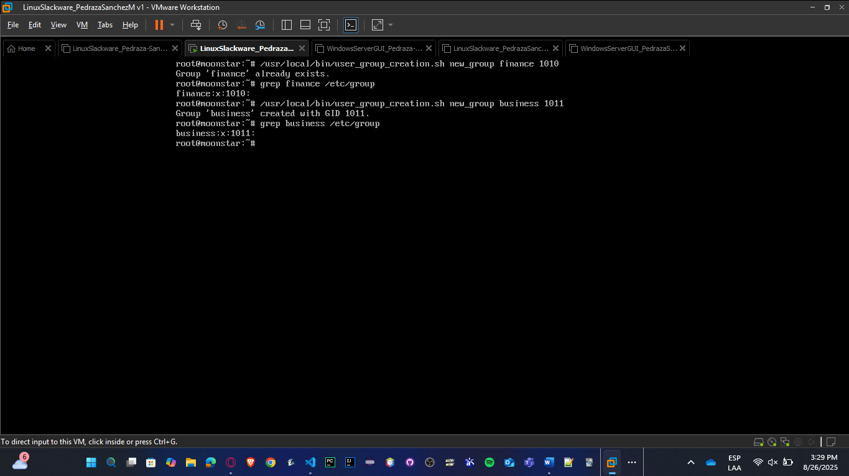

1. **Create ander user**

/usr/local/bin/user_group_creation.sh newuser ander finance "Systems Engineering student - AI enthusiast"

/usuarios/ander /bin/bash 7 5 0

**Expected:** Andersson’s directory created, and confirm it with command **ls -ld /usuarios/ander**

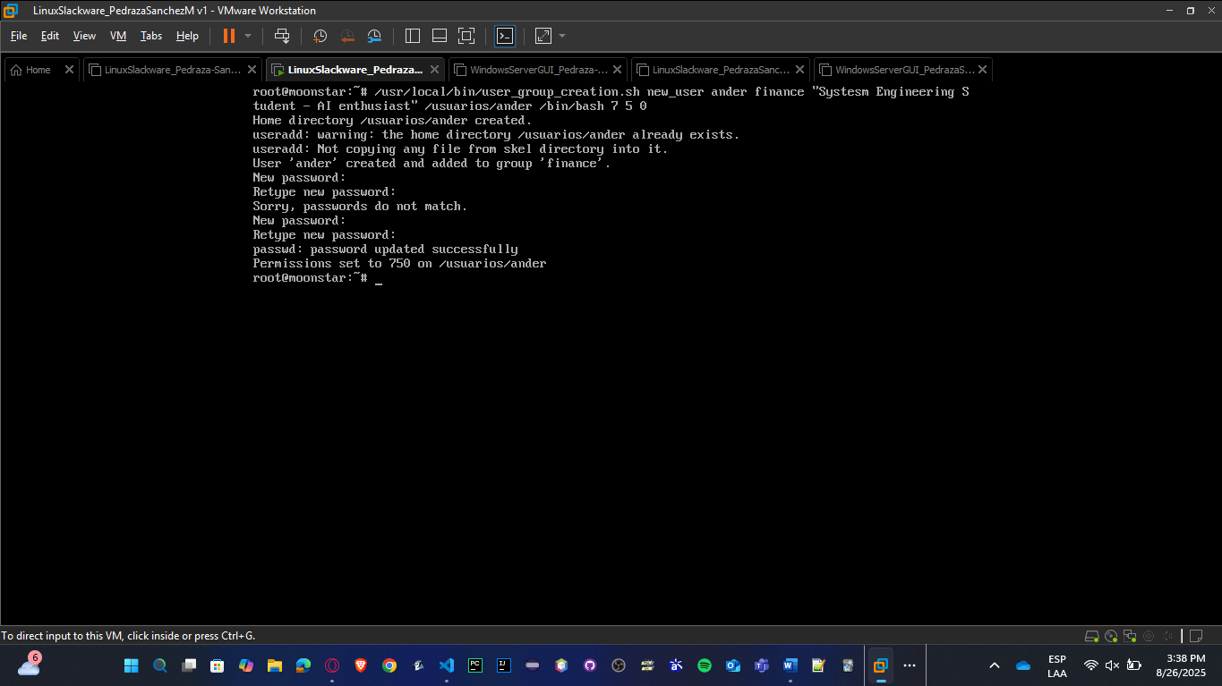

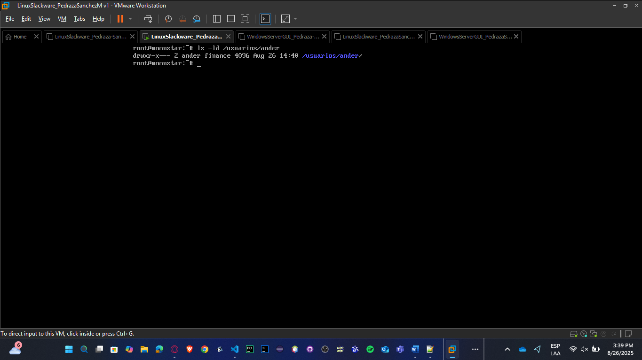

1. **Create Marie user in business group**

/usr/local/bin/user_group_creation.sh newuser marie business "IT Support Specialist - Database management"

/usuarios/marie /bin/bash 7 5 0

**Expected:** User created with home /usuarios/elena with permissions 750

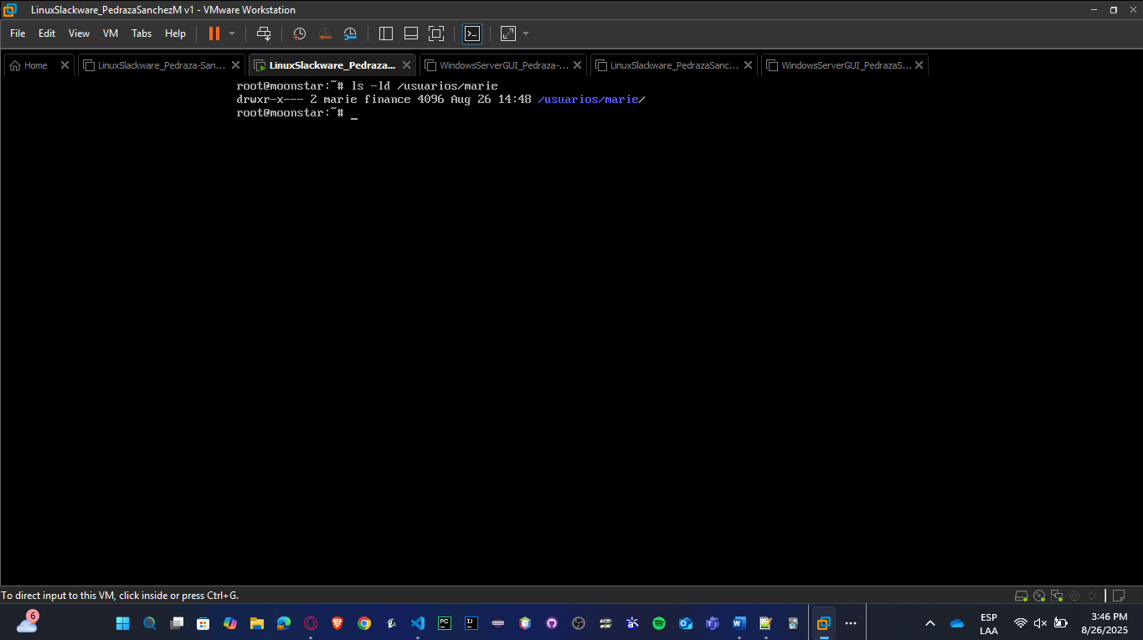

**SOLARIS:**

* **Save:** nano /usr/local/bin/user_group_creation.sh

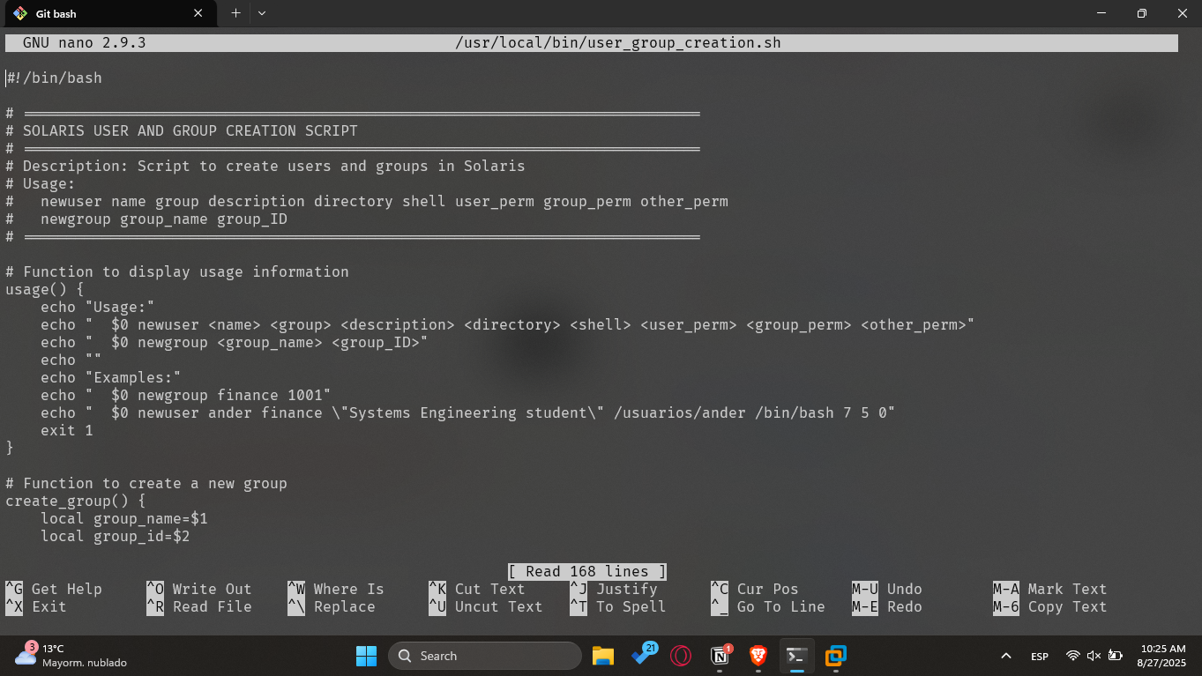

* **Exec:** chmod +x /usr/local/bin/user_group_creation.sh

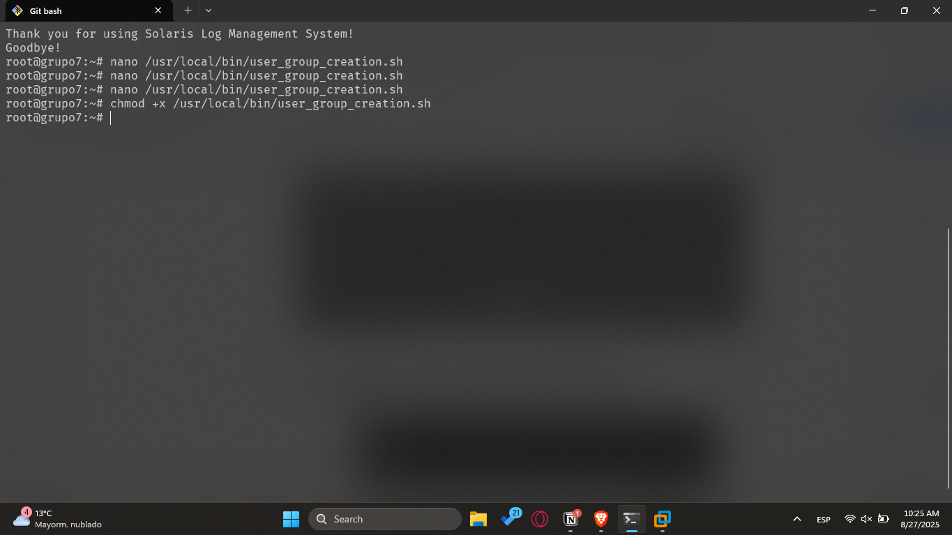

* **Run:** /usr/local/bin/user_group_creation.sh

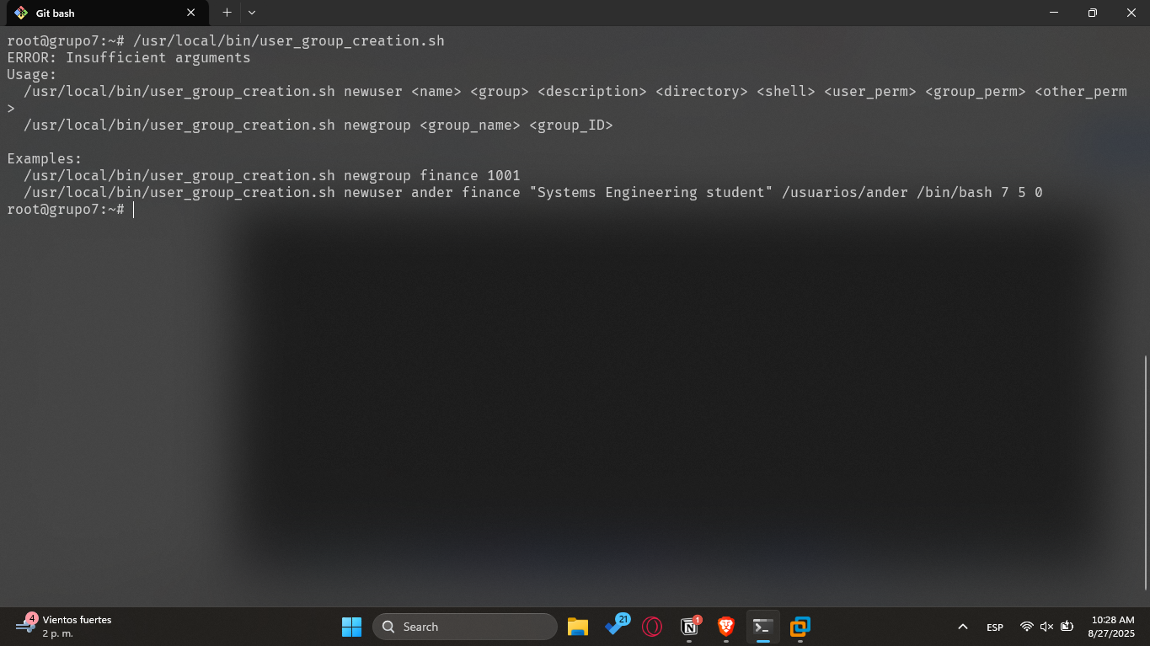

* **Tests:**

Make sure:

**chmod +x /usr/local/bin/user_group_creation.sh**

**mkdir -p /usuarios**

* 1. **Create groups**

/usr/local/bin/user_group_creation.sh newgroup finance 1001

/usr/local/bin/user_group_creation.sh newgroup business 1002

**Expected:** Confirm the group creation with commands: **grep finance /etc/group** and **grep /etc/group business.**

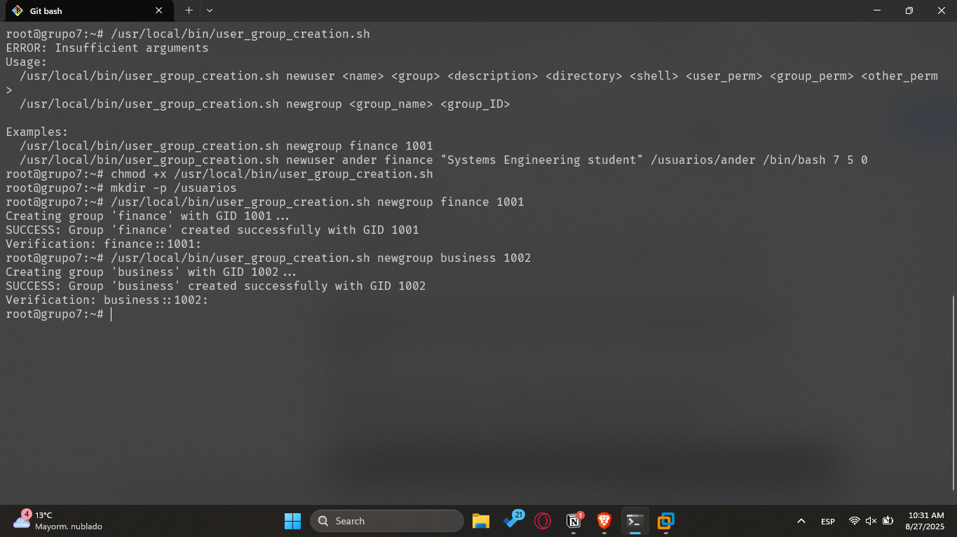

* 1. **Create ander user**

/usr/local/bin/user_group_creation.sh newuser ander finance "Systems Engineering student - AI enthusiast" /usuarios/ander /bin/bash 7 5 0

**Expected:** Andersson’s directory created, and confirm it with command **ls -ld /usuarios/ander**

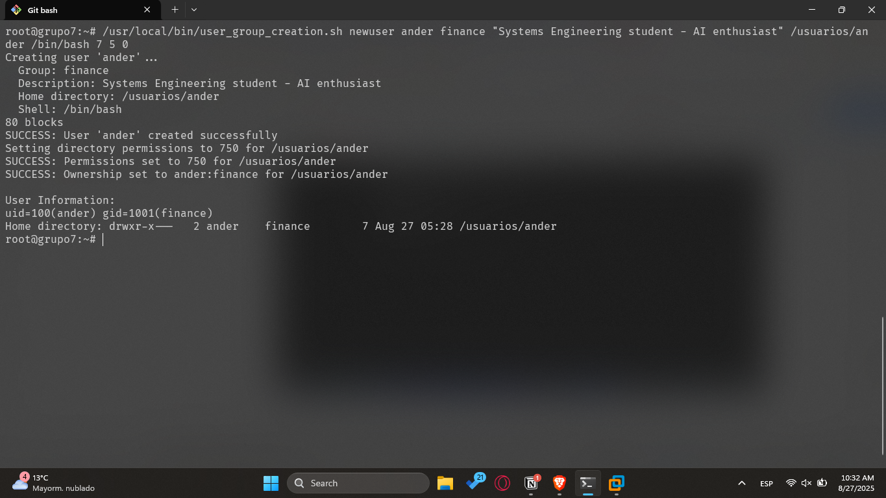

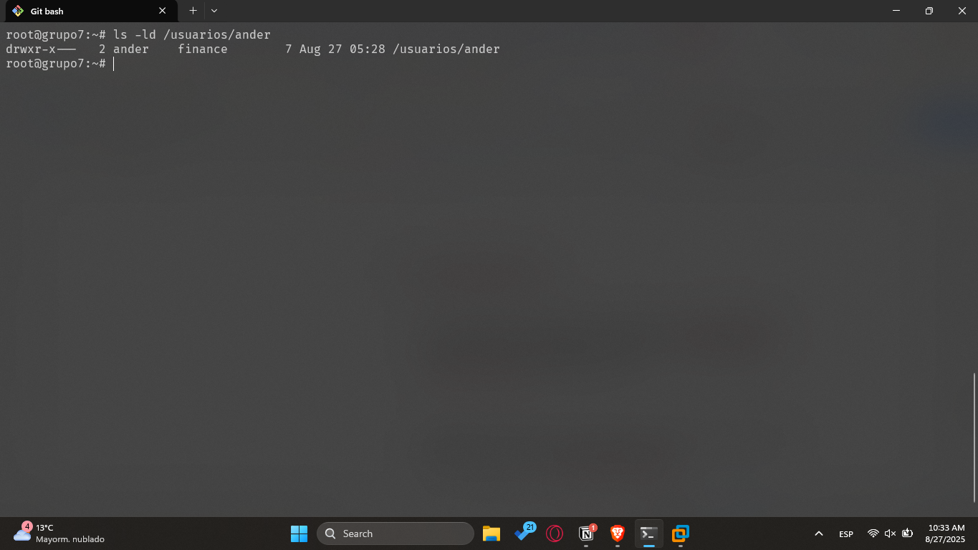

* 1. **Create Marie user in business group**

/usr/local/bin/user_group_creation.sh newuser marie business "IT Support Specialist - Database management" /usuarios/marie /bin/bash 7 5 0

**Expected:** User created with home /usuarios/elena with permissions 750

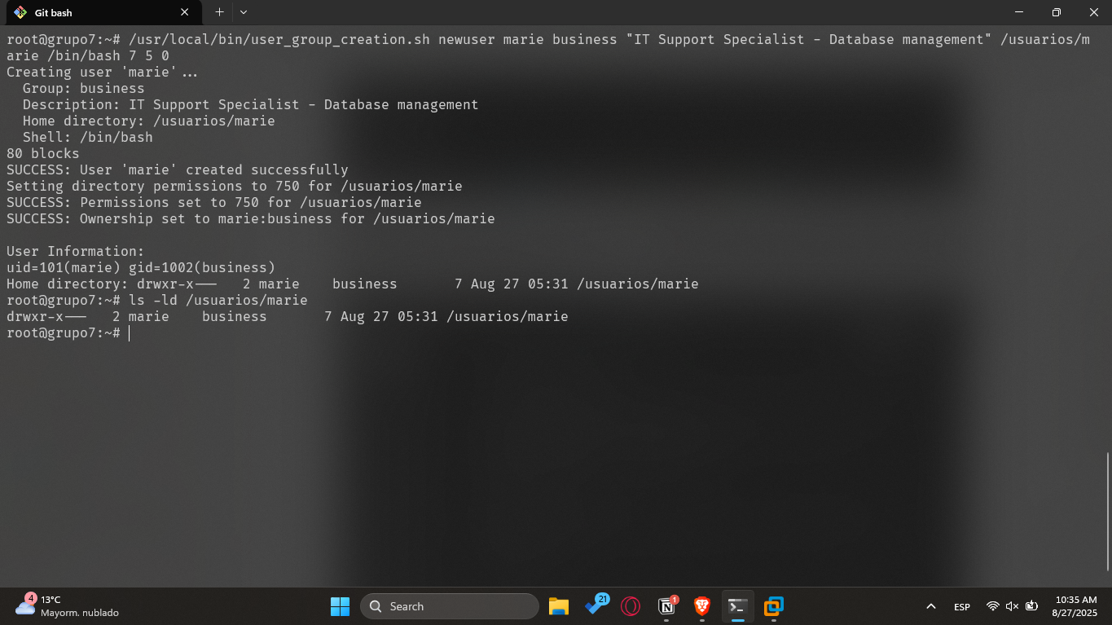

**NOTE**: Show your professor the execution of your programs.

## VI Editor in Linux/Unix

* **Use the VI editor to create a file. Indicate the commands used.**

We use the command **vi himno.txt** to open vi and create a file.

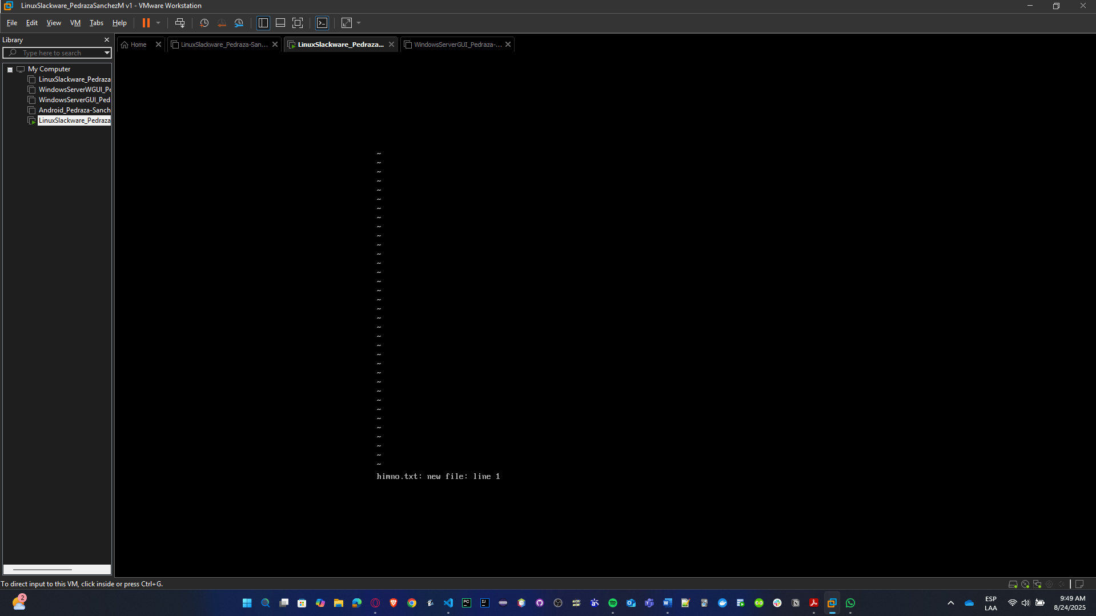

* **Type the following text and document the commands used. Note: Each line in the text should correspond to one line in the editor, meaning you must press ENTER at the end of each line.**

To enter Insert Mode and type the text inside vi, press: **i**

This puts you in *Insert mode*. Then type:

HIMNO DE LA ESCUELA

Press **ENTER** at the end of the line.  
(Each line you type, press ENTER at the end to start the next line.)

When done, press **ESC** to return to *Command mode*.

|  |
| --- |
| HIMNO DE LA ESCUELA |

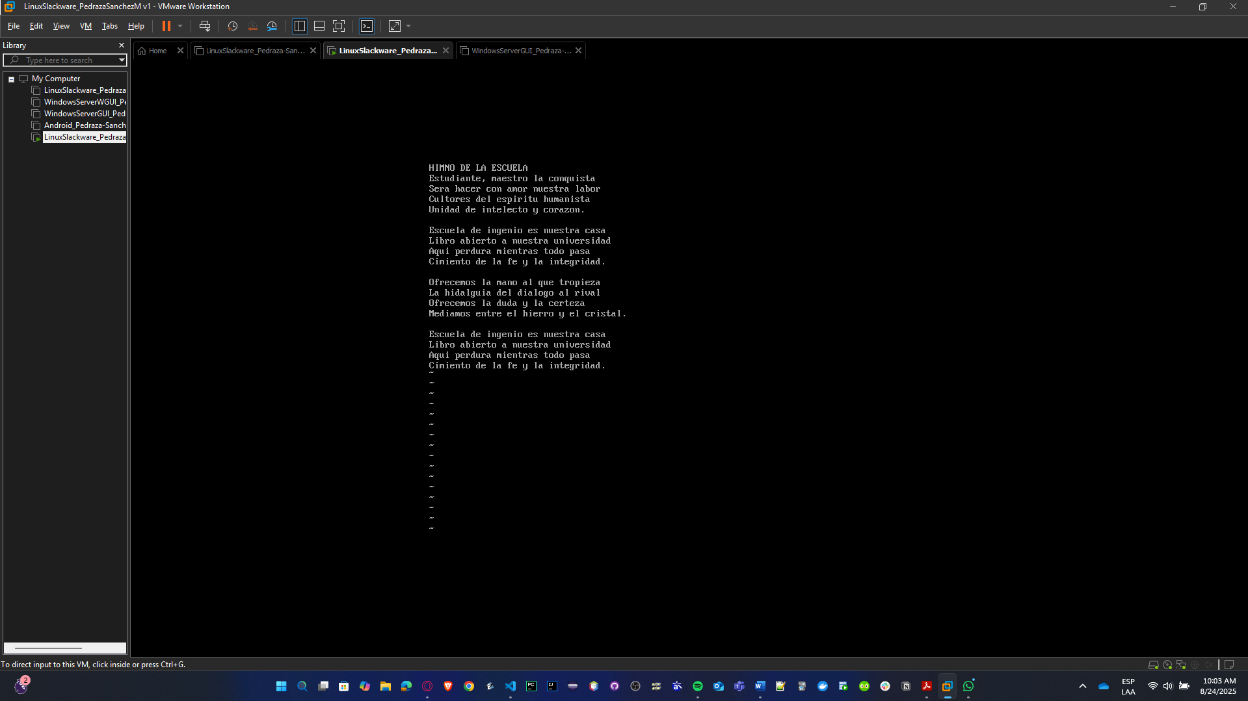

* **Save the work without exiting the editor**

Use the command **:w**

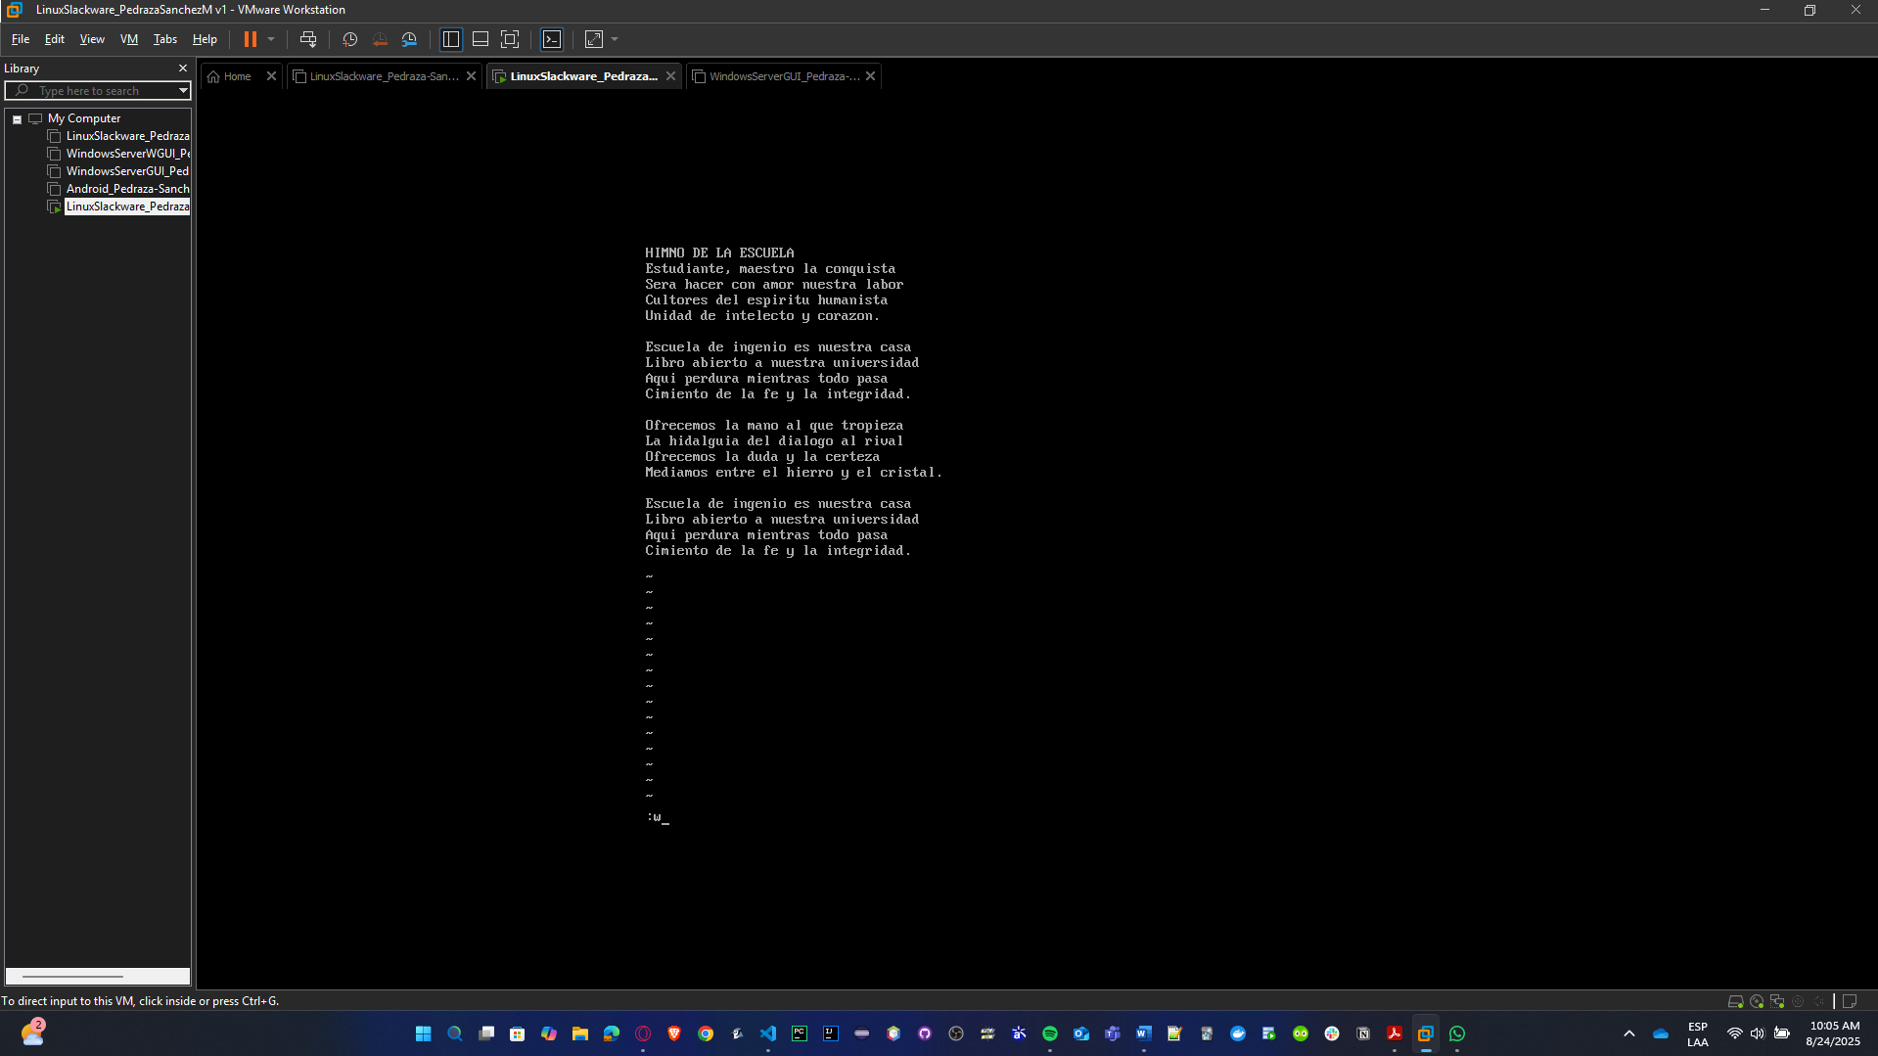

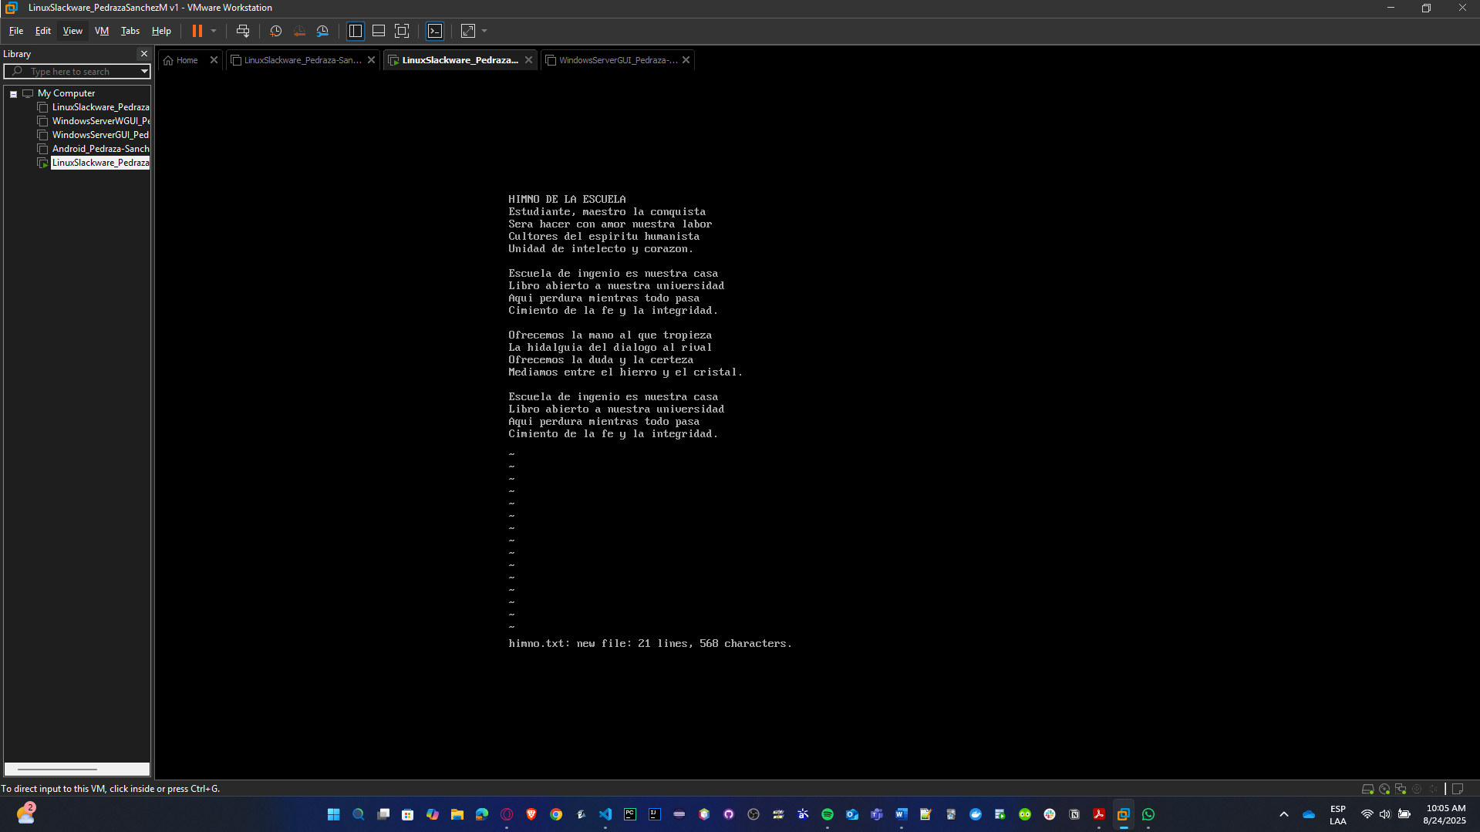

* **Replace all the 'a' characters in the first paragraph with a hyphen (-).**

Use the command **:1,5s/a/-/g**

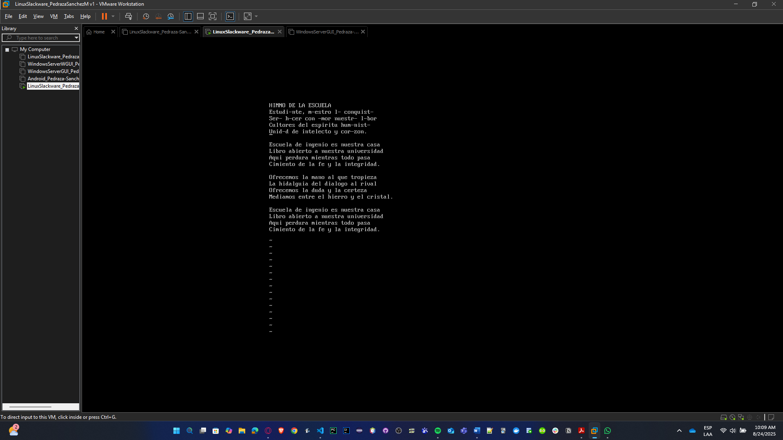

* **Replace all instances of the word "al" in the entire text with the symbol ##.**

Use the command **:%s/al/##/g**

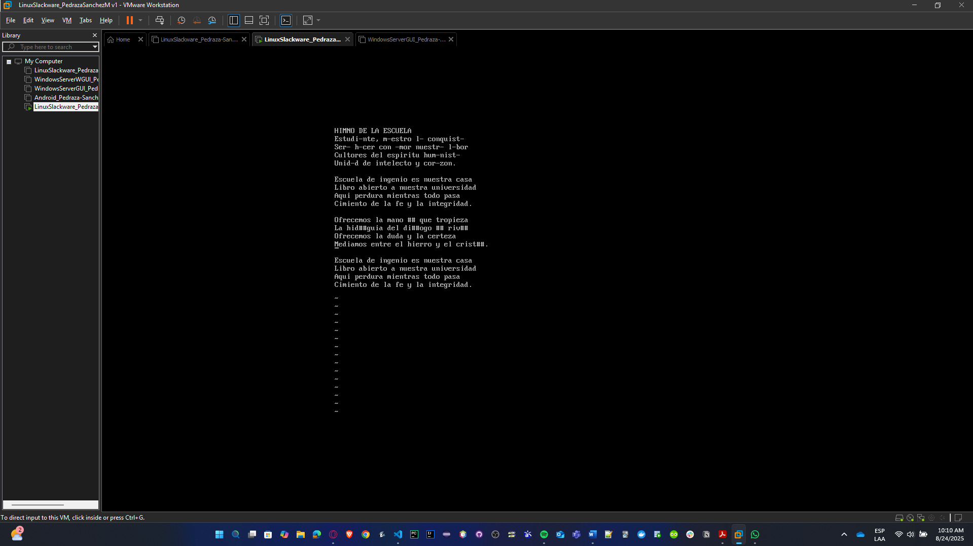

* **What command can be used to delete a word in VI?**

In command mode, position cursor over the word and type: **dw**

* **Delete the last 4 lines of the document with a single command.**

Use the command **:.-3,$d**

From the current line (.) minus 3 to the last line ($), delete.  
If you are at the last line, it deletes the last 4.

Alternative simpler **:$-3,$d**

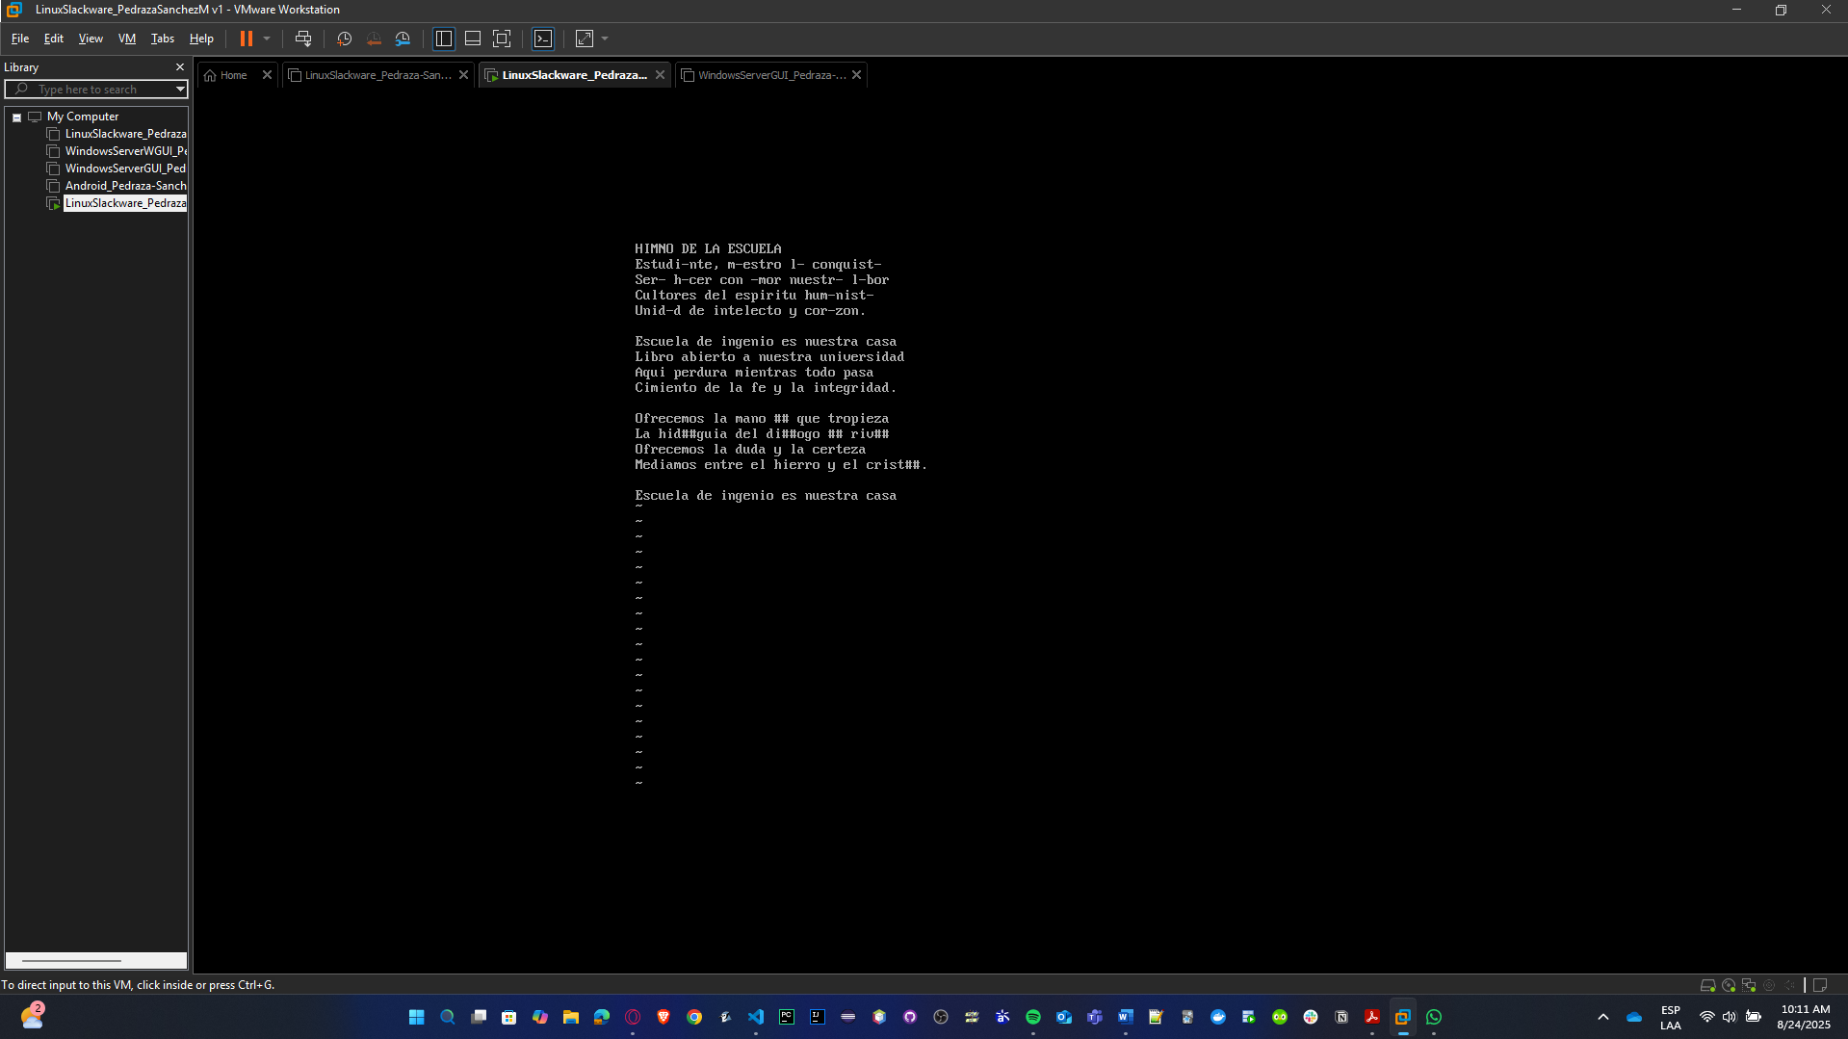

* **Undo the previous command.**

Use the command **u**

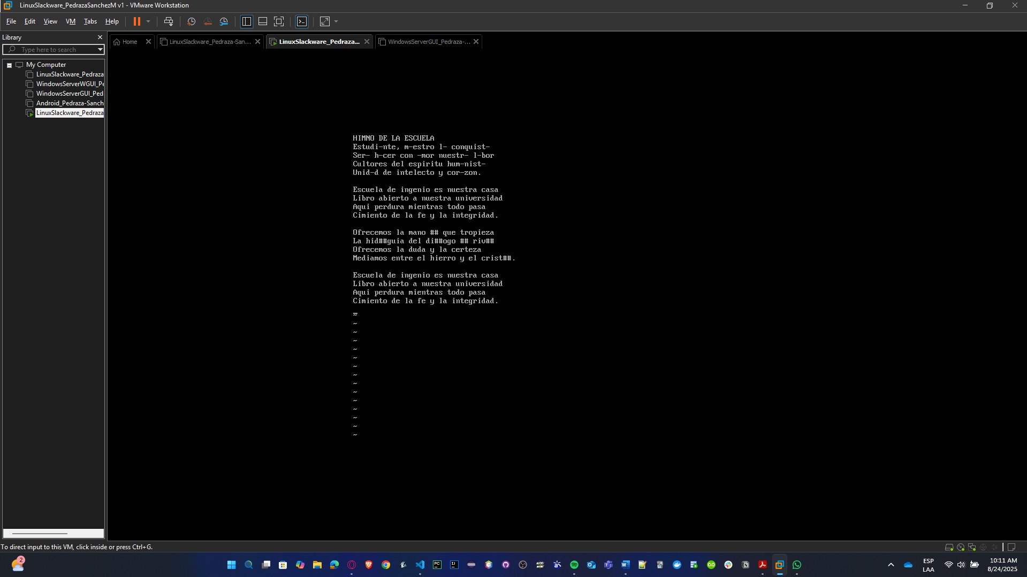

* **Change the last line of the document to uppercase.**

Use the command **:$!tr ‘a-z’ ‘A-Z’**

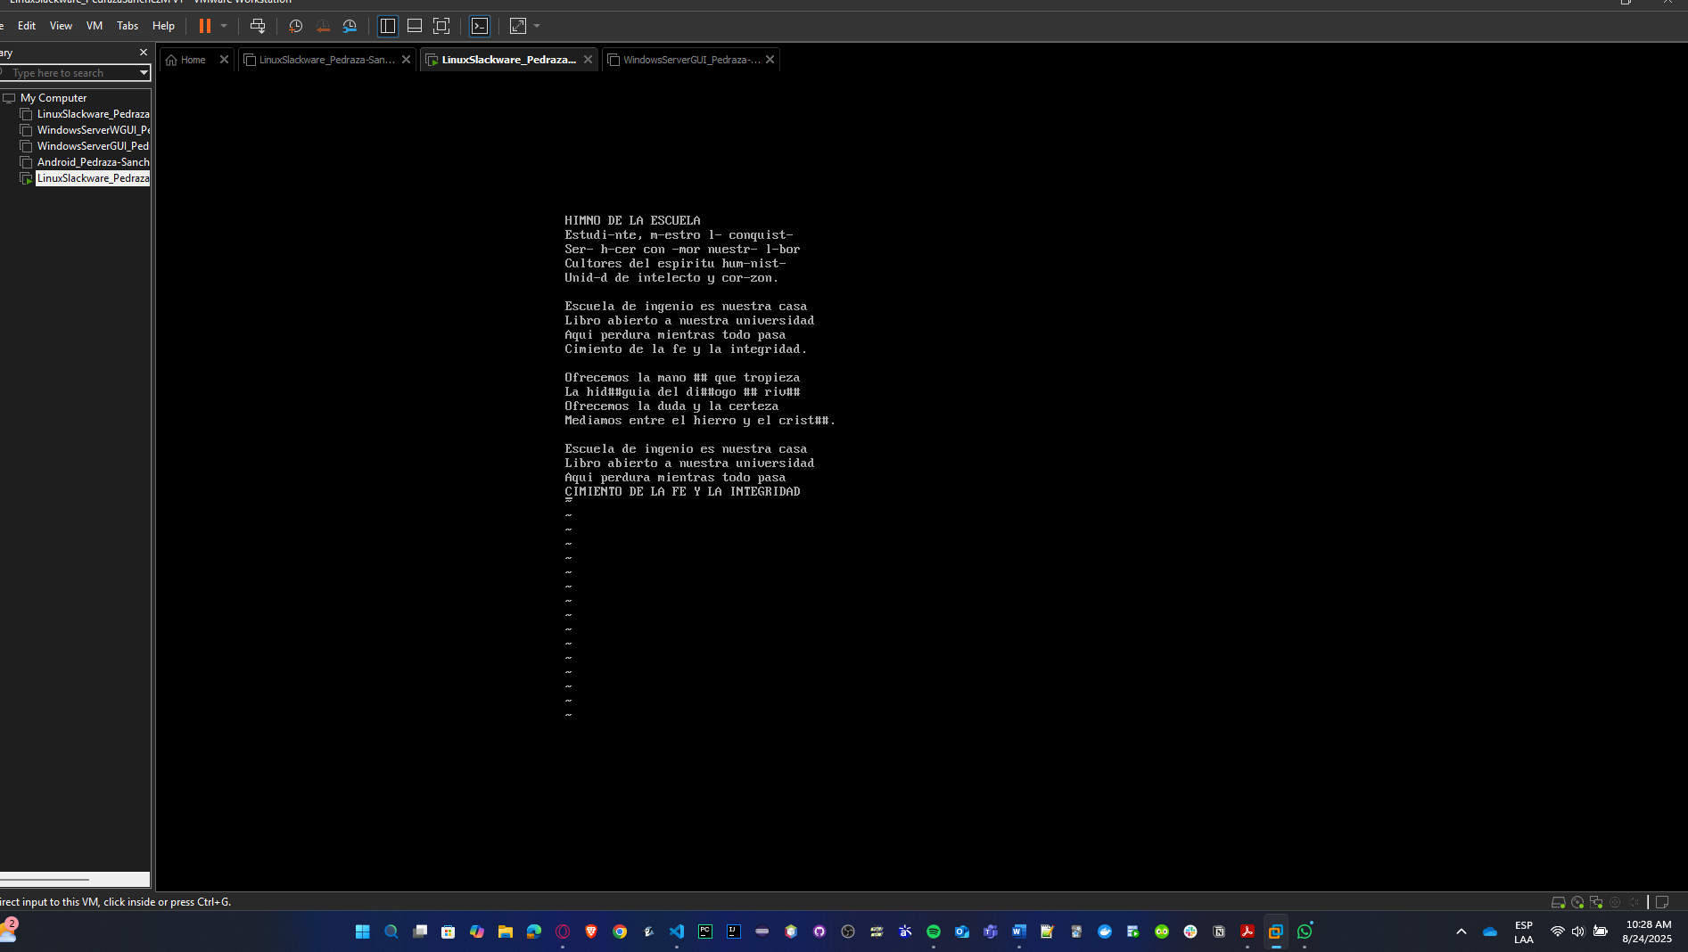

* **Copy the last 2 lines of the second paragraph to the end of the file.**

Second paragraph is lines 7–10 → copy lines 9–10 to the end **:9,10t$**

(t$ = copy to end of file)

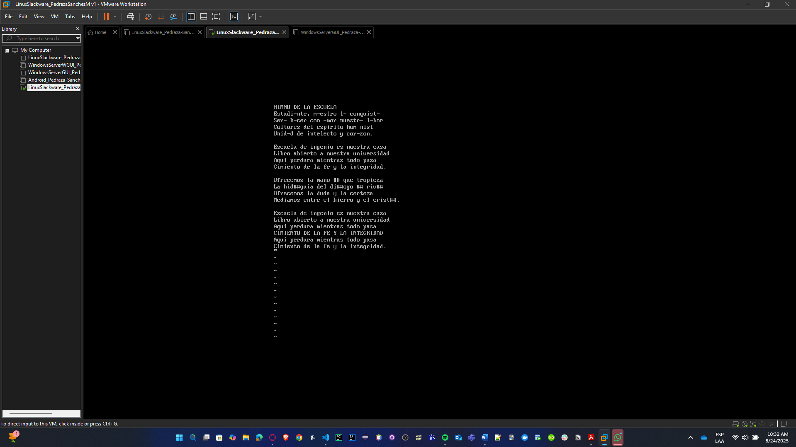

* **Search for the word "Escuela" within the text.**

Use the command **g/Escuela/p**

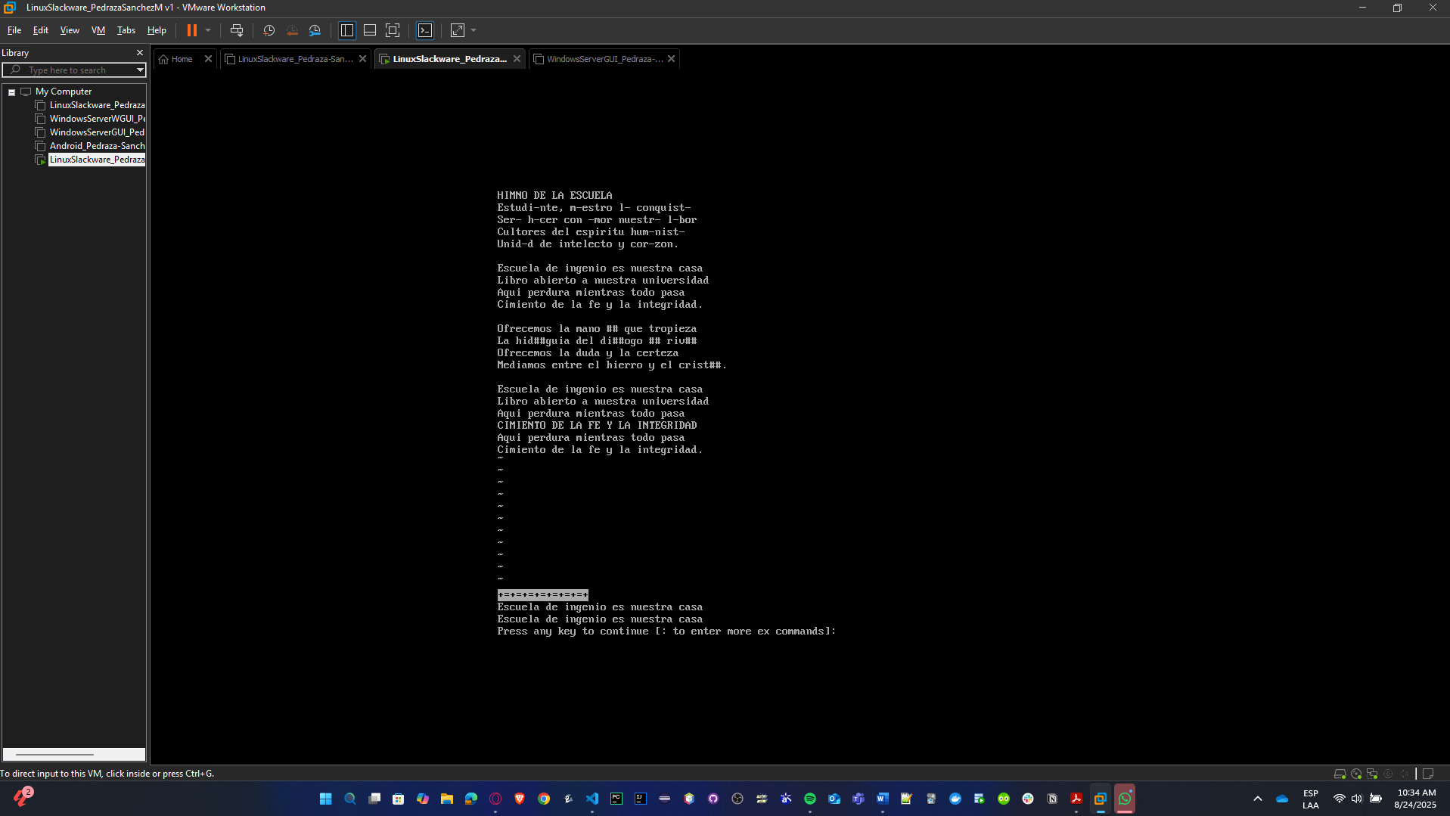

* **Go to line 5 using a command.**

Use the command **:5**

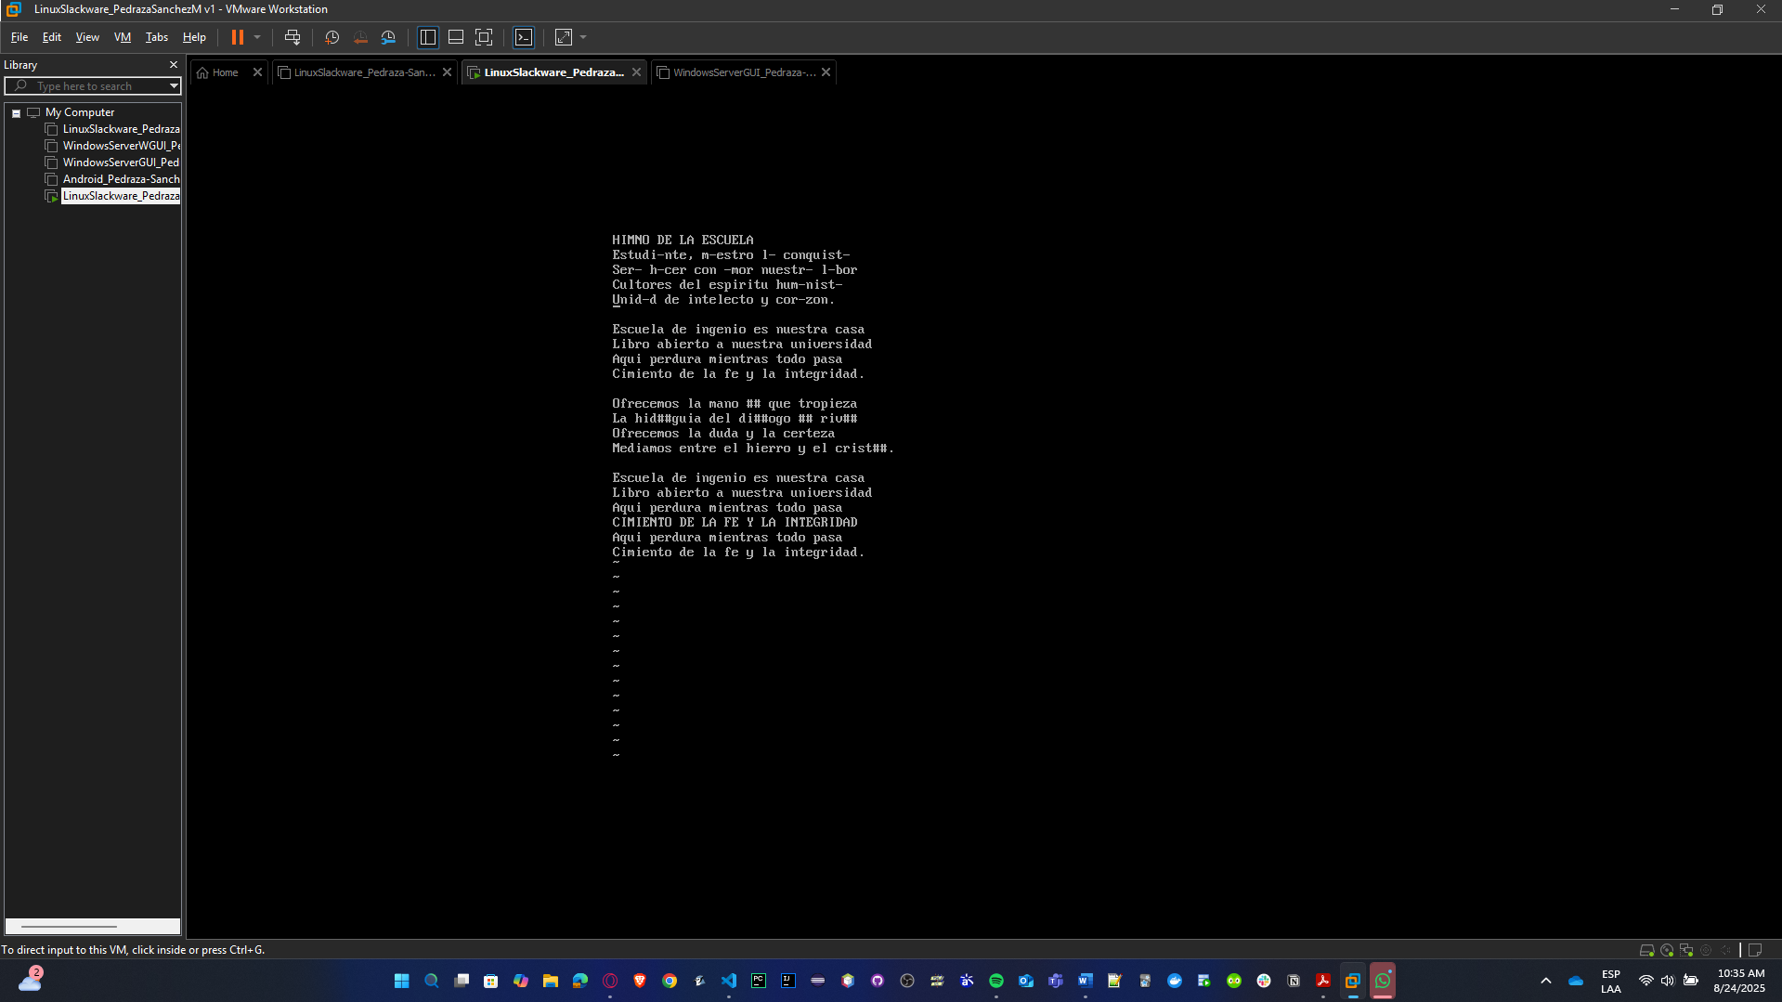

* **Create a summary box with common VI commands.**

| **Action** | **Command** |
| --- | --- |
| Insert mode | i |
| Save | :w |
| Save & quit | :wq |
| Quit without saving | :q! |
| Delete word | dw |
| Delete line | dd |
| Undo | u |
| Redo | Ctrl + r |
| Copy (yank) line | yy |
| Paste | p |
| Replace char under cursor | r<char> |
| Search forward | /word |
| Go to line N | :N |
| Uppercase whole line | gUU |

* **Save the work and exit the editor.**

Use the command **:wq**

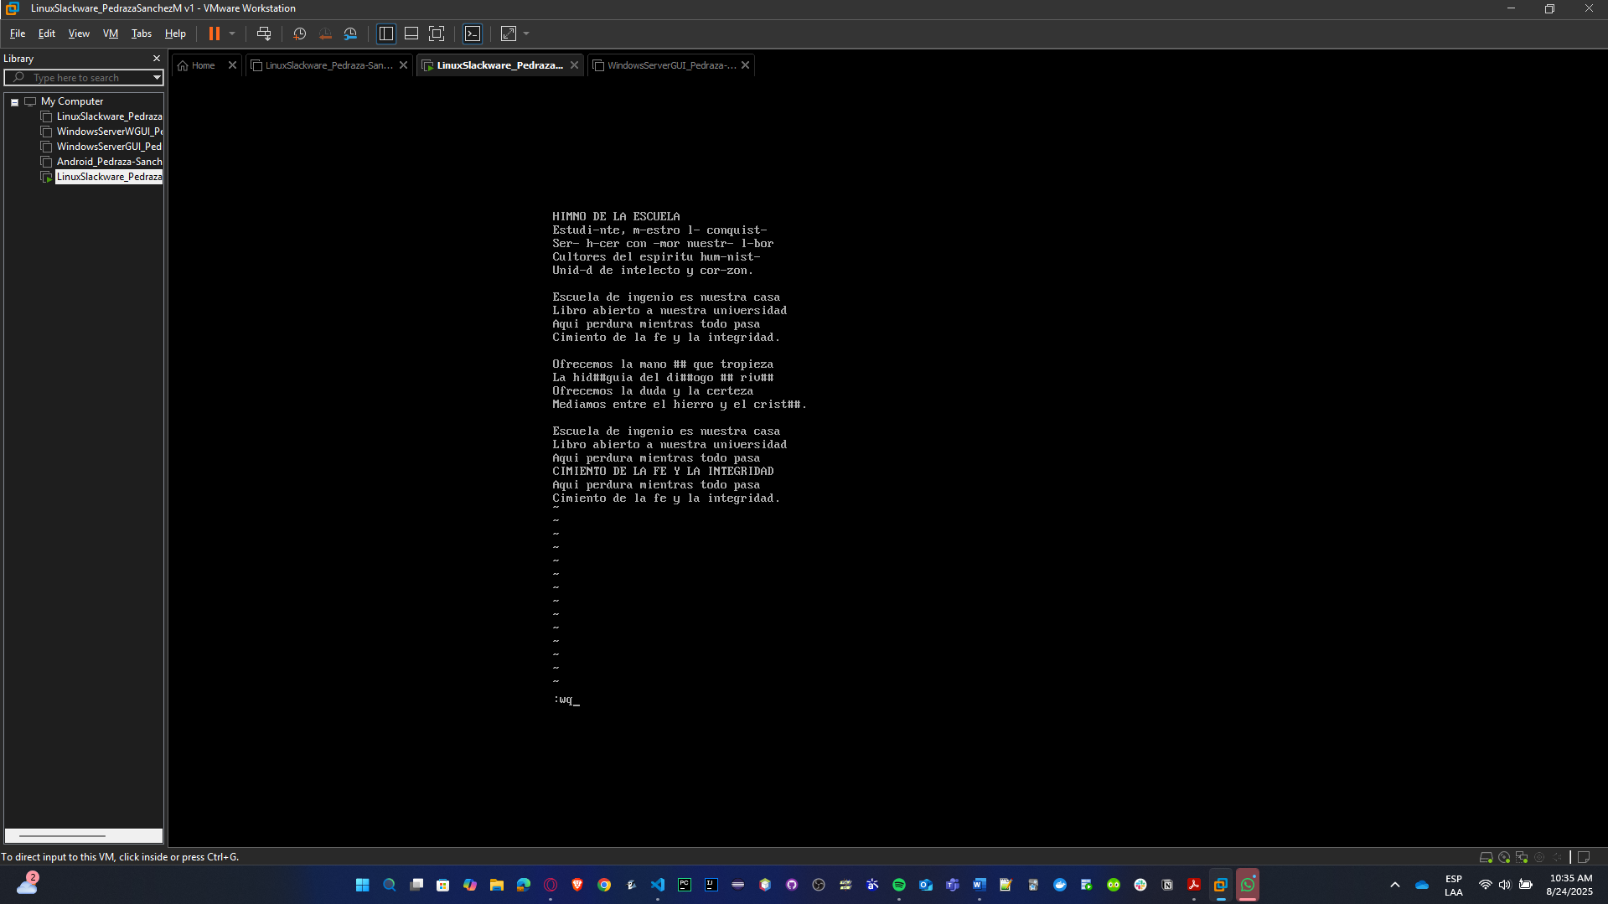

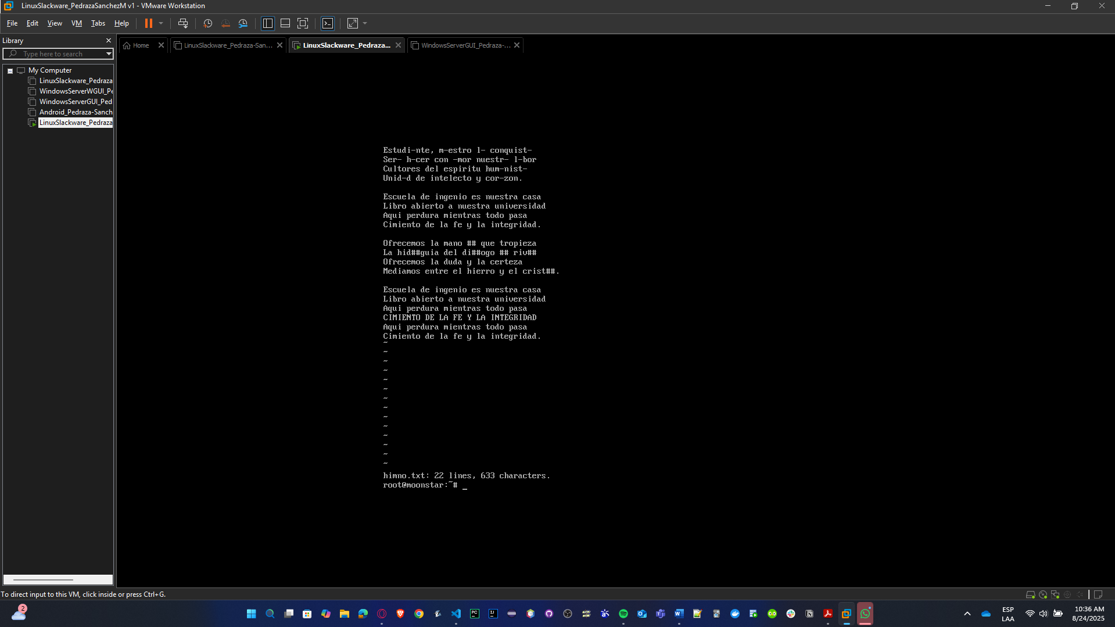

* **Re-enter and delete the first 5 lines.**

Use the command **vi himno.txt**

Inside vi **:1,5d**

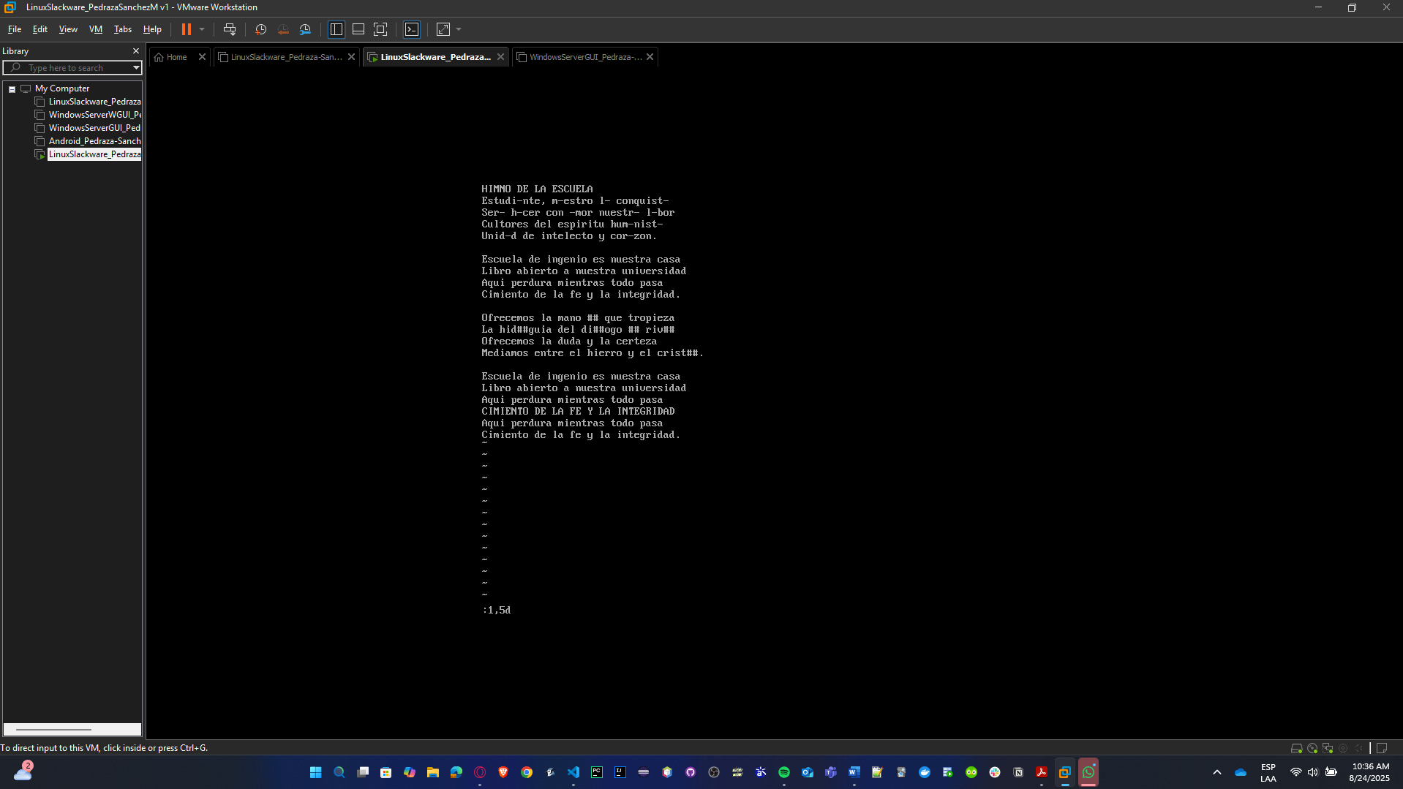

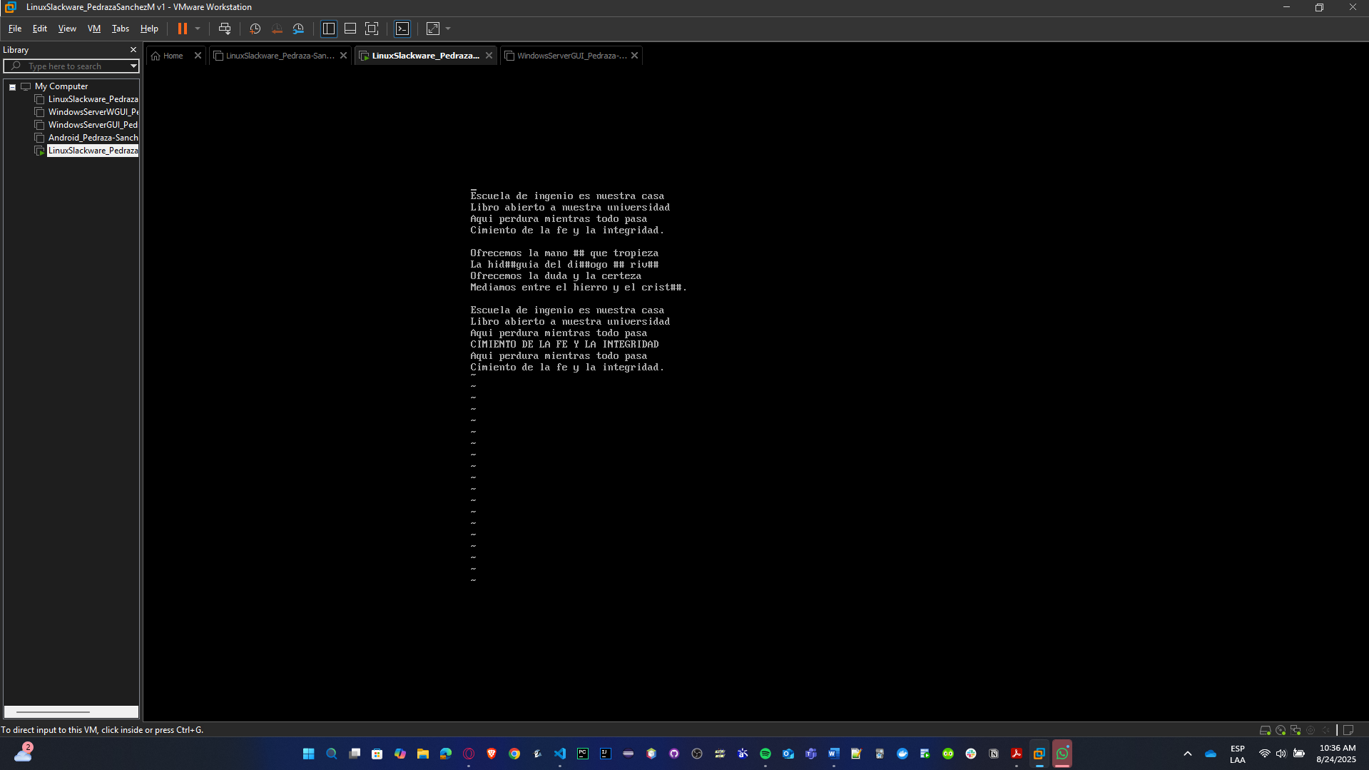

* **Exit the file without saving.**

Use the command **:q!**

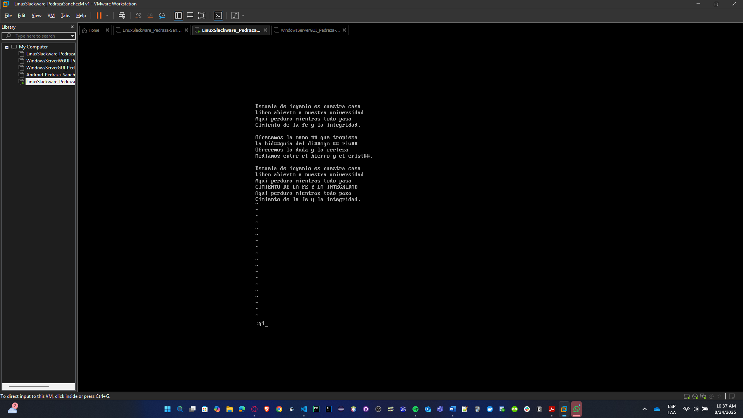

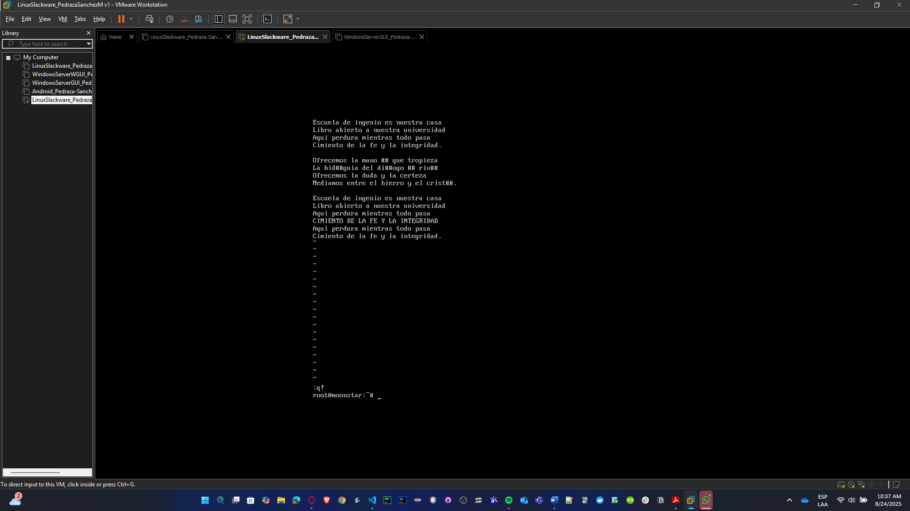

## Machine Generation

For the semester project, you will need 2 virtual machines of each installed operating system, except for Windows Server without GUI and Android. Generate the new machines and verify that they can see each other and access the internet.

**Tests to verify the new VMs are correctly generated with access to Internet**

**SLACKWARE with IP 10.2.77.176:**

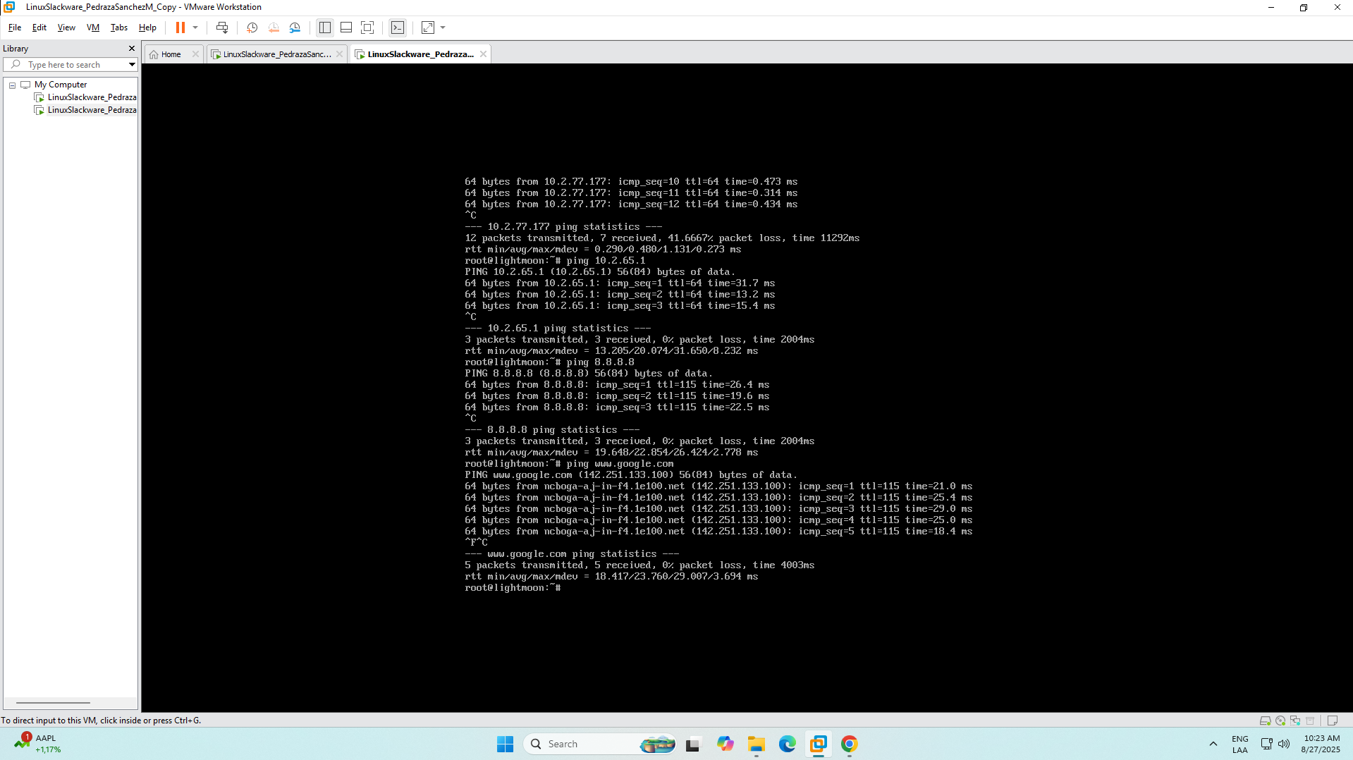

**SOLARIS with IP 10.2.77.178:**

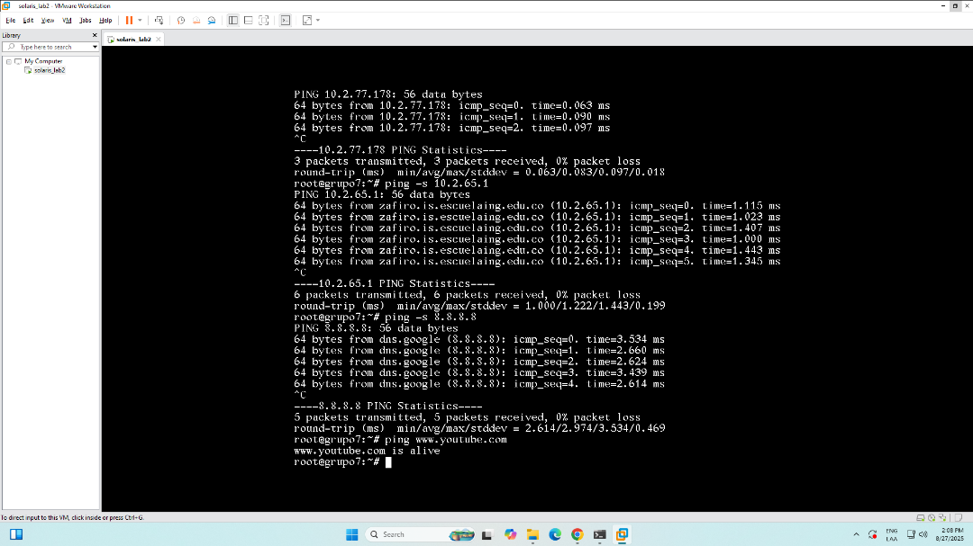

**WINDOWS SERVER WITH GUI with IP 10.2.77.182:**

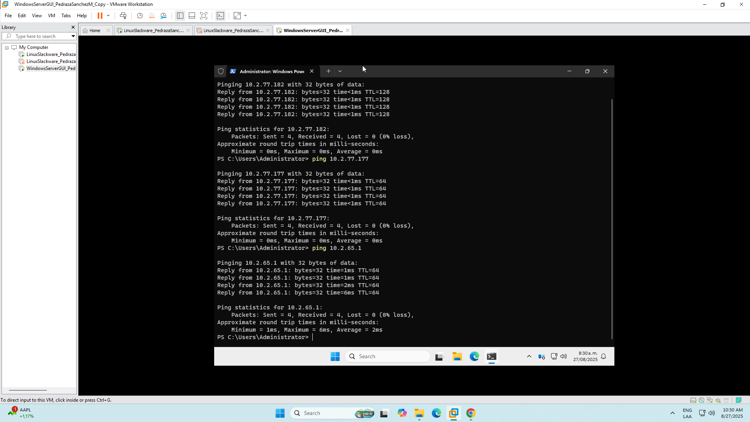

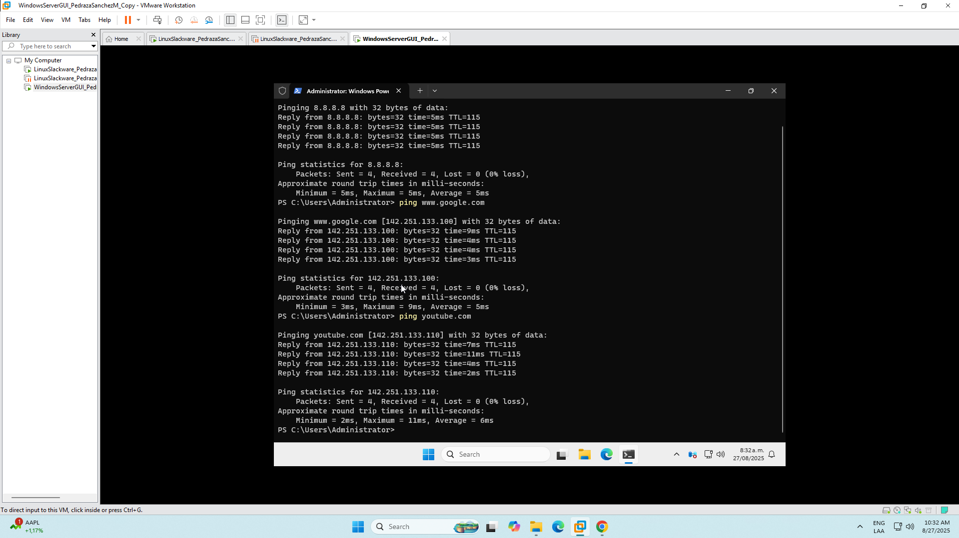

## File Sharing

One of the key services in an enterprise environment is shared file systems, where employees can save and share files with their workgroup. using SMB/Samba, enabling file sharing between the three operating systems (Linux Slackware, Solaris, Windows, and CentOS for groups of 3 students).

**It’s important to know in a more detailed way what’s Samba and what’s their characteristics:**

Samba is an open-source software suite that implements the SMB/CIFS protocol family — the same file-and-printer sharing protocol that Windows uses. In practical terms, Samba lets your Linux machine behave like a Windows file server: Windows, Linux and Solaris clients can mount shares, list folders, and read/write files with user authentication and file permissions.

As the key characteristics we can mention:

* **Protocol bridge:** Samba speaks SMB/CIFS (Windows language) and maps it to POSIX files and users on the Unix side. That’s how a Windows PC sees a Linux folder as a network drive.
* **Authentication modes:** It can authenticate users in several ways (local Samba user database, system users, or integrated with AD). For a lab, security = user with tdbsam is simplest and secure enough.
* **Permissions mapping:** Samba respects Unix file ownership and permissions; you control access with Unix groups and file modes. Samba can also force a group on created files to keep collaboration clean.
* **SMB versions:** Modern Samba supports SMB2/SMB3. Avoid SMB1 unless forced by legacy clients — SMB1 is insecure.
* **Services involved:** smbd serves files/printers; nmbd handles NetBIOS name resolution (only needed for legacy browsing); winbind is used for AD integration (not needed for a simple lab).
* **Logs & debugging:** Samba writes per-client logs (you can raise log level to debug problems). testparm checks smb.conf syntax.

Now, we can detail the step-to-step SMB installation.

We will start with Samba installation in Solaris because it’ll be the way to share files in the other two VMs, so Slackware and Windows with GUI are clients that can see Solaris files.

**0 — Preconditions & notes**

* You need **root** privileges.
* Pick a server IP or hostname and make sure clients can reach it (ping <IP>).
* It’s recommended to use ssh service to connect the VM because of the need to not copy manually the commands, just as simple as copy and paste.

**1 — SSH Service Installation (mentioned before depending on the VM)**

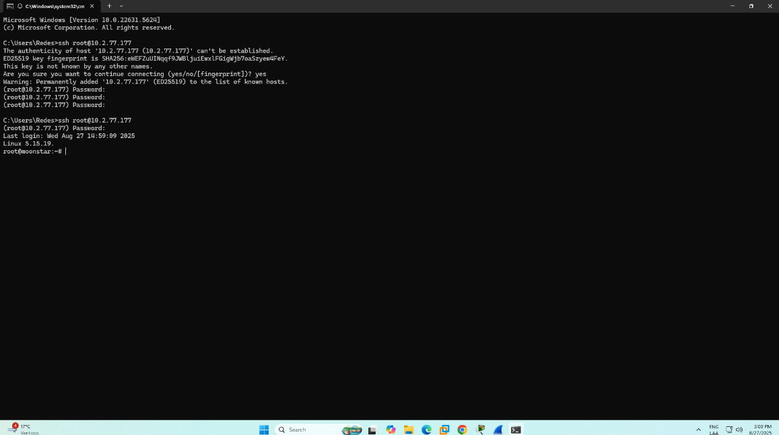

**2 — Install Samba package in Solaris**

1. **Install Samba on Solaris**

First, we must check if Samba is already installed:

pkg list samba *# or*   
 pkginfo | grep -i samba

If not installed, install it:

pkg install samba

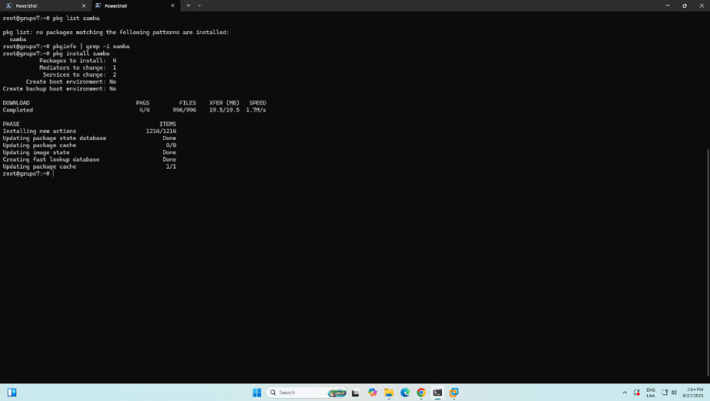

1. **Create Shared Directory**

Create a directory to share:

sudo mkdir -p /export/shared

sudo chmod 755 /export/shared

sudo chown nobody:nobody /export/shared

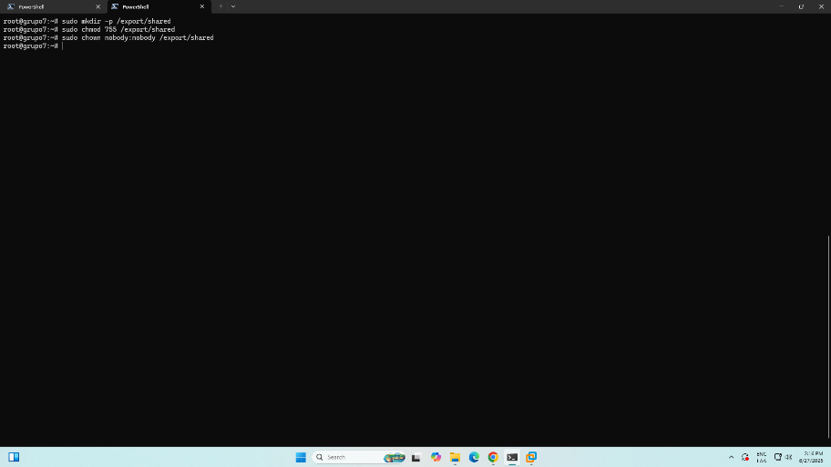

1. **Configure Samba**

Edit the Samba configuration file (you can use vi editor or nano or cat):

[global]

workgroup = WORKGROUP

server string = Solaris Samba Server

security = user

map to guest = bad user

dns proxy = no

[shared]

path = /export/shared

browseable = yes

writable = yes

guest ok = yes

read only = no

create mask = 0777

directory mask = 0777

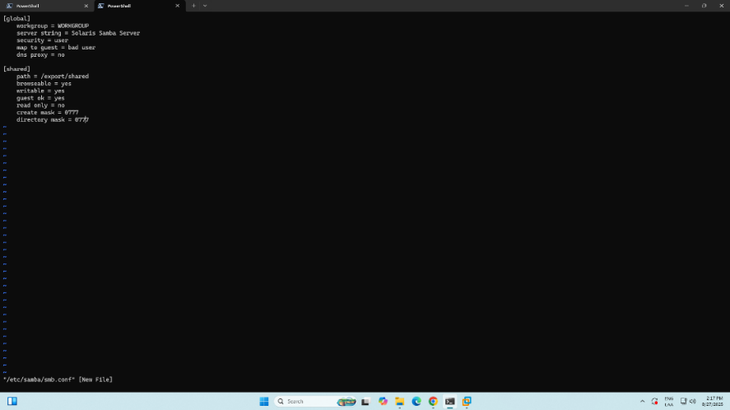

1. **Create Samba Users**

Add system users and Samba users:

# Create a system user

sudo useradd -m smbuser

# Add user to Samba

sudo smbpasswd -a smbuser

# Enter password when prompted

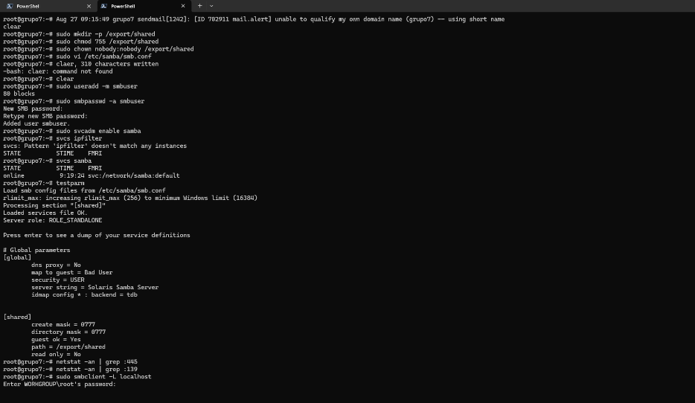

1. **Start Samba Services**

Enable and start Samba services:

# For Solaris 11

sudo svcadm enable samba

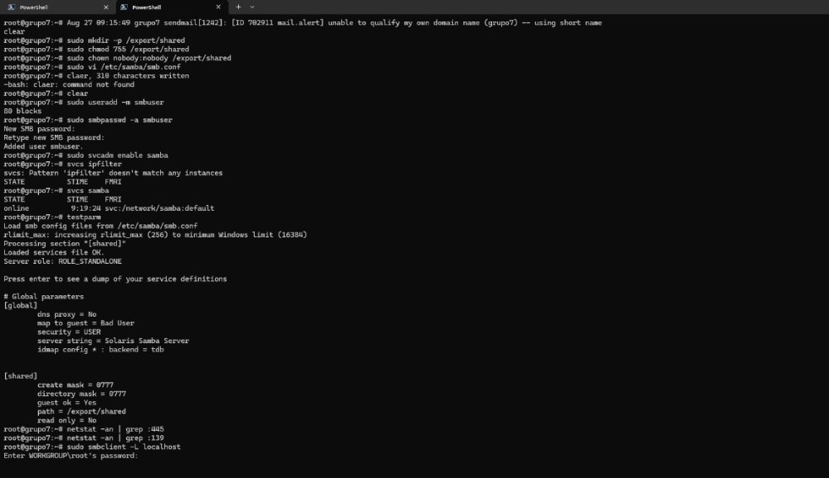

1. **Configure firewall**

For this case, it’s not necessary to open ports to run the firewall

1. **Test the Configuration**

Check if Samba is running:

sudo smbclient -L localhost

testparm # Test configuration file

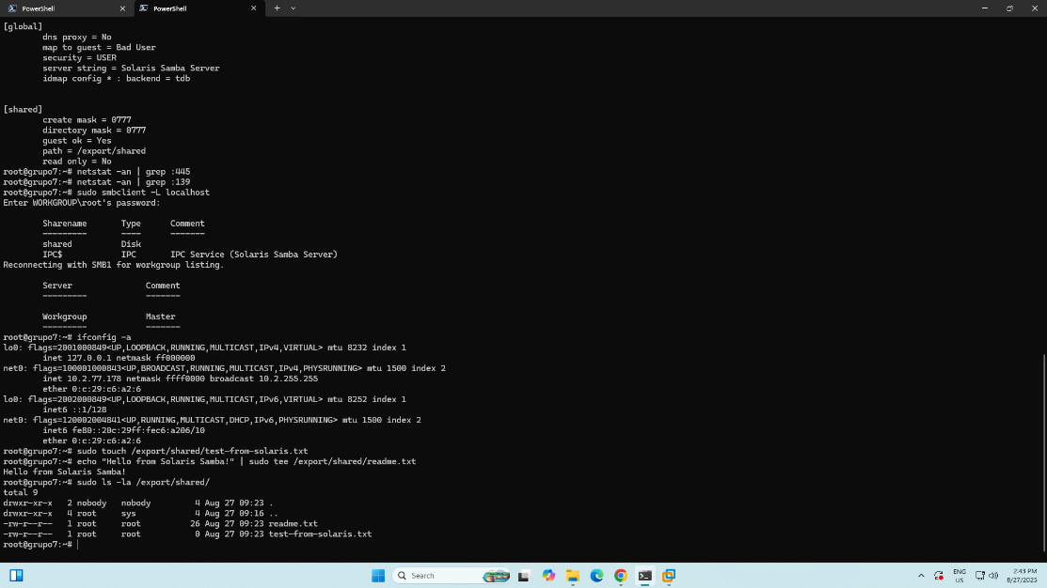

1. **Troubleshooting**

If you have issues:

# Check Samba status

svcs -xv samba

# Check logs

tail -f /var/samba/log/smbd.log

# Check network configuration

ifconfig -a

netstat -an | grep :445

# Check if Samba processes are running

ps -ef | grep smbd

ps -ef | grep nmbd

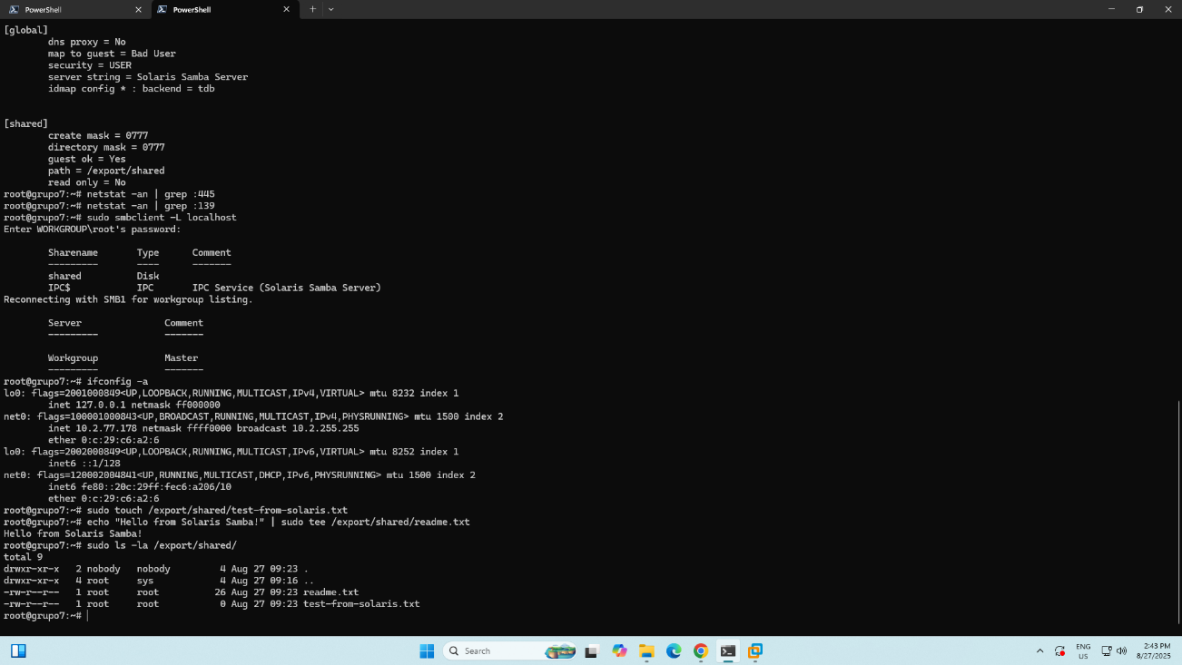

1. **Quick Test Files**

Create some test files in the shared directory:

sudo touch /export/shared/test-from-solaris.txt

echo "Hello from Solaris!" | sudo tee /export/shared/readme.txt

sudo ls -la /export/shared/

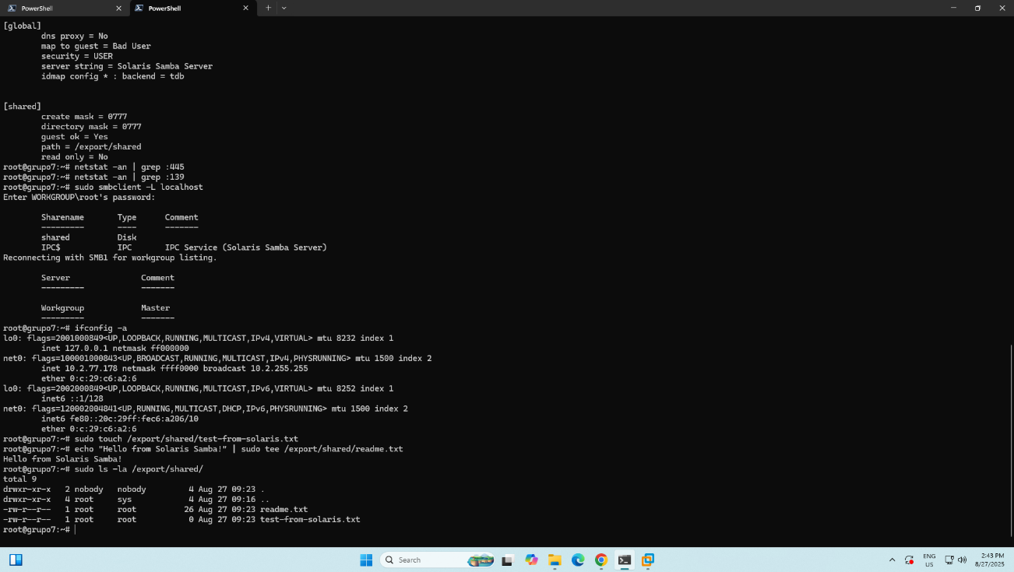

**3 — Install Samba package in Slackware to see the Solaris shared folder**

1. **Update and install samba package:**

slackpkg update

slackpkg install samba

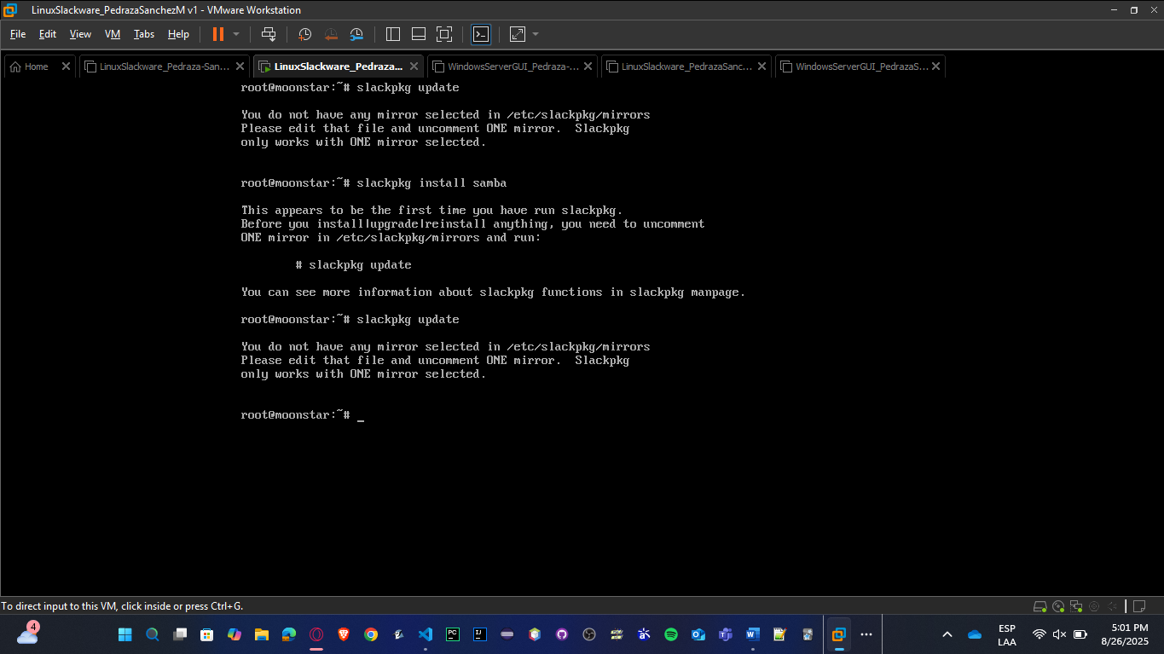

You need to solve a problem related to the lack of mirror selected in /etc/slackpkg/mirrors, so you must uncomment one URL to install samba; this is the process to do:

* **Edit the mirrors file**

nano /etc/slackpkg/mirrors

You’ll see a long list of mirrors grouped by version (Slackware 15.0, Slackware64 15.0, Slackware-current, etc.).

Now uncomment it (remove the # in **one** of them):

<http://mirrors.xmission.com/slackware/slackware-15.0/> USA Server

Save and exit (Ctrl+O, Enter, Ctrl+X in nano).

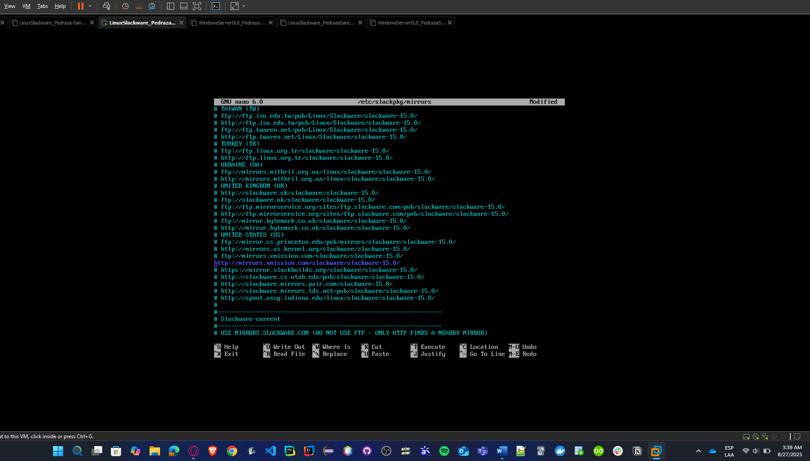

* **Skip GPG verification:**

# Check current GPG setting

grep CHECKGPG /etc/slackpkg/slackpkg.conf

# If it shows "on", disable it:

sudo sed -i 's/CHECKGPG=on/CHECKGPG=off/' /etc/slackpkg/slackpkg.conf

# Verify the change

grep CHECKGPG /etc/slackpkg/slackpkg.conf

* **Install diff command:**

# Look for diffutils package

slackpkg search diff

slackpkg install diffutils

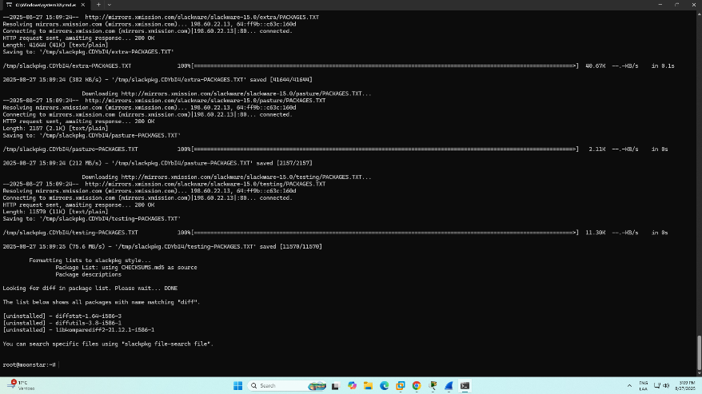

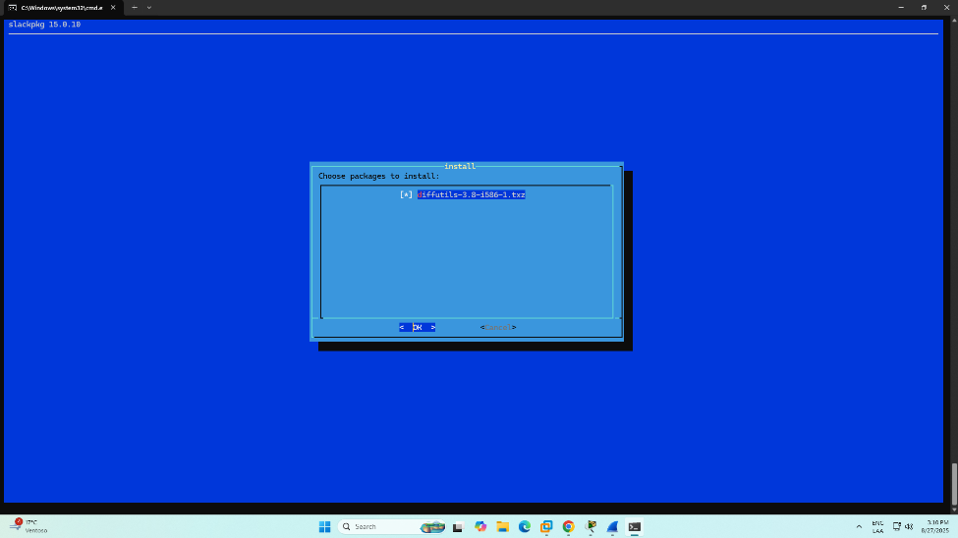

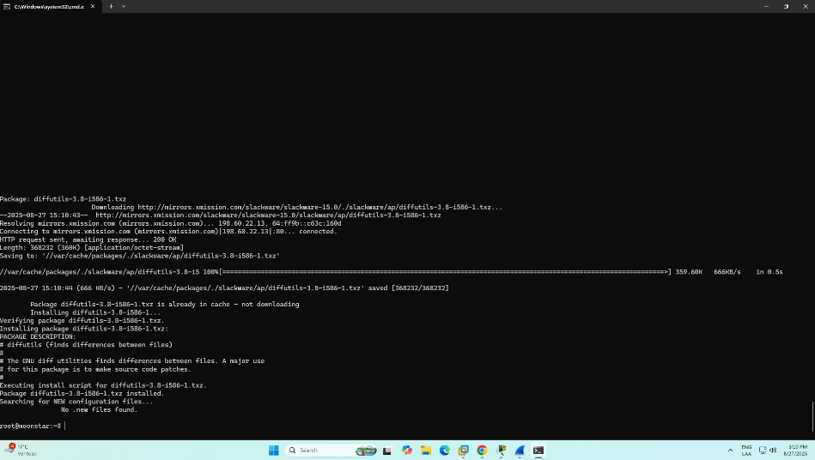

* Repeat the first two commands, and you will see everything is working now, so you can install samba package.

slackpkg update

slackpkg install samba

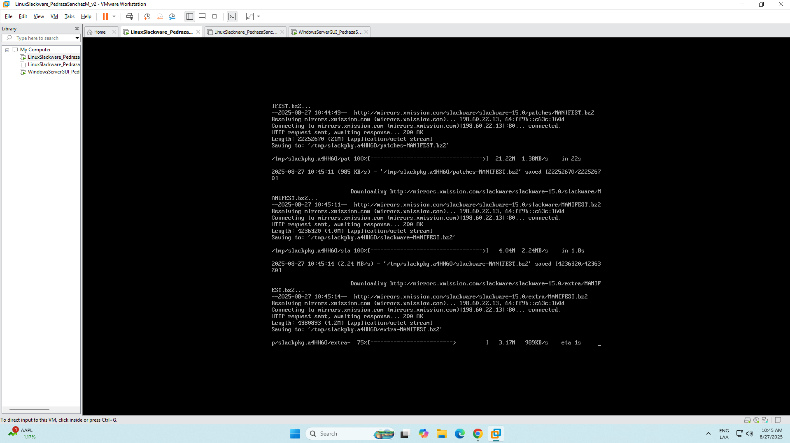

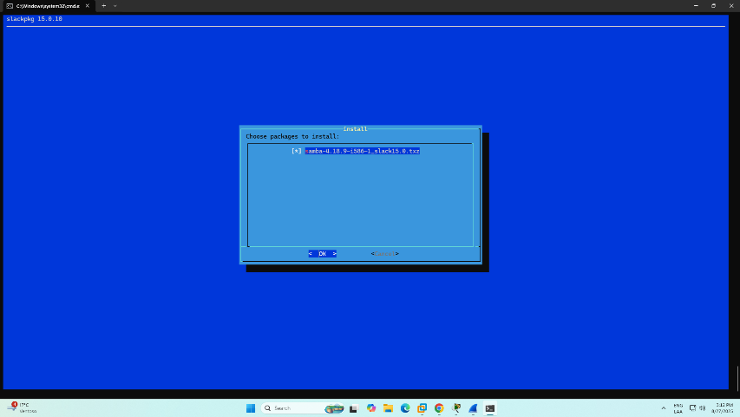

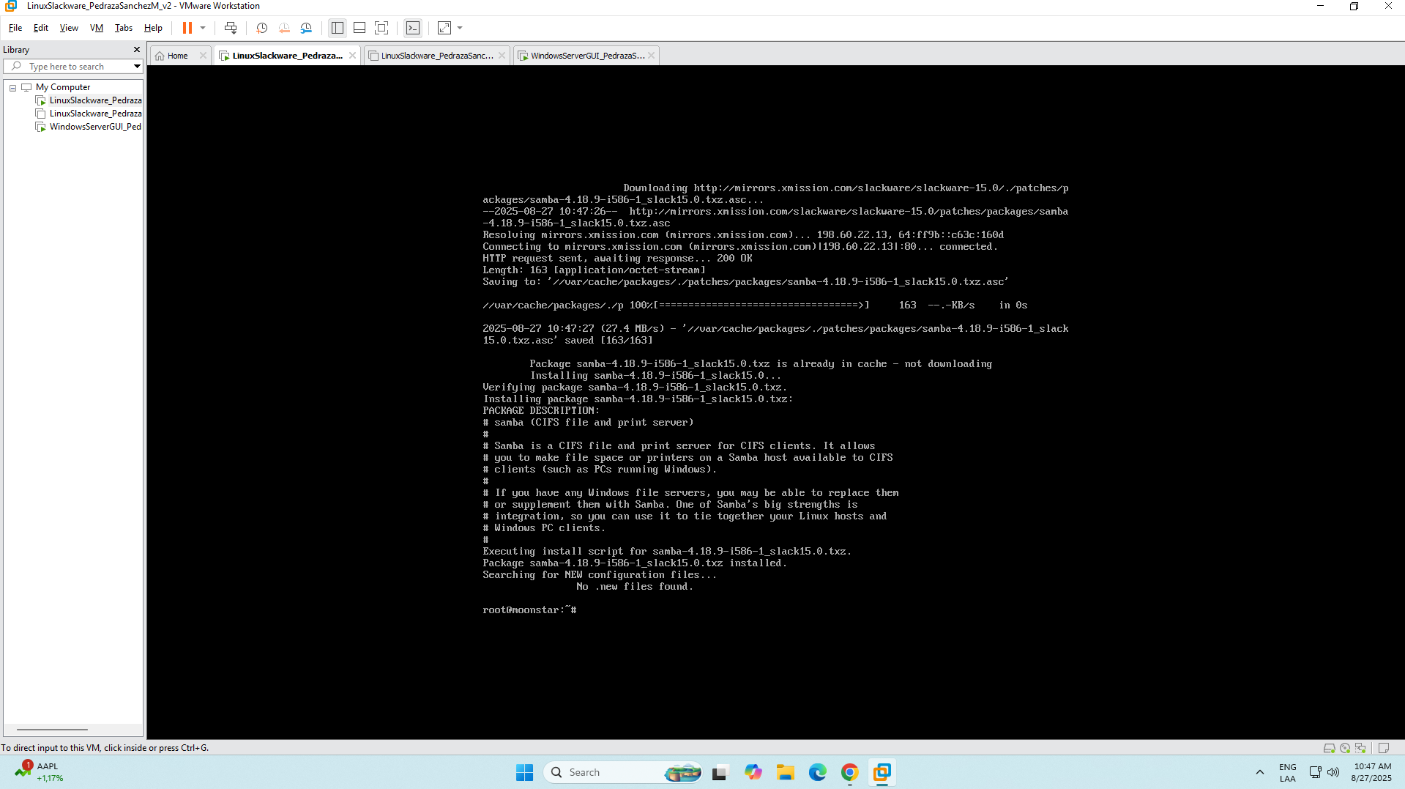

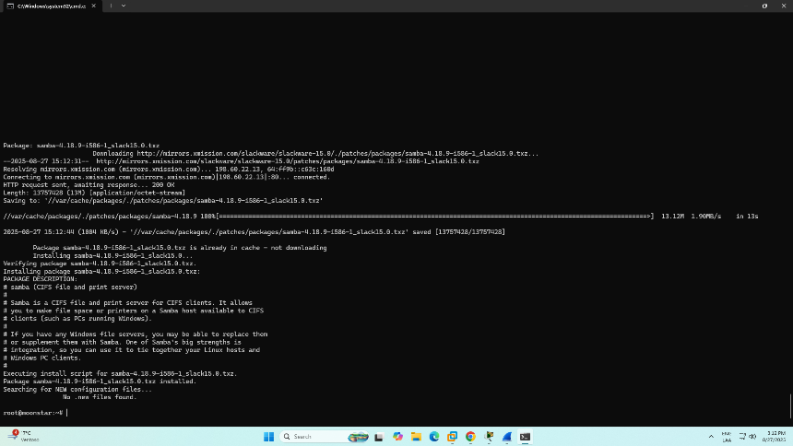

* Then verify:

smbd –version

1. **Install missing libraries to run command smbclient**

* **To know all missing libraries at once**

# Check what libraries smbclient needs

ldd /usr/bin/smbclient | grep "not found"

# Install ICU (International Components for Unicode)

slackpkg search icu

slackpkg install icu4c

* **After that, we will be able to know what libraries we need to install.**

# Search for libarchive packages

slackpkg search libarchive

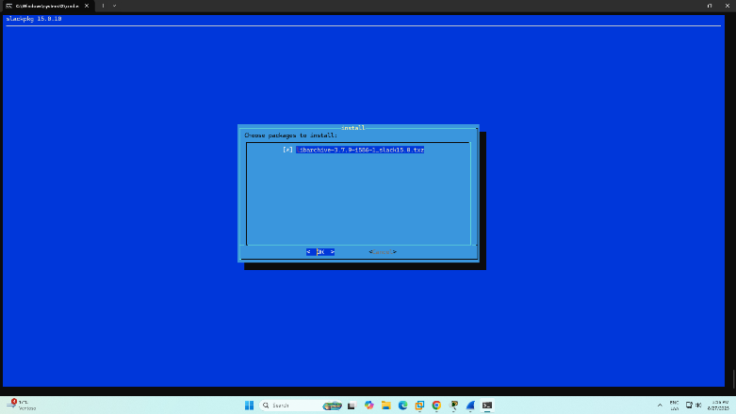

# Install libarchive

slackpkg install libarchive

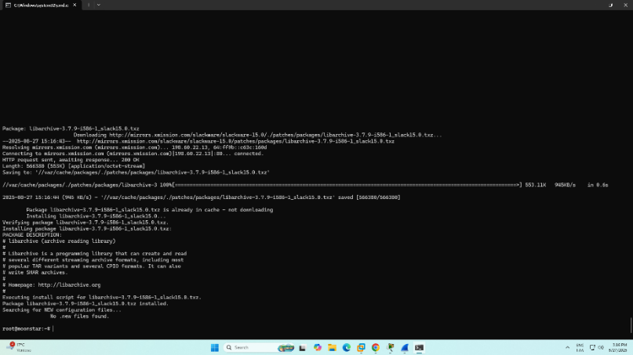

# Search for gnutls packages

slackpkg search gnutls

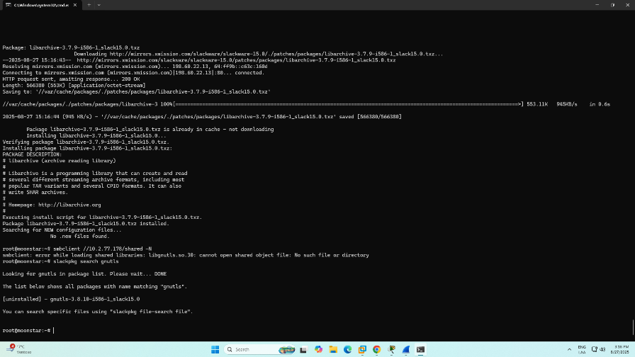

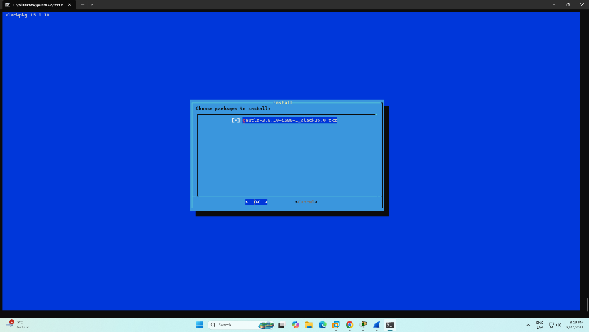

# Install gnutls

slackpkg install gnutls

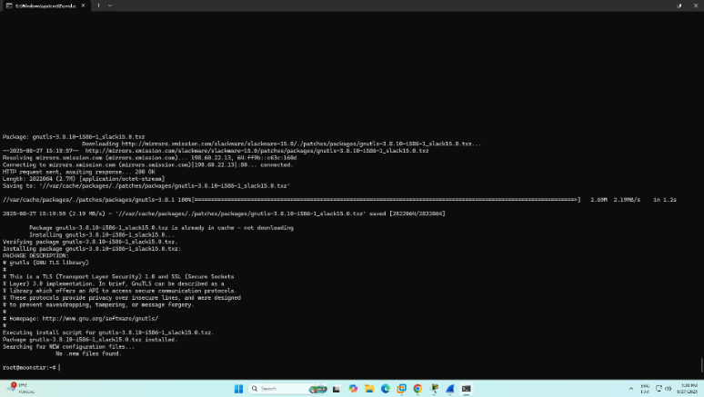

# Install ICU libraries

slackpkg install icu4c

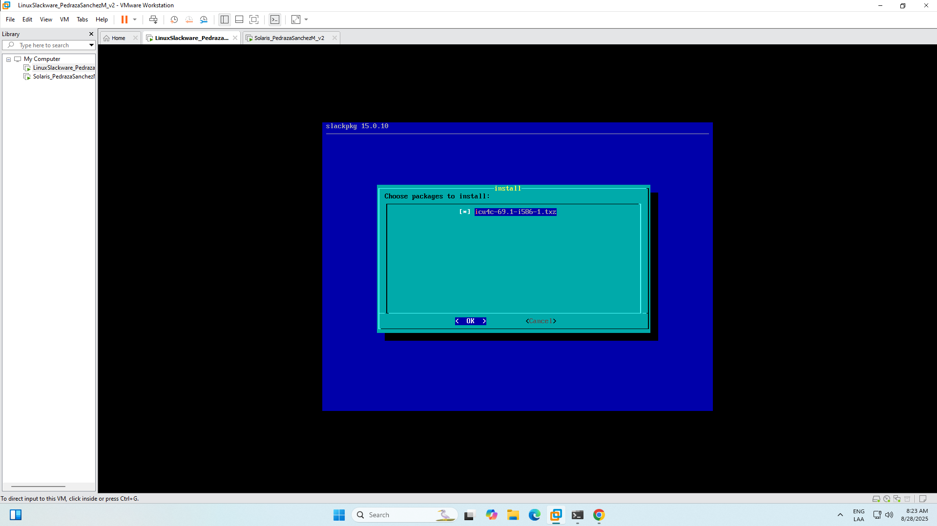

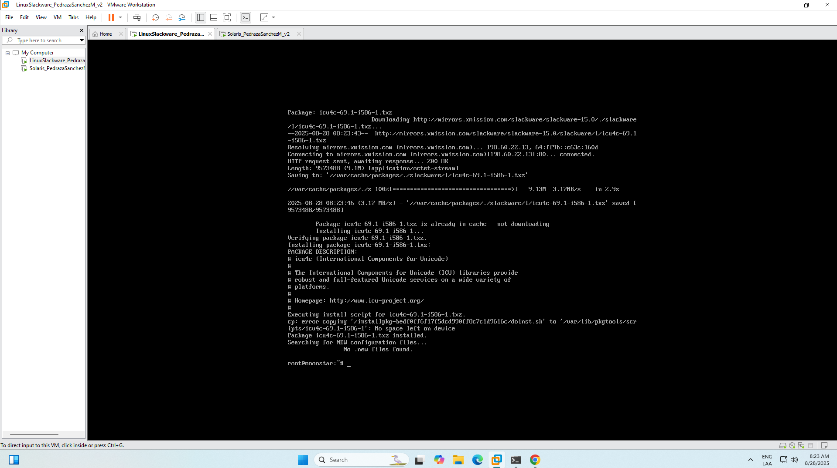

# Install LZ4 compression library

slackpkg install lz4

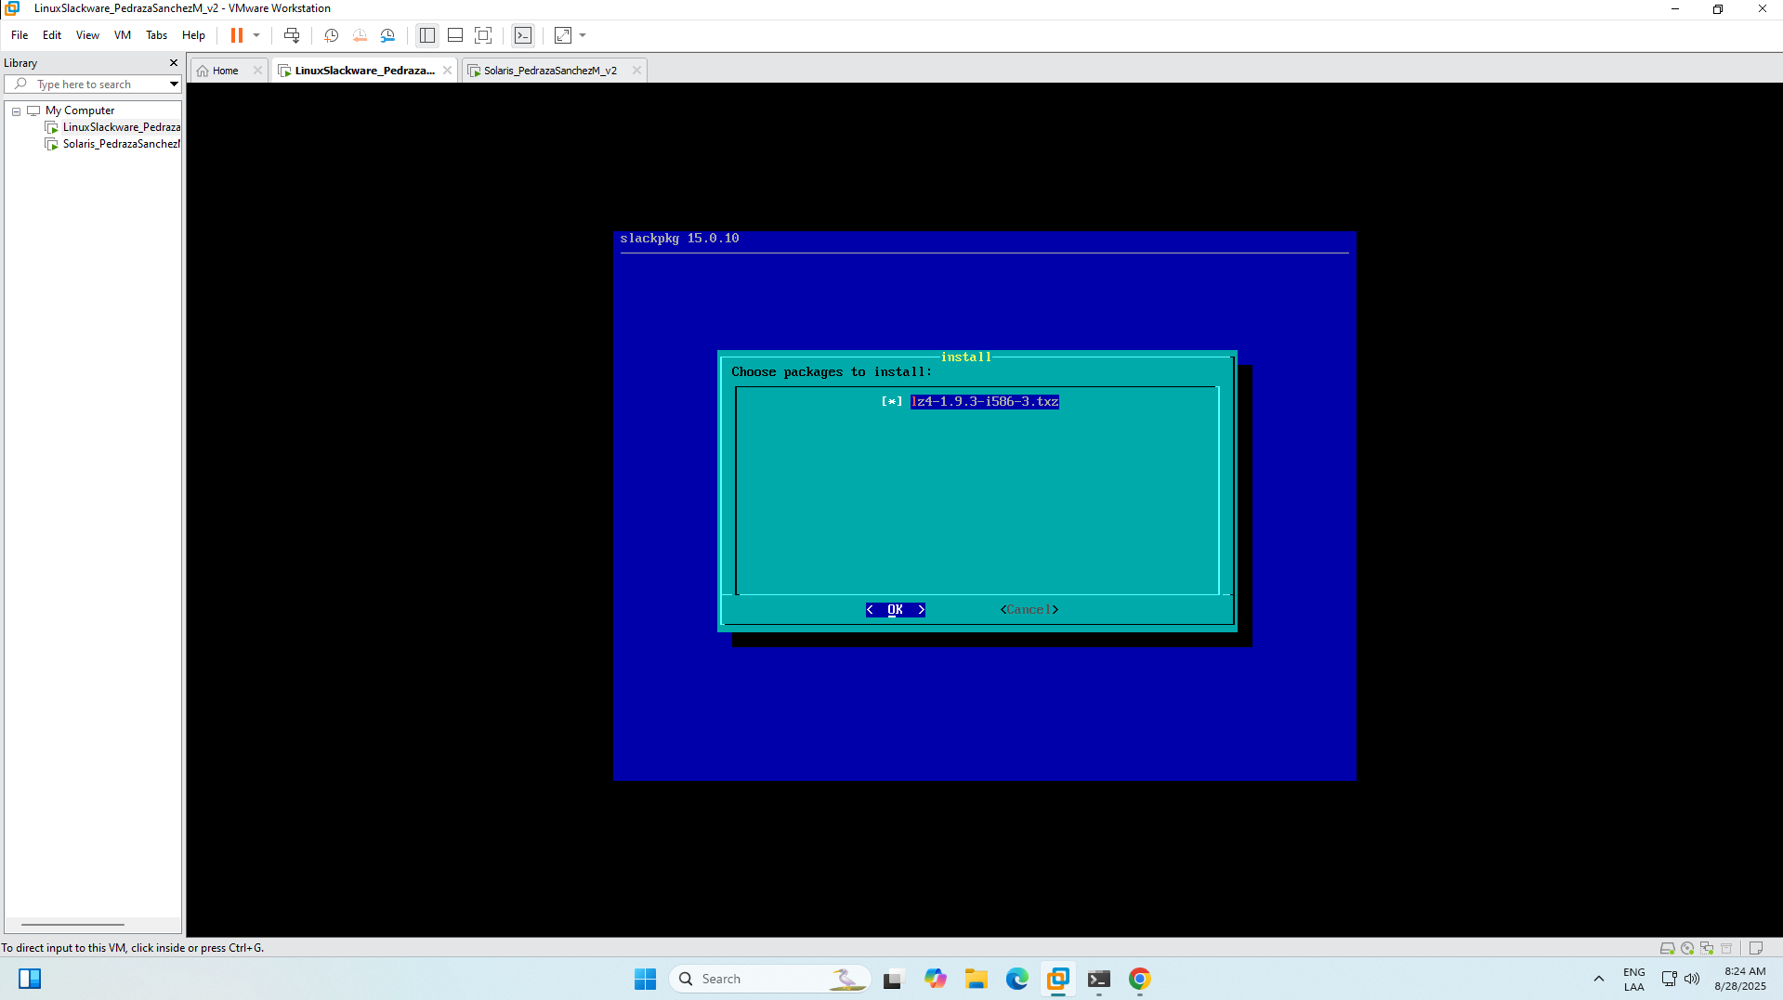

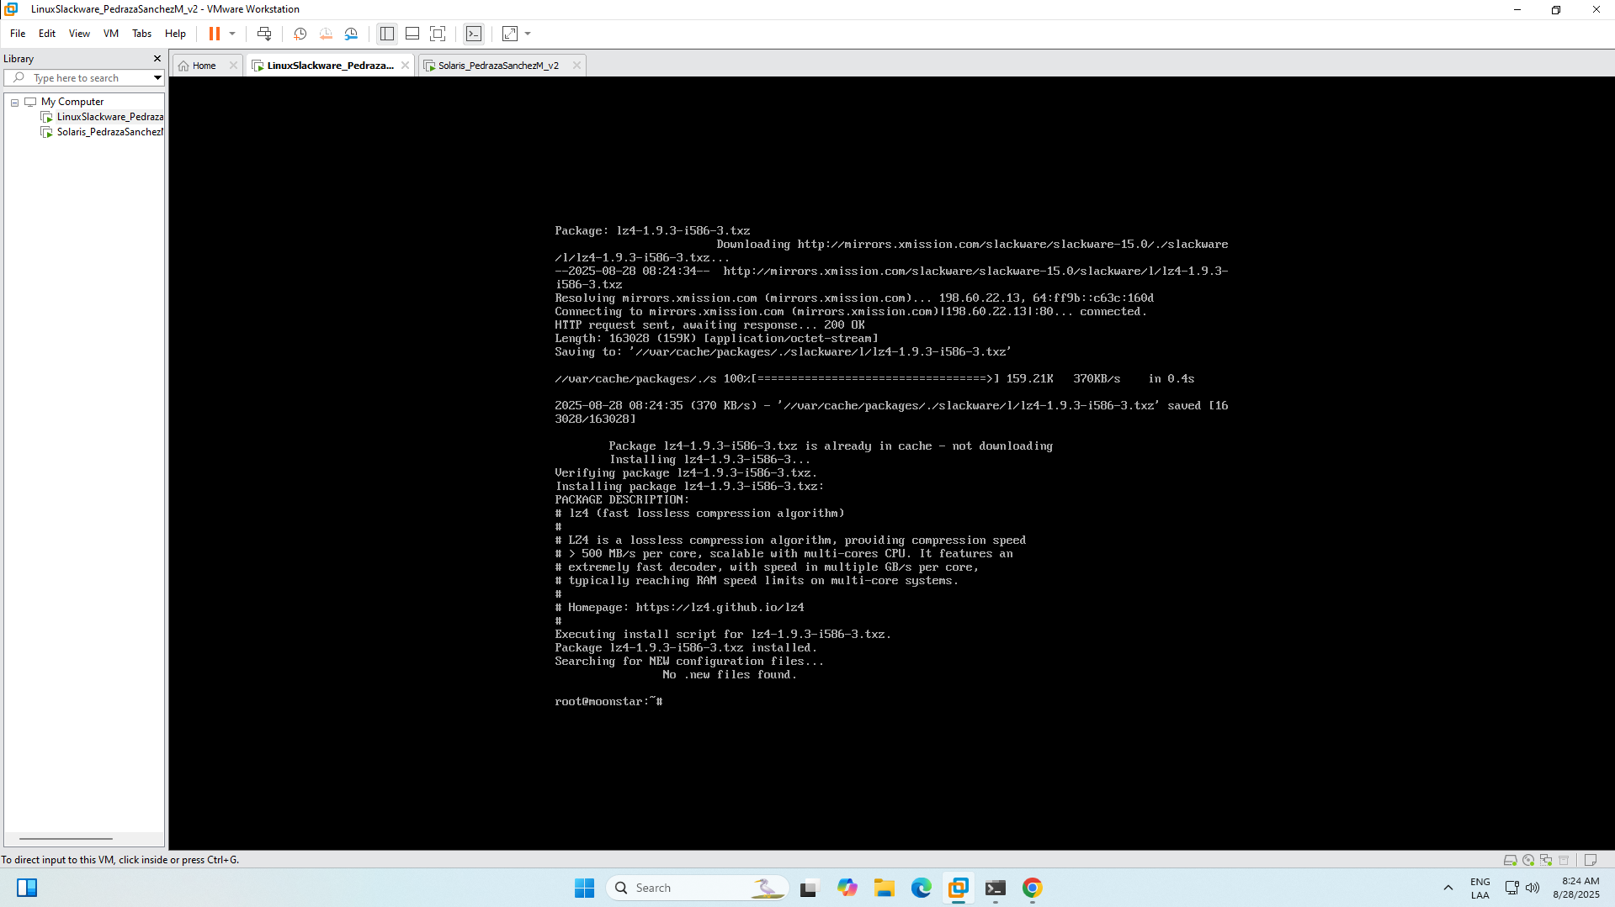

# Install libxml2

slackpkg install libxml2

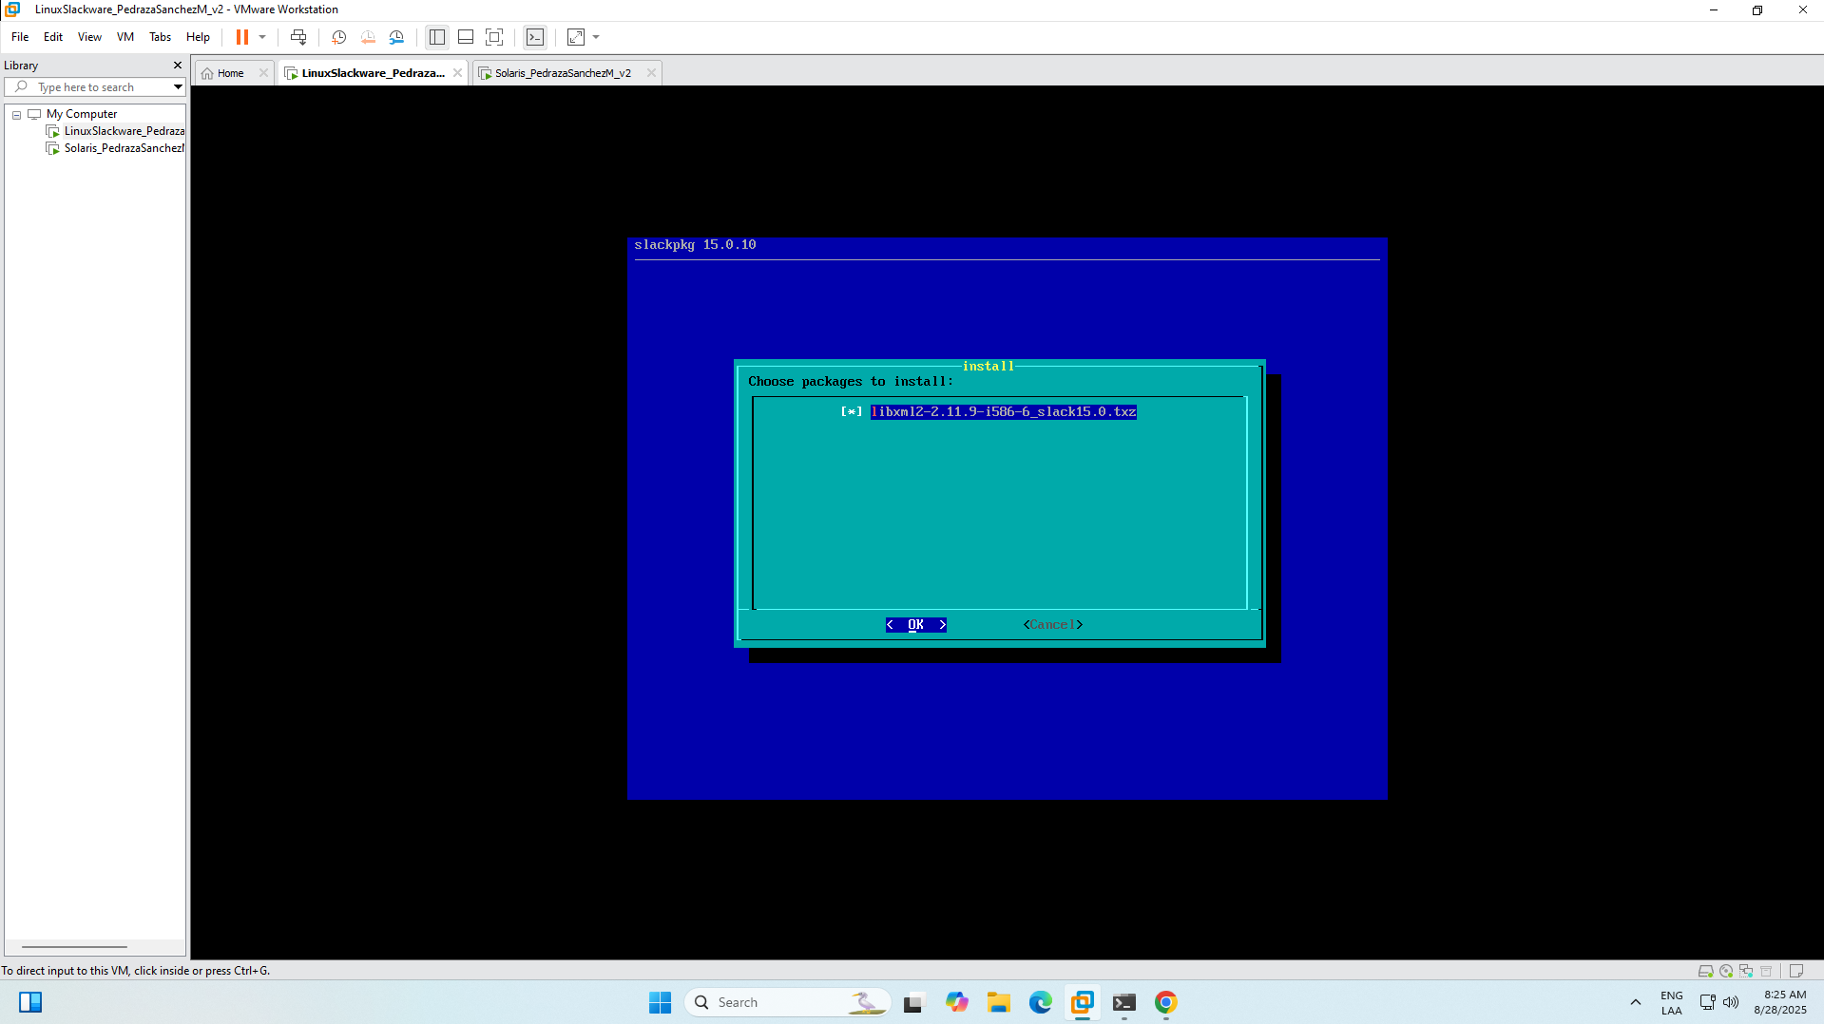

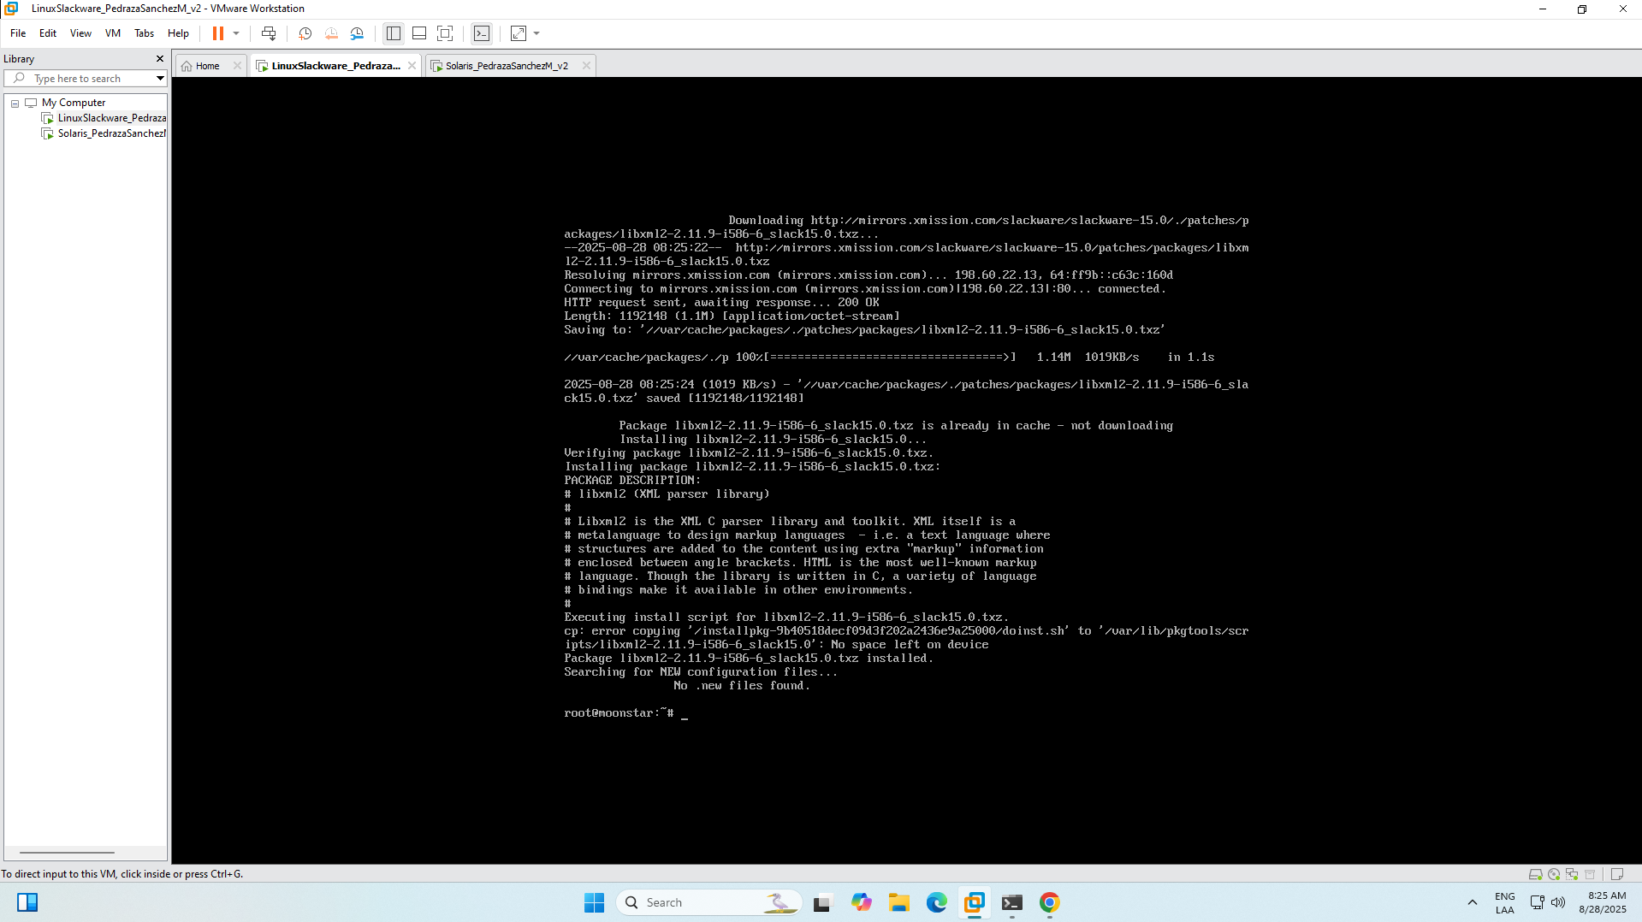

# Install Brotli compression libraries

slackpkg search brotli

slackpkg install brotli

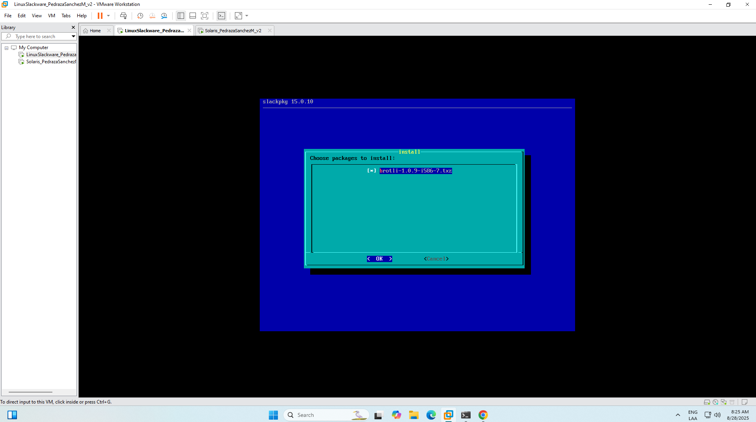

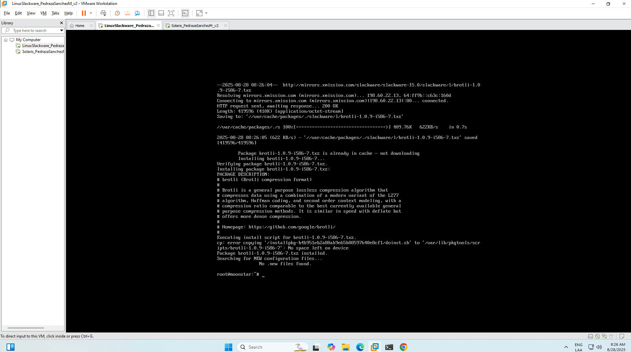

# Install p11-kit (PKCS#11 toolkit)

slackpkg search p11-kit

slackpkg install p11-kit

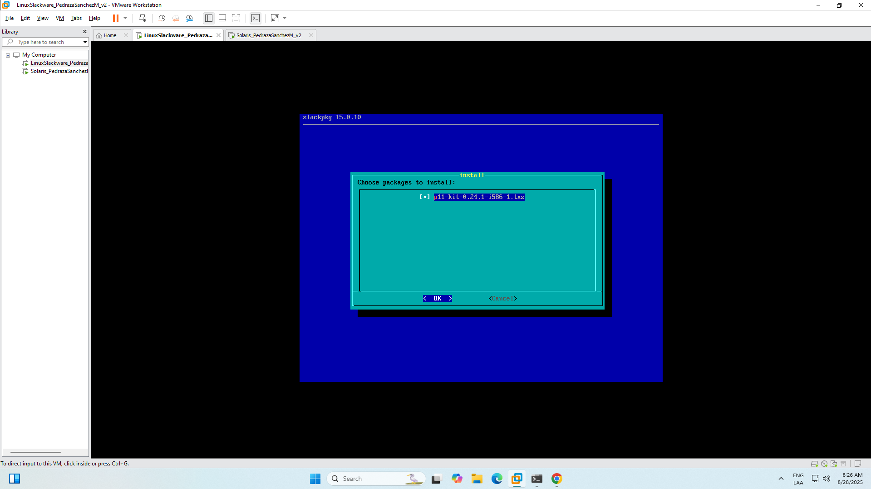

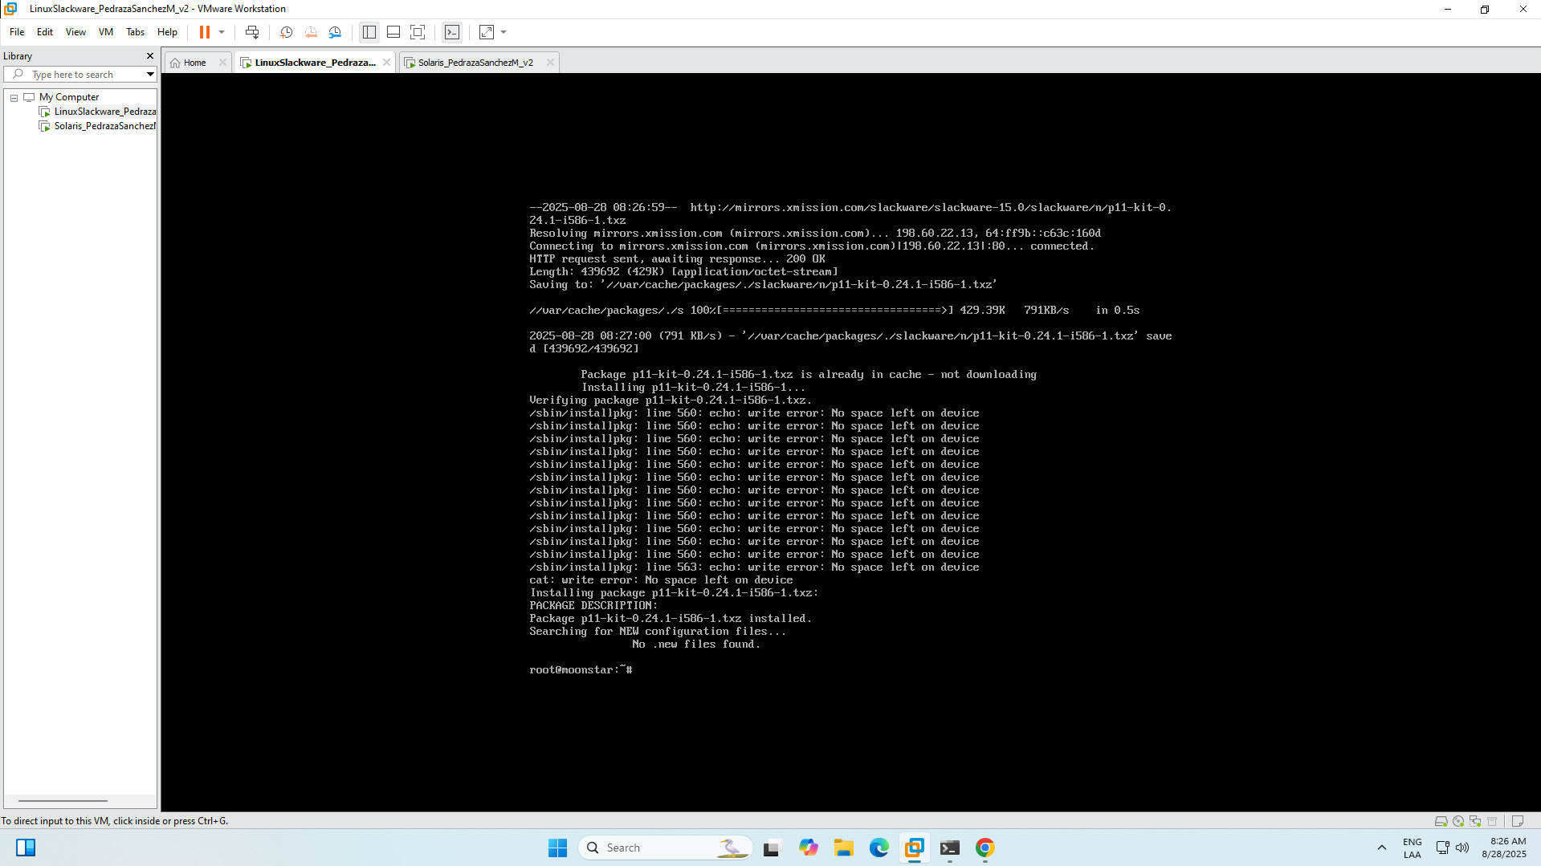

# Install Nettle cryptographic library

slackpkg search nettle

slackpkg install nettle

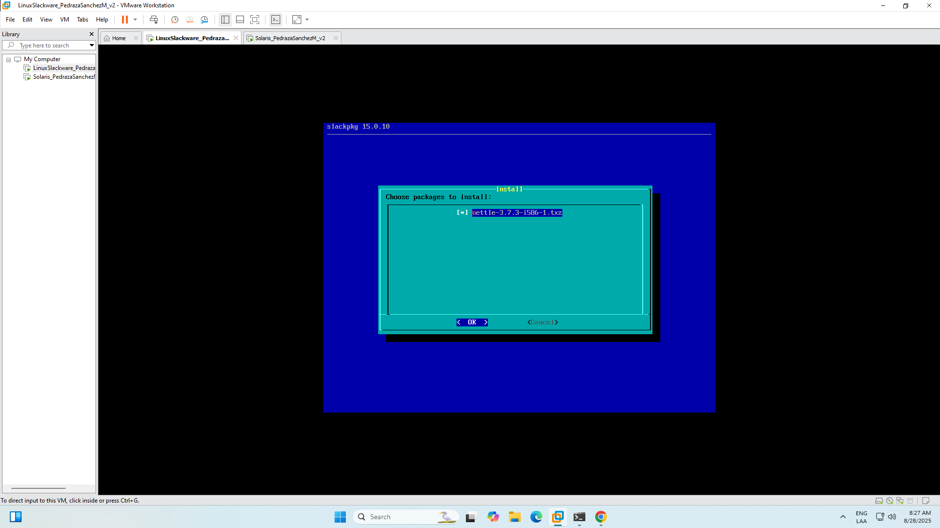

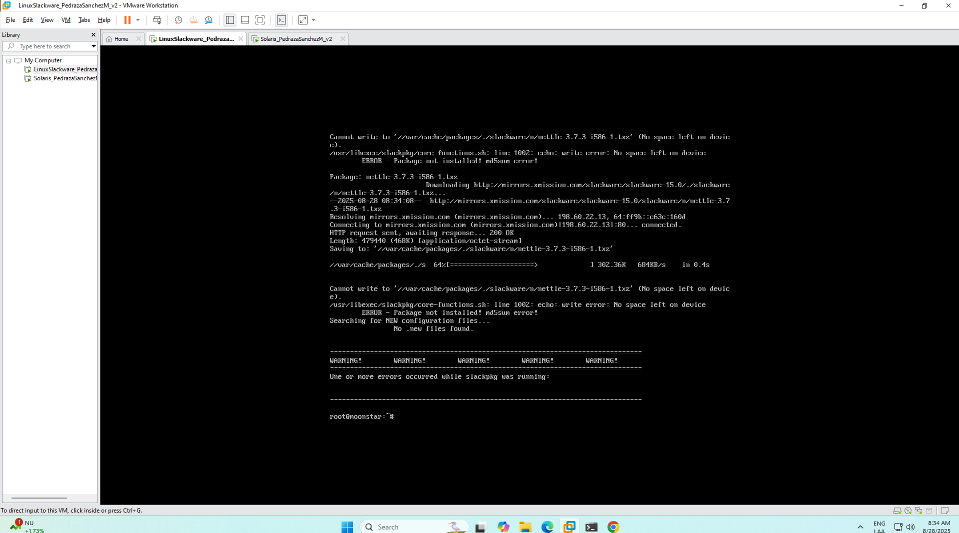

# Install Jansson JSON library

slackpkg search jansson

slackpkg install jansson

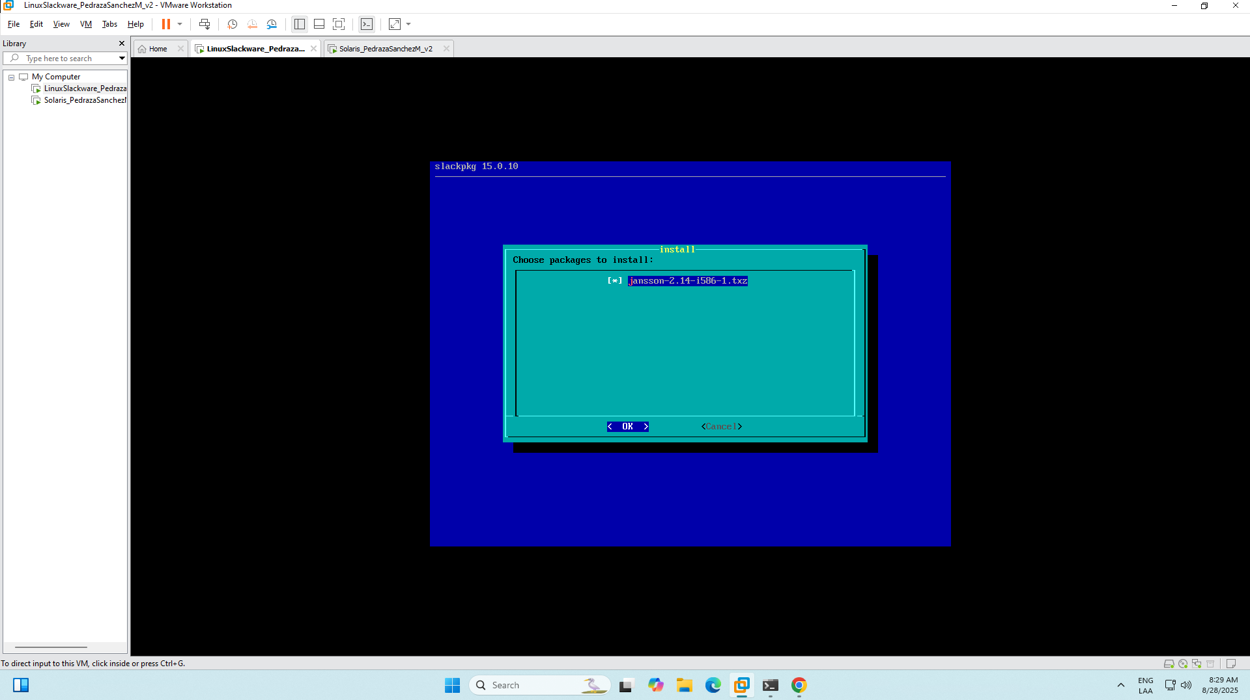

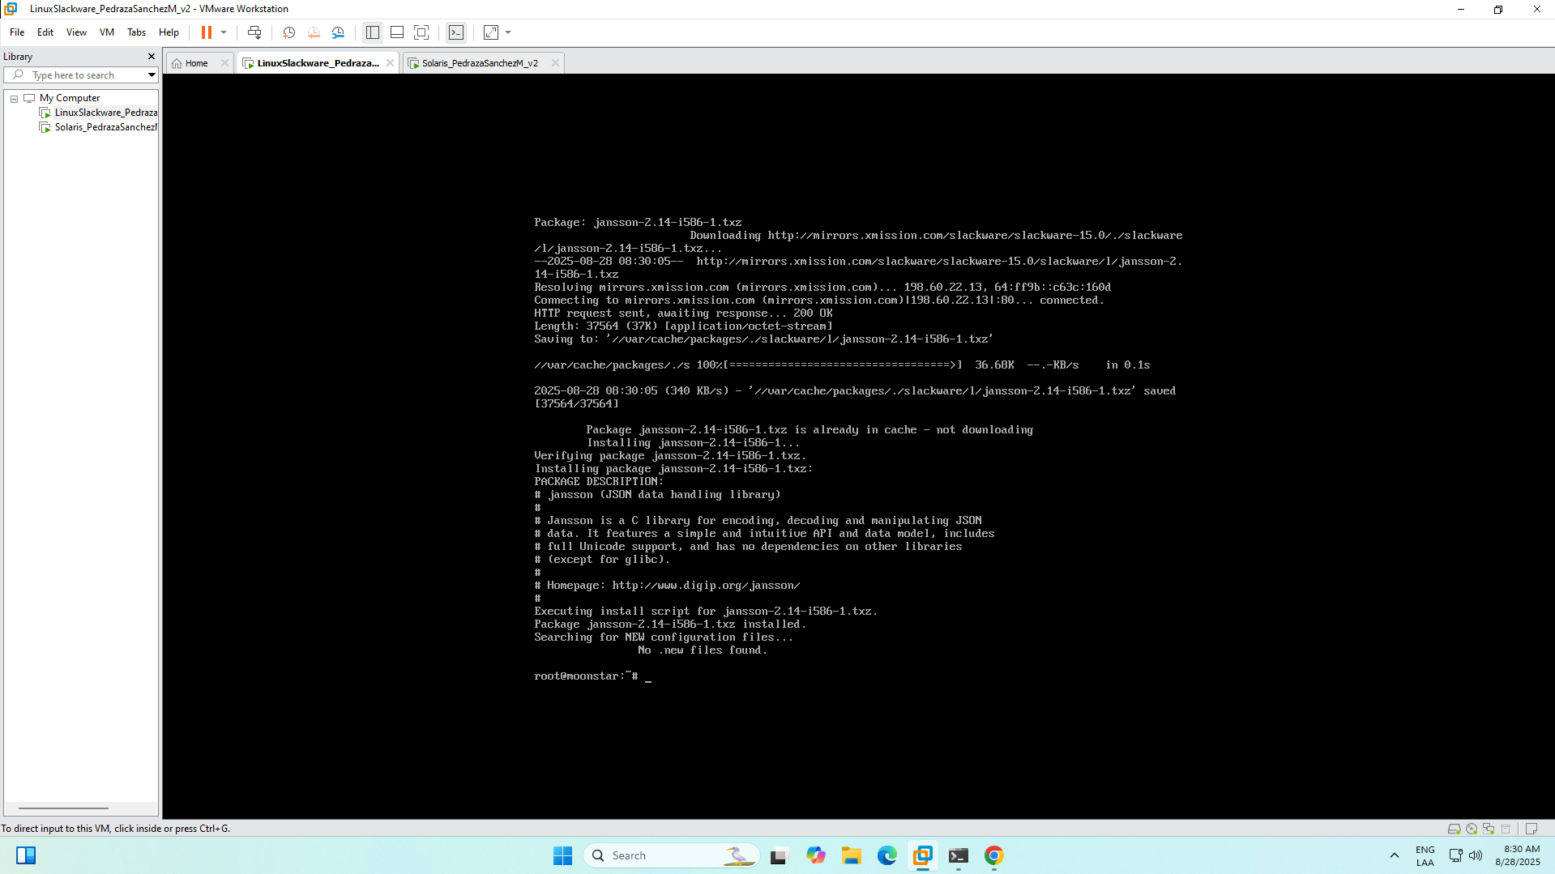

# Install SASL authentication library

slackpkg search sasl

slackpkg install cyrus-sasl

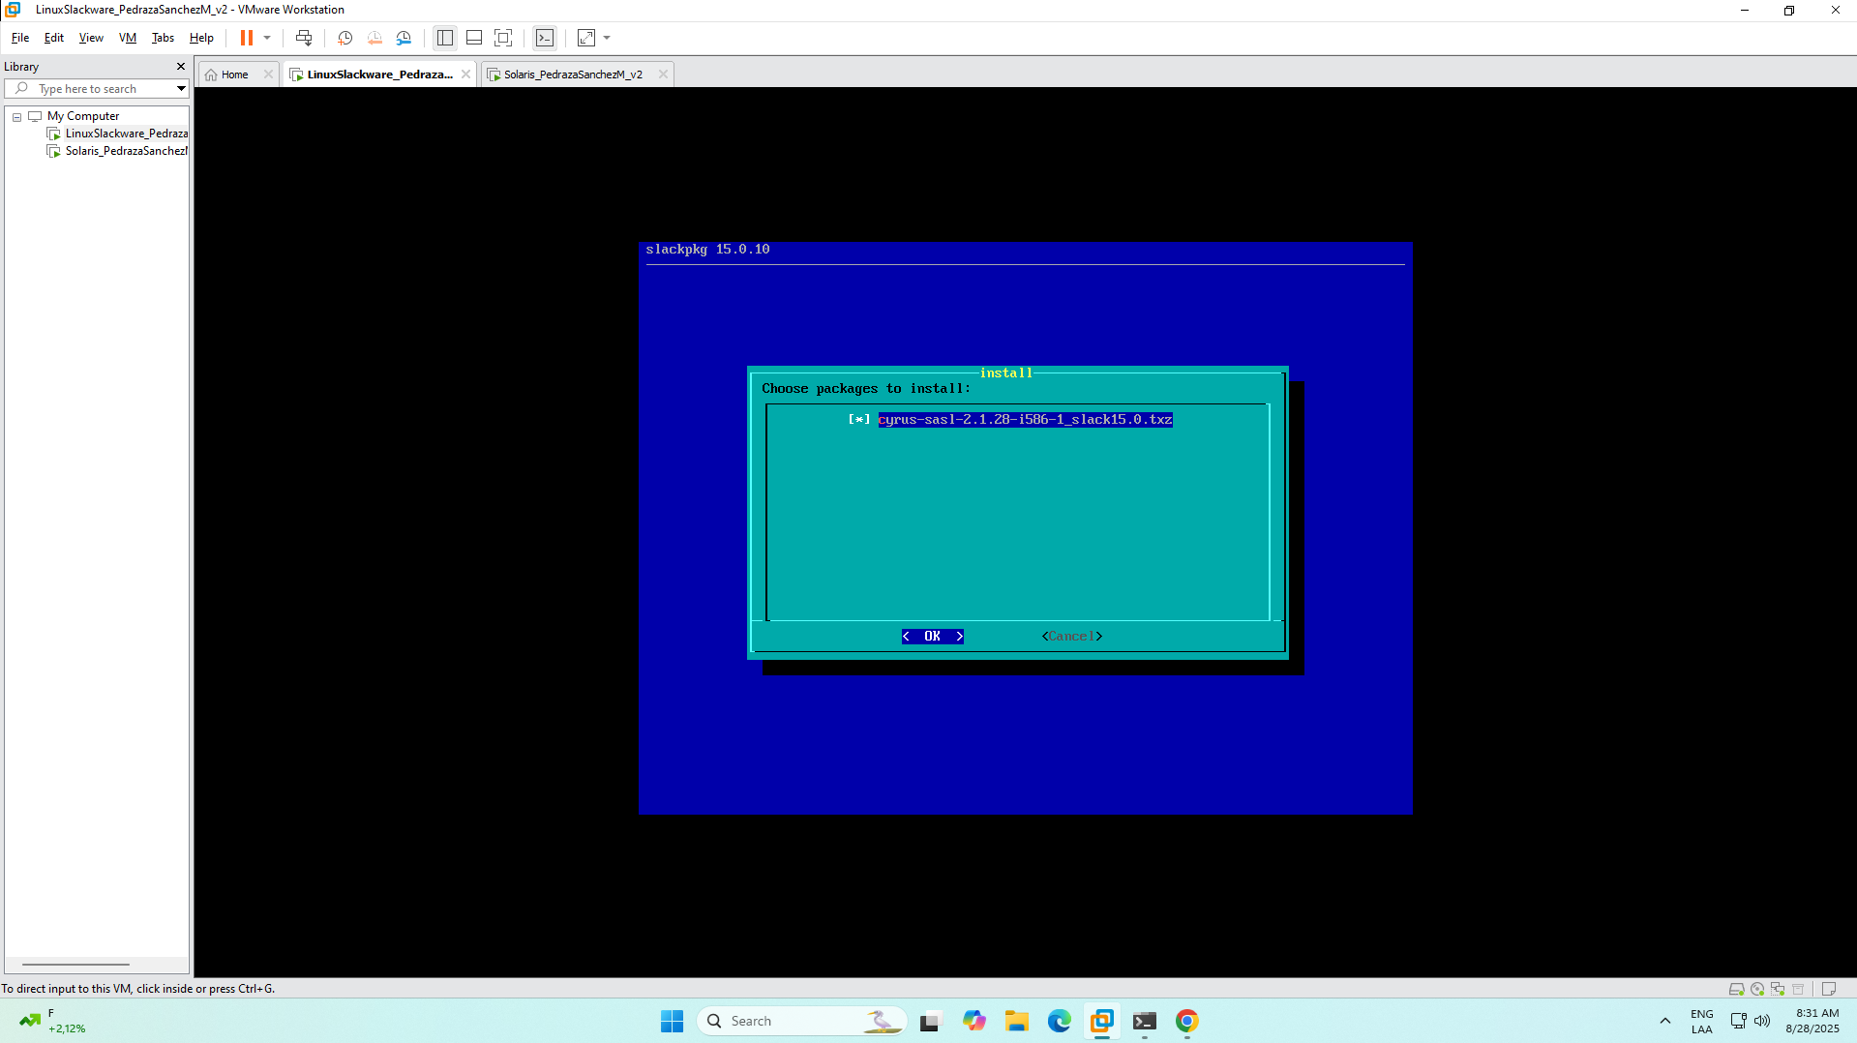

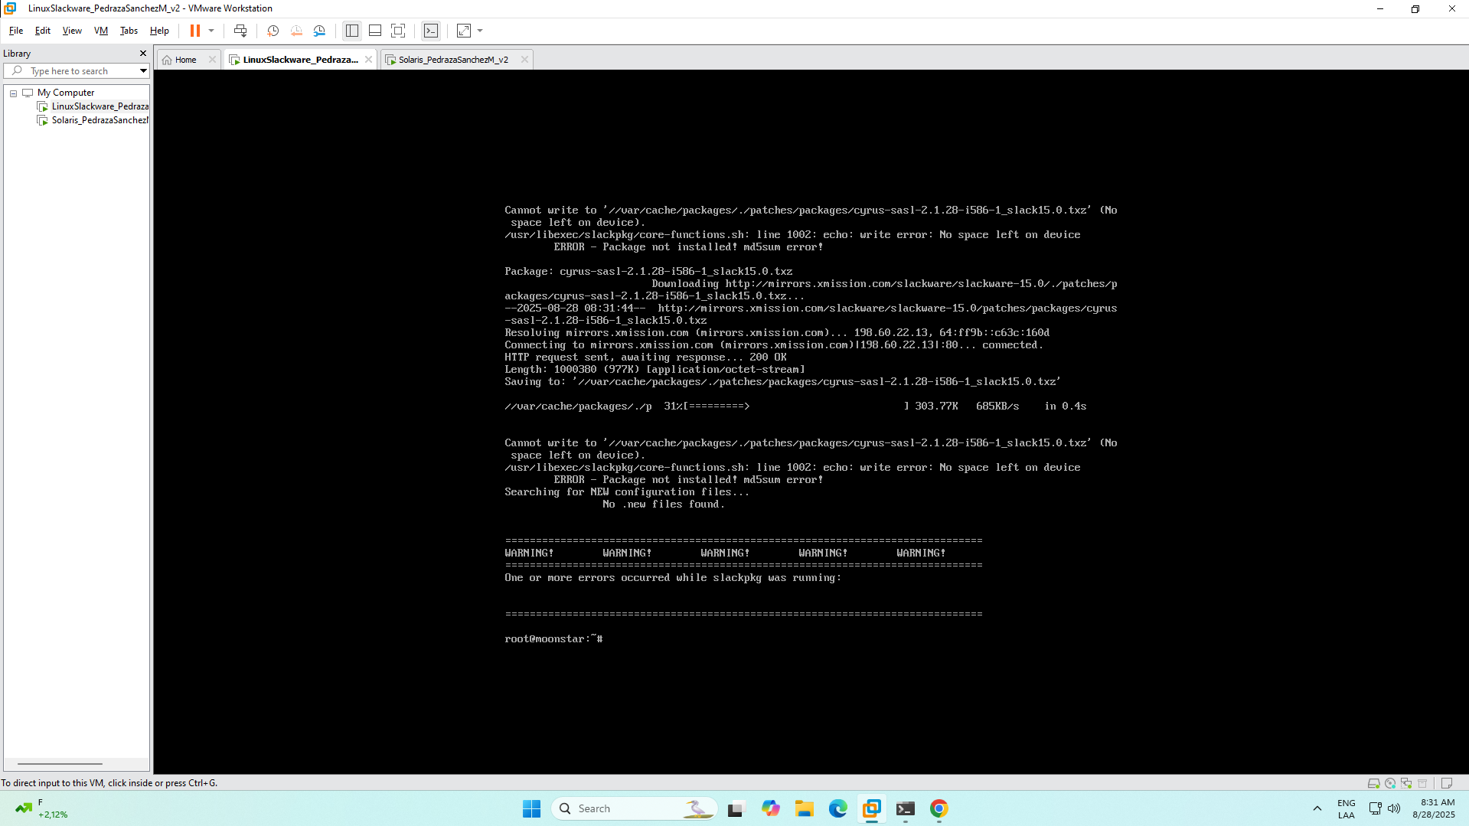

1. **Test command smbclient**

# Test if smbclient is now available

which smbclient

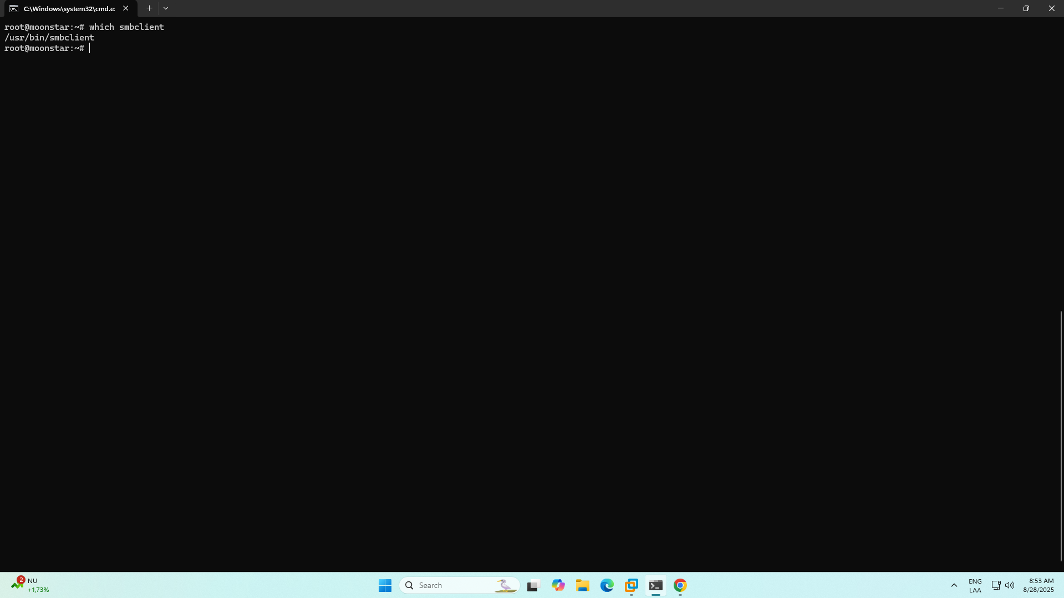

# Test connection to the Solaris Samba server

smbclient //10.2.77.178/shared -N (-N indicates to enter without smbuser password)

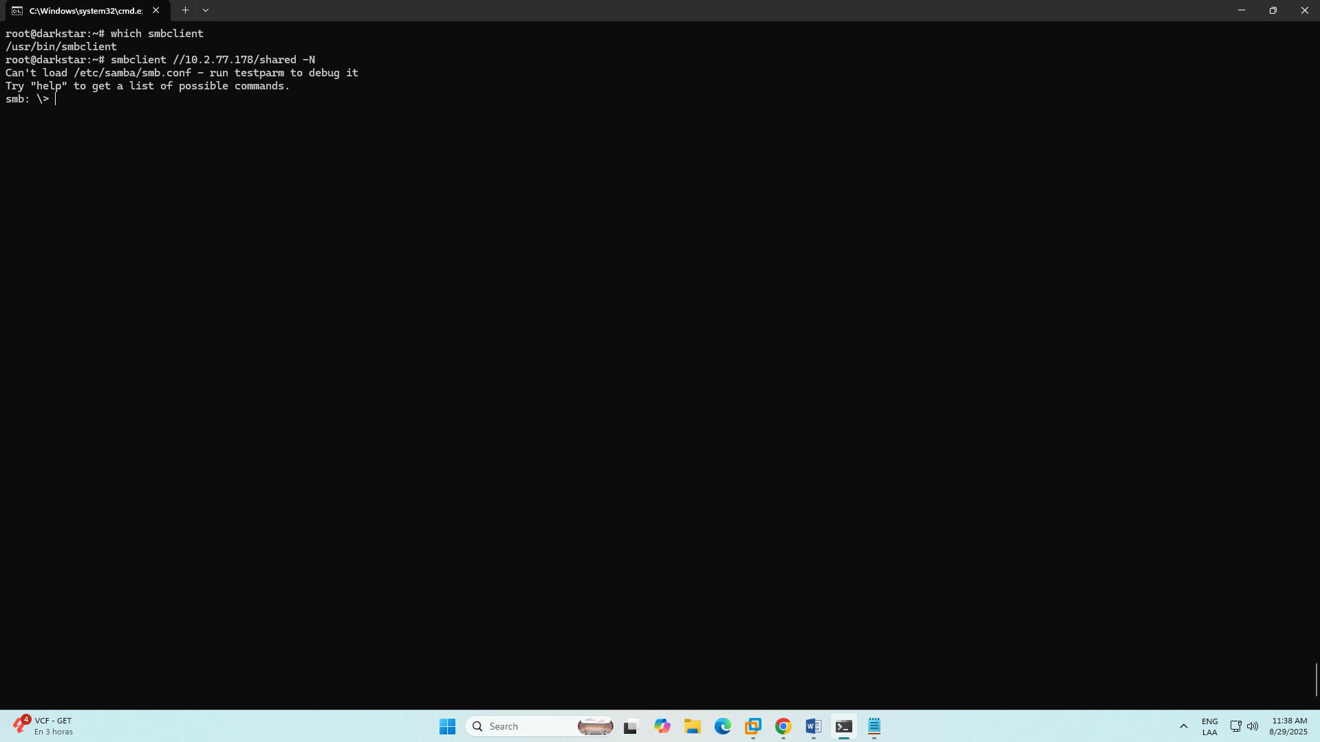

Once we are in smb client, we use **ls** command to see Solaris files

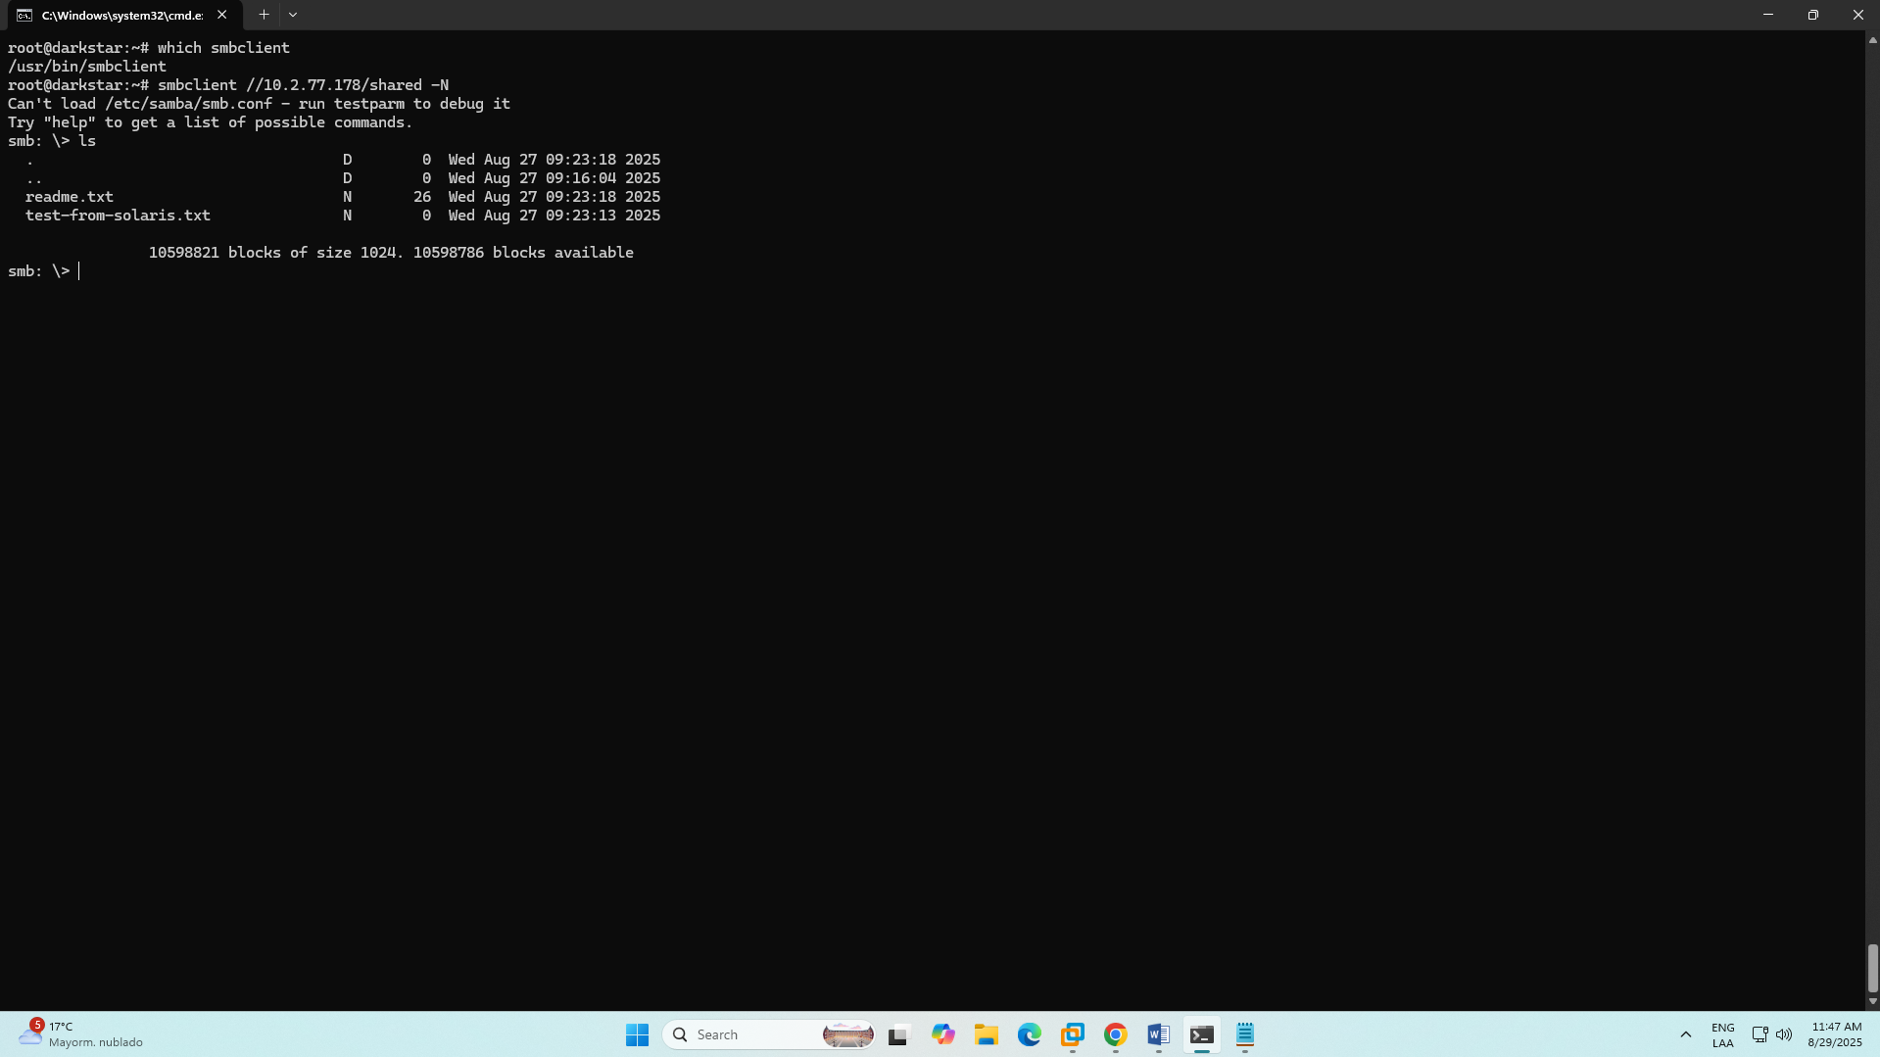

We provide another example to test SMB:

# Download a file to test

get readme.txt

# Create and upload a test file

!echo "Hello from Slackware!" > /tmp/slackware-test.txt

put /tmp/slackware-test.txt slackware-message.txt

# List files again to see your new file

ls

# Exit smbclient

exit

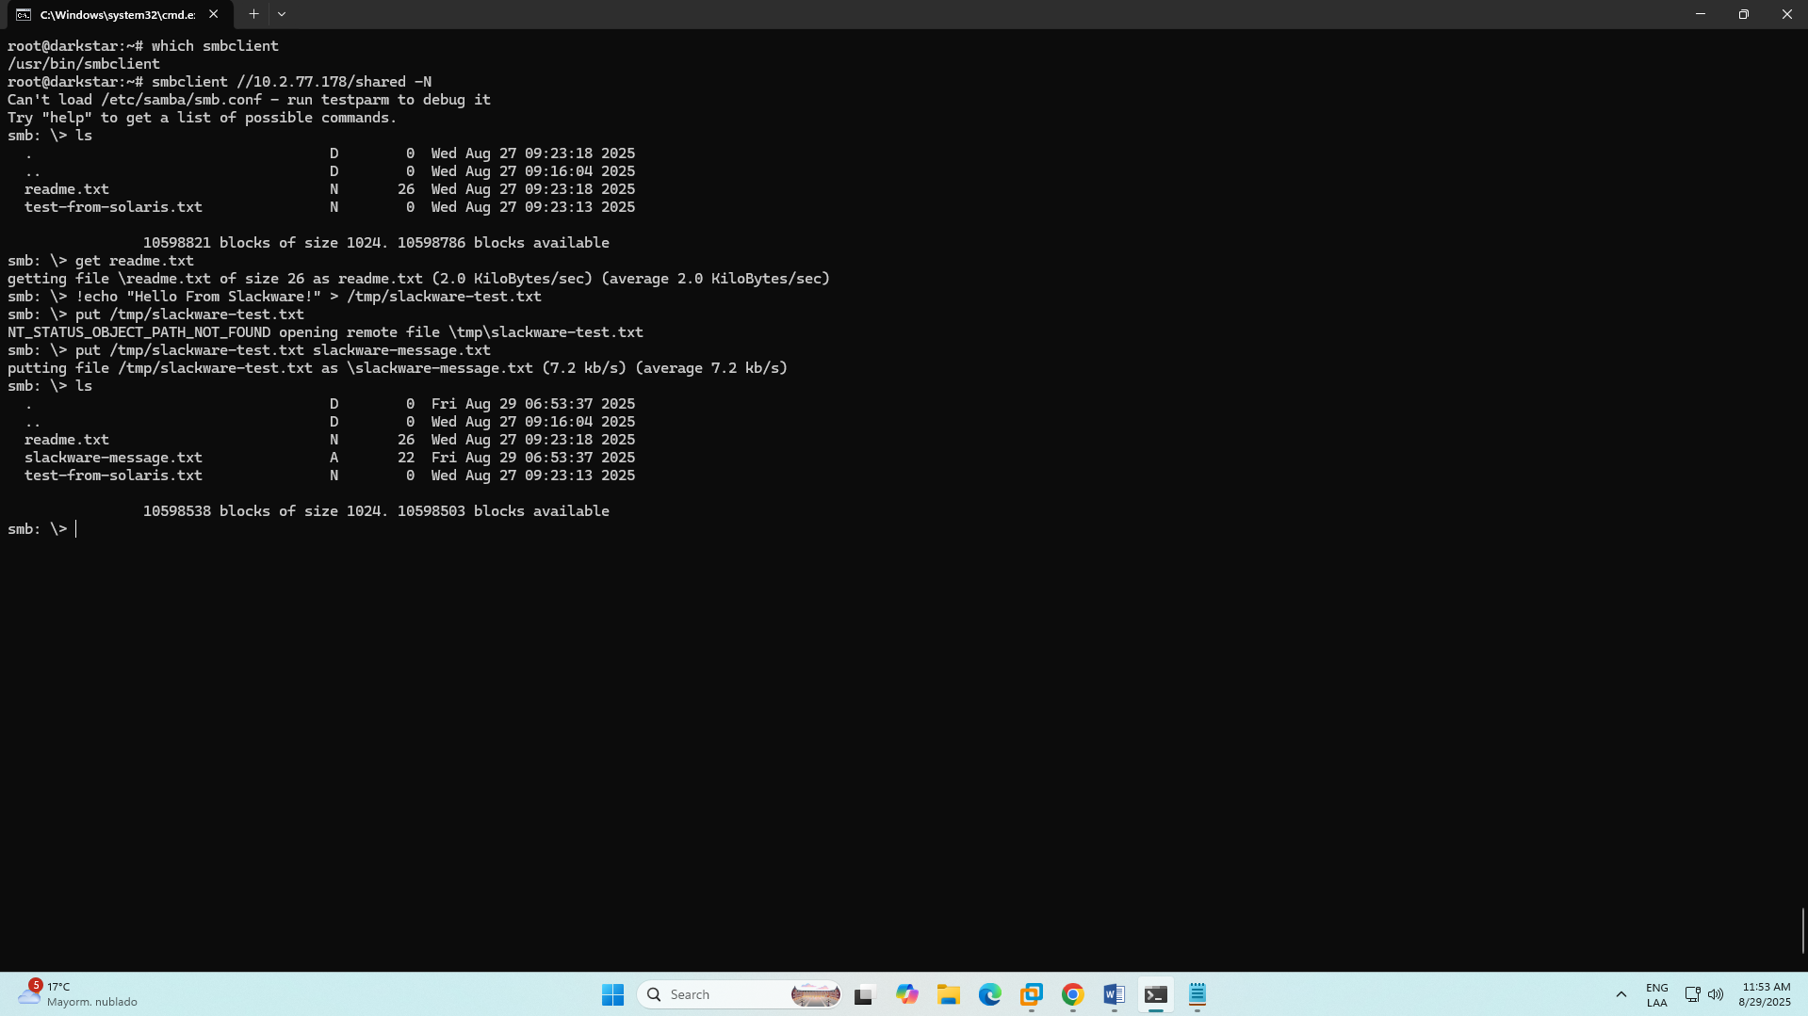

You can also enter with smbuser, and you will see the same shared files.

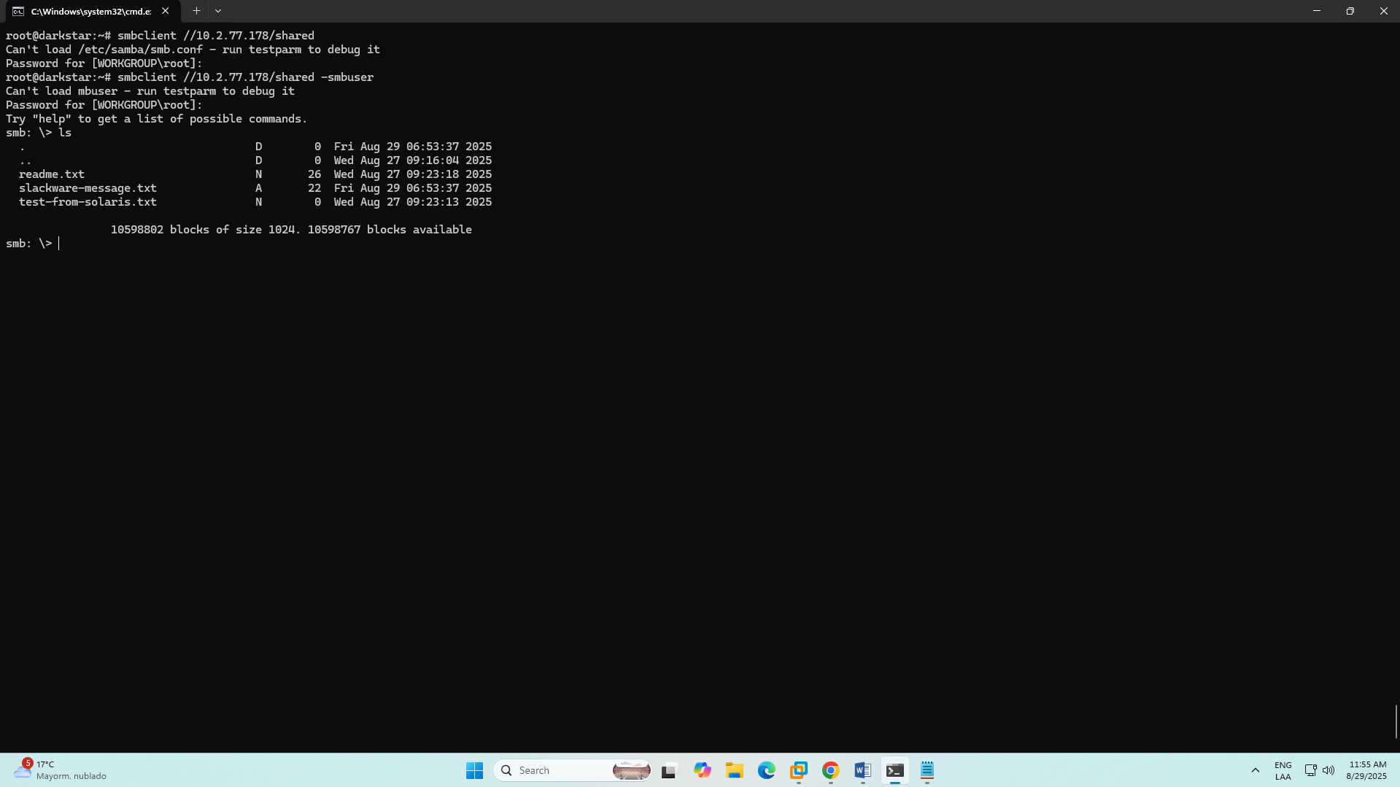

**4 - Solaris shared folder in Windows GUI machine:**

* In File Explorer address bar: \\<SLACKWARE_IP>\shared
* When prompted, provide smbuser and the SMB password you assigned.
* If Windows rejects the connection, use \\<IP>\shared instead of hostname and check Windows SMB client Network security policy if SMB2/3 issues appear.

For this case, you can see the shared folder was added to the machine correctly

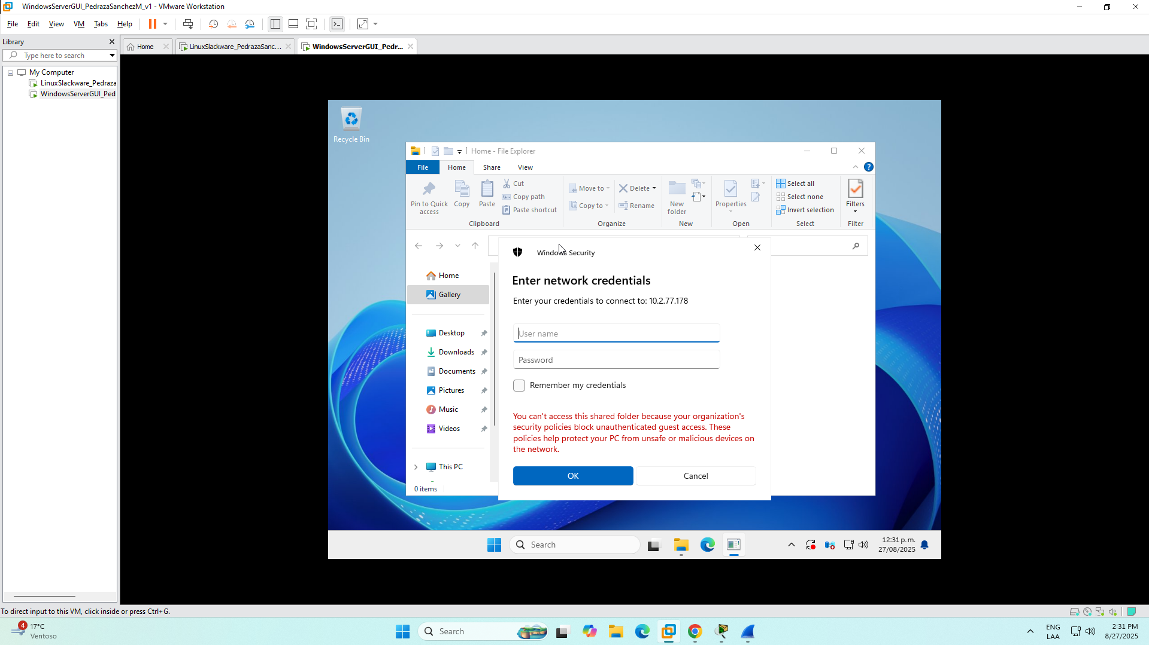

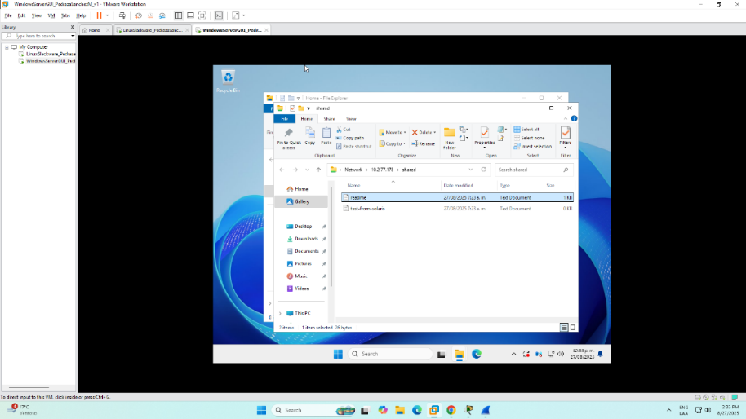

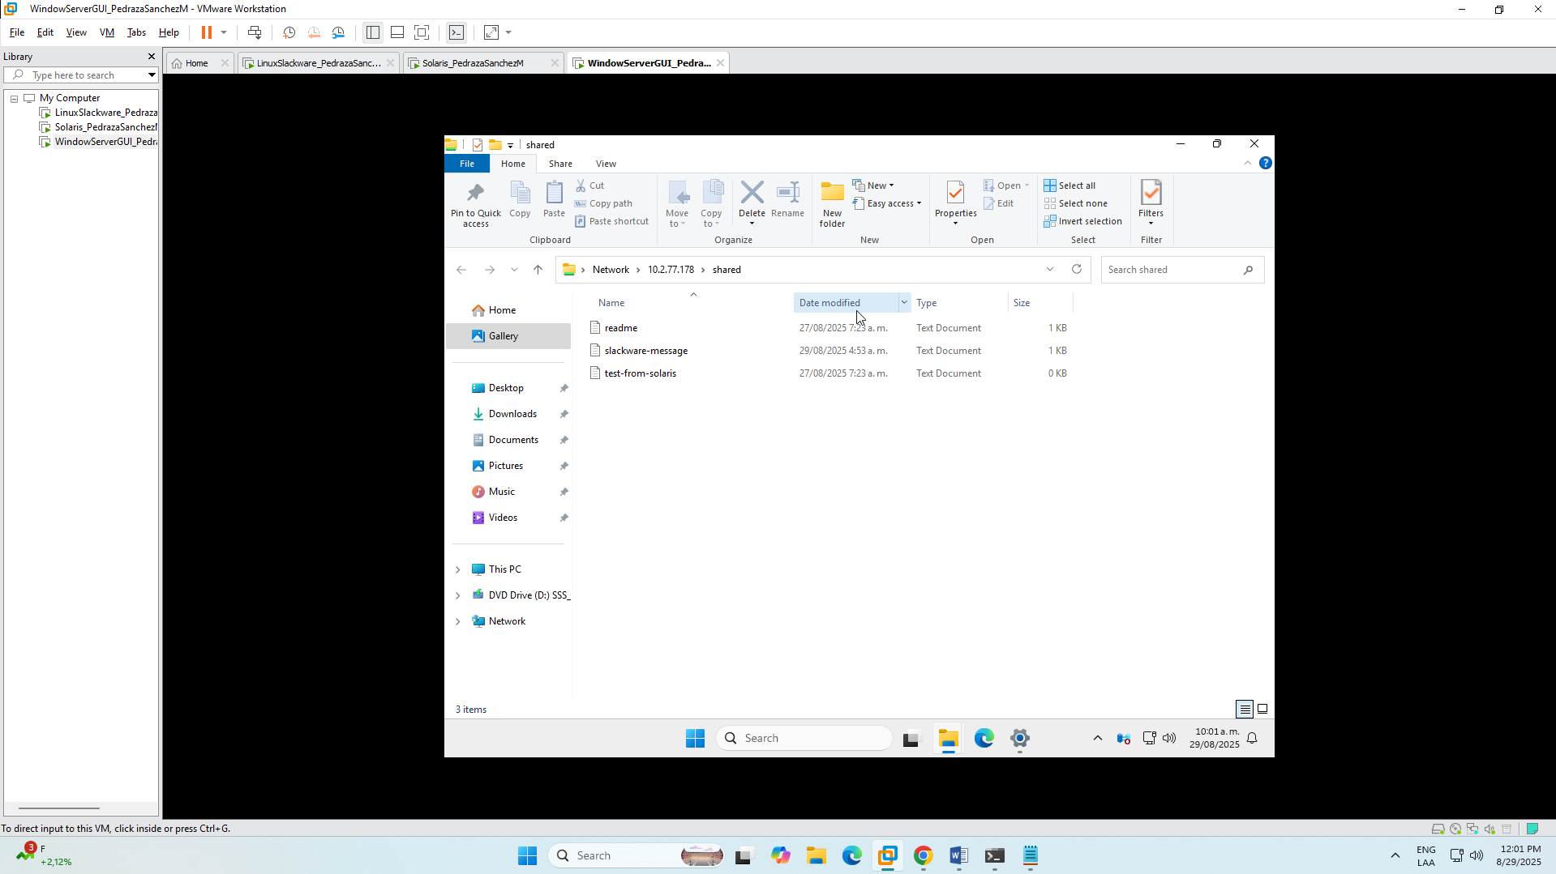

## Bibliography

* <https://www.wireshark.org/docs>
* <https://www.netacad.com/cisco-packet-tracer>
* <https://products.vmssoftware.com/samba>
* <https://www.openssh.com>
* <https://www.redhat.com/en/blog/introduction-vi-editor>
* <https://www.whatsupgold.com/es/blog/que-es-un-servidor-syslog-y-como-funciona>

1. Basado en 2.6.2: Using Packet Tracer to View Protocol Data Units. CCNA1
2. https://www.welivesecurity.com/la-es/2013/01/28/uso-filtros-wireshark-para-detectar-actividad-maliciosa/